import numpy as np  
import pandas as pd  
import scipy  
import sklearn  
from sklearn import preprocessing  
from sklearn import neighbors  
from sklearn.model_selection import train_test_split  
from sklearn import metrics  
import matplotlib.pyplot as plt

grade = pd.read_csv("rp2.csv")  
grade.columns = ['HS_GPA', 'FU_GPA']

grade.head()

HS_GPA FU_GPA  
0 3.4 3.18  
1 4.0 3.33  
2 3.8 3.25  
3 3.8 2.42  
4 4.0 2.63

grade.shape

(1000, 2)

X = grade.drop('FU_GPA', axis=1).values  
y = grade['FU_GPA'].values

X_train, X_test, y_train, y_test = train_test_split(X,y,test_size = 0.1, shuffle=False)

from sklearn.neighbors import KNeighborsRegressor

KNR=KNeighborsRegressor(9)  
KNR.fit(X_train, y_train)

KNeighborsRegressor(n_neighbors=9)

y_test_predict = KNR.predict(X_test)

plt.scatter(X_test, y_test_predict, color='blue')  
plt.show()

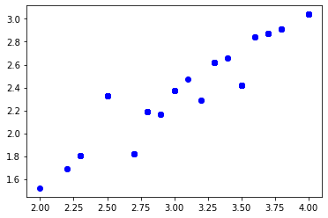

from sklearn.metrics import mean_absolute_error  
from sklearn.metrics import mean_squared_error  
from sklearn.metrics import mean_squared_log_error  
from sklearn.metrics import median_absolute_error  
from sklearn.metrics import r2_score

mean_absolute_error(y_test, y_test_predict)

0.4457222222222221

mean_squared_error(y_test, y_test_predict)

0.31526786419753083

mean_squared_log_error(y_test, y_test_predict)

0.030294633562256045

mean_absolute_error(y_test, y_test_predict)

0.4457222222222221

r2_score(y_test, y_test_predict)

0.2990699197164698

from sklearn.model_selection import GridSearchCV  
params = {'n_neighbors':[2,3,4,5,6,7,8,9]}

model = GridSearchCV(KNR, params, cv=5)

model.fit(X_train, y_train) model.best_params_

model.fit(X_train, y_train)   
model.best_params_

{'n_neighbors': 8}