import numpy as np  
import pandas as pd  
import scipy  
import sklearn  
from sklearn import preprocessing  
from sklearn import neighbors  
from sklearn.model_selection import train_test_split  
from sklearn import metrics  
import matplotlib.pyplot as plt

grade = pd.read_csv("rp3.csv")  
grade.columns = ['SAT_Score', 'FU_GPA']

grade.head()

SAT_Score FU_GPA  
0 1270 3.18  
1 1220 3.33  
2 1160 3.25  
3 950 2.42  
4 1070 2.63

grade.shape

(1000, 2)

X = grade.drop('FU_GPA', axis=1).values  
y = grade['FU_GPA'].values

X_train, X_test, y_train, y_test = train_test_split(X,y,test_size = 0.1, shuffle=False)

from sklearn.neural_network import MLPRegressor  
reg = MLPRegressor(hidden_layer_sizes=(100,50,25), activation="relu", alpha=0.0001, batch_size = 'auto',   
 learning_rate = 'constant', learning_rate_init = 0.001, random_state=1, max_iter=2000).fit(X_train, y_train)

y_test_predict = reg.predict(X_test)

plt.scatter(X_test, y_test_predict)  
plt.show()

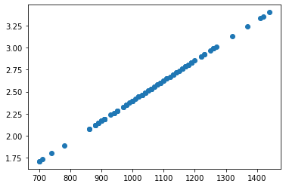

from sklearn.metrics import mean_absolute_error  
from sklearn.metrics import mean_squared_error  
from sklearn.metrics import mean_squared_log_error  
from sklearn.metrics import median_absolute_error  
from sklearn.metrics import r2_score

mean_absolute_error(y_test, y_test_predict)

0.495291979687835

mean_squared_error(y_test, y_test_predict)

0.3741761345070943

mean_squared_log_error(y_test, y_test_predict)

0.03731791612222039

median_absolute_error(y_test, y_test_predict)

0.4656119596923818

r2_score(y_test, y_test_predict)

0.16810008952922417

from sklearn.model_selection import GridSearchCV  
from sklearn.model_selection import ShuffleSplit  
cv=ShuffleSplit(n_splits=10, test_size=0.1, random_state=1)  
params = {'hidden_layer_sizes':[100,50,25], 'activation':['relu'], 'max_iter':[2000], 'random_state':[1],   
 'learning_rate':['constant']}  
model = GridSearchCV(MLPRegressor(), params, cv=cv)  
model.fit(X_test, y_test_predict)  
model.best_params_

{'activation': 'relu',  
 'hidden_layer_sizes': 25,  
 'learning_rate': 'constant',  
 'max_iter': 2000,  
 'random_state': 1}