**Guide to Learning Prompt Engineering for Optimization Tasks**

**Step 1: Understand the Basics of Python**

Before diving into prompt engineering, it's crucial to have a solid understanding of Python, as this will be the programming language you'll use to interact with LLAMA. Here's how you can get started:

1. **Python Basics:**
   * **Variables and Data Types:** Learn how to declare variables, and understand different data types like strings, integers, lists, and dictionaries.
   * **Control Structures:** Understand if statements, loops (for and while), and functions. These are essential for writing logic in your code.
   * **Functions:** Learn how to define and call functions, pass arguments, and return values.

**Resources:**

* + [Python for Beginners](https://docs.python.org/3/tutorial/index.html) (Official Python Tutorial)
  + Here is various [Codecademy Python Course](https://www.codecademy.com/catalog/language/python) (Interactive Learning)

1. **Practice Python:**
   * Use platforms like [LeetCode](https://leetcode.com/) or HackerRank to practice Python problems.

**Step 2: Introduction to Large Language Models (LLMs)**

To understand prompt engineering, you first need to grasp what Large Language Models (LLMs) are and how they function.

1. **Understanding LLMs:**
   * Learn what LLMs are, how they are trained, and their common applications.
   * Understand the basics of transformer architecture, as this underlies most modern LLMs like LLAMA.

**Resources:**

* + [Introduction to Transformer Models](https://www.youtube.com/watch?v=XfpMkf4rD6E) (Illustrated Guide)
  + Hugging Face Course (Focus on Transformers)

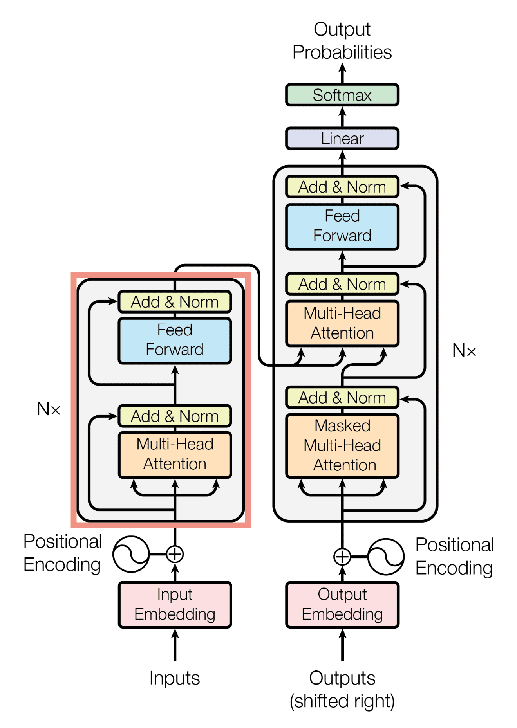

**Step 3: Learning Prompt Engineering**

Prompt engineering is the art of designing prompts to get the desired output from an LLM. Here’s how to learn it:

1. **Introduction to Prompt Engineering:**
   * Understand what prompts are and why they are crucial for getting accurate and relevant responses from LLMs.
   * Learn about different types of prompts: zero-shot, few-shot, and how to craft them.

**Resources:**

* + [OpenAI Prompt Guide](https://beta.openai.com/docs/guides/completion/prompt-design)
  + [Prompt Engineering YouTube Videos](https://www.youtube.com/watch?v=GrX4WfT5FI4&list=PL6gx4Cwl9DGDv5eyBLEd9l3ZZzVoroxIZ&index=1)

1. **Crafting Effective Prompts:**
   * Learn the best practices for writing prompts, such as being clear and specific, and providing context when needed.
   * Experiment with varying the wording, order, and structure of your prompts to see how it affects the model's output.

**Resources:**

* + Practice with small, interactive tools like [OpenAI Playground](https://platform.openai.com/playground) (if available).
  + [Prompt Engineering Techniques](https://www.promptingguide.ai/) (Advanced Tips)

1. **Hands-on Practice:**
   * Start by using the LLAMA model in simple tasks, such as text completion or question answering.
   * Gradually move to more complex tasks related to your project, like optimization problems, by framing the problems as prompts.

**Exercises:**

* + Create a prompt to solve a basic text-based problem.
  + Modify existing prompts to see how different inputs change the output.
  + Develop a prompt that aligns with the solving algorithm provided by the instructor.

**Step 4: Applying Prompt Engineering to Optimization Problems**

Now that you understand the basics of prompt engineering, apply this knowledge to your specific task—group optimization problems.

1. **Understand the Problem:**
   * Clearly define what the optimization problem is and how it can be framed as a prompt for the LLAMA model.
   * Consider the inputs, constraints, and expected outputs.
2. **Design Prompts for Optimization:**
   * Start by designing prompts that help LLAMA understand the optimization problem.
   * Iterate on these prompts by testing and refining them to get closer to the optimal solution.
   * Collaborate with peers to compare different prompt designs and outcomes.

**Additional:**

* + Review the solving algorithm provided and think about how it can be broken down into steps that the LLAMA model can understand.

**Step 5: Testing and Iteration**

Finally, it's crucial to test your prompts and iterate based on the results you get.

1. **Testing:**
   * Run the prompts through the LLAMA model and evaluate the outputs.
   * Check if the outputs align with the expected results and refine your prompts accordingly.
2. **Iteration:**
   * Use the feedback from your tests to improve your prompts.
   * Document your process and findings to create a guide for future reference.

**Tools:**

* + Use VS Code, Jupyter Notebooks or similar environments to write, test, and iterate on your prompts.