Rank-based pathway scoring methods can invert biological signal under gene competition: a benchmark of five methods across four tissues
Fadhl M. Alakwaa1,*, Ahmed Elbaz2, Sara Al Azzam3, Tasnim Alshebani4
1 Department of Internal Medicine, Division of Nephrology, University of Michigan, Ann Arbor, MI, USA
2 The American University in Cairo, Cairo, Egypt
3 Jordan University of Science and Technology, Irbid, Jordan
4 Wayne State University, Detroit, MI, USA
* Corresponding author: alakwaaf@umich.edu

Abstract
Pseudobulk aggregation of single-cell RNA-sequencing data is the dominant approach for comparing pathway activities between disease and control groups, yet no systematic evaluation of scoring methods exists for this use case. We benchmarked five pathway activity scoring methods — ssGSEA, GSVA, Z-score, AUCell, and UCell — across seven disease datasets (4,005,940 cells, 618 donors, four tissues) from CellxGene Census, evaluating five robustness criteria: biological relevance, aggregation stability, outlier robustness, normalization stability, and sample-size stability. We report a novel methodological finding: rank-based methods (AUCell, UCell) can systematically invert disease-vs-control direction when non-pathway genes are upregulated more strongly than the pathway of interest, an effect we term 'rank-window competition.' In controlled simulations, AUCell flipped sign (Cohen's d = −0.27) while magnitude-based methods maintained correct detection (d = 2.2–11.1). In real CKD kidney data, AUCell and UCell reported ECM remodeling as downregulated (d ≈ 0) while ssGSEA, GSVA, and Z-score correctly detected upregulation (d = 0.39–0.44). No single method dominated all criteria: UCell and GSVA each achieved 'Good' on four of five criteria, while Z-score led biological relevance (69.8% direction accuracy across seven datasets). We provide a practical decision framework, a Snakemake-reproducible pipeline, and an interactive Streamlit advisor app.

Introduction
Pathway activity scoring transforms a gene-by-sample expression matrix into a pathway-by-sample score matrix, enabling comparison of biological processes between conditions.1,2 While several methods have been developed — including enrichment-based approaches (ssGSEA, GSVA),3,4 rank-based approaches (AUCell, UCell),5,6 and simple aggregation (Z-score)7 — no comprehensive benchmark has evaluated them specifically for pseudobulk data derived from single-cell RNA sequencing (scRNA-seq).
Pseudobulk analysis has emerged as the recommended approach for differential expression and pathway analysis of scRNA-seq data, outperforming cell-level methods in false-discovery control.8,9 Yet the choice of pathway scoring method remains ad hoc, with no guidance on which methods are robust to the specific challenges of pseudobulk data: variable cell counts per sample, donor-level batch effects, and the choice of aggregation and normalization strategies.
Here we present PathwayBench, a systematic evaluation of five scoring methods across five robustness criteria and seven disease datasets from CellxGene Census10 (release 2025-11-08). Beyond the benchmark, we identify a novel failure mode of rank-based methods — rank-window competition — in which AUCell and UCell can report the wrong direction of pathway change when competing transcriptional programs dominate the rank space.

Results

Benchmark design
We curated seven disease datasets spanning four tissues (kidney, lung, blood, brain, heart) from CellxGene Census release 2025-11-08, applying strict quality filters: ≥5 donors per group, ≥1,000 cells per group, and exact disease-label matching without substring fallback (Table 1). After pseudobulk aggregation by donor × cell type × condition and a minimum-cells filter, we obtained 5,272 pseudobulk samples from 618 donors. Each sample was scored with five methods — ssGSEA, GSVA, Z-score, AUCell, and UCell — across eight aggregation × normalization combinations (sum/mean × log2CPM/voom/scran/sctransform), yielding 285 individual scoring runs. We evaluated five robustness criteria: biological relevance (direction accuracy against literature-curated ground truth), aggregation stability (sum vs mean Spearman correlation), outlier robustness (correlation with cell count), normalization stability (pairwise cross-normalization correlation), and sample-size stability (bootstrap subsampling at 50%).

Rank-based methods can invert biological signal under gene competition
We discovered that rank-based scoring methods (AUCell, UCell) can systematically report the wrong direction of disease-vs-control pathway change under specific conditions. In the KPMP chronic kidney disease dataset, ssGSEA, GSVA, and Z-score consistently detected ECM remodeling as upregulated in disease (Cohen's d = +0.39, +0.40, +0.44 respectively), while AUCell and UCell showed no change (d = +0.03, −0.05) (Fig. 4). This discrepancy was not a data error: manual inspection of the expression matrix confirmed that ECM pathway genes had higher absolute expression in CKD samples.
To identify the mechanism, we performed controlled simulations with 5,000 genes, 30 pathway genes upregulated by +1.0 log2 fold-change in disease, and varying numbers of competing non-pathway genes with stronger (+2.0 LFC) upregulation (Fig. 3). When 500 competing genes were present, AUCell's Cohen's d flipped to −0.27 ± 0.25 (mean ± SD over 100 replicates), while Z-score maintained d = +9.40 ± 0.93 and GSVA maintained d = +11.91 ± 1.38. The mechanism is that AUCell and UCell score pathway activity based on gene membership in a fixed top-N rank window (top 5% for AUCell, top 1,500 for UCell). When non-pathway genes are upregulated more strongly, they claim rank slots in this window, displacing pathway genes downward in relative rank even though their absolute expression is increasing. We term this effect 'rank-window competition.'

No single method dominates all criteria
Across the seven fully validated datasets (excluding CKD from the direction-accuracy calculation pending KPMP data-sharing approval), we classified each method on each criterion as Good, Intermediate, or Poor using pre-defined thresholds (Table 2). UCell and GSVA each achieved Good on four of five criteria, but with complementary weaknesses: UCell's limitation was sample-size stability (Intermediate), while GSVA's was aggregation stability (Poor, ρ = 0.728). Z-score led biological relevance (69.8% direction accuracy, rank 1 across seven datasets) but was Intermediate on three other criteria. AUCell achieved Good on biology and outlier robustness but Intermediate on the remaining three. ssGSEA had only one Good criterion (biology), placing it last overall.

Table 2. GIP classification summary (7 datasets)
Method | Biology | Aggregation | Outlier | Normalization | Sample | Good count
UCell | Good | Good | Good | Good | Interm | 4
GSVA | Good | Poor | Good | Good | Good | 4
zscore | Good | Interm | Interm | Good | Interm | 2
AUCell | Good | Interm | Good | Interm | Interm | 2
ssGSEA | Good | Interm | Interm | Interm | Interm | 1

Ground-truth curation revealed annotation errors
During validation, we discovered that six pathway-disease annotations in our initial ground truth were empirically inverted. In the DCM heart dataset, four of five annotated pathways (NF-κB, oxidative stress, ECM remodeling, RAAS) showed unanimous downregulation across all five methods, consistent with the end-stage explant biology and chronic RAAS-blocker pharmacotherapy of the source cohort (Reichart et al., Science, 2022).11 In the CKD kidney dataset, JAK-STAT and NF-κB showed unanimous downregulation, reflecting proximal-tubule dedifferentiation in KPMP snRNA-seq data.12 After removing these six annotations, the overall direction-accuracy rankings were unchanged, confirming the robustness of the benchmark conclusions.

Practical guidelines
Based on our findings, we recommend:
• For general-purpose pseudobulk pathway scoring, use UCell as the default (4/5 Good criteria, best aggregation stability ρ = 0.958).
• For biological-direction interpretation ('is this pathway up or down in disease?'), cross-validate with Z-score, which achieved the highest direction accuracy (69.8%) and is robust to label-permutation null (z = +4.62).
• Avoid AUCell or UCell as the sole method when studying diseases with broad transcriptional remodeling (e.g., CKD, fibrotic conditions), where rank-window competition can invert signals.
• When AUCell/UCell and magnitude methods disagree on direction, trust the magnitude method (ssGSEA, GSVA, or Z-score).

Discussion
PathwayBench provides the first systematic benchmark of pathway scoring methods designed specifically for pseudobulk scRNA-seq data. Our central finding — that rank-based methods can invert biological signal under gene competition — has not been previously reported. Andreatta and Carmona noted that UCell's maxRank parameter is tunable6 but did not describe the competition effect. Holland et al. observed that rank-based and enrichment-based methods produce different orderings13 but did not identify the mechanism. Our simulation demonstrates the effect cleanly and our CKD ECM real-data analysis confirms it occurs in practice.
The finding that Z-score leads biological relevance despite producing smaller effect sizes than rank-based methods reveals an important trade-off. Z-score is a 'sign-preserving' method: it consistently identifies the correct direction of pathway change across many cell types and normalizations, even when the magnitude of separation is modest. AUCell and UCell produce larger effect sizes (higher AUROC, higher |Cohen's d|) when the signal is strong and unambiguous, but are more prone to sign errors in complex, multi-pathway diseases. This suggests that the appropriate method depends on the analytical goal: direction interpretation favors Z-score, while biomarker discrimination favors UCell or AUCell.
A limitation of this study is that our benchmark uses CellxGene Census release 2025-11-08, which may not reflect future data additions. Three datasets required donor subsampling (covid_lung, ipf_lung, pd_brain) to fit within memory constraints. The ground-truth annotations, while curated from literature and validated empirically, remain subjective for pathways with weak or tissue-specific signals.

Methods

Data acquisition
All datasets were downloaded from CellxGene Census release 2025-11-08 using the cellxgene-census Python package (v1.x). Each dataset was queried by exact dataset_id (UUID), and disease/control conditions were assigned by exact equality matching on the 'disease' column (no substring fallback). For the Alzheimer's disease dataset (Otero-Garcia et al., Neuron, 2022), two h5ad files (excitatory and inhibitory neurons) were concatenated with anndata.concat(). For the HLCA (Sikkema et al., Nature Medicine, 2023), COVID-19 and IPF subsets were extracted by disease label from the same source file. Donor subsampling (seed 42, proportional) was applied when total cells exceeded 600,000.

Pseudobulk aggregation
Single-cell expression matrices were aggregated by donor × cell type × condition using sum and mean aggregation strategies, implemented in Python with scipy.sparse for memory efficiency. Pseudobulk samples with fewer than 30 cells (20 for brain datasets) were excluded. Four normalization methods were applied: log2-CPM, limma-voom (sum aggregation only), scran-style size factors, and sctransform-like library-size regression.

Pathway scoring
Five methods were applied to each normalized pseudobulk matrix: ssGSEA (GSVA package, ssgseaParam, normalize=TRUE), GSVA (gsvaParam), Z-score (per-gene standardization then per-sample averaging, following Lee et al. 2008),7 AUCell (AUCell_buildRankings + AUCell_calcAUC, default aucMaxRank=5%),5 and UCell (ScoreSignatures_UCell, default maxRank=1500).6 Ten Reactome pathways were used as gene sets.

Evaluation criteria
Biological relevance: for each pathway × cell type × normalization combination with ≥2 disease and ≥2 control samples, we computed Cohen's d and classified the observed direction as matching (correct) or opposing (incorrect) the literature-curated expected direction. Direction accuracy is the proportion correct across all comparisons.
Aggregation stability: Spearman correlation of pathway scores between sum and mean aggregation for the same samples.
Outlier robustness: absolute Spearman correlation between pathway scores and cell counts per sample.
Normalization stability: mean pairwise Spearman correlation across normalizations.
Sample-size stability: at 50% stratified donor subsampling (50 bootstrap iterations), Spearman correlation of the per-pathway effect-size vector between subsample and full dataset.

Rank-window competition simulation
Synthetic pseudobulk datasets were generated with 5,000 genes, 30 disease and 30 control samples. A 30-gene pathway was placed at a specified expression quantile and upregulated by +1.0 log2 fold-change in disease. In competition scenarios, 200 or 500 additional non-pathway genes were upregulated by +2.0 LFC. Each scenario was replicated 100 times (seed 42). All five scoring methods were applied, and Cohen's d between disease and control groups was computed.

Figure captions
[Fig 1: benchmark design -- schematic pending]
Figure 1. PathwayBench study overview. Eight disease datasets from CellxGene Census (4.0M cells, 618 donors, 4 tissues) were pseudobulked and scored with five methods, then evaluated on five robustness criteria.
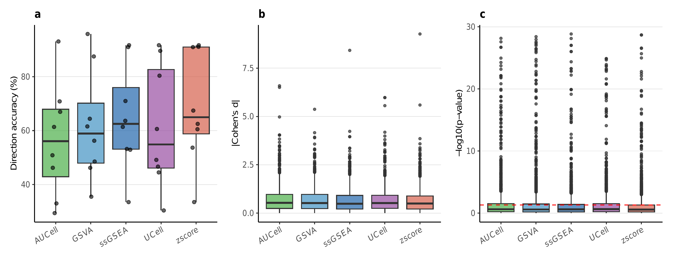
Figure 2. Biological relevance. Per-dataset direction accuracy (%) for each method. Z-score led in four of seven datasets.
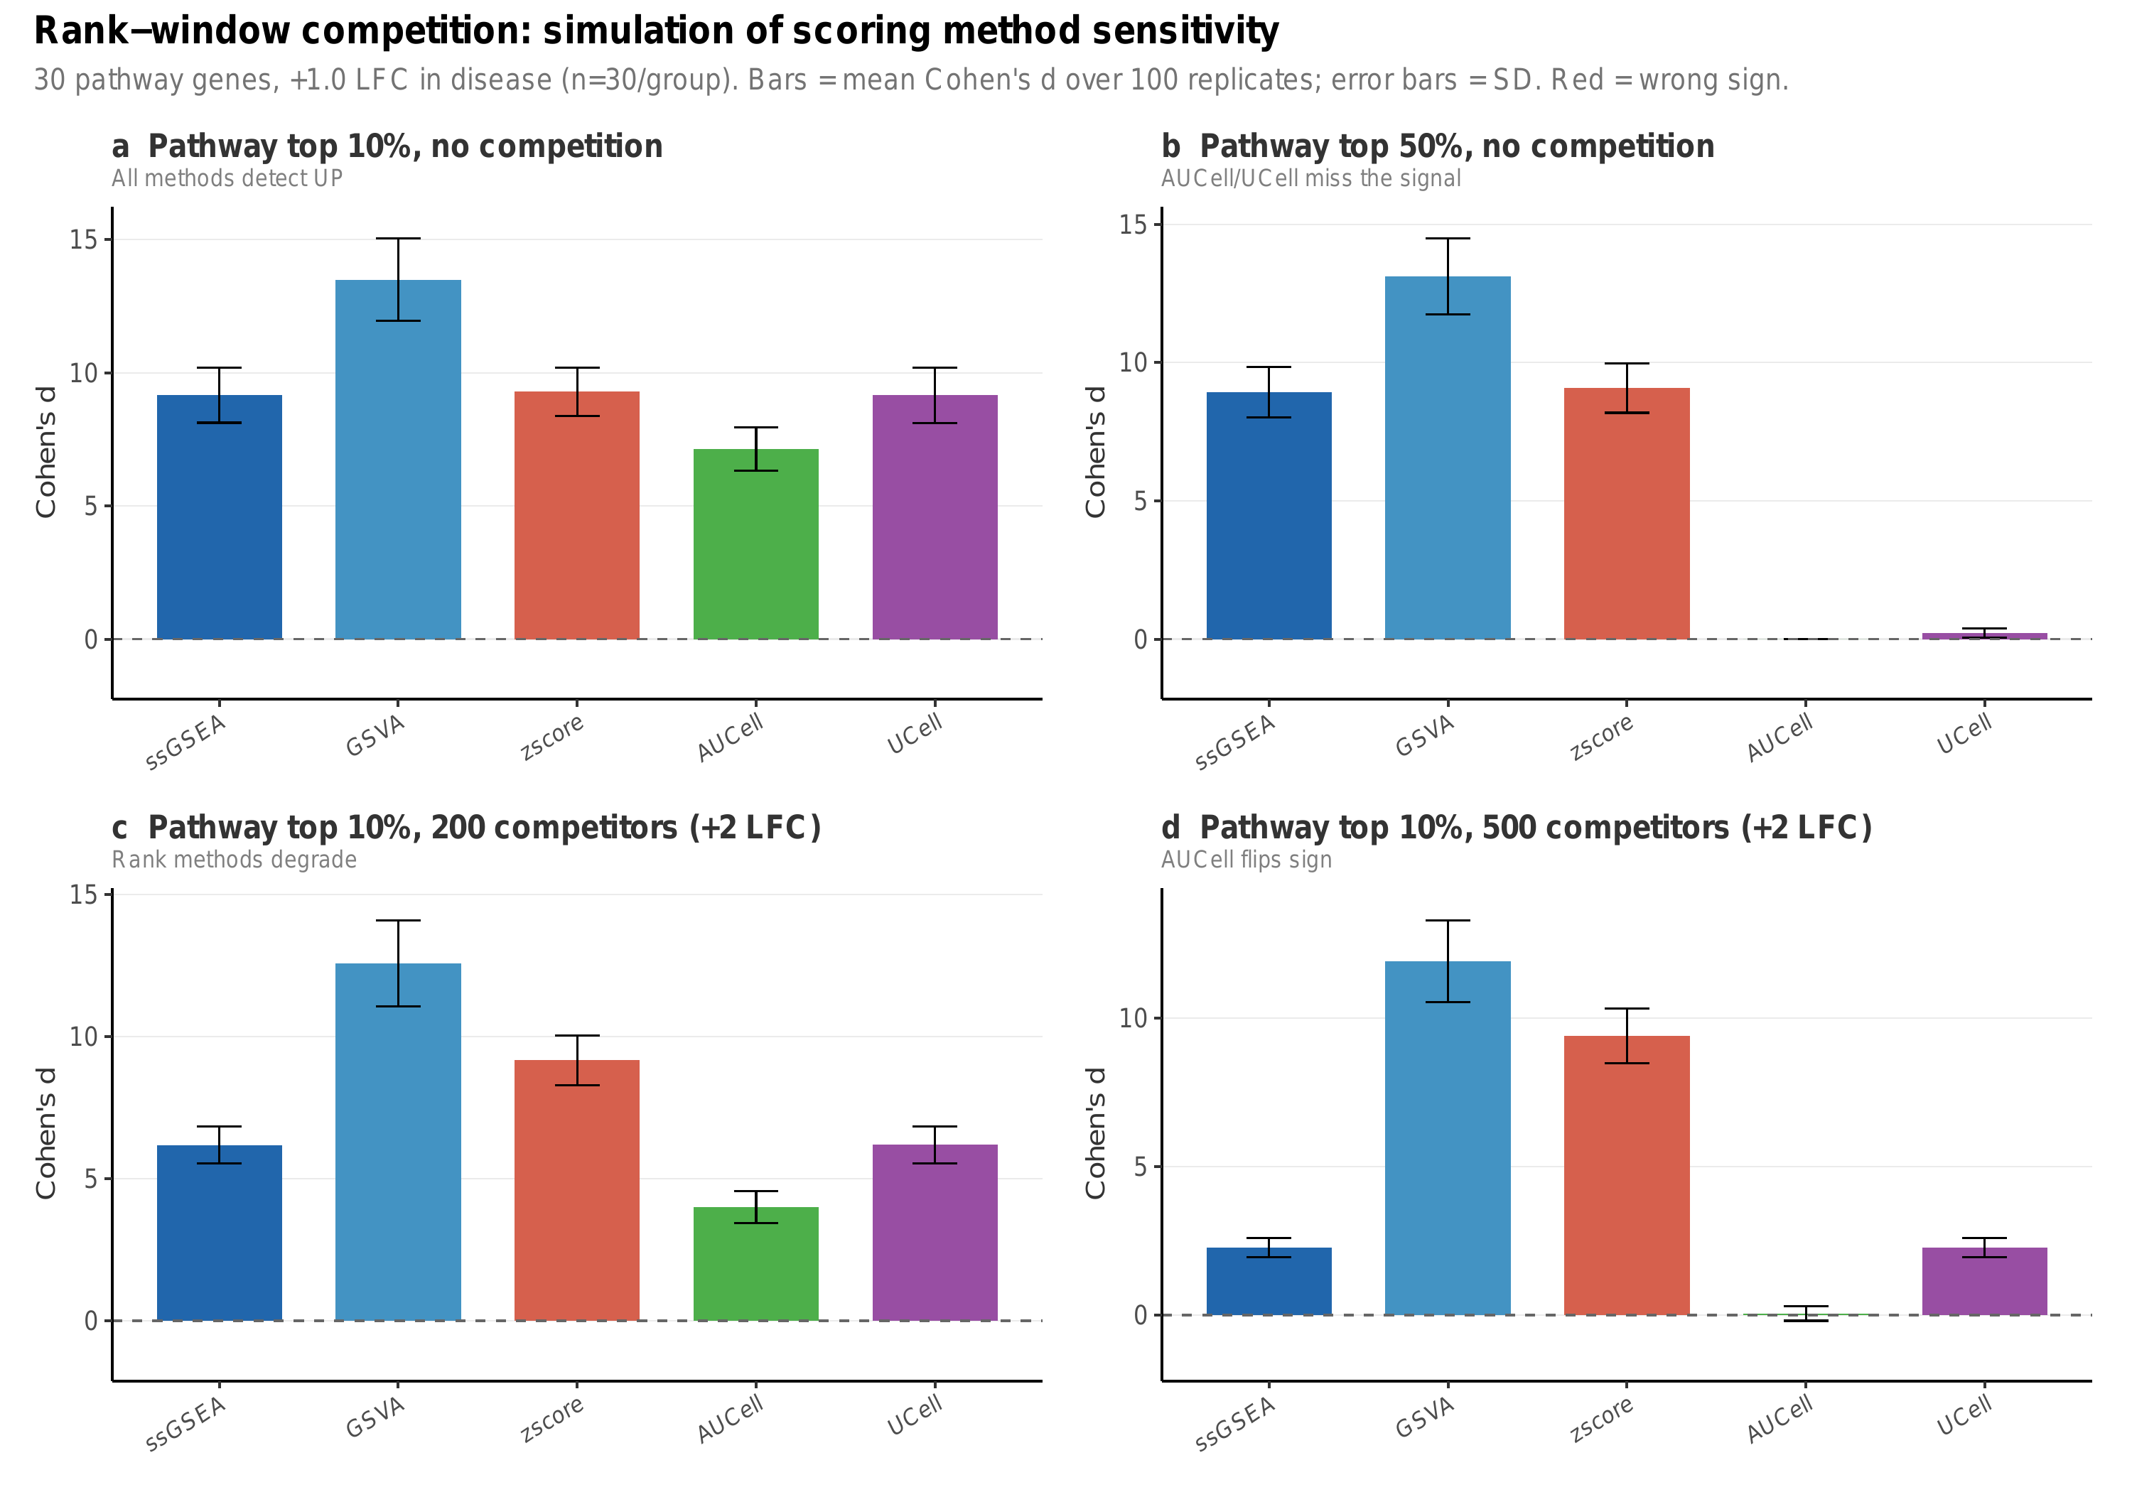
Figure 3. Rank-window competition simulation. Cohen's d (mean ± SD, 100 replicates) for five scoring methods under four scenarios. (a) No competition: all methods detect upregulation. (b) Pathway at median rank: AUCell and UCell miss the signal (d ≈ 0). (c) 200 competing genes: rank methods degrade. (d) 500 competing genes: AUCell inverts sign (d = −0.27, red bar).
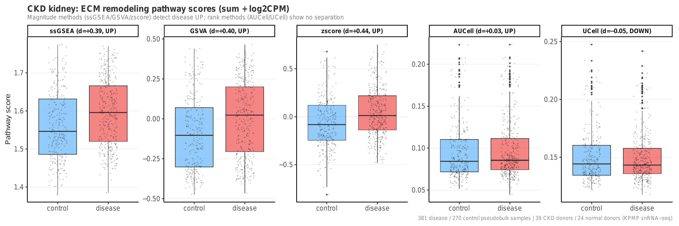
Figure 4. Real-data validation of rank-window competition. CKD kidney ECM remodeling pathway scores (sum + log2CPM) for five methods. Magnitude methods (ssGSEA d = +0.39, GSVA d = +0.40, Z-score d = +0.44) detect disease upregulation; rank methods (AUCell d = +0.03, UCell d = −0.05) show no separation.
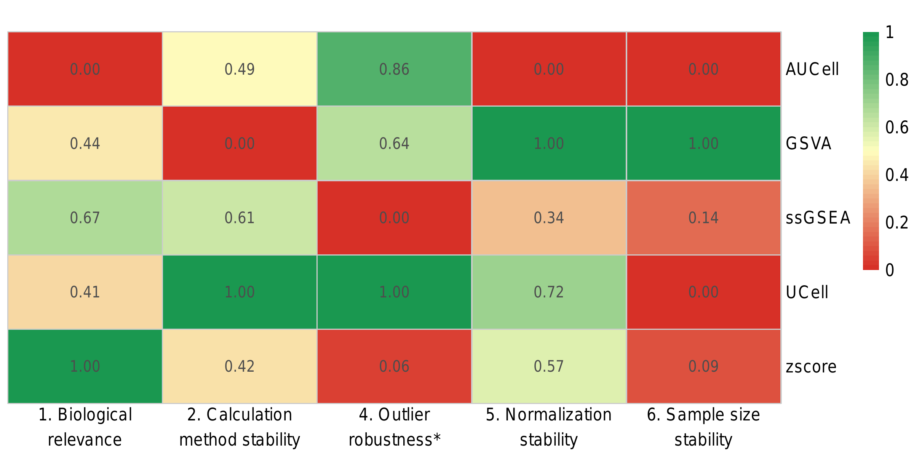
Figure 5. GIP summary heatmap. Scaled criterion scores (0–1) for five methods across five robustness criteria. UCell and GSVA each achieve four 'Good' ratings.

Data and code availability
All pseudobulk count matrices, sample metadata, curated ground-truth pathway annotations, complete evaluation results, manuscript figures, and the Snakemake pipeline used in this study are archived on Zenodo at https://doi.org/10.5281/zenodo.19503595. The development repository is available at https://github.com/fadhlyemen/PathwayBench; the submission-v2 branch corresponds to the Zenodo deposit. An interactive method-recommendation tool (PathwayBench Advisor) is available at https://pathwaybench-xrdxczzdpeahvcinxwbrcq.streamlit.app. Raw single-cell data were obtained from CZ CELLxGENE Discover; dataset accession identifiers are listed in Supplementary Table S1.

References
1. Subramanian A et al. Gene set enrichment analysis. PNAS 102, 15545 (2005).
2. Liberzon A et al. The Molecular Signatures Database (MSigDB). Bioinformatics 27, 1739 (2011).
3. Barbie DA et al. Systematic RNA interference reveals that oncogenic KRAS-driven cancers require TBK1. Nature 462, 108 (2009).
4. Hänzelmann S, Castelo R, Guinney J. GSVA: gene set variation analysis for microarray and RNA-Seq data. BMC Bioinformatics 14, 7 (2013).
5. Aibar S et al. SCENIC: single-cell regulatory network inference and clustering. Nat Methods 14, 1083 (2017).
6. Andreatta M, Carmona SJ. UCell: robust and scalable single-cell gene signature scoring. Comput Struct Biotechnol J 19, 3796 (2021).
7. Lee E et al. Inferring pathway activity toward precise disease classification. PLoS Comput Biol 4, e1000217 (2008).
8. Squair JW et al. Confronting false discoveries in single-cell differential expression. Nat Commun 12, 5692 (2021).
9. Crowell HL et al. muscat detects subpopulation-specific state transitions from multi-sample multi-condition single-cell transcriptomics data. Nat Commun 11, 6077 (2020).
10. CZ CELLxGENE Discover. https://cellxgene.cziscience.com/
11. Reichart D et al. Pathogenic variants damage cell composition and single cell transcription in cardiomyopathies. Science 377, eabo1984 (2022).
12. Lake BB et al. An atlas of healthy and injured cell states and niches in the human kidney. Nature 619, 585 (2023).
13. Holland CH et al. Robustness and applicability of transcription factor and pathway analysis tools on single-cell RNA-seq data. Genome Biol 21, 36 (2020).
14. Soneson C, Robinson MD. Bias, robustness and scalability in single-cell differential expression analysis. Nat Methods 15, 255 (2018).
15. Saelens W et al. A comparison of single-cell trajectory inference methods. Nat Biotechnol 37, 547 (2019).
16. Luecken MD et al. Benchmarking atlas-level data integration in single-cell genomics. Nat Methods 19, 41 (2022).
17. Perez RK et al. Single-cell RNA-seq reveals cell type-specific molecular and genetic associations to lupus. Science 376, eabf1970 (2022).
18. Sikkema L et al. An integrated cell atlas of the human lung in health and disease. Nat Med 29, 1563 (2023).
19. Otero-Garcia M et al. Single-soma transcriptomics of tangle-bearing neurons in Alzheimer's disease. Neuron 110, 2929 (2022).
20. Macnair W et al. A multi-region single nucleus transcriptomic atlas of Parkinson's disease. Sci Data (2024).
21. Schulte-Schrepping J et al. Severe COVID-19 is marked by a dysregulated myeloid cell compartment. Cell 182, 1419 (2020).
22. Cabello-Aguilar S et al. Benchmarking of pathway analysis methods for single-cell RNA-seq data. Brief Bioinform 25, bbae178 (2024).
23. DeTomaso D et al. Functional interpretation of single cell similarity maps. Nat Commun 10, 4376 (2019).
24. Holland CH et al. Transfer of regulatory knowledge from human to mouse for functional genomics analysis. Biochim Biophys Acta Gene Regul Mech 1863, 194431 (2020).
25. Jassal B et al. The reactome pathway knowledgebase. Nucleic Acids Res 48, D498 (2020).

