Francisco Fierro

EE 380

Lab 1

1.)

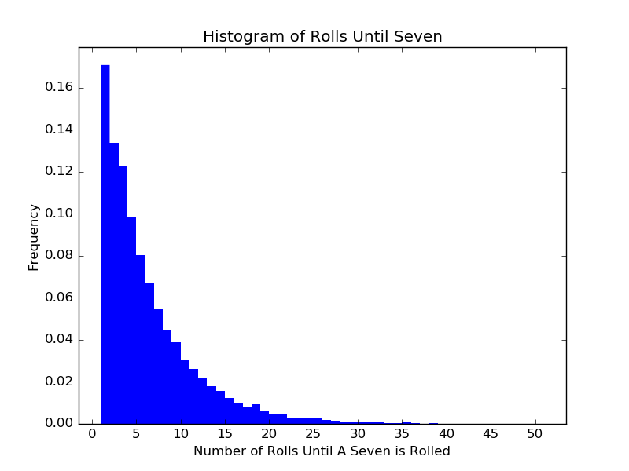

import matplotlib.pyplot as plt

import numpy as np

die1 = 0

die2 = 0

A = np.zeros(10000)

numRolls = 0

for i in range(10000):

numRolls = 0

die1 = 0

die2 = 0

while(die1 + die2 != 7):

die1 = np.random.randint(1,7)

die2 = np.random.randint(1,7)

numRolls += 1

A[i] = numRolls

print(A)

plt.hist(A, bins = 50, normed = True)

plt.title("Histogram of Rolls Until Seven")

plt.xlabel("Number of Rolls Until A Seven is Rolled")

plt.ylabel("Frequency")

plt.show()

2.) Mathematically:

$\frac{\left({100 \atop 50}\right)\left({50 \atop 50}\right)}{2^{100}}={\frac{100!}{\left(100-50\right)!50!}}/{2^{100}}\sim \frac{{1.0089* 10}^{29}}{1.2677* {10}^{30}}=$ 0.0796

By Simulation (10000 Trials): Probability of 0.0806

import matplotlib as plt

import numpy as np

fiftyHeads = 0

rounds = 10000

for i in range(rounds):

instances = 0;

for i in range(100):

if(np.random.randint(0,2) == 0):

instances = instances + 1

if(instances == 50):

fiftyHeads = fiftyHeads + 1

probability = fiftyHeads / rounds

print(probability)

3.)

Mathematically:

13 kinds of cards; choose one of each suit. 1 card of any other kind; choose 1 of any suit

$$\frac{\left({13 \atop 1}\right)\left({4 \atop 4}\right)\left({12 \atop 1}\right)\left({4 \atop 1}\right)}{\left({52 \atop 5}\right)}= \frac{13*12*4}{{52!}/{\left(52-5\right)!5!}}=\frac{624}{2598960}= 0.00024009603$$

By Simulation (100000 Trials): Probability of 0.00025

import matplotlib as plt

import numpy as np

rounds = 100000

A = np.arange(1,53)

B = np.zeros(5)

fourOfAKind = 0

instances = 0

for i in range(rounds):

A = np.random.permutation(A)

instances = 0

for i in range(5):

B[i] = A[i] % 13

B = np.sort(B)

for i in range(5):

if B[i] == B[3]:

instances = instances + 1

if instances == 4:

fourOfAKind = fourOfAKind + 1

probability = fourOfAKind / rounds

print(probability)