Francisco Fierro

EE 380

Lab 3

Problem 1:

Using Taylor Series:

$$E\left[y\right]= \frac{980\sin{2μ_{x}}}{9.8}- 2\frac{980\sin{2μ_{x}}}{9.8}\left(\frac{{\left(-\frac{π}{2}\right)}^{2}}{12}\right)= \frac{980\sin{\frac{2π}{4}}}{9.8}- 2\frac{980\sin{\frac{2π}{4}}}{9.8}\left(\frac{{\left(-\frac{π}{2}\right)}^{2}}{12}\right)=100-200\left(\frac{π^{2}}{48}\right)=100-200* .205617=100-41.1234=58.8766$$

By Simulation:

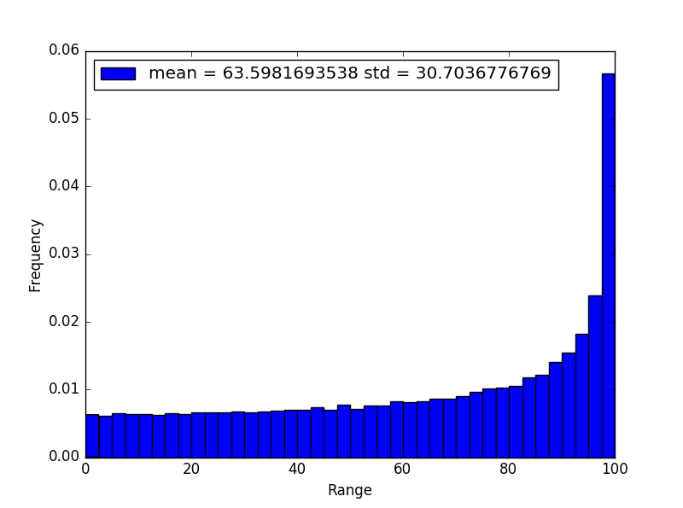

import numpy as np

import matplotlib.pyplot as plt

gravity = 9.8

rounds = 80000

velocity = np.sqrt(980)

f = np.zeros(rounds)

p = np.zeros(rounds)

for i in range(rounds):

angle = np.random.random() \* np.pi / 2

f[i] = velocity \* velocity / gravity \* np.sin(2 \* angle)

mean = np.mean(f)

std = np.std(f)

labels= ["mean = " + str(mean) + " std = " + str(std)]

plt.hist(f, 40, normed = True)

plt.xlabel("Range")

plt.ylabel("Frequency")

plt.legend(labels, loc = 0)

plt.show()

Problem 2:

Using Taylor Series:

$$E\left[y\right]= {μ_{x}}^{2}R+\frac{2R}{2}=0+R*{\left(2*{10}^{3}\right)}^{2}=5* 4*{10}^{6}=2*{10}^{5}$$

$$V\left[y\right]= {\left(2μ_{x}R\right)}^{2}\left(2*{10}^{3}\right)= {\left(2*0* 5\right)}^{2}\left(2*{10}^{3}\right)=0$$

By Simulation:

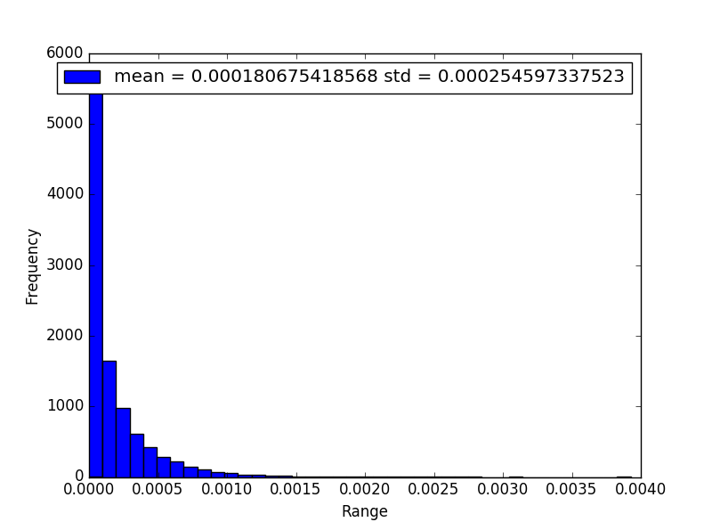

import numpy as np

import matplotlib.pyplot as plt

rounds = 50000

R = 5

P = np.zeros(rounds)

for i in range(rounds):

I = (np.random.randn() \* 3 \* .002)

P[i] = I \* I \* R

mean = np.mean(P)

std = np.std(P)

labels= ["mean = " + str(mean) + " std = " + str(std)]

plt.hist(P, 40, normed = True)

plt.xlabel("Range")

plt.ylabel("Frequency")

plt.legend(labels, loc = 0)

plt.show()

Problem 3:

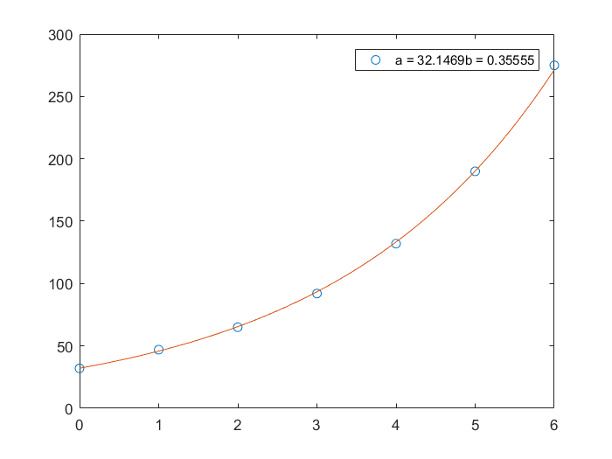

clear;

clc;

A = [0,1,2,3,4,5,6];

B =[32,47,65,92,132,190,275];

plot(A,B,'o')

[P]=polyfit(A,log(B),1);

b=P(1);

a=exp(P(2));

func =@(x)(a\*exp(b\*x));

legend(['a = ',num2str(a),'b = ', num2str(b)])

hold on

fplot(func,[0,6])

hold off