Lab Report
Lab 31: Using SCP and SFTP
Student: Fahad Bin Adeel (Fero)  Program: ICS – Al-Nafi AI Operations / Cybersecurity Track | Environment: Al-Nafi Cloud Labs – AWS EC2 (Ubuntu)  Date: July 11-12, 2026

Objectives
- Understand and utilize SCP (Secure Copy Protocol) for securely transferring files between local and remote systems.
- Master SFTP (Secure File Transfer Protocol) for secure file upload and download operations.
- Ensure and verify file integrity after transfer using SHA-256 hashing.

Environment and Topology
This lab was performed entirely on a single Al-Nafi Cloud Labs AWS EC2 instance (Ubuntu), accessed through the browser-based Lab Terminal. Since only one remote instance was provisioned for the lab, an SSH loopback method was used: a dedicated key pair was generated on the instance itself, and SCP/SFTP connections were made to 127.0.0.1 (localhost). This is functionally identical to transferring files between two separate machines — the SCP and SFTP protocols operate the same way regardless of whether the destination host is local or remote — while keeping the exercise self-contained within the assigned cloud machine.
Host / IP | xx.xx.xxx.xxx (redacted – ephemeral AWS lab IP; loopback used: 127.0.0.1)
SSH Port | xxxx (redacted – internal sshd port: 22)
Username | ubuntu
Auth Method | SSH key pair (redacted for confidentiality; a second local key pair generated for the loopback transfer)

Task 1: Securely Copy a File with SCP
A local SSH key pair was generated on the instance and added to authorized_keys to permit passwordless loopback connections:
ssh-keygen -t rsa -f ~/.ssh/lab_key -N ""
cat ~/.ssh/lab_key.pub >> ~/.ssh/authorized_keys
chmod 600 ~/.ssh/authorized_keys
A sample file was created:
echo "This is a test file for Lab 31" > example.txt
The file was then copied to the remote directory (upload) and retrieved back (download) using SCP:
# Upload (local -> remote)
scp -i ~/.ssh/lab_key -P 22 example.txt ubuntu@127.0.0.1:/home/ubuntu/uploaded_example.txt

# Download (remote -> local)
scp -i ~/.ssh/lab_key -P 22 ubuntu@127.0.0.1:/home/ubuntu/uploaded_example.txt ./downloaded_example.txt
Both transfers completed successfully, each reporting 100% completion, as shown below.
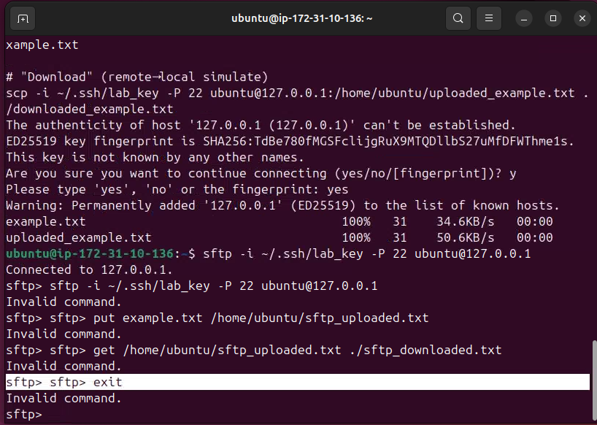
Figure 1: SCP upload and download completed successfully (100%) on the Lab Terminal.

Task 2: Upload/Download Files with SFTP
An SFTP session was started against the same loopback target:
sftp -i ~/.ssh/lab_key -P 22 ubuntu@127.0.0.1
Within the interactive SFTP session, the put command was used to upload the file, and the get command was used to download it back, followed by exit to close the session:
put example.txt /home/ubuntu/sftp_uploaded.txt
get /home/ubuntu/sftp_uploaded.txt ./sftp_downloaded.txt
exit
Both the upload and download operations completed without errors, confirming the file was correctly transferred in both directions via SFTP.

Task 3: Verify File Integrity After Transfer
To confirm that no data corruption occurred during transfer, SHA-256 hashes were generated for the original file and for both transferred copies (SCP and SFTP):
sha256sum example.txt
sha256sum downloaded_example.txt
sha256sum sftp_downloaded.txt
All three hash values matched, confirming that the files retained full data integrity across both the SCP and SFTP transfer methods.

Conclusion
This lab demonstrated the use of both SCP and SFTP for secure file transfer. SCP provided a fast, single-command method for copying files in either direction, while SFTP offered an interactive, FTP-like session for uploading and downloading files with put and get. Matching SHA-256 hashes before and after transfer confirmed that both methods preserved file integrity, reinforcing why these protocols are considered reliable for secure file operations in networked and cloud environments.

