Installation instructions project

Step 1: Unzip the file C1212L_Group1_Sem4

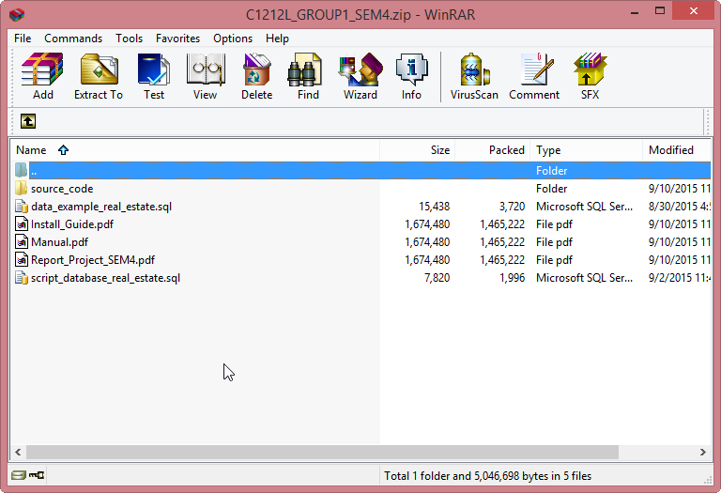

Step 2: Select a folder to the project on Netbean

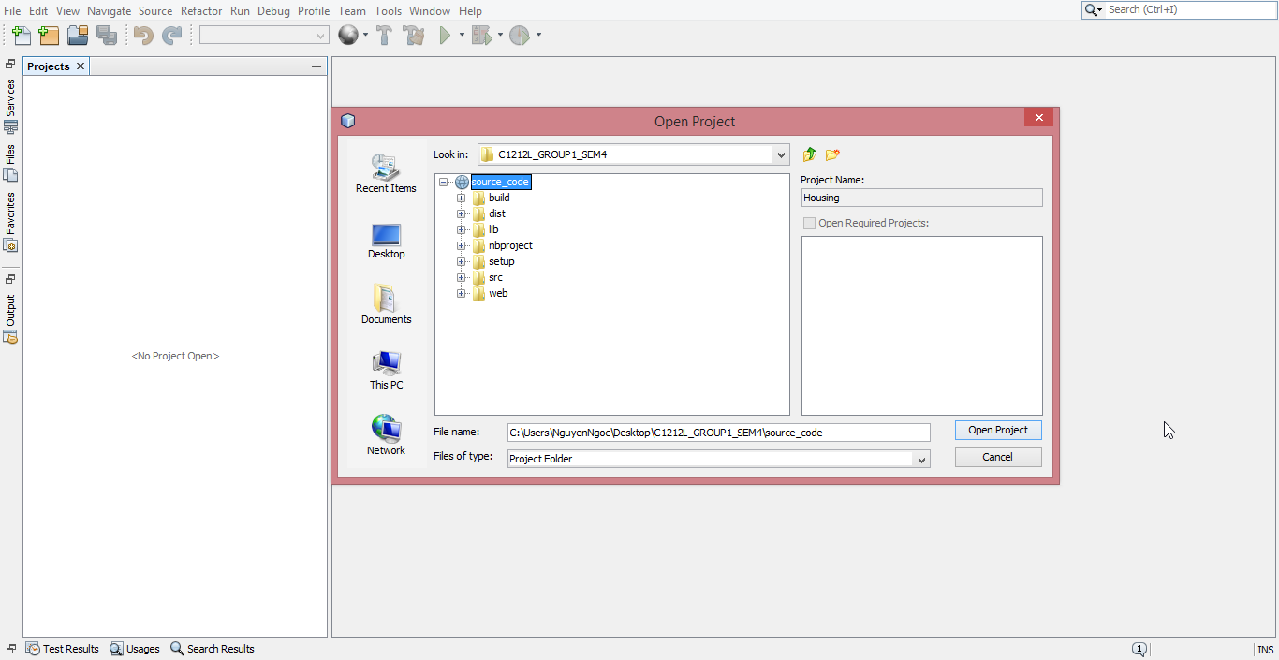

Step 3: Reconfigure card persistence.xml file to connect to the database

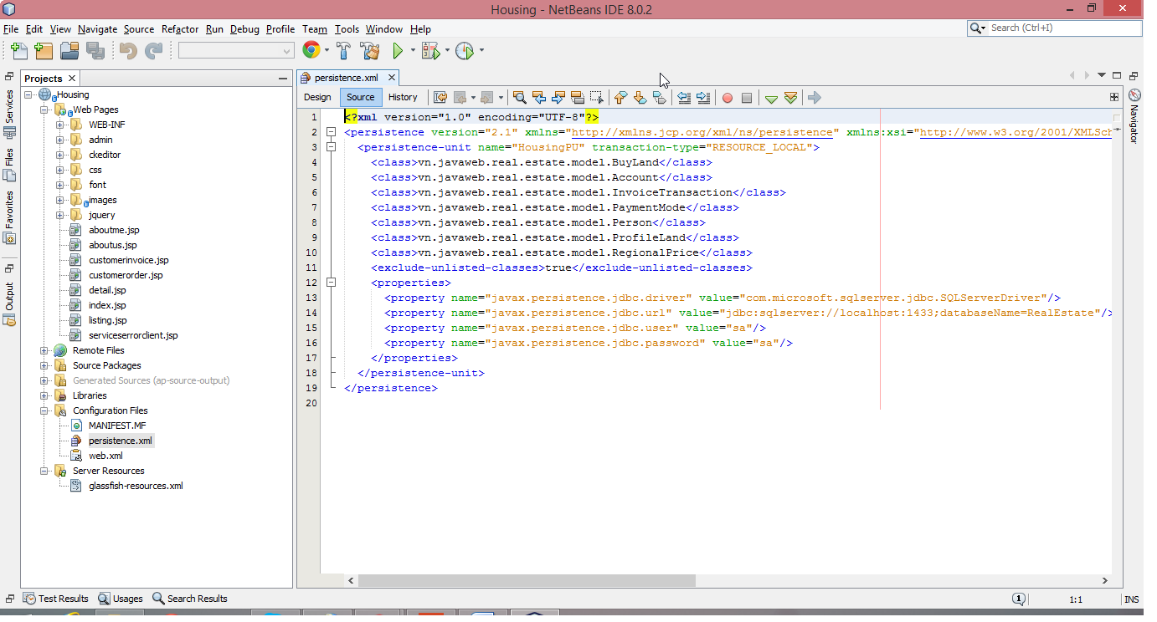

Step 4: Open script_database_real_estate.sql script with SQL server to create the database and table

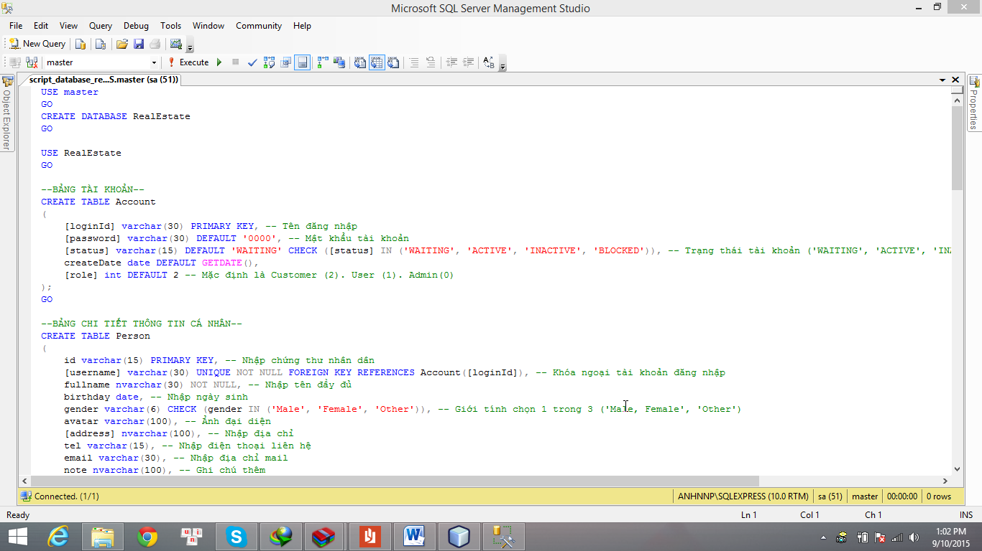

Step 5: Choose clean and build project

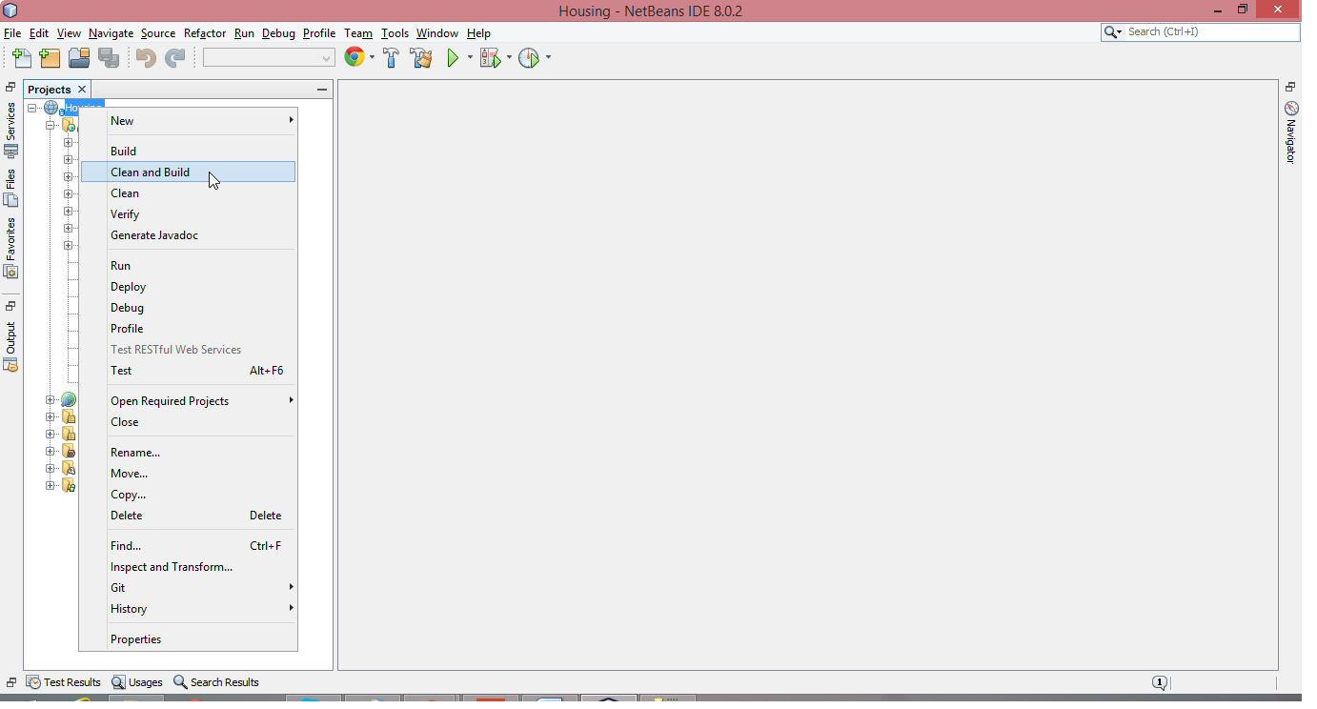

Step 6: Choose deploy project

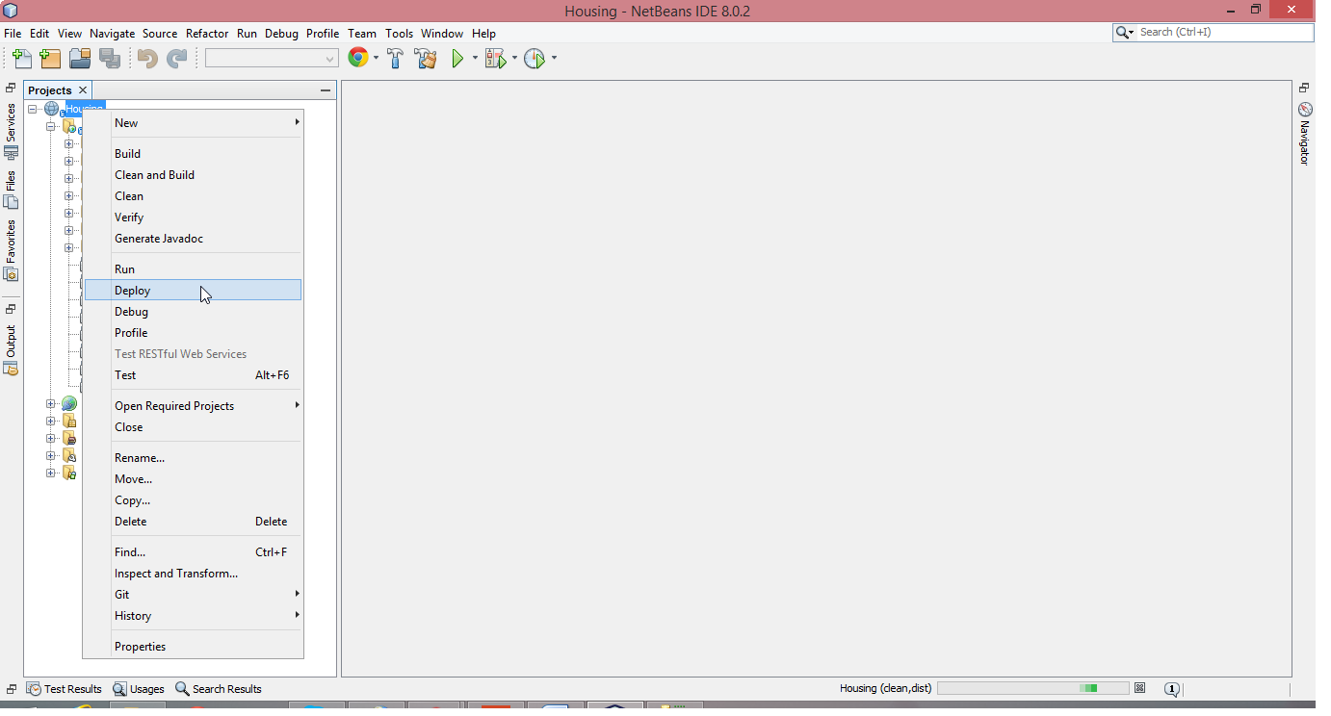

Step 7: Choose run project

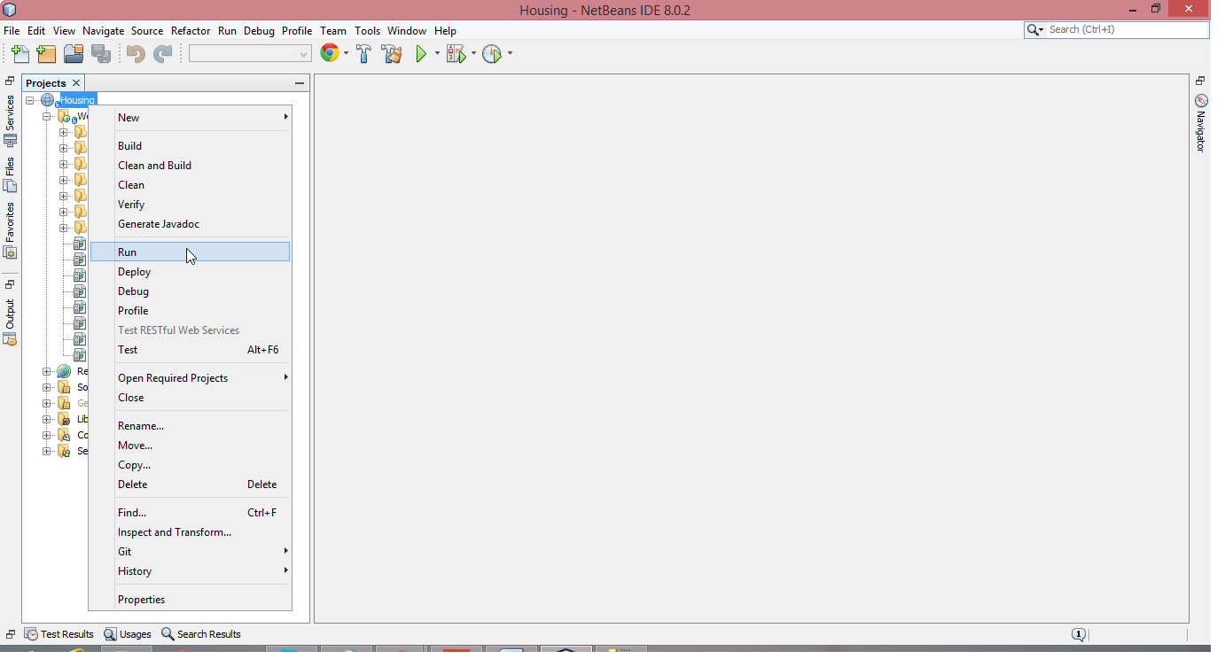

Step 8: And results in a browser

