**APTECH COMPUTER EDUCATION**

**FPT – APTECH VIET NAM**

-----------~~~-----------



**PROJECT NAME:**

### NTB Stamp Duty

### and Registration Details

|  |  |
| --- | --- |
| **Design by:** | ***Nguyen Ngoc Phan Anh***  ***Phan Van Sang***  ***Nguyen Tuan Anh*** |
| **Class:** | ***Batch C1212L*** |
| **Group:** | ***1*** |
| **Instructor:** | ***Mr. Nguyen Tuan*** |

# 1. Problem Definition

*Introduction:*

Our client, “**National Territory Builders**” **(NTB)** is one of the famous builders in the territory, who constructs the buildings for residential and the commercial purposes, and takes up the contracts for and supervising the constructions or repair or re-modeling of the houses or buildings or complexes or offices. Once the buildings are constructed, they advertise about the buildings constructed, with the help of the hoardings, new papers, etc. so that they reach out for the customers, who might be interested in owning (purchasing) the same from the builder.

***Existing Scenario:***

Currently they follow the following procedures.

They first own a land, and then they will lay out a plan and design the model of the building and then apply for the approval of the building permit. Once they receive the permission for constructing a building from the government, they start up with the plan as designed and laid by them for constructing it.

Once they are done with the construction of the building, they apply for the approval of the occupancy permit to the respective department of the government. Once the Occupancy permit is attained, they start advertising about the sale of the building (s) thus constructed, for whom they had received both the building permit and the occupancy permit.

The various procedures followed for advertising are done through news papers, hoardings, internet, etc. so that they can reach out to the customers, who might be interested in purchasing the same from the builder. The builder used to maintain the details of the sales done (i.e., the registrations happened, amount paid, etc.) in the form of documents and store them in files.

They used to maintain separate racks for maintaining these documents and files. One for maintaining the records which received building permit, other for the ones which received occupancy permit, other for the one which is waiting for the approval of the building permit, other for the one which is waiting for the approval of the occupancy permit, and the other for maintaining the sold out ones, and the other for the ones that are to be sold, others for maintaining the records of the rejected building permit, and the others for the rejected occupancy permit.

They are currently facing the following problems with the current system:

1. There is no proper tracking of the records, and there are chances of the slip-ups in the system or misplacement of the records, as the data is maintained in the form of the documents and files.
2. The details of the buildings, price charts, sales done (i.e., registration details, stamp duty details, payment details, etc.) are not in place.
3. There is no automation involved to speed up the tracking or any other business processes
4. Difficulties in communication and updating data due to distributed set up
5. Calculating the total charges for the ones that are to be sold (i.e., for the ones for which the occupancy permit is received)
6. Analyzing sales data to streamline constructed volumes
7. Preparing Invoices as well as dispatching the related documents and routing them to relevant departments or locations.

*Proposed Solution:*

The builder wants to incorporate an online application system through which he can automate the process and reduce the paper work by maintaining the whole data on to this application, so as to increase the rate of ease for tracking, and modifying the date that is once maintained.

Hence he approached us to help him, by understanding the process that they follow, and develop an online application for him, with the following functionalities included in it.

# 2. Customer Requirement Specification (CRS)

**User Profiles**

The following user types are expected for the eBilling and Invoicing System:

|  |  |
| --- | --- |
| **User** | **Brief Description of Use Actions** |
| Sales Representative | Downloads and uploads customer and order information, which affects accounting, inventory and product data. View customer and product data as described in metrics, track orders and deliveries. |
| Manager | All sales representative use actions, and management reports, quota establishment, reporting and adjustment. |
| Accountant | View and print stocks, track orders. Update product details like price. |

**Requirements Summary**

The following preliminary lists are based on initial interviews

**Business / Project Objecttive:**

The business goal for the application is to support an increase the productivity and complete automation of existing manual bill and invoice generation process. Business requirements are discussed in the Scope section, with the following additional detail:

* Sales representatives need a method to store and access sales opportunity data, and when a sale is generated, convert some or all of the information into a sales order without re-entering information.
* Each sales representative should receive customer and sales data pertinent only to them.
* The accountant should be able to enter or update product information in one interface only, with all necessary product information being received by sales staff.
* Manager must receive his or her customer and appointment data plus detailed and rollup information for each sales representative on his or her team.
* The application should support the capability to use multi user environment.
* Operating system information reports as needed.
* Administrators considered statistically bill, invoice management in a variety of specific criteria.

The sales staff wants to improve their current ability to analyze their customers. In particular, they want to focus on identifying their best customers and building long-term relationships within that base. To enable them to accomplish this goal, they want to extract meaningful data that easily answers the following questions:

* What are the early warning signs of problems?
* Who are my best customers across product lines?
* With whom do I focus my efforts for building a long-term relationship?
* What are my customers' issues as groups?
* Geographically, where are my best customers?
* What products are my customers buying and at what rate?

**User Requirements**

User requirements are categorized by user type.

**Sales Staff (Representatives and Managers)**

* View the data in various ways, for example:
* Customers who are the top buyers of specific items
* Best customers based on criteria to be determined
* Drops in a customer's sales
* Identify which product prices have been modified, especially on current orders in progress
* Use opportunity rules, which are statements that help the sales representative convert an opportunity into a sale
* Add third-party data sources and financial evaluation tools
* Enable capture, analysis, and sharing of data about a customer across the company
* Use forecasts to establish sales goals

**Accountant**

• Update product details, including price, photo, and description

• Add, delete, and update product specifications

• Generate stock reports and check the availability, order the item as and when needed.

### Operational Requirements

The following requirements provide a high-level view of how the system will run:

* Processor usage should not exceed 80 percent during concurrent uses.
* Ensure that information is easy to access either, and meaningful for the sales representative and the company.
* Minimize the technical knowledge that sales and marketing staff need to access the data, generate ad hoc queries, track promotions, and view customer segmentation information.
* Any change to information must be reflected immediately, and the changes must be propagated to the search engine so that employees that perform searches see this new information.
* The application should work with the existing communications and networking infrastructure.
* The application should deploy with a minimum of additional operational processes, manual or otherwise.

### System Requirements

These are additional constraints from a system perspective:

* Previous data of customer, product details must be imported in the new system.
* The administrator must be able to monitor everything from the IT department.
* The information must be accessible by everyone in the company as per the rights specify.

**Success Criteria**

To determine the success of this project, the following metrics can be quantified and used to analyze success factors.

### Sales Automation

* **Problem customer identification**. Ability to identify top 10 developing problem customers by sales representative.
* **Identification of best customers across product lines and regions**. All customers can be sorted by the factors (to be determined) that rank them qualitatively. Variable sorts and rankings can be chosen by the sales representative.
* **Identification of issues across groups**. All customers can be sorted by the issues (to be determined) within group categories that can be updated. Variable sorts and rankings can be chosen by the sales representative or other user.
* **Analysis of quantities and rates of products**. Products can be sorted by the quantity and dates sold. Variable sorts and rankings can be chosen by the user.

# Design Goals and Constraints

**Performance**

No more than a 5-percent degradation in average query response is allowed while all concurrent user are using the system.

Processor utilization should not exceed 80 percent during all concurrent users are using the system.

**Availability**

Because the system is accessed by sales representative to book the order and print the invoice, and their should not be any single point of failure.

**Reliability**

Because of the need no single point failure, automatic failover will be required. In addition, existing disaster recovery and backup plans and procedures must be revised to incorporate the eBilling and Invoicing System.

**Scalability**

eBilling and Invoice System an average load of 50 concurrent users after the system is fully operational, and expects that to grow by 5 percent each year for the next five years.

**Security**

For the sensitive customer and order data, all users will need to log on the system with their user id and password.

Every resource in the system are defined by the role and privileged. System administrator assigned user role and privileged for their access rights.

Interoperability

In Version 1.0 of the eBilling and Invoice System, there are no requirements for interoperability with other systems.

**Location**

The eBilling and Invoice System are used in the company office only.

**Setup/Installation**

Setup and installation must not interrupt the sales staff’s daily tasks and work flow.

# Use Case Summary

**Manage Orders**

### Description

This function will enable sales representative to place orders for eBilling and Invoice System products, track submitted orders, and view completed orders and print the invoice.

### Business Need

This function will enable sales representative to interact with eBilling and Invoice System catalog directly without the intervention of any other employees.

### Priority

High

**Manage Products**

**Description**

This function allows user of eBilling and Invoice System to create, maintain, and delete information about products in the product database that can then be viewed and ordered by customers, and accessed and updated by the sales staff.

### Business Need

This function will support the sales staff with accurate and relevant information, and will also support the Manage Orders function by ensuring up-to-date product information.

### Priority

High

**Analyze Customers**

### Description

This function allows management to analyze the customer database and find out information, such as the identities of the best customers, the top buyers, and the most popular products.

### Business Need

This function will allow management to determine the most (and least) profitable customers and product lines, enabling better decision making in the running of the business.

### Priority

Medium

## **Forecast Sales**

### Description

This function allows management to plan and track production costs, track sales results, and plan sales staffing needs.

### Business Need

This function will allow management to manage the revenue streams of the organizations and control costs.

### Priority

Medium

**Establish Sales Goals**

**Description**

This function allows management to view current sales trends and employee performance and to determine sales goals for the sales staff within the organization.

**Business Need**

This function will allow management to set goals for staff, review the performance of staff members, and track employee performance.

**Priority**

Medium

**Input provided by the client:**

* Inputs for the application
* Outputs from the application
* Process Involved in the application
* List of Reports

**Hardware Requirements:**

* A minimum computer system that will help you access all the tools in the courses is a Pentium 200 or a higher capability CPU
* 256 Megabytes of RAM or higher

**Software Requirements:**

* Java RE 7.0
* NetBeans 8.0
* MS SQL Server 2005

# 3. Architecture and Design of the Project

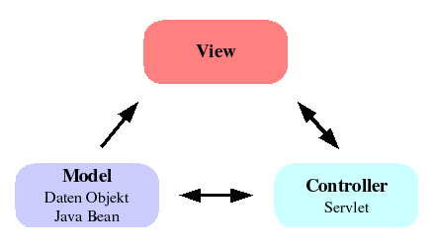

**Picture 1: Architecture MVC : Model view controller**

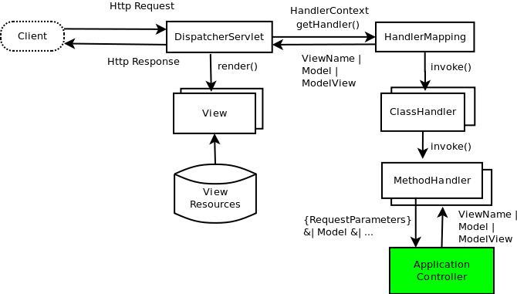

### Picture 2: MVC architecture with servlets and jsp

# 4. Data Flow Diagram

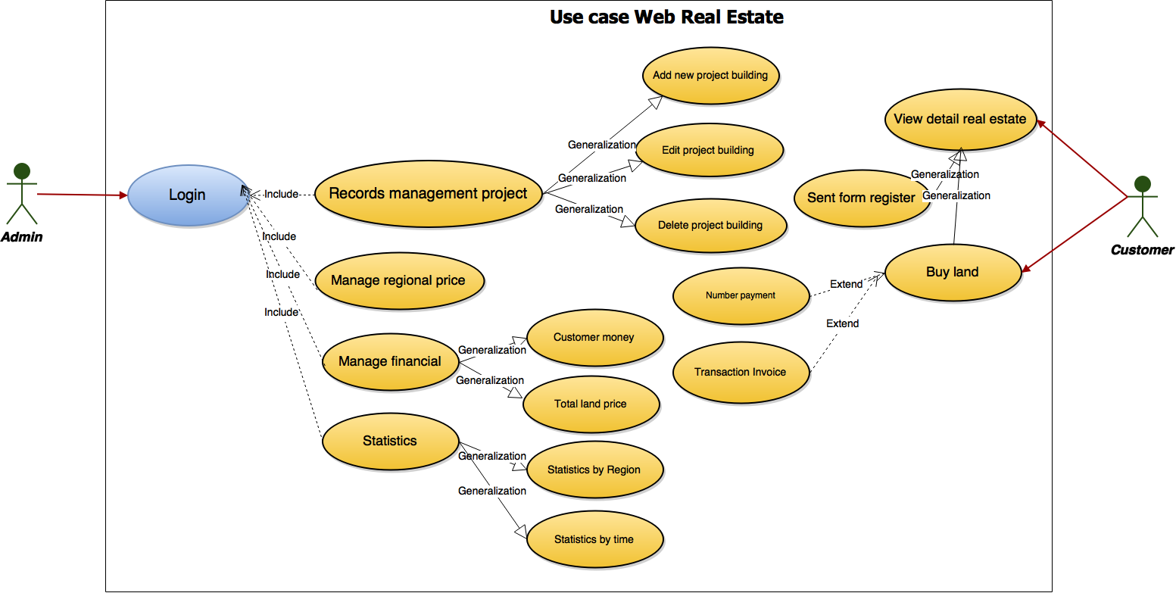

# 5. Entity Relationship (ER) Diagram

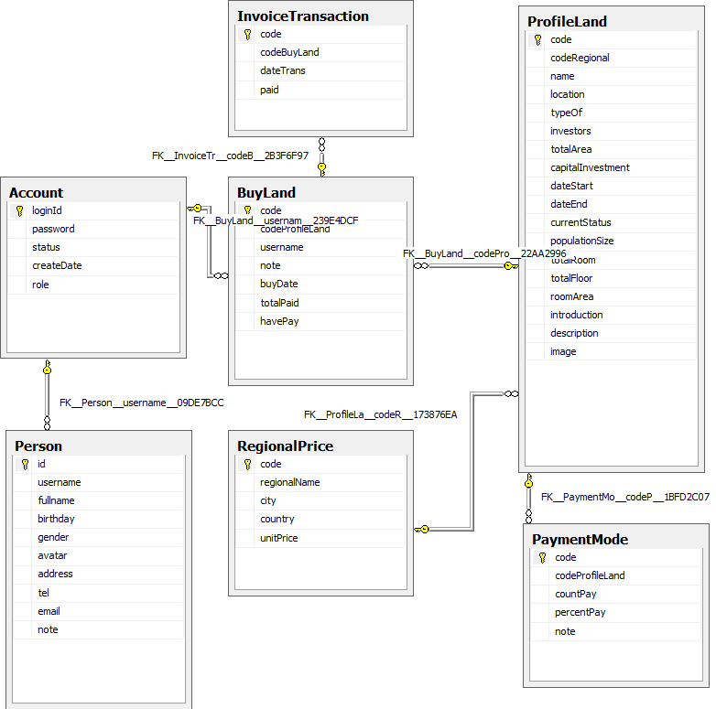

**E-R Diagram**

# 6. Database Design/Structure

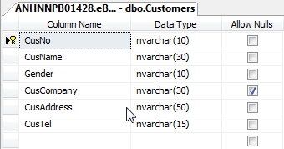

**Table Customers**

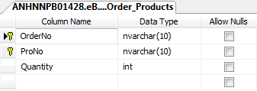

**Table Order_Products**

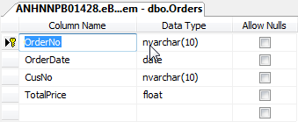

**Table Orders**

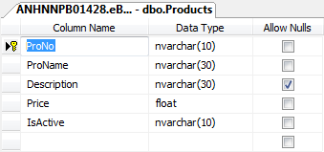

**Table Products**

# 7. Form Design



**Picture 1: Form main application**

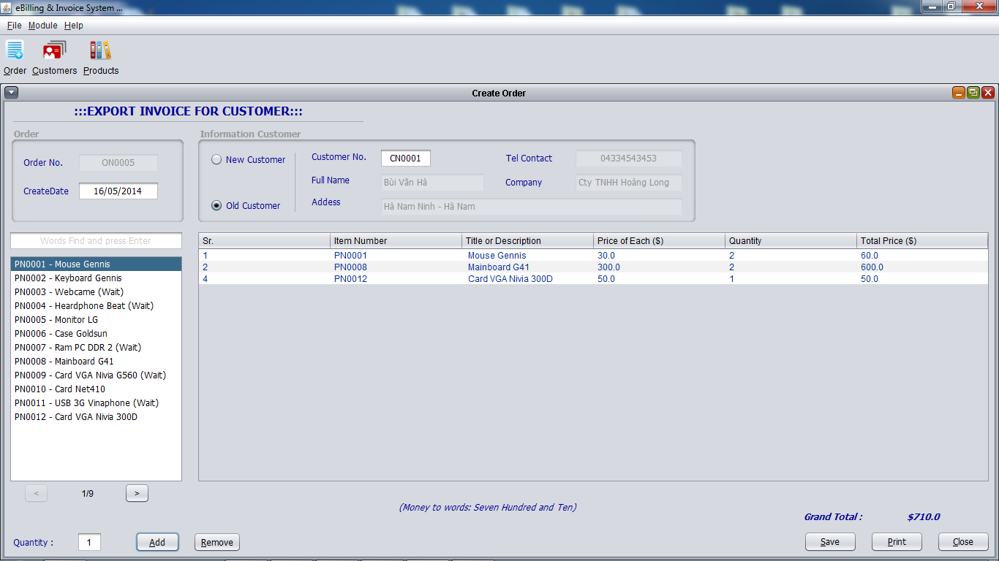

**Picture 2: Form Create Orders**

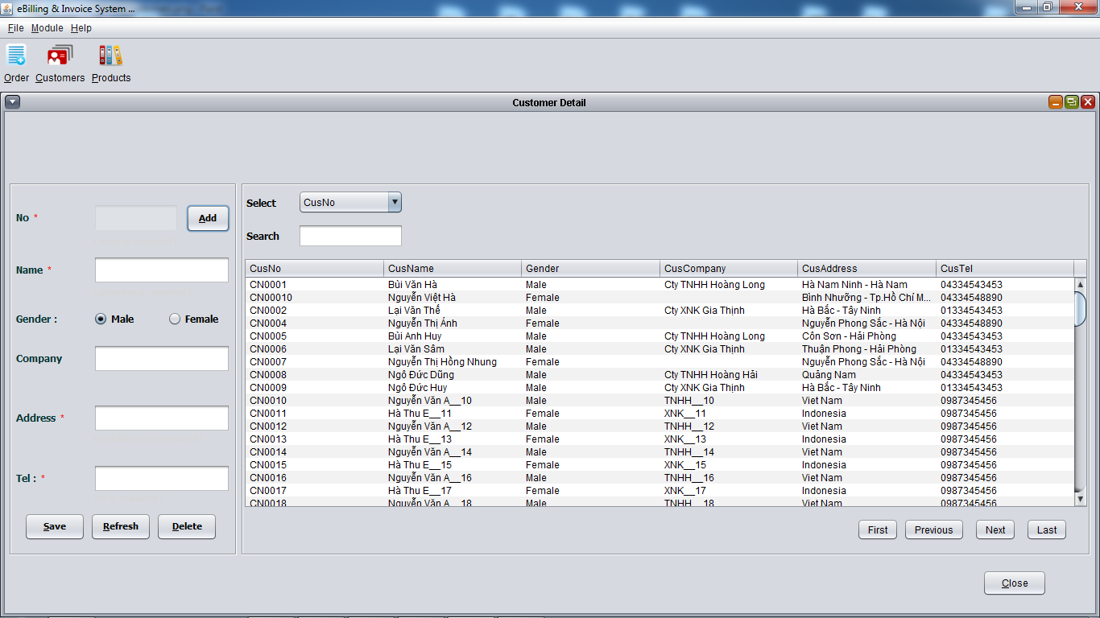

**Picture 3: Form Info Customer**

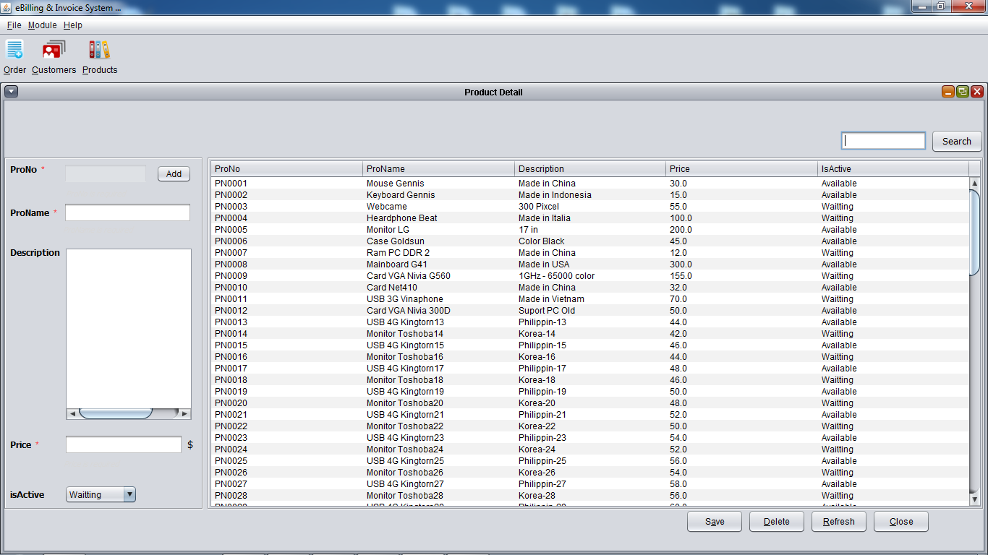

**Picture 4: Form Info Products**

# 8. Checklist of Validations

|  |  |
| --- | --- |
| **Option** | **Validated** |
| Can a new user who gets registered, enter the application after logging in? | No |
| Do all the options present in the application display the correct result? | Yes |
| Does the application’s functionality resolve the user problem, and satisfy their needs? | Yes |
| Has the hardware and software been correctly chosen? | Yes |

# 9. Submission Checklist

|  |  |  |  |  |  |
| --- | --- | --- | --- | --- | --- |
| **Sr. No.** | **Particulars** | **Yes** | **No** | **NA** | **Comments** |
| 1 | As a cashier, I want to change the product in order? | Yes |  |  |  |
| 2 | As a cashier, I want to set up orders for customers? | Yes |  |  |  |
| 3 | As a cashier, I want to choose products based on customer for orders | Yes |  |  |  |
| 4 | As a cashier, I would like additional information on customer orders | Yes |  |  |  |
| 5 | As admin, I want to log into the system to manage: Users, Bills, Products, Companies, Clients | Yes |  |  |  |
| 6 | As a cashier, I want to log into the system to manage sales invoices |  | No |  | Check validate |
| 7 | As a cashier, I want to print invoices for customers |  | No |  | Debug error |
| 8 | As a cashier, I want to save every purchase | Yes |  |  |  |