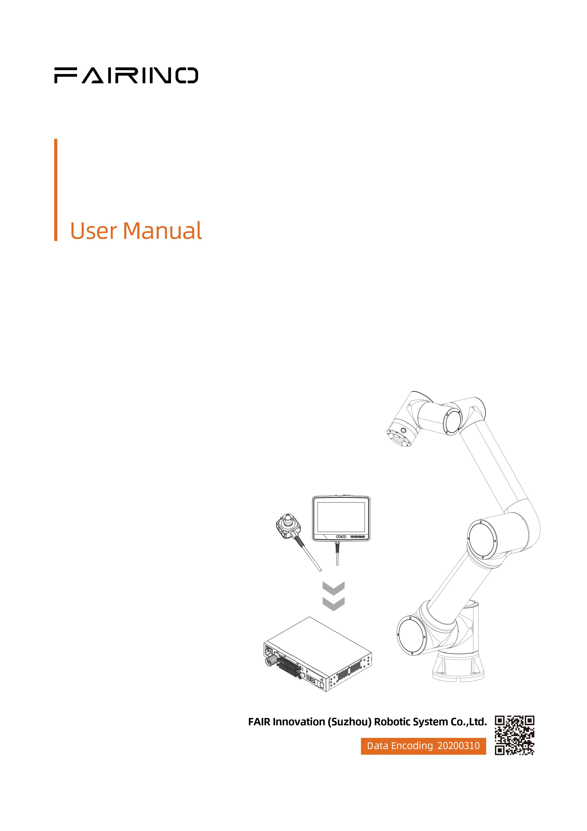

Cobot C# SDK user manual version update content(3.8.1)

**Revision Record**

|  |  |  |
| --- | --- | --- |
| **Date** | **Version** | **Description** |
| 2025/01/08 | V3.7.7 | Create |
| 2025/01/20 | V3.8.0 | 1. EndForceDragControl() added params for ingularity Constraints  2.ArcWeldTraceControl() added params for offset  3.add WeaveChangeStart() command  4.add WeaveChangeEnd()command  5.add LoadTrajectoryLA()command  6.add MoveTrajectoryLA()command  7.add CustomCollisionDetectionStart()command  8.add CustomCollisionDetectionEnd()command |
| 2025/04/11 | V3.8.1 | 1. Command ConveyorSetParam() add followType, startDis, endDis param 2. Add Command AccSmoothStart() 3. Add Command AccSmoothEnd() 4. Add Command RbLogDownload() 5. Add Command AllDataSourceDownload() 6. Add Command DataPackageDownload() 7. Add Command GetRobotSN() 8. Add Command ShutDownRobotOS() 9. Add Command ConveyorComDetect()   Add Command ConveyorComDetectTrigger() |
|  |  |  |
|  |  |  |
|  |  |  |
|  |  |  |

**Notes:**

**①This manual is applicable to WebApp version 3.8.1 Cobots and is subject to change without notice. For other versions , please visit：**

[Welcome to FAIR’s documentation! — FAIRINO Collaborative Robot User Manual 3.8.1 documentation](https://fair-documentation.readthedocs.io/en/latest/)

Catalogue

1 Modify the interface 1

1.1 Conveyor Parameter Configuration 1

1.1.1 Interface Description 1

2 Added Command 1

2.1 Acceleration smooth on 1

2.1.1 Interface Description 1

2.2 Acceleration smooth off 2

2.2.1 Interface Description 2

2.2.2 Code Example 2

2.3 Downloading Controller Logs 2

2.3.1 Interface Description 2

2.3.2 Code Example 3

2.4 Downloading all Data Sources 3

2.4.1 Interface Description 3

2.4.2 Code Example 3

2.5 Downloading the Data Backup Package 4

2.5.1 Interface Description 4

2.5.2 Code Example 4

2.6 Obtain the SN of the control box 4

2.6.1 Interface Description 4

2.6.2 Code Example 4

2.7 Shut down the robot operating system 5

2.7.1 Interface Description 5

2.7.2 Code Example 5

2.8 Conveyor communication input detection 5

2.8.1 Interface Description 5

2.9 Conveyor communication input detection triggered 5

2.9.1 Interface Description 5

2.9.2 Code Example 6

# Modify the interface

## Conveyor Parameter Configuration

### Interface Description

Chapter: 14. Other Interfaces

1. /**
2. * @brief Drive Belt Parameter Configuration
3. * @param [in] para[0] Encoder channels 1-2
4. * @param [in] para[1] The number of pulses for one revolution of the encoder
5. * @param [in] para[2] The distance traveled by the conveyor belt when the encoder rotates one full circle
6. * @param [in] para[3] Select the workpiece coordinate system number for the tracking motion function, and set the tracking grasping and TPD tracking to 0
7. * @param [in] para[4] Does it have vision? 0 does not have 1
8. * @param [in] para[5] Speed ratio for the conveyor belt tracking grasping option (1-100), the default for other options is 1
9. * @param [in] followType Tracking motion type, 0- tracking motion; 1- Follow-up inspection campaign
10. * @param [in] startDis tracking and grasping need to be set. The starting distance for tracking is -1: automatic calculation (automatic tracking and grasping after the workpiece reaches the bottom of the robot), unit: mm, default value: 0
11. * @param [in] endDis tracking and grasping need to be set, tracking termination distance, unit: mm, default value: 100
12. * @return error code
13. * /
14. int ConveyorSetParam(int encChannel, int resolution, double lead, int wpAxis, int vision, double speedRadio, int followType, int startDis, int endDis)Adding an Interface

# Added Command

## Acceleration smooth on

### Interface Description

Section: 3 Movement

1. /**
2. * @brief  Acceleration smooth on
3. * @param  [in] saveFlag Power-off save or not
4. * @return  Error code
5. */
6. int AccSmoothStart(bool saveFlag);

## Acceleration smooth off

### Interface Description

Section: 3 Movement

1. /**
2. * @brief  Acceleration smooth off
3. * @param  [in] saveFlag Power-off save or not
4. * @return  Error code
5. */
6. int AccSmoothEnd(bool saveFlag);

### Code Example

1. private void button6_Click(object sender, EventArgse)
2. {
3. bool saveFlag = false;
4. int rtn = 0;
5. JointPos p1Joint = new JointPos(88.927, -85.834, 80.289, -85.561, -91.388, 108.718);
6. DescPose p1Desc = new DescPose(88.739, -527.617, 514.939, -179.039, 1.494, 70.209);
7. JointPos p2Joint = new JointPos(27.036, -83.909, 80.284, -85.579, -90.027, 108.604);
8. DescPose p2Desc = new DescPose(-433.125, -334.428, 497.139, -179.723, -0.745, 8.437);
9. JointPos p3Joint = new JointPos(60.219, -94.324, 62.906, -62.005, -87.159, 108.598);
10. DescPose p3Desc = new DescPose(-112.215, -409.323, 686.497, 176.217, 2.338, 41.625);
11. ExaxisPos exaxisPos = new ExaxisPos(0, 0, 0, 0);
12. DescPose offdese = new DescPose(0, 0, 0, 0, 0, 0);
13. }

## Downloading Controller Logs

### Interface Description

Chapter: 14. Other Interfaces

1. / * *
2. * @brief Controller logs are downloaded
3. * @param savePath Save file path "D://zDown/"
4. * @return Error code
5. */
6. int RbLogDownload(String savePath)

### Code Example

1. private void button6_Click(object sender, EventArgse)
2. {
3. Console.WriteLine("RbLogDownload start");
4. int rtn = robot.RbLogDownload(@"D:\zDOWN1\");
5. Console.WriteLine($"RbLogDownload rtn is {rtn}");
6. }

## Downloading all Data Sources

### Interface Description

Chapter: 14. Other Interfaces

1. / * *
2. * @brief All data source downloads
3. * @param savePath Save file path "D://zDown/"
4. * @return Error code
5. */
6. int AllDataSourceDownload(String savePath)

### Code Example

1. private void button6_Click(object sender, EventArgse)
2. {
3. Console.WriteLine("AllDataSourceDownload start");
4. int rtn = robot.AllDataSourceDownload(@"D:\zDOWN\");
5. Console.WriteLine($"AllDataSourceDownload rtn is {rtn}");
6. }

## Downloading the Data Backup Package

### Interface Description

Chapter: 14. Other Interfaces

1. / * *
2. * @brief Data backup package download
3. * @param savePath Save file path "D://zDown/"
4. * @return Error code
5. */
6. int DataPackageDownload(String savePath)

### Code Example

1. private void button6_Click(object sender, EventArgse)
2. {
3. Console.WriteLine("DataPackageDownload start");
4. int rtn = robot.DataPackageDownload(@"D:\zDOWN\");
5. Console.WriteLine($"DataPackageDownload rtn is {rtn}");
6. }

## Obtain the SN of the control box

### Interface Description

Chapter: 2. Fundamentals of robots

1. / * *
2. * @brief Obtain the SN of the control box
3. * @param SNCode SN code of the control box
4. * @return Error code
5. */
6. int GetRobotSN(ref string SNCode)

### Code Example

1. private void button6_Click(object sender, EventArgse)
2. {
3. string SN = "";
4. int rtn = robot.GetRobotSN(ref SN);
5. Console.WriteLine($"robot SN is {SN}");
6. }

## Shut down the robot operating system

### Interface Description

Chapter: 2. Fundamentals of robots

1. / * *
2. * @brief shut down the robot operating system
3. * @return Error code
4. */int ShutDownRobotOS()

### Code Example

1. private void button6_Click(object sender, EventArgse)
2. {
3. int rtn = robot.ShutDownRobotOS();
4. Console.WriteLine($"ShutDownRobotOS rtn is {rtn}");
5. }

## Conveyor communication input detection

### Interface Description

Chapter: 14. Other Interfaces

1. /**
2. * @brief Conveyor communication input detection
3. * @param [in] timeout Waiting timeout(ms)
4. * @return Error code
5. */
6. int ConveyorComDetectTrigger();

## Conveyor communication input detection triggered

### Interface Description

Chapter: 14. Other Interfaces

1. /**
2. * @brief Conveyor communication input detection triggered
3. * @return Error code
4. */
5. int ConveyorComDetectTrigger();

### Code Example

1. private void button3_Click(object sender, EventArgs e)
2. {
3. button3.Enabled = false;
4. Thread conveyorThread = new Thread(ConveyorTest);
5. conveyorThread.IsBackground = true;
6. conveyorThread.Start();
7. }
8. private void button4_Click(object sender, EventArgs e)
9. {
10. string input = texBox.Text;
11. Console.WriteLine($"please input a number to trigger:{input}");
12. int rtn = robot.ConveyorComDetectTrigger();
13. Console.WriteLine($"ConveyorComDetectTrigger 返回值: {rtn}");
14. }
15. private void ConveyorTest()
16. {
17. this.Invoke((MethodInvoker)delegate {
18. Console.WriteLine("开始传送带测试...");
19. });
20. int retval = 0;
21. int index = 1;
22. int max_time = 30000;
23. bool block = false;
24. retval = 0;
25. DescPose startdescPose = new DescPose(139.176f, 4.717f, 9.088f, -179.999f, -0.004f, -179.990f);
26. JointPos startjointPos = new JointPos(-34.129f, -88.062f, 97.839f, -99.780f, -90.003f, -34.140f);
27. DescPose homePose = new DescPose(139.177f, 4.717f, 69.084f, -180.000f, -0.004f, -179.989f);
28. JointPos homejointPos = new JointPos(-34.129f, -88.618f, 84.039f, -85.423f, -90.003f, -34.140f);
29. ExaxisPos exaxisPos = new ExaxisPos(0, 0, 0, 0);
30. DescPose offdese = new DescPose(0, 0, 0, 0, 0, 0);
31. retval = robot.MoveL(homejointPos, homePose, 1, 1, 100, 100, 100, -1, exaxisPos, 0, 0, offdese, 1, 1);
32. Console.WriteLine($"MoveL 到安全位置返回值: {retval}");
33. retval = robot.ConveryComDetect(1000 * 10);
34. Console.WriteLine($"ConveyorComDetect 返回值: {retval}");
35. retval = robot.ConveyorGetTrackData(2);
36. Console.WriteLine($"ConveyorGetTrackData 返回值: {retval}");
37. retval = robot.ConveyorTrackStart(2);
38. Console.WriteLine($"ConveyorTrackStart 返回值: {retval}");
39. robot.MoveL(startjointPos, startdescPose, 1, 1, 100, 100, 100, -1, exaxisPos, 0, 0, offdese, 1, 1);
40. robot.MoveL(startjointPos, startdescPose, 1, 1, 100, 100, 100, -1, exaxisPos, 0, 0, offdese, 1, 1);
42. retval = robot.ConveyorTrackEnd();
43. Console.WriteLine($"ConveyorTrackEnd 返回值: {retval}");
44. robot.MoveL(homejointPos, homePose, 1, 1, 100, 100, 100, -1, exaxisPos, 0, 0, offdese, 1, 1);
45. this.Invoke((MethodInvoker)delegate {
46. Console.WriteLine("传送带测试完成!");
47. button3.Enabled = true;
48. });
49. }