**FAIR-by-Design Methodology for Learning Materials   
Training of Trainers Webinar**

17-19 October 2023

**Location:** [Skills4EOSC Learning Platform, BBB room](https://learning.skills4eosc.eu/course/view.php?id=19)

**Purpose:** The main goal of this ToT is to provide guidance and instructions on how to use the proposed FAIR-by-Design Methodology for development of FAIR learning materials in practice. The training will take you through all steps in the methodology and showcase their implementation using practical examples and developed templates.

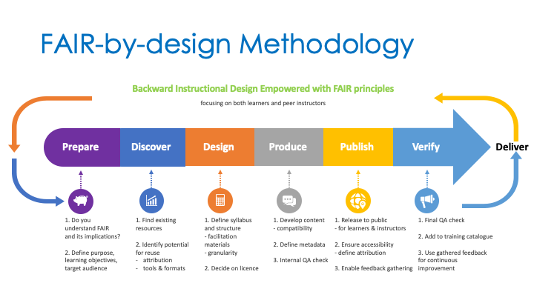

**Target Audience:** All project members that will need to develop learning materials for any type of project related training.

**Prerequisites:** This is a beginner’s level training; no prior knowledge is required to follow the training.

**Duration:** The training will take place in the course of three days in the half day + full day + half day format. The total length of the training is 12 hours.

**Training Objectives:** Upon successful completion of the training, the trainees will be able to

* Define FAIR learning objects
* Adapt and mix FAIR learning objects
* Identify licenses and attribute correspondingly
* Structure comprehensive learning materials
* Manage file formats and tools
* Define metadata using a schema
* Create and publish FAIR-by-Design learning materials
* Collaborate with other instructors
* Assess FAIR-ness of existing learning objects

**Training Schedule** (starting time is given in CEST)

**Day 1: FAIR-by-Design Preparation and Discovery**

|  |  |  |  |
| --- | --- | --- | --- |
| **Start** | **Step** | **Topic** | **Duration** |
| 9:00 |  | Introduction | 30 mins |
| 9:30 | Prepare | FAIR skills & principles | 30 mins |
| 10:00 |  | = coffee break = | 15 mins |
| 10:15 | Prepare | Defining FAIR learning objects | 60 mins |
| 11:15 |  | = coffee break = | 15 mins |
| 11:30 | Discover | Discovering existing learning materials | 60 mins |

**Day 2: Designing and Producing Learning Materials**

|  |  |  |  |
| --- | --- | --- | --- |
| **Start** | **Step** | **Topic** | **Duration** |
| 9:00 | Design | Conceptualisation | 30 mins |
| 9:30 | Design | Licensing and Attribution | 45 mins |
| 10:15 |  | = coffee break = | 15 mins |
| 10:30 | Design | Instruction facilitation | 30 mins |
| 11:00 | Design | Materials structure | 30 mins |
| 11:30 |  | = coffee break = | 15 mins |
| 11:45 | Produce | Content design | 60 mins |
| 12:45 |  | = Lunch break = | 60 mins |
| 13:45 | Produce | Design tools | 60 mins |
| 14:45 |  | = coffee break = | 15 mins |
| 15:00 | Produce | Accessibility | 60 mins |
| 16:00 |  | = coffee break = | 15 mins |
| 16:15 | Produce | Formats | 30 mins |
| 16:45 | Produce | Metadata | 30 mins |
| 17:15 | Produce | Initial Quality Assurance | 15 mins |

**Day 3: Finalising FAIR-by-Design Learning Materials**

|  |  |  |  |
| --- | --- | --- | --- |
| **Start** | **Step** | **Topic** | **Duration** |
| 9:00 | Publish | Depositing | 60 mins |
| 10:00 |  | = coffee break = | 15 mins |
| 10:15 | Publish | Versioning | 30 mins |
| 10:45 |  | Feedback gathering | 30 mins |
| 11:15 | Verify | = coffee break = | 15 mins |
| 11:30 | Verify | FAIR verification | 60 mins |

**Resources:** All training resources will be available on the FAIR-by-Design methodology course on the learning platform. You will need to self-enrol in the course to gain access to the materials. Additional equipment and software needed to take full advantage of the training activities:

* Headset with microphone
* GitHub account
* Zenodo account
* MD editor of choice (e.g. VS Code)
  + You can also use an online demo version such as <https://demo.hedgedoc.org/>

**Certification**: All trainees that will successfully pass all training unit assessments available on the course on the learning platform will obtain the “FAIR Instructor” badge.

**Contact:** For more information regarding the training please contact the T2.3 FAIR-by-Design Methodology Task Leader Sonja Filiposka using [sonja.filiposka@finki.ukim.mk](mailto:sonja.filiposka@finki.ukim.mk)

We are looking forward to making FAIR learning materials with you!

