**Why conduct a Post-Mortem evaluation of your implementation of the FAIR-by-Design methodology?**  
  
Using the FAIR-by-Design methodology to develop learning objects can contribute with a lot of new knowledge about how we put the elements into practice, the potentials and challenges, but also a lot of new learning about our culture of designing learning objects. The aim of the FAIR-by-Design methodology is to ensure that editable learning objects are versioned, stored, shared and published properly with the correct metadata and with an added facilitator package.

**Purpose**  
To ensure that this knowledge and our experiences are not going to be lost but used for improvement, please conduct this ”health check” of the FAIR-by-Design methodology at the end of the development of your learning object, that is, do a 'Post mortem.' Use this template to structure your discussion on the application of the FAIR-by-Design methodology, what went well, and what did not go so well. The purpose is to have an honest discussion about the project process that will drive future improvements as well as mitigate future risks.

**An overview of the FAIR-by-Design Methodology**

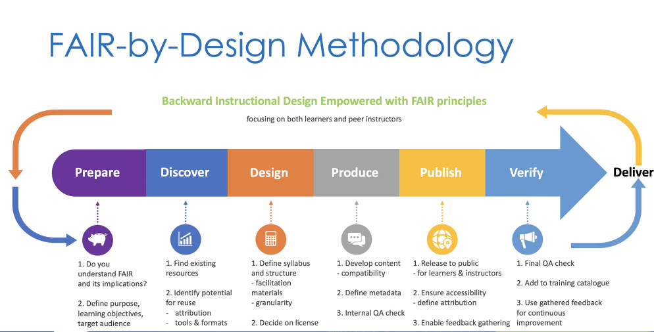

**Tips for filling out the form**To ensure that everyone contributes with their thoughts and experiences working in a FAIR-by-Design way, the task or learning object leader sends the Post-mortem as preparation to a meeting in which the FAIR-by-Design methodology is discussed in plenum. Ask the workgroup to familiarize themselves with the Post-mortem template and think about the development of the learning object and reflect on what they think went well in the application of the FAIR-by-Design methodology, what did not go so well, and the lessons they want to carry forward.

**How the post-mortem documents will be used**Completed post-mortem documents will not be shared outside of the project. The content will be included in a qualitative, thematic analysis. Results of the analysis will be published in a report regarding the development of the FAIR-by-design method and how the method was applied in the project. Direct citations from the post-mortems will be anonymised.

**Learning object**

|  |
| --- |
| *Write the name of the learning object that is the seed of the evaluation of the FAIR-by-Design process in this box* |

**Learning objectives**

|  |
| --- |
| *Write the object’s learning objectives in this box* |

**List the tools you used in the development of the learning object**

|  |
| --- |
| *List all the tools you used in the development of the learning object – think about all the stages you went through, i.e. did you use a jamboard/white board to develop ideas? PowerPoint slides to structure the content? Interactive quizzes?* |

**What went well?**

|  |
| --- |
| *Provide a summary of your or task/working group members experiences* |

**What did not go so well?**

|  |
| --- |
| *Provide a summary of your or all task/working group members experiences.* |

**Lessons learned**

|  |
| --- |
| *Describe briefly your or all task/working group members experiences of using the FAIR-by-Design methodology , materials and workflow. These experiences can include ideas to future workflows in FAIR-by-Design learning object development, how to include FAIR-by-Design support, need for upskilling, change in current practices, etc.* |

**Complimentary survey**

|  |
| --- |
| If you have not done so already, please fill out the following survey, in which we capture quantitative data regarding the practical implementation of the FAIR-by-Design methodology.  In the rubric ”help us improve” please just note you have filled out the Post Mortem. As the survey is anonymous, do not write the name of the learning object in this rubric.  <https://ec.europa.eu/eusurvey/runner/FAIR-by-Design_Open_Survey> |

**Please write in the box below if we may NOT cite content from the post-mortem that links the comment to the learning object. No task or group members will be named under any circumstance.**

|  |
| --- |
|  |

**Links to developed and supporting materials, which may prove useful in filling out the Post-Mortem**

* FAIR-by-Design git book <https://fair-by-design-methodology.github.io/FAIR-by-Design_ToT/latest/>
* FAIR-by-Design methodology deliverable <https://zenodo.org/records/8305540>
* FAIR-by-Design microlearning <https://fair-by-design-methodology.github.io/microlearning/latest>
* FAIR-by-Design Training materials  
  <https://learning.skills4eosc.eu/course/view.php?id=19>
* GitHub templates for structuring learning objects  
  <https://github.com/FAIR-by-Design-Methodology/templates>
* Quality assurance checklists  
  <https://workplace.skills4eosc.eu/Products/Files/DocEditor.aspx?fileid=5075>

**Actions**

|  |  |  |
| --- | --- | --- |
| **START** | **STOP** | **CONTINUE . . . .** |
| *Fill out during the meeting…*  *Describe which actions you will start implementing next time you use the FAIR-by-Design methodology.* | *Fill out during the meeting…*  *Describe which actions you will not repeat next time you use the FAIR-by-Design methodology.* | *Fill out during the meeting…*  *Describe which actions you will continue the next time you use FAIR-by-Design methodology.* |

