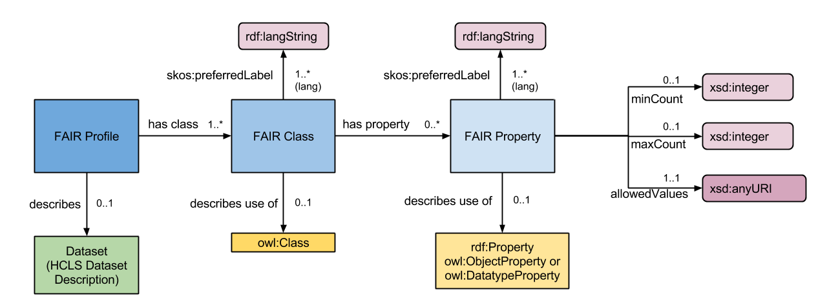Fig 1. FAIR Ontology (https://github.com/FAIRDataInitiative/DataFairPort; FAIR-Schema.png).

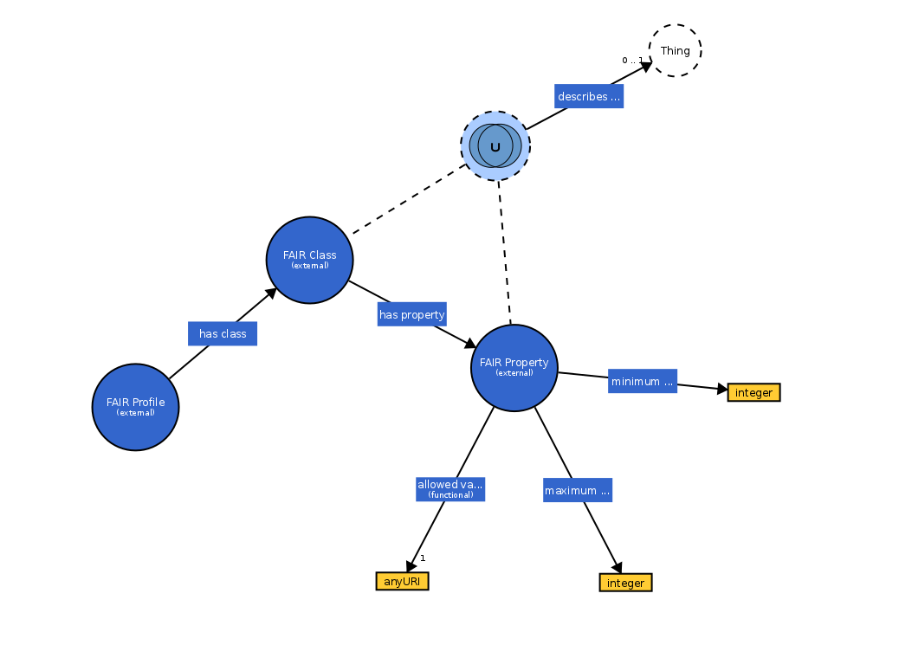Fig 2. FAIR Ontology (FAIR-schema.owl; WebVOWL beta 0.4.0).

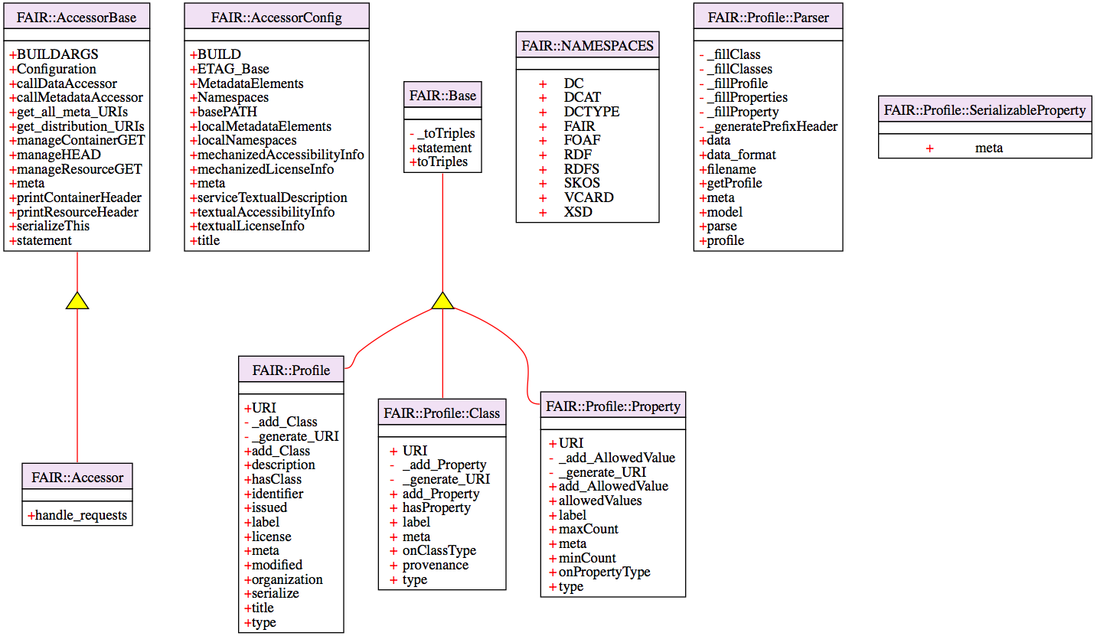Fig 3. UML class diagram generated from the DataFairPort/Libraries/Perl/FAIR/lib/FAIR code base using the UML::Class::Simple Perl module (v0.20).
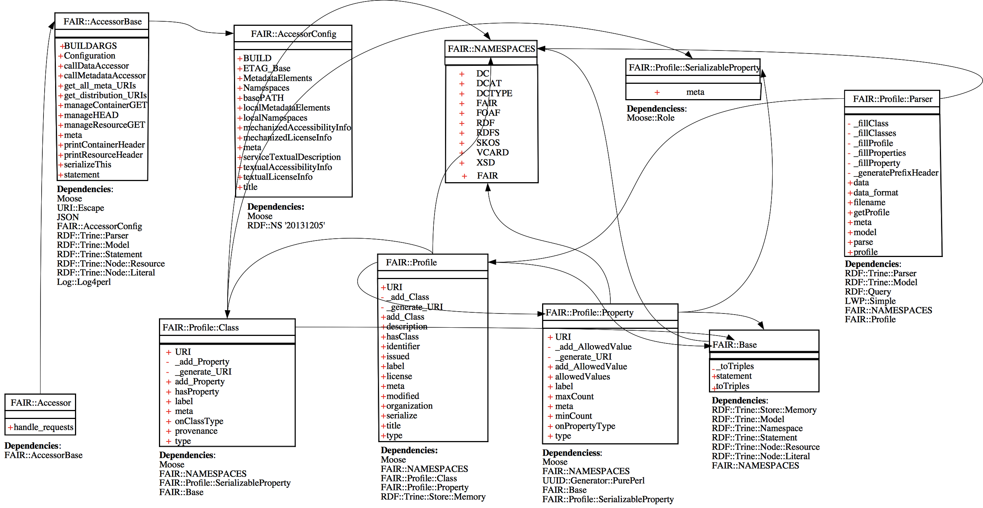Fig 4. UML class diagram based on Fig3 but with additional dependecies added manually due to some limitations of the UML::Class:Simple Perl module, which are well documented. Note that the missing relations in Fig 3 might be due to a mix of OO styles i.e. Moose vs. Perl's old style used in the FAIR library.

Tests performed on the Data FAIRport Perl prototype

Test environment:
Mac OS X v10.7.5; Perl v5.16.3; DataFairPort v0.231
Examples directory:
DataFairPort/Libraries/Perl/FAIR/examples

### SUCCESS ###
perl Allele_Profile_Descriptive.pl # output: Allele_Profile_Descriptive.rdf
perl Allele_Profile_EDAM.pl # output: Allele_Profile_EDAM.rdf
perl Allele_Profile_SIO.pl # output: Allele_Profile_SIO.rdf
perl CreateAccessorDescriptor.pl # output: DragonDB_Allele_Accessor.rdf
perl DragonDB_Allele_Profile2.pl # output: DragonDB_Allele_ProfileImagesSIO.rdf
perl testparser.pl Allele_Profile_Descriptive.rdf # *.rdfduplicate.rdf

### FAILED ###
perl testparser.pl Allele_Profile_EDAM.rdf
Attribute (modified) does not pass the type constraint because: Validation failed for 'Str' with value undef at /opt/local/lib/perl5/site_perl/5.16.3/darwin-thread-multi-2level/Moose/Object.pm line 24
Moose::Object::new('FAIR::Profile', 'URI', 'http://biordf.org/DataFairPort/ProfileSchemas/Allele_Profile_EDAM.rdf#Profile', 'label', 'FAIR Profile Allele Images (EDAM)', 'title', 'FAIR Profile the Image portion of an Allele record', 'description', 'FAIR Profile the Image portion of an Allele record using EDAM:Image classification', 'modified', undef, 'license', 'Anyone may use this freely', 'issued', 'May 21, 2015', 'organization', 'wilkinsonlab.info', 'identifier', 'doi:Mark.Dragon.P3') called at ../lib/FAIR/Profile/Parser.pm line 260
FAIR::Profile::Parser::_fillProfile('FAIR::Profile::Parser=HASH(0x7fba8c029e60)', 'RDF::Query::Node::Resource=ARRAY(0x7fba8c03ae28)') called at ../lib/FAIR/Profile/Parser.pm line 213
FAIR::Profile::Parser::getProfile('FAIR::Profile::Parser=HASH(0x7fba8c029e60)') called at ../lib/FAIR/Profile/Parser.pm line 200
FAIR::Profile::Parser::parse('FAIR::Profile::Parser=HASH(0x7fba8c029e60)') called at testparser.pl line 7

perl testparser.pl Allele_Profile_SIO.rdf
Attribute (modified) does not pass the type constraint because: Validation failed for 'Str' with value undef at /opt/local/lib/perl5/site_perl/5.16.3/darwin-thread-multi-2level/Moose/Object.pm line 24
Moose::Object::new('FAIR::Profile', 'URI', 'http://biordf.org/DataFairPort/ProfileSchemas/Allele_Profile_SIO.rdf#Profile', 'label', 'FAIR Profile of Allele Images(SIO)', 'title', 'FAIR Profile the Image portion of an Allele record', 'description', 'FAIR Profile the Image portion of an Allele record using SIO:Image classification', 'modified', undef, 'license', 'Anyone may use this freely', 'issued', 'May 21, 2015', 'organization', 'wilkinsonlab.info', 'identifier', 'doi:Mark.Dragon.P2') called at ../lib/FAIR/Profile/Parser.pm line 260
FAIR::Profile::Parser::_fillProfile('FAIR::Profile::Parser=HASH(0x7fe86b029e60)', 'RDF::Query::Node::Resource=ARRAY(0x7fe86b03ae28)') called at ../lib/FAIR/Profile/Parser.pm line 213
FAIR::Profile::Parser::getProfile('FAIR::Profile::Parser=HASH(0x7fe86b029e60)') called at ../lib/FAIR/Profile/Parser.pm line 200
FAIR::Profile::Parser::parse('FAIR::Profile::Parser=HASH(0x7fe86b029e60)') called at testparser.pl line 7

perl testparser.pl DragonDB_Allele_Accessor.rdf
Entity: line 1: parser error : error parsing attribute name
<http://antirrhinum.net> <http://www.w3.org/2000/01/rdf-schema#label> "The Antir
^
Entity: line 1: parser error : attributes construct error
<http://antirrhinum.net> <http://www.w3.org/2000/01/rdf-schema#label> "The Antir
^
Entity: line 1: parser error : xmlParseStartTag: problem parsing attributes
<http://antirrhinum.net> <http://www.w3.org/2000/01/rdf-schema#label> "The Antir
^
Entity: line 1: parser error : Couldn't find end of Start Tag http: line 1
<http://antirrhinum.net> <http://www.w3.org/2000/01/rdf-schema#label> "The Antir
^
Entity: line 1: parser error : Extra content at the end of the document
<http://antirrhinum.net> <http://www.w3.org/2000/01/rdf-schema#label> "The Antir

perl testparser.pl DragonDB_Allele_ProfileImagesSIO.rdf
Attribute (modified) does not pass the type constraint because: Validation failed for 'Str' with value undef at /opt/local/lib/perl5/site_perl/5.16.3/darwin-thread-multi-2level/Moose/Object.pm line 24
Moose::Object::new('FAIR::Profile', 'URI', 'http://biordf.org/DataFairPort/ProfileSchemas/DragonDB_Allele_ProfileImagesSIO.rdf', 'label', 'FAIR Profile the Image portion of Allele records of DragonDB using SIO:Image classification', 'title', 'FAIR Profile the Image portion of Allele records of DragonDB using SIO:Image classification', 'description', 'FAIR Profile the Image portion of Allele records of DragonDB using SIO:Image classification', 'modified', undef, 'license', 'Anyone may use this freely', 'issued', 'May 21, 2015', 'organization', 'wilkinsonlab.info', 'identifier', 'doi:Mark.Dragon.P2') called at ../lib/FAIR/Profile/Parser.pm line 260
FAIR::Profile::Parser::_fillProfile('FAIR::Profile::Parser=HASH(0x7f9549029e60)', 'RDF::Query::Node::Resource=ARRAY(0x7f954903a138)') called at ../lib/FAIR/Profile/Parser.pm line 213
FAIR::Profile::Parser::getProfile('FAIR::Profile::Parser=HASH(0x7f9549029e60)') called at ../lib/FAIR/Profile/Parser.pm line 200
FAIR::Profile::Parser::parse('FAIR::Profile::Parser=HASH(0x7f9549029e60)') called at testparser.pl line 7

perl testFAIRProfile.pl
Attribute (onPropertyType) is required at /opt/local/lib/perl5/site_perl/5.16.3/darwin-thread-multi-2level/Moose/Object.pm line 24
Moose::Object::new('FAIR::Profile::Property', 'property_type', 'http://datafairport.org/examples/ProfileSchemas/Examples/ORCID_Class#orcid_id', 'label', 'ORCID ID') called at testFAIRProfile.pl line 41

### FAILED to install Spreadsheet::XLSX::Reader::LibXML dependency ###
perl EHDN_Accessor
Can't locate Spreadsheet/XLSX/Reader/LibXML.pm in @INC (@INC contains: /opt/local/lib/perl5/site_perl/5.16.3/darwin-thread-multi-2level /opt/local/lib/perl5/site_perl/5.16.3 /opt/local/lib/perl5/vendor_perl/5.16.3/darwin-thread-multi-2level /opt/local/lib/perl5/vendor_perl/5.16.3 /opt/local/lib/perl5/5.16.3/darwin-thread-multi-2level /opt/local/lib/perl5/5.16.3 /opt/local/lib/perl5/site_perl /opt/local/lib/perl5/vendor_perl/5.16.0/darwin-thread-multi-2level /opt/local/lib/perl5/vendor_perl/5.16.0 /opt/local/lib/perl5/vendor_perl .) at EHDN_Accessor line 174.
BEGIN failed--compilation aborted at EHDN_Accessor line 174.

