FAIRmat page on the NFDI website

Visit page: [EN](https://www.nfdi.de/consortia-fairmat/?lang=en) | [DE](https://www.nfdi.de/u-konsortien-fairmat/)

February 3, 2025

# (Co-)applicant institutions and (co-)speakers:

|  |
| --- |
| New text |
| * Leibniz-Institut für Kristallzüchtung (IKZ) - Martin Albrecht * Friedrich-Alexander-Universität Erlangen-Nürnberg (FAU) - Heiko Weber * Ruhr-University Bochum (RUB) - Silvana Botti * Technical University of Munich (TUM) - Hans-Joachim Bungartz * Karlsruhe Institute of Technology (KIT) - Christof Wöll * FAIR-DI e.V. - Claudia Draxl |

# Participating institutes:

|  |
| --- |
| New text |
| * German Physical Society (DPG) * Leibniz Information Centre for Science and Technology (TIB) * Max Planck Computing and Data Facility (MPCDF) * Technical University of Kaiserslautern * Jülich Supercomputing Centre * Fritz Haber Institute of the Max Planck Society * Heidelberg University * Research Center Jülich (FZJ) * Max Planck Institute for Chemical Physics of Solids * Leipzig University * Ulm University * Technical University Berlin * Leibniz Institute for Interactive Materials (DWI) * Technical University Dresden (TU Dresden) * Max Planck Institute for Chemical Energy Conversion * Friedrich Schiller University Jena * Justus Liebig University Giessen * Georg-August-University Göttingen * Martin-Luther-University Halle-Wittenberg * University Duisburg-Essen * Max-Planck-Institut für Eisenforschung GmbH * Zuse Institute Berlin * Christian-Albrechts-Universität zu Kiel * Helmholtz Zentrum Berlin * Goethe University Frankfurt * University of Cologne * Helmholtz Zentrum Dresden-Rossendorf * Technical University of Darmstadt * Max Planck Institute for Polymer Research |

# Updates checklist:

* Update the FAIRmat logo  
  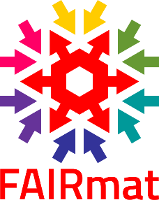
* Update the FAIRmat wheel  
  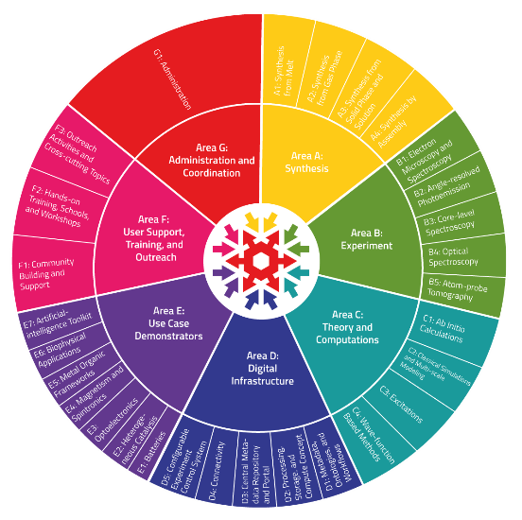
* Include links to Discord, BlueSky, GitHub page, FAIRmat Zenodo community, and NOMAD.
  + Discord: <https://discord.gg/Gyzx3ukUw8>
  + Bluesky: <https://bsky.app/profile/fairmat.bsky.social>
  + GitHub: <https://github.com/FAIRmat-NFDI>
  + FAIRmat Zenodo Community: <https://zenodo.org/communities/fairmat_nfdi/>
  + NOMAD: <https://nomad-lab.eu>