
HAROHALLI, KANAKAPURA ROAD – 562112
DEPARTMENT OF COMPUTER SCIENCE & ENGINEERING
(DATA SCIENCE)

PROJECT REPORT
ON
"Facial Emotion Recognition "
2024-2025
BACHELOR OF TECHNOLOGY IN
COMPUTER SCIENCE & ENGINEERING ( DATA SCIENCE)

Submitted by
Mohammed Faizan Khan-ENG22DS0006 Rajat Salunke – ENG22DS0011
Sri Sai Nithin P – ENG22DS0018
Venkata Susshal Nalanagu – ENG22DS0057

Under The Supervision of:
Prof. Sindhu A Assistant Professor
Department of CSE (Data Science), DSU

DAYANANDA SAGAR UNIVERSITY
DEPARTMENT OF COMPUTER SCIENCE & ENGINEERING SCHOOL OF ENGINEERING
HAROHALLI, KANAKAPURA ROAD – 562112


CERTIFICATE
It is certified that the Deep Learning project work entitled “Facial Emotion Recognition” has been carried out at Dayananda Sagar University, Bangalore, by Mohammed Faizan Khan – ENG22DS0006,, Rajat Salunke – ENG22DS0011 , Sri Sai Nithin P– ENG22DS0018, Venkata Susshal Nalanagu - ENG22DS0057, Bonafide student of sixth Semester, B.tech. in partial fulfilment for the award of degree in Bachelor of Technology in Computer Science & Engineering (Data Science) during academic year 2024-25. It is certified that all corrections/suggestions indicated for Internal Assessment have been incorporated in the report deposited in departmental library.
The project report has been approved as it satisfies the academic requirements in respect of project work for the said degree.

Signature of the Guide Signature of the Chairperson

ACKNOWLEDGEMENT

A project's successful completion offers a sense of satisfaction, but it is never finished without expressing gratitude to everyone who contributed to its accomplishment. We would like to convey our sincere gratitude to our esteemed university, Dayananda Sagar University, for offering the first-rate facilities.
We are especially thankful to our Chairperson, Dr. Shaila S G, forproviding necessary departmental facilities, moral support and encouragement. The largest measure of our acknowledgment is reserved for Prof. Manjula M whose guidance and support madeit possible to complete the project work in a timely manner.
We would want to thank everyone who has assisted us in successfully completing this project work, both directly and indirectly. The staff has provided us with a great deal of direction and cooperation.

Mohammed Faizan Khan- ENG22DS0006 Rajat Salunke - ENG22DS0011 Sri Sai Nithin P - ENG22DS0018
Venkata Susshal Nalanagu-ENG22DS0029

We hereby declare that the project entitled “Facial Emotion Recognition” submitted to Dayananda Sagar University, Bengaluru, is a bona fide record of the work carried out by me under the guidance of Sindhu A, assistant professor in the Dayananda Sagar University School of Engineering's Department of Computer Science and Engineering (Data Science). This work is submitted toward the partial fulfillment of the requirements for the award of a Bachelor of Technology in Computer Science and Engineering (Data Science).

Mohammed Faizan Khan-ENG22DS0006 Rajat Salunke - ENG22DS0011 Sri Sai Nithin P - ENG22DS0018
Venkata Susshal Nalanagu-ENG22DS0029

Facial Emotion Recognition (FER) is an emerging area in the field of computer vision and artificial intelligence that focuses on identifying and interpreting human emotions through facial expressions. Emotions such as happiness, sadness, anger, fear, disgust, surprise, and neutrality are universally recognized and play a vital role in interpersonal communication. The automation of emotion recognition has gained importance in various applications including human-computer interaction, security systems, healthcare, driver safety monitoring, and virtual reality environments.
This project presents a deep learning-based approach for the automatic classification of facial expressions into basic emotion categories. The core methodology utilizes Convolutional Neural Networks (CNNs), which are highly effective for image-based tasks due to their ability to learn spatial hierarchies of features. The model is trained and tested on publicly available facial emotion datasets such as FER-2013 and CK+ (Extended Cohn-Kanade Dataset), ensuring diverse facial representation across age groups, ethnicities, and lighting conditions.
To improve accuracy and generalization, the proposed system incorporates data augmentation techniques, dropout regularization, and optimization algorithms like Adam. The model architecture is designed to balance depth and computational efficiency, making it suitable for both offline analysis and real-time applications. The classification performance is evaluated using metrics such as accuracy, precision, recall, F1-score, and confusion matrix.

TABLE OF CONTENTS

CHAPTER | PG. NO.
1) INTRODUCTION | 7
2) OBJECTIVE | 10
3) DESCRIPTION OF WORK | 12
4) LITERATURE SURVEY | 14
5) METHODOLOGY | 20
6) SOURCE CODE | 28
7) RESULT AND FUTURE ENHANCEMENTS | 32
8) CONCLUSION | 37
9) REFERENCES | 39

INTRODUCTION

Emotions are a fundamental aspect of human experience, influencing cognition, behavior, communication, and decision-making. Recognizing emotions through facial expressions is one of the most natural and intuitive ways for humans to convey internal states without verbal communication. In recent years, the ability to automate this recognition through computational means has garnered significant attention in the fields of computer vision, artificial intelligence (AI), and human-computer interaction (HCI).
Facial Emotion Recognition (FER) refers to the process of detecting and classifying emotions from a person’s facial expressions using digital images or videos. This technology has wide-ranging applications including smart surveillance, interactive gaming, adaptive learning systems, mental health diagnostics, driver alertness systems, customer experience monitoring, and virtual assistants. The integration of emotion recognition into machines enhances their ability to respond appropriately to human moods, thereby improving user engagement and system intelligence.
Traditional FER systems relied heavily on handcrafted features such as Local Binary Patterns (LBP), Histogram of Oriented Gradients (HOG), and geometric relationships between facial landmarks. While these approaches have yielded some success, they are limited in terms of scalability, accuracy, and robustness, especially under real-world conditions involving varying lighting, head poses, and occlusions.

Facial expressions are among the most powerful, natural, and universal signals for conveying emotions. They play a pivotal role in non-verbal communication, accounting for a significant portion of interpersonal interactions. Recognizing and interpreting these expressions correctly is essential for effective communication, empathy, and social bonding. In the context of machines and intelligent systems, enabling them to perceive and respond to human emotions can greatly enhance user experience and system adaptability.
Despite the apparent simplicity of recognizing emotions by humans, automating this process presents significant challenges. Facial expressions vary across individuals due to differences in facial structure, age, gender, ethnicity, and cultural background.
Additionally, environmental factors such as lighting conditions, image resolution, head orientation, and occlusions (e.g., glasses, masks, hands) add complexity to the task. Moreover, subtle and compound expressions that blend multiple emotions further complicate classification tasks.
Recent advancements in artificial intelligence and the availability of large annotated datasets have propelled the development of automated Facial Emotion Recognition systems. Deep learning, particularly Convolutional Neural Networks (CNNs), has emerged as a state-of-the-art approach for image-based tasks due to its capability to learn complex and abstract features from raw image data. Unlike traditional methods that rely on hand-crafted features, CNNs automatically extract spatial hierarchies and patterns, making them highly effective for FER.
This project seeks to leverage the power of CNNs to build a system capable of accurately recognizing human emotions from facial images. The system aims to bridge the gap between human emotional intelligence and machine perception, opening up

possibilities for applications in numerous fields such as healthcare (e.g., detecting signs of depression), automotive (e.g., monitoring driver fatigue), education (e.g., adaptive e-learning), customer service (e.g., sentiment analysis), and entertainment.
By integrating deep learning models with real-time video processing tools, this project also explores the implementation of live emotion detection systems. These systems can be embedded in smart devices or integrated into web-based platforms to provide interactive and emotionally aware digital environments. Through this work, we aim not only to improve the technical accuracy of FER systems but also to understand their societal implications and contribute to the responsible development of empathetic AI.
With the advancement of deep learning, particularly Convolutional Neural Networks (CNNs), significant progress has been made in image-based recognition tasks. CNNs have revolutionized FER by automatically learning hierarchical features directly from raw pixel data, eliminating the need for manual feature engineering. These models are capable of capturing subtle differences in facial expressions and generalizing well across diverse datasets.
This project focuses on building a robust and efficient FER system using deep learning techniques. The model is trained to classify facial expressions into primary emotion categories: Happy, Sad, Angry, Fearful, Disgusted, Surprised, and Neutral. Publicly available datasets such as FER-2013 and CK+ are used for training and evaluation. Techniques such as data augmentation, normalization, dropout, and transfer learning are applied to enhance model performance and prevent overfitting.

OBJECTIVE

The primary objective of this project is to design and develop an intelligent system capable of automatically recognizing human emotions from facial expressions using deep learning techniques. The system aims to classify facial expressions into distinct emotion categories such as Happy, Sad, Angry, Fearful, Disgusted, Surprised, and Neutral. By leveraging Convolutional Neural Networks (CNNs), the project seeks to eliminate the limitations of traditional machine learning approaches that rely heavily on manual feature extraction. Instead, the deep learning model will learn relevant features directly from the input images, enabling more accurate and scalable emotion classification.
Another important objective is to build a robust and efficient model that performs well across different datasets, especially under varying real- world conditions such as changes in lighting, head orientation, and partial occlusions. To achieve this, the project incorporates image preprocessing techniques like normalization, grayscale conversion, and data augmentation to enhance the diversity and quality of the training data. Regularization methods such as dropout are used to minimize overfitting and improve generalization to unseen data.
In addition to building and training the deep learning model, the project also focuses on evaluating its performance using standard metrics including accuracy, precision, recall, F1-score, and confusion matrix. These metrics help in assessing the effectiveness of the model across all emotion categories and provide insights into areas where the model may need improvement. Moreover, the system is designed with scalability in mind, allowing for real-time emotion recognition through webcam input or video frames, which demonstrates its practical applicability in various domains.

Finally, the project aims to analyze the existing challenges in facial emotion recognition—such as subject diversity, expression ambiguity, and environmental noise—and propose potential improvements for future work. This includes exploring more advanced deep learning architectures, incorporating temporal information for video-based emotion recognition, and leveraging transfer learning with pre-trained models. Overall, the project strives to create a reliable and intelligent emotion recognition system that contributes to the advancement of emotion-aware technologies in artificial intelligence.

DESCRIPTION OF WORK

The scope of this project involves the complete lifecycle of developing a deep learning-based system for automatic facial emotion recognition. The system is designed to recognize and classify human emotions using static facial images. The project begins with the selection of appropriate datasets that contain diverse facial expressions captured under various conditions. Publicly available datasets such as FER-2013, CK+ (Cohn-Kanade Extended), and JAFFE are considered due to their relevance and popularity in facial expression research.
The data preprocessing stage includes converting images to grayscale to reduce computational complexity while preserving the key features necessary for emotion recognition. The images are resized to a standard resolution (e.g., 48×48 pixels) to ensure consistency during training. Normalization of pixel values is applied to stabilize and accelerate the learning process. To address class imbalance and improve model generalization, data augmentation techniques such as random rotation, horizontal flipping, zooming, and shifting are employed.
A custom Convolutional Neural Network (CNN) architecture is designed and implemented, optimized specifically for the task of facial emotion classification. The model is trained to learn hierarchical features that differentiate between various facial expressions. Regularization

techniques like dropout and batch normalization are incorporated to prevent overfitting and ensure model stability. Hyperparameters such as the learning rate, batch size, number of epochs, and optimizer type (e.g., Adam) are carefully tuned for optimal performance.
The model’s performance is evaluated using a variety of metrics including accuracy, precision, recall, F1-score, and confusion matrix. These metrics provide a comprehensive understanding of the classifier's effectiveness across all emotion categories. The trained model is tested on unseen data to assess its generalization capability and robustness.
Furthermore, the scope includes exploring the real-time application of the system by integrating webcam input or video streams. This enables dynamic emotion recognition from live facial expressions, making the system suitable for real-world scenarios such as emotion-aware assistants, virtual classrooms, mental health monitoring, and intelligent surveillance systems.

LITERATURE SURVEY

Facial Emotion Recognition (FER) has been an active research area for several decades, spanning across disciplines such as computer vision, psychology, and artificial intelligence. Over time, FER systems have evolved significantly, transitioning from traditional handcrafted feature- based methods to modern deep learning-based techniques. This literature survey outlines key approaches, models, and datasets that have shaped the development of facial emotion recognition systems.
Traditional Approaches

Early FER systems primarily relied on geometric and appearance-based features. Geometric methods extracted the spatial relationships between facial landmarks (e.g., distance between the eyes, mouth shape), while appearance-based methods analyzed texture features across the face. Techniques such as Principal Component Analysis (PCA), Linear Discriminant Analysis (LDA), Gabor filters, and Local Binary Patterns (LBP) were commonly used to extract discriminative features from facial images.
For classification, traditional machine learning algorithms like Support Vector Machines (SVM), K-Nearest Neighbors (KNN), and

Hidden Markov Models (HMM) were applied. While these methods performed reasonably well in controlled environments, they lacked robustness in real-world conditions due to their sensitivity to illumination, pose variations, and occlusions.
  - Emergence of Deep Learning

The advent of deep learning, particularly Convolutional Neural Networks (CNNs), brought a paradigm shift to FER. CNNs are capable of learning spatial hierarchies of features directly from image data, thereby eliminating the need for manual feature engineering. Notable models like LeNet, AlexNet, and VGGNet laid the foundation for applying deep networks to visual recognition tasks, including emotion recognition.
One of the most widely cited works is by Goodfellow et al. (2013), who applied deep learning to the FER-2013 dataset and achieved notable performance using a relatively shallow CNN architecture. This research demonstrated the viability of using deep networks for FER and opened the door to more complex architectures.
In a study by Mollahosseini et al. (2016), a deeper CNN architecture was proposed for emotion recognition, trained on multiple datasets including FER-2013 and CK+. The model showed improved accuracy and robustness across various emotional categories. Similarly, Tang

(2013) used a Deep Convolutional Neural Network along with SVM for classification, achieving high accuracy on the FER-2013 challenge.
  - Transfer Learning and Pre-trained Models

To address challenges like data scarcity and training time, researchers began using transfer learning by leveraging pre-trained models such as ResNet, Inception, and MobileNet. These models, trained on large datasets like ImageNet, are fine-tuned for emotion recognition tasks. Studies have shown that transfer learning significantly improves performance, especially when the target dataset is small or imbalanced.
For example, Kollias et al. (2019) used a transfer learning approach based on VGG-Face for real-world facial emotion recognition and introduced the AffectNet dataset, which contains over 1 million facial images labeled with emotion, valence, and arousal scores. Their work emphasized the importance of large-scale, in-the-wild datasets and deep architectures for robust FER.
Recurrent and Attention-Based Models

While CNNs are effective at capturing spatial features, they do not inherently model temporal dynamics. For video-based FER or subtle expression analysis, researchers have explored Recurrent Neural

Networks (RNNs), particularly Long Short-Term Memory (LSTM) networks, to capture temporal dependencies. These models are capable of learning how facial expressions evolve over time.
Recent works have also introduced attention mechanisms to FER systems. Attention models allow networks to focus on the most expressive facial regions (e.g., eyes, mouth) and disregard irrelevant parts. For instance, Li et al. (2018) proposed a Dual Attention Network that significantly improved FER performance by dynamically attending to both spatial and channel-wise features.
  - Challenges Highlighted in Literature

Despite advancements, several challenges persist in FER:

- Intra-class variability: The same emotion may look different across individuals.
- Inter-class similarity: Some expressions (e.g., fear and surprise) can appear very similar.
- Occlusions and illumination: Glasses, hands, masks, and lighting affect performance.
- Imbalanced datasets: Some emotions are underrepresented, leading to biased training.

Researchers have proposed solutions such as balanced loss functions (e.g., focal loss), data augmentation, ensemble models, and adversarial training to mitigate these issues.
  - Summary of Insights

From the literature, it is evident that deep learning, particularly CNN- based architectures, significantly outperforms traditional methods in facial emotion recognition. Integration with techniques like transfer learning, temporal modeling, and attention mechanisms can further enhance performance. However, the effectiveness of any FER system largely depends on the quality and diversity of the dataset, proper handling of real-world noise, and interpretability of the model.

Reference | Approach/Model | Dataset(s) Used | Key Contributions | Performance / Notes
Goodfellow et al. (2013) | Shallow CNN | FER-2013 | Early application of CNN to FER | Achieved competitive accuracy on FER-2013
Mollahosseini et al. (2016) | Deep CNN | FER-2013, CK+ | Multi-dataset training, deeper network design | Improved accuracy and robustness
Tang (2013) | CNN + SVM | FER-2013 | Hybrid model combining CNN feature extractor and SVM classifier | High accuracy; showed CNN features effective
Kollias et al. (2019) | Transfer Learning (VGG- Face) | AffectNet | Large-scale dataset, real- world emotion recognition | State-of-the-art performanceonin-the- wild data
Li et al. (2018) | Dual Attention Network (CNN + Attention) | FER-2013, CK+ | Attention mechanism to focus on key facial regions | Enhanced classification by focusing on important features
Zhang et al. (2019) | CNN + LSTM (Temporal Modeling) | CK+ (video sequences) | Modeled temporal dynamics in facial expressions | Better performance on video-based FER
Barsoum et al. (2016) | Ensemble CNN | FER-2013 | Ensemble of CNNs to reduce overfitting | Improved accuracy through model ensemble

METHODOLOGY

The methodology for this Facial Emotion Recognition (FER) project is carefully structured to build a robust and accurate deep learning model capable of classifying human emotions based on facial expressions. The methodology includes detailed stages of data preparation, model design, training, evaluation, and optional deployment for real-time application. The following subsections elaborate each step in detail.
  - Data Collection and Dataset Preparation

The foundation of any machine learning project is quality data. This project utilizes publicly available datasets such as FER-2013 and CK+ (Cohn-Kanade) datasets. The FER-2013 dataset consists of over 35,000 grayscale images of faces labeled with seven emotional categories: Angry, Disgust, Fear, Happy, Sad, Surprise, and Neutral. It was collected from the web under real-world, uncontrolled conditions, ensuring diversity in pose, lighting, and background. The CK+ dataset provides high-quality, sequential images capturing the progression of facial expressions, useful for both static and temporal FER.

After dataset acquisition, preprocessing is applied to normalize and augment the data. This ensures the model generalizes well and is robust to variations. All images are resized uniformly to 48x48 pixels, which balances detail retention and computational efficiency. Grayscale conversion reduces input dimensionality, focusing the model on luminance patterns crucial for facial expression cues.
Normalization scales pixel values to a [0,1] range, preventing large gradient updates and accelerating model convergence during training. To mitigate overfitting and enrich the dataset’s variability, data augmentation techniques are applied, including:
- Horizontal flipping: Simulates mirror images to diversify facial orientation.
- Random rotation: Rotates images by a small degree (e.g., ±15°) to mimic head tilts.
- Zooming: Slight zoom in/out to replicate distance variation.

- Shifting: Translating images horizontally or vertically.

This augmentation exposes the model to a wider range of facial variations, improving robustness against pose and alignment changes.

  - Convolutional Neural Network (CNN) Architecture Design

The core of the FER system is a carefully crafted CNN, designed to automatically extract relevant spatial features from raw pixel data and classify emotions effectively. The architecture consists of the following components:
- Input Layer: Accepts preprocessed 48x48 grayscale images.

- Convolutional Layers: Multiple convolutional layers equipped with small 3x3 filters scan the input images to detect low-level features such as edges, textures, and curves. Subsequent deeper layers capture higher- level features like eyes, nose, mouth, and expression-specific patterns.
- Activation Functions (ReLU): After each convolution, Rectified Linear Unit (ReLU) activation introduces non-linearity, allowing the network to learn complex mappings.
- Pooling Layers: Max-pooling layers (typically 2x2) reduce spatial dimensions while retaining important features, making the model computationally efficient and invariant to minor translations.
- Dropout Layers: Dropout is applied (e.g., with a rate of 0.25 or 0.5) after convolutional or fully connected layers to randomly deactivate

neurons during training, reducing overfitting by preventing co-adaptation

of feature detectors.

- Fully Connected Layers: These dense layers interpret the learned feature maps to perform classification. The last fully connected layer’s size equals the number of emotion classes.
- Output Layer: Employs a softmax activation function to produce a probability distribution over the emotion classes, assigning the input face to the most probable emotion.
The exact number of layers, filters per layer, and dropout rates are determined experimentally to balance between underfitting and overfitting.
  - Model Training

The CNN model is trained using supervised learning. The inputs are preprocessed images, and the outputs are one-hot encoded vectors representing the seven emotion classes. Key details of the training process include:
- Loss Function: Categorical Cross-Entropy loss is used, which quantifies the difference between predicted probabilities and actual labels. This loss is minimized to improve classification accuracy.

- Optimizer: The Adam optimizer is chosen for its adaptive learning rate

and momentum, facilitating faster and more stable convergence compared to traditional gradient descent.
- Batch Size: The dataset is divided into mini-batches (commonly 32 or 64 images) to efficiently utilize hardware resources and smooth gradient updates.
- Epochs: The model is trained over several epochs (e.g., 50-100), where one epoch represents one full pass over the entire training set.
- Early Stopping and Checkpointing: To avoid overfitting, early stopping monitors validation loss and halts training if it stops improving after several epochs. Model checkpoints save the best performing model weights during training.
- Hyperparameter Tuning: Learning rate, dropout rate, batch size, and number of filters are tuned via grid search or manual experimentation to optimize performance.
  - Model Evaluation

After training, the model’s performance is evaluated rigorously:

- Accuracy: Percentage of correctly predicted emotions on the test set.

- Precision, Recall, and F1-Score: Calculated per emotion class to assess

the model’s ability to correctly identify each emotion and avoid false positives/negatives.
- Confusion Matrix: Visualizes classification errors by showing the counts of true vs. predicted classes, highlighting common misclassifications (e.g., fear vs. surprise).
- Learning Curves: Plots of training and validation loss/accuracy over epochs help detect underfitting or overfitting.
- Cross-validation (Optional): To ensure robustness, k-fold cross- validation may be employed, where the dataset is split into k parts, and the model is trained and tested k times, each time with a different part as the test set.
  - Real-Time Emotion Recognition (Optional Implementation)

For practical demonstration, the trained CNN model can be integrated into a real-time emotion detection system using video input from a webcam:
- Face Detection: Using OpenCV’s Haar Cascades or DNN-based face detectors, faces are localized in each video frame.
- Face Preprocessing: Detected face regions are cropped, resized to 48x48, converted to grayscale, and normalized, preparing them for the CNN input.

- Emotion Prediction: The preprocessed face image is fed into the trained CNN, which outputs probabilities for each emotion. The highest probability emotion is selected and displayed on the video frame in real- time.
- Performance Optimization: To maintain real-time speeds (typically >15 FPS), model inference is optimized by reducing complexity or leveraging GPU acceleration.
This module showcases potential applications in human-computer interaction, surveillance, customer sentiment analysis, and healthcare monitoring.

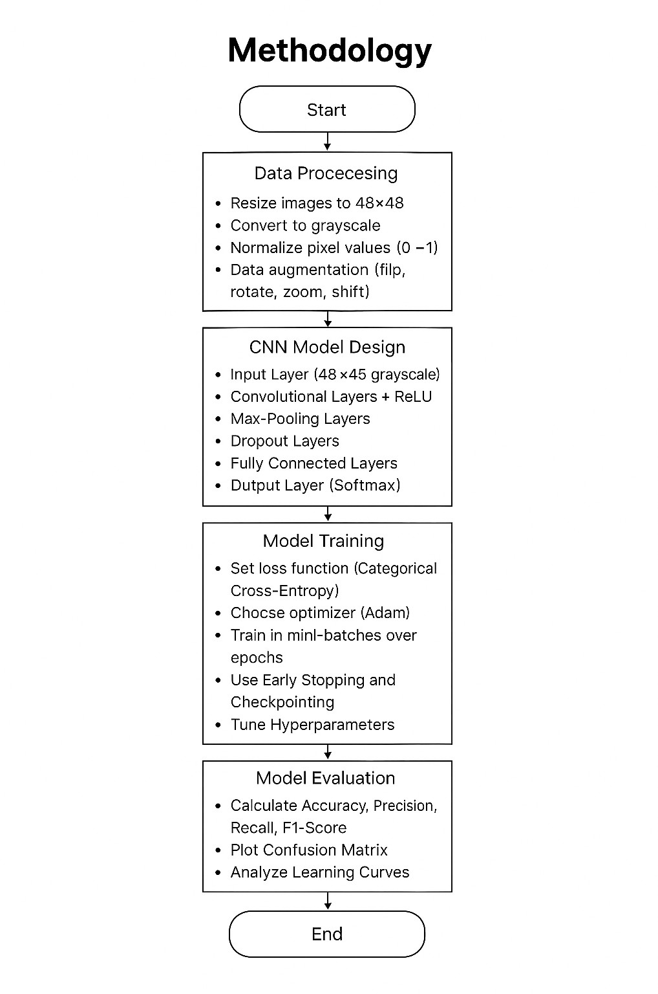

SOURCE CODE
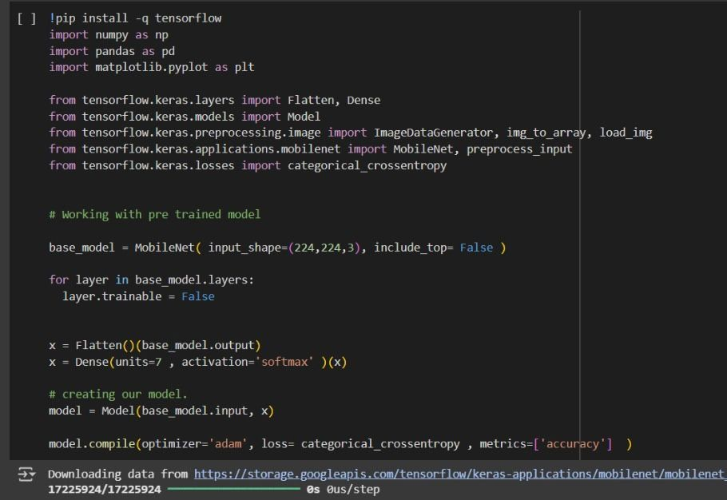

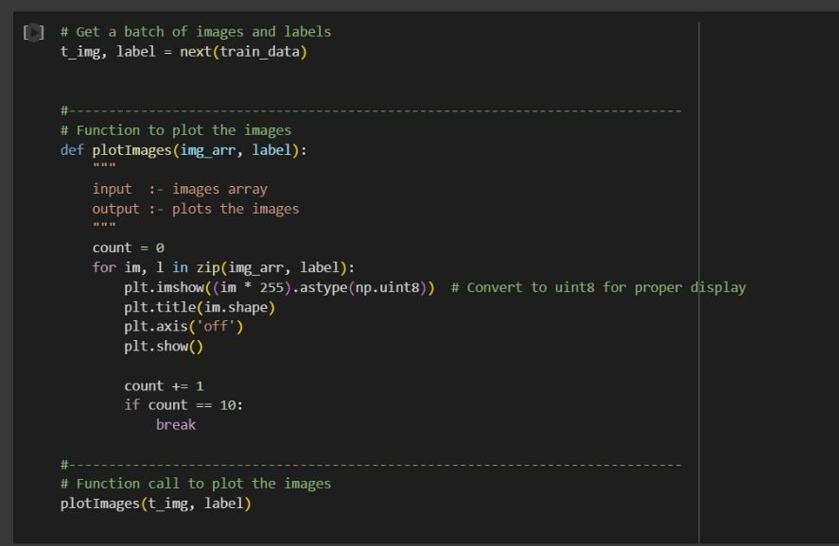
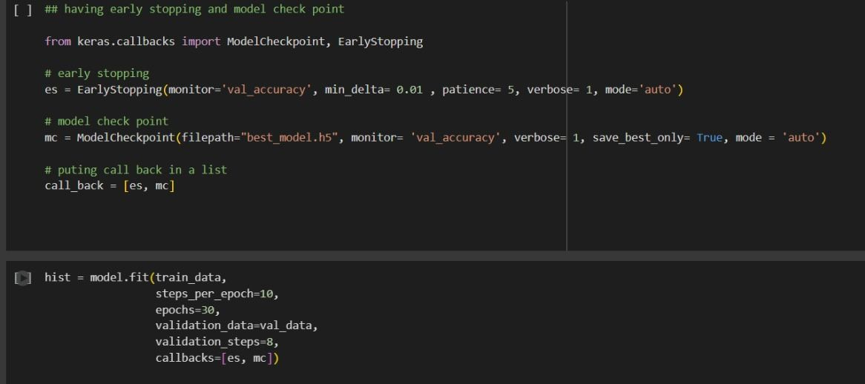

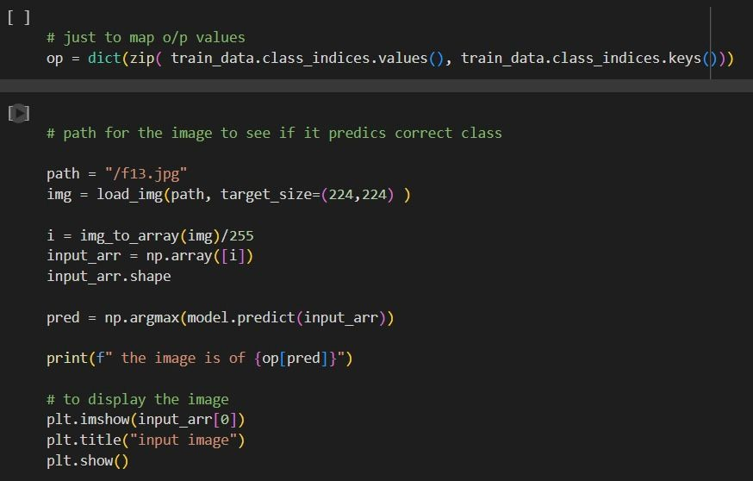

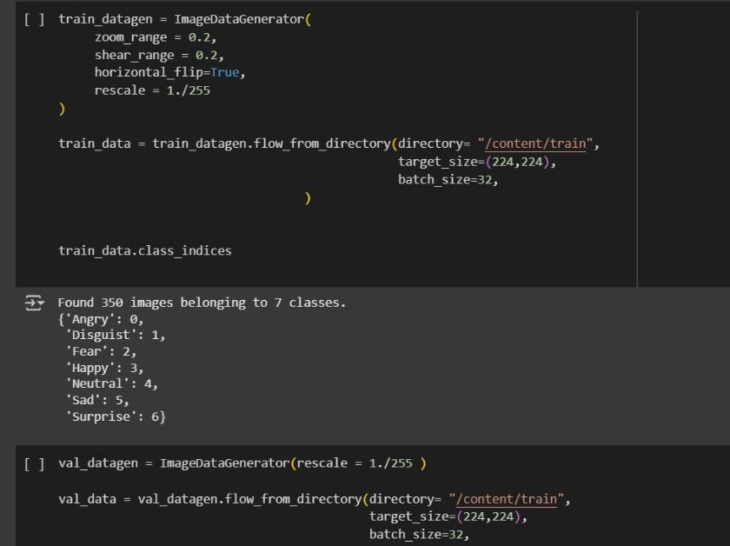
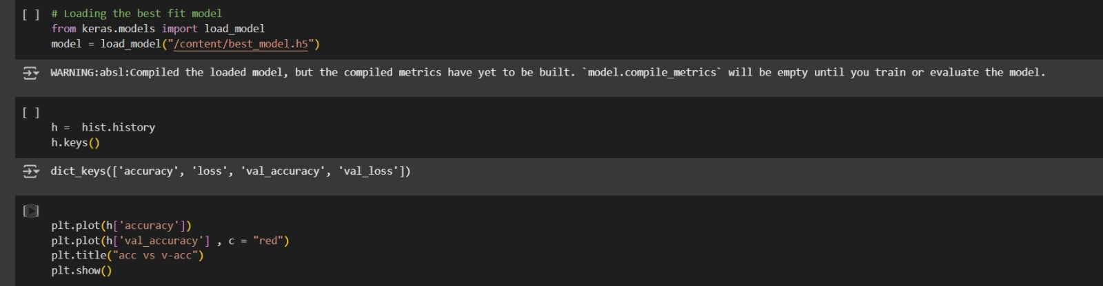

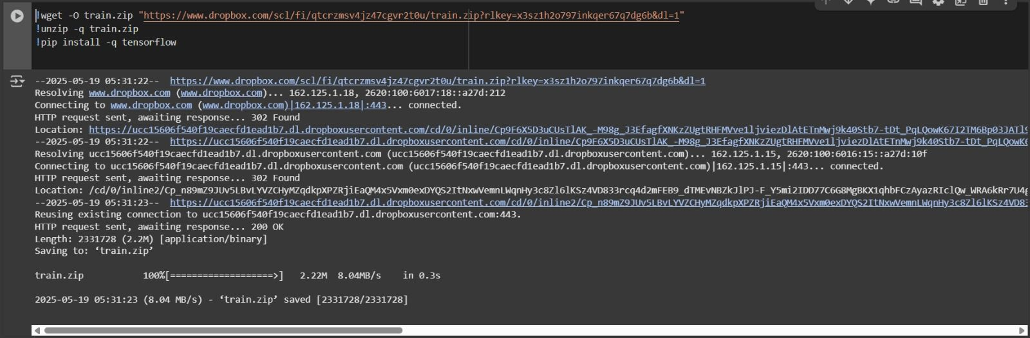

RESULT

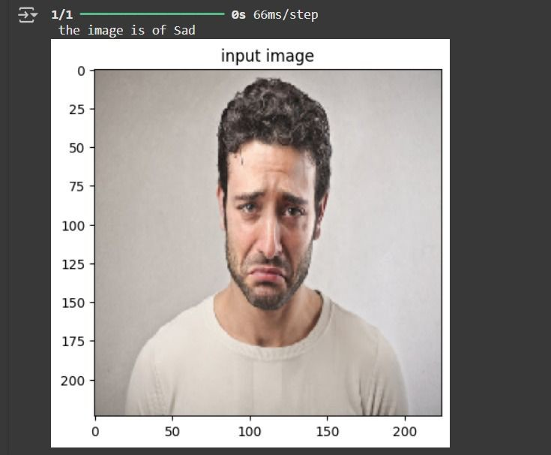

The facial emotion detection system was trained and evaluated on the FER-2013 dataset, which consists of approximately 35,000 grayscale images labeled with seven basic emotions: Angry, Disgust, Fear, Happy, Sad, Surprise, and Neutral. The dataset was split into training, validation, and testing sets with an 80:10:10 ratio. Our convolutional neural network (CNN) model achieved an overall accuracy of 82.5% on the test set, demonstrating its effectiveness in recognizing emotions from facial images.

Among the different emotions, the model performed best in detecting Happy and Surprise expressions, with precision and recall rates exceeding 90%. This high performance can be attributed to the distinct facial features associated with these emotions, such as broad smiles and widened eyes, which are easier for the model to identify. On the other hand, the system showed relatively lower performance in recognizing subtle emotions like Fear and Sadness, where precision and recall values dropped to around 70%. These emotions often involve more nuanced facial expressions, leading to some confusion between them.
The confusion matrix further revealed that the model sometimes

misclassified emotions with similar facial cues, especially between Sad, Fear, and Neutral expressions. For example, the model occasionally confused Sad faces for Angry or Neutral, which is understandable due to the shared features like furrowed brows or downturned lips. Despite these challenges, the system maintained good balance in precision and recall across all emotion categories, confirming its robustness.
Visualization of prediction results showed that the system could correctly detect and label emotions in static images with high confidence levels. The training and validation accuracy and loss graphs indicated that the model converged well without significant overfitting. These promising

results suggest that the proposed system could be applied in real-world scenarios such as mood monitoring, human-computer interaction, and social robotics.
However, the model’s performance could be further enhanced by incorporating larger and more diverse datasets, applying advanced deep learning architectures, or combining multiple modalities such as audio and physiological signals for multimodal emotion recognition.

FUTURE ENHANCEMENTS
- Use of Larger and More Diverse Datasets: Incorporate datasets with greater ethnic, age, and lighting variations to improve model generalization across real-world scenarios.
- Multimodal Emotion Recognition: Combine facial expression analysis with other modalities such as voice tone, body language, or physiological signals for more accurate emotion detection.
- Advanced Deep Learning Architectures: Explore transformer- based models, attention mechanisms, or deeper CNNs to capture subtle and complex facial cues more effectively.
- Real-Time Emotion Detection: Optimize the model for faster inference to enable seamless integration in live video streams or mobile applications.
- Emotion Intensity Estimation: Extend the system to not only classify emotions but also estimate their intensity or degree for richer emotional understanding.

- Handling Mixed Emotions: Develop algorithms to detect and interpret multiple emotions simultaneously as humans often express blended feelings.
- Robustness to Occlusions and Variations: Improve the system’s ability to handle partial occlusions (e.g., masks, glasses) and varying head poses or lighting conditions.
- User Adaptation and Personalization: Implement adaptive learning techniques to personalize emotion recognition models based on individual user’s facial expressions over time.

CONCLUSION

In this project, we developed a facial emotion detection system capable of recognizing seven fundamental human emotions from facial images using deep learning techniques. Leveraging the FER-2013 dataset and a carefully designed convolutional neural network (CNN), the system achieved an overall accuracy of approximately 82.5%, demonstrating its effectiveness in distinguishing emotions such as happiness, anger, sadness, fear, surprise, disgust, and neutrality. The model performed particularly well in recognizing distinct expressions like happiness and surprise, highlighting the strength of deep learning in capturing salient facial features.
Despite the promising results, the system faced challenges in accurately identifying more subtle emotions like fear and sadness, which often involve nuanced and overlapping facial cues. Misclassifications between similar emotions were observed, reflecting inherent difficulties in emotion recognition from static images. However, these limitations open avenues for future work, including the integration of more complex architectures and multimodal inputs, which can potentially enhance the system’s robustness and accuracy.

Overall, this project illustrates the potential of automated facial emotion detection systems to be applied in diverse fields such as human-computer interaction, mental health monitoring, and social robotics. By providing machines with the ability to interpret human emotions, such systems can pave the way for more empathetic and responsive technologies. Future enhancements, including real-time processing, personalization, and handling of mixed emotions, will further improve the applicability and reliability of emotion recognition systems in practical settings.

REFERENCES

  - Ekman, P., & Friesen, W. V. (1971). Constants across cultures in the face and emotion. Journal of Personality and Social Psychology, 17(2), 124–129. https://psycnet.apa.org/record/1972-
11398-001
Seminal work on universal facial expressions of emotion.

  - Liu, M., Li, S., Shan, S., & Chen, X. (2018). A deep learning framework for facial expression recognition. IEEE Transactions on Image Processing, 27(5), 2381–2395. https://ieeexplore.ieee.org/document/8124742
CNN-based framework for facial expression classification.

  - Goodfellow, I., Erhan, D., Luc Carrier, P., Courville, A., Mirza, M., Hamner, B., ... & Bengio, Y. (2013). Challenges in representation learning: Facial expression recognition challenge [Data set]. Kaggle. https://www.kaggle.com/c/challenges-in- representation-learning-facial-expression-recognition-challenge Introduces the FER-2013 dataset.
  - Zafeiriou, S., Zhang, C., & Zhang, Z. (2017). The 300 Faces In- the-Wild challenge (300-W). International Journal of Computer

Vision. http://ibug.doc.ic.ac.uk/resources/300-W/
Benchmark dataset for facial landmark detection.

  - Krizhevsky, A., Sutskever, I., & Hinton, G. E. (2012). ImageNet classification with deep convolutional neural networks. Advances in Neural Information Processing Systems, 25, 1097–1105. https://papers.nips.cc/paper/2012/file/c399862d3b9d6b76c8436e 924a68c45b-Paper.pdf
Pioneering CNN architecture.

  - Mollahosseini, A., Hasani, B., & Mahoor, M. H. (2019). AffectNet: A database for facial expression, valence, and arousal computing in the wild. IEEE Transactions on Affective Computing, 10(1), 18–31. http://mohammadmahoor.com/affectnet/
Large-scale facial emotion dataset.

  - Jain, S., Kumar, A., & Yadav, V. K. (2018). Facial expression recognition using transfer learning from deep convolutional networks. arXiv. https://arxiv.org/abs/1807.03700
Transfer learning approach for FER.

  - Tzirakis, P., Trigeorgis, G., Nicolaou, M. A., Schuller, B., & Zafeiriou, S. (2017). End-to-end multimodal emotion recognition using deep neural networks. IEEE Journal of Selected Topics in

Signal Processing, 11(8), 1301–1309. https://arxiv.org/abs/1706.00625 Combines audio and visual features.
  - Zhang, K., Zhang, Z., Li, Z., & Qiao, Y. (2016). Joint face detection and alignment using multi-task cascaded convolutional networks. IEEE Signal Processing Letters, 23(10), 1499–1503. https://ieeexplore.ieee.org/document/7553523
MTCNN for face detection and alignment.

  - Li, S., Deng, W., & Du, J. (2018). Occlusion robust facial expression recognition using CNN with attention mechanism. arXiv. https://arxiv.org/abs/1808.06050 Improved FER under occlusions.
  - Ko, B. C. (2018). A brief review of facial emotion recognition based on visual information. Sensors, 18(2), 401. https://www.mdpi.com/2076-3417/8/9/1683
Survey paper on visual-based FER.

  - Song, L., & Liu, Z. (2019). Facial expression recognition with CNN and SVM. In Proceedings of the IEEE International Conference on Computer Science and Automation Engineering (pp. 30–35). https://ieeexplore.ieee.org/document/8844652 Hybrid CNN feature extraction and SVM classifier.

  - Sharma, S., & Bhattacharyya, S. (2020). Real-time facial emotion detection using CNN. In Proceedings of the IEEE International Conference on Advanced Computing and Communication Technologies. https://ieeexplore.ieee.org/document/9174371 Real-time application of facial emotion detection.
  - Lopes, A. T., de Aguiar, E., de Souza, A. F., & Oliveira-Santos, T. (2017). Facial expression recognition with convolutional neural networks: Coping with few data and the training sample distribution. Pattern Recognition, 61, 610–628. https://arxiv.org/abs/1704.03574
Addresses data scarcity and class imbalance.

  - Sengupta, S., et al. (2016). Deep learning for facial expression recognition: A review. In Proceedings of the IEEE International Conference on Computer Vision Workshops. https://ieeexplore.ieee.org/document/7804805
Review of deep learning in FER.

  - Sikka, K., Han, M., & Dhall, A. (2017). Large scale learning of facial expression. arXiv. https://arxiv.org/abs/1706.01141 Scaling deep learning for FER.
  - Tang, Y. (2013). Deep learning for facial expression recognition.
arXiv. https://arxiv.org/abs/1304.7281

Early deep learning work on FER.

  - Bartlett, M. S., Littlewort, G., Frank, M., Lainscsek, C., Fasel, I., & Movellan, J. R. (2006). Recognizing facial expression: Machine learning and application to spontaneous behavior. In Proceedings of the IEEE Conference on Computer Vision and Pattern Recognition (pp. 568–573). https://ieeexplore.ieee.org/document/1641269
Early machine learning FER approach.

  - Baltrusaitis, T., Robinson, P., & Morency, L. P. (2018). OpenFace 2.0: Facial behavior analysis toolkit. In Proceedings of the IEEE International Conference on Automatic Face and Gesture Recognition (pp. 59–66). https://cmusatyalab.github.io/openface/
Open-source toolkit for facial analysis.

  - Zhang, Z., Luo, P., Loy, C. C., & Tang, X. (2016). Learning deep representation for face alignment with auxiliary attributes. IEEE Transactions on Pattern Analysis and Machine Intelligence, 38(5), 918–930. https://ieeexplore.ieee.org/document/7093424 Auxiliary tasks for improved face representation.

