CUSTOMER PERSONALITY ANALYSIS
Exploratory Data Analysis (EDA) Report
AI Lab 99 Machine Learning Internship Program 2026
Module Code: ML-M04 – Exploratory Data Analysis (EDA)
Submitted By: Fakhr Ul Islam
Program: Bachelor of Software Engineering (BSE)
University: COMSATS University Islamabad, Attock Campus

Table of Contents
1. Introduction ......................................................................................................................................... 3
2. Project Objectives .................................................................................................................................. 3
3. Dataset Description ............................................................................................................................... 3
4. Tools and Technologies ......................................................................................................................... 4
5. Exploratory Data Analysis Tasks .............................................................................................................. 4
• Task 1: Dataset Overview .................................................................................................................... 4
• Task 2: Customer Demographic Analysis .......................................................................................... 5
• Task 3: Customer Spending Analysis ................................................................................................ 6
• Task 4: Purchasing Behavior Analysis .............................................................................................. 7
• Task 5: Website Engagement Analysis .............................................................................................. 7
• Task 6: Customer Recency Analysis ................................................................................................. 8
• Task 7: Marketing Campaign Analysis ............................................................................................... 8
• Task 8: Customer Complaint Analysis ................................................................................................ 9
• Task 9: Correlation Analysis .............................................................................................................. 9
• Task 10: Customer Segmentation ..................................................................................................... 10
• Task 11: Business Insights & Marketing Recommendations ................................................................... 11
6. Visualization Summary & Conclusion .................................................................................................... 12

1. Introduction
Exploratory Data Analysis (EDA) is a critical process in data science that helps understand datasets through statistical analysis and visualization techniques.
This project focuses on analyzing the Customer Personality Analysis Dataset to understand customer demographics, purchasing behavior, marketing campaign effectiveness, website engagement, customer activity patterns, and business trends.
The purpose of this analysis is to identify customer segments, discover relationships between variables, detect patterns, and generate actionable business recommendations.
2. Project Objectives
The main objectives of this project are:
- Understand customer demographics.
- Analyze customer spending behavior.
- Identify purchasing patterns.
- Evaluate marketing campaign performance.
- Study website engagement.
- Analyze customer activity levels.
- Detect relationships between numerical variables.
- Segment customers based on behavior.
- Generate business insights.
3. Dataset Description
The dataset contains comprehensive details regarding customer profiles, purchase amounts across various product categories, channel interaction frequencies, and responses to marketing campaigns.
Dataset Overview Table
Description | Value
Dataset Name | Customer Personality Analysis Dataset
Total Rows | 2,240
Total Columns | 29
Numerical Features | 26
Categorical Features | 3

4. Tools and Technologies
- Programming Language: Python
- Data Processing Libraries: Pandas, NumPy
- Data Visualization Libraries: Matplotlib, Seaborn
- Development Environments: Jupyter Notebook, Google Colab, VS Code
5. Exploratory Data Analysis Tasks
The exploratory analysis was divided into 11 detailed analytical tasks:
Task 1: Dataset Overview
Objective: To understand dataset structure, data quality, missing values, and statistical properties.
- Dataset Dimensions: 2,240 rows and 29 columns.
- Duplicate Records: 0 duplicate rows were found.
Missing Value Analysis
Feature Name | Missing Values Count | Percentage
Income | 24 | 1.07%
All Remaining Columns (28) | 0 | 0.00%

Task 2: Customer Demographic Analysis
Objective: Analyze customer characteristics including age, income, education, marital status, and family composition.
Age & Income Summary
Metric | Age (Years) | Income ($)
Average / Mean | 57.19 | $52,247
Median | - | $51,381
Minimum | 30 | -
Maximum | 133 | $666,666

The majority of customers belong to middle-aged and older age groups. Income distribution shows some high-income customers and extreme outliers.
Education Level Breakdown
Education Level | Number of Customers
Graduation | 1127
PhD | 486
Master | 370
2n Cycle | 203
Basic | 54

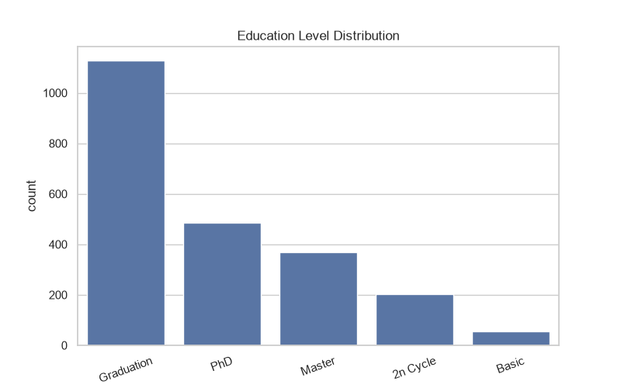
Figure: Education Level Bar Chart
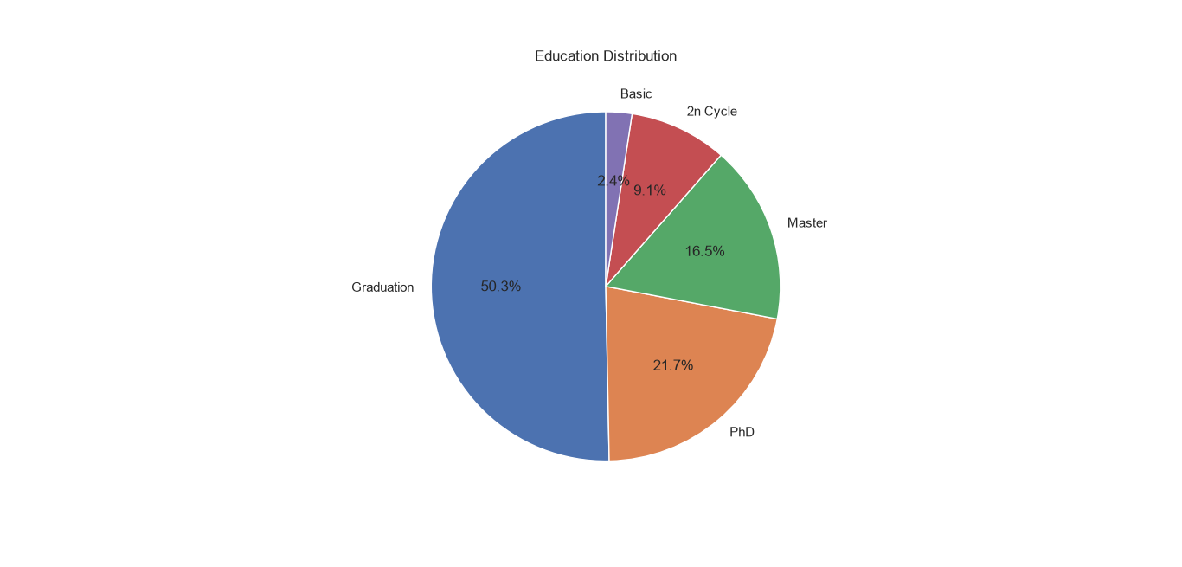
Figure: Education Level Distribution Pie Chart
Marital Status Breakdown
Marital Status | Number of Customers
Married | 864
Together | 580
Single | 480

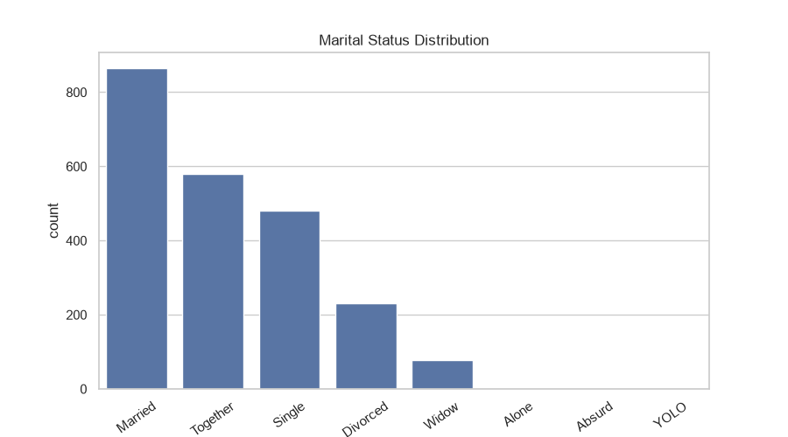
Figure: Marital Status Bar Chart
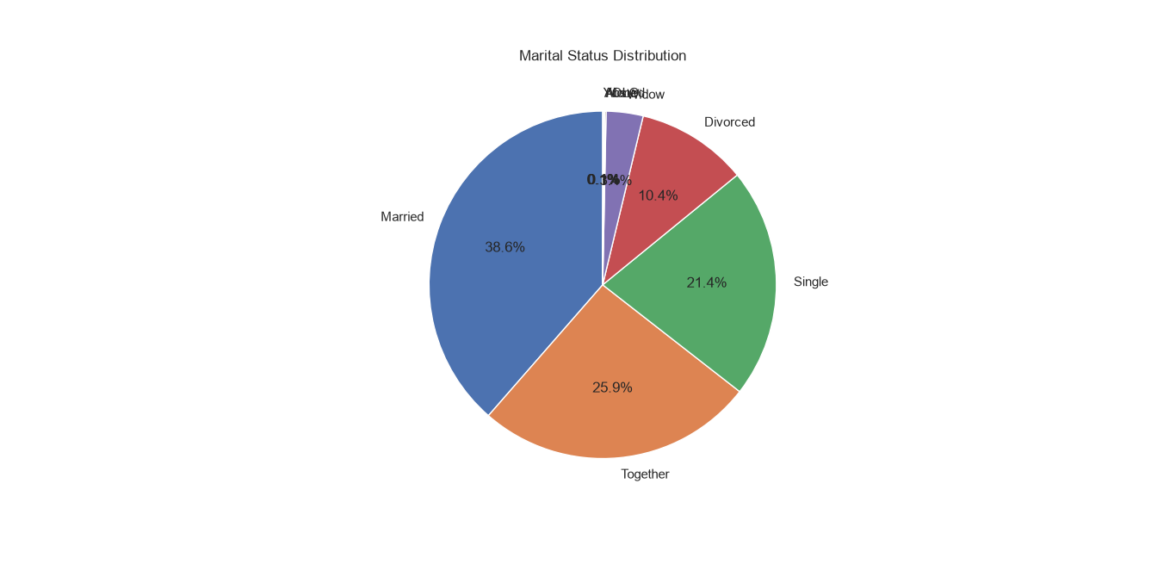
Figure: Marital Status Distribution Pie Chart
Household Composition
Children in Household | Customer Count
0 | 638
1 | 1128
2 | 421
3 | 53

On average, households contain 0.44 young children and 0.51 teenagers.
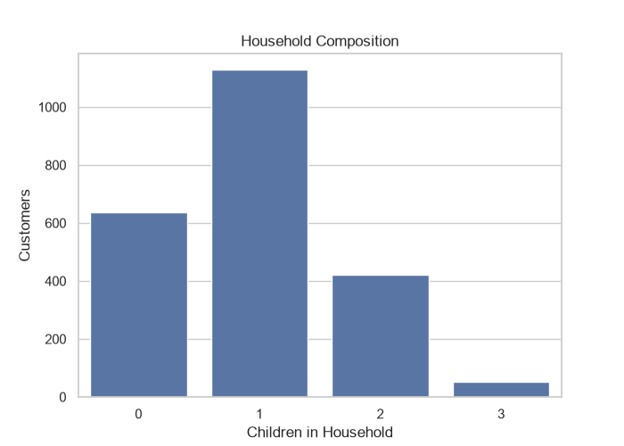
Figure: Household Composition Overview
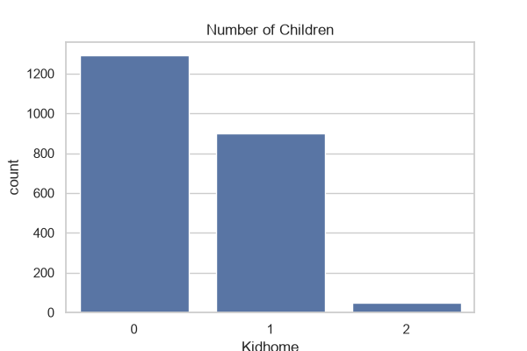
Figure: Number of Children (Kidhome)
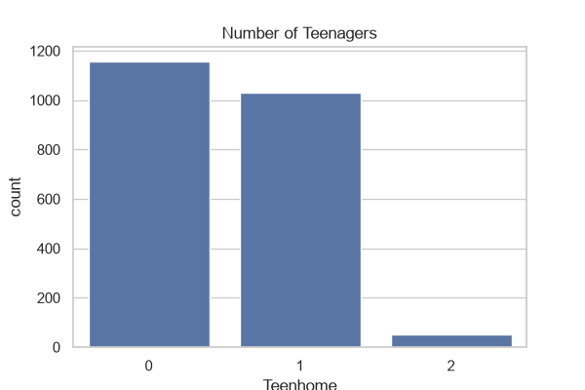
Figure: Number of Teenagers (Teenhome)
Task 3: Customer Spending Analysis
Objective: Analyze total customer spending and product category performance.
Total Spending Statistics
Metric | Value ($)
Average Spending | $605.80
Median Spending | $396.00
Maximum Spending | $2,525.00
Minimum Spending | $5.00

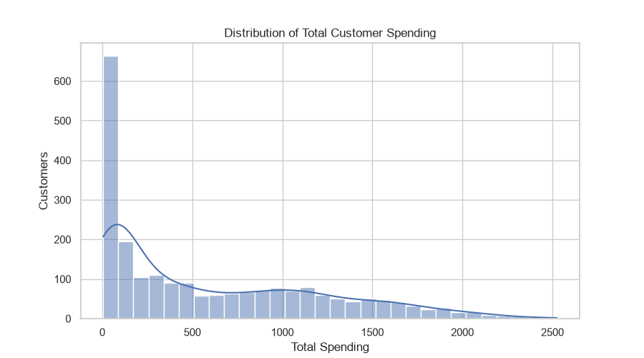
Figure: Distribution of Total Customer Spending
Product Category Revenue
Product Category | Total Revenue ($)
Wine Products | $680,816
Meat Products | $373,968
Gold Products | $98,609
Fish Products | $84,057
Sweet Products | $60,621
Fruits | $58,917

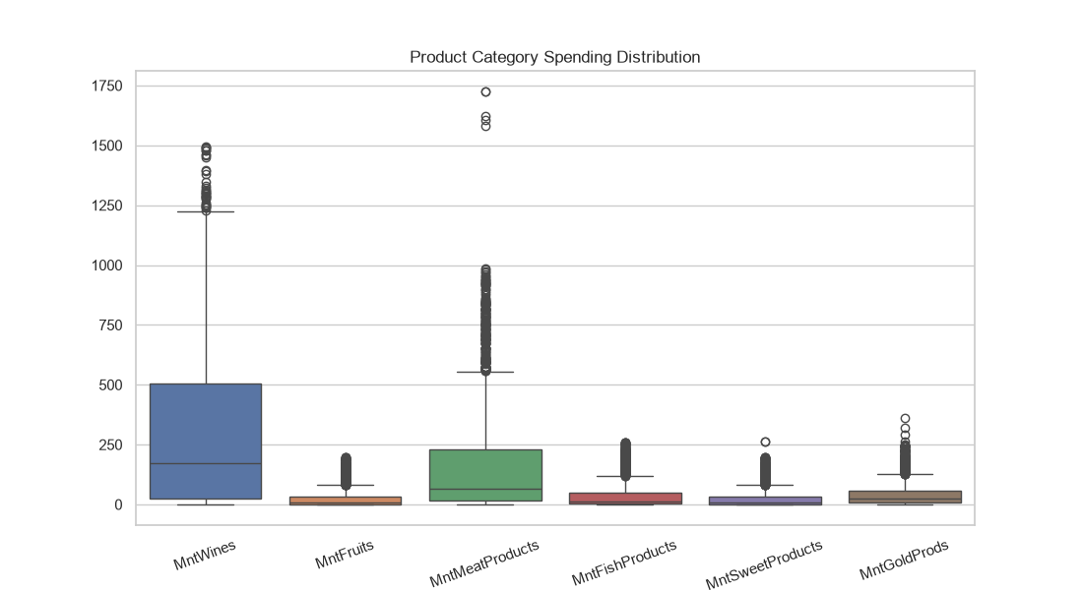
Figure: Product Category Spending Box Plots
📌 KEY FINDING: Wine products generate the highest revenue ($680,816), followed by Meat products ($373,968). Together they constitute the majority of store revenue.

Task 4: Purchasing Behavior Analysis
Objective: Analyze customer purchasing channels and purchase frequency.
- Average Purchases: 12.54 total purchases per customer.
- Maximum Purchases: 32 total purchases.
Purchase Channel Breakdown
Channel | Total Purchases Recorded
Store Purchases | 12,970
Web Purchases | 9,150
Catalog Purchases | 5,963

📌 KEY FINDING: The most popular purchasing channel is the physical Store Purchase Channel with 12,970 total transactions.

Task 5: Website Engagement Analysis
Objective: Analyze customer interaction with the company website.
- Average Monthly Web Visits: 5.32 visits
- Maximum Visits: 20 visits | Minimum Visits: 0 visits
Customer Engagement Levels
Engagement Level | Number of Customers
Medium Engagement | 839
Low Engagement | 830
High Engagement | 571

📌 KEY FINDING: 830 customers have low website engagement, indicating a significant need for UI/UX improvements and re-engagement strategies.

Task 6: Customer Recency Analysis
Objective: Analyze customer activity based on days since last purchase.
- Average Recency: 49.11 Days
- Minimum Recency: 0 Days | Maximum Recency: 99 Days
Customer Activity Breakdown
Activity Status | Customer Count
Active | 724
Moderately Active | 654
Inactive | 862

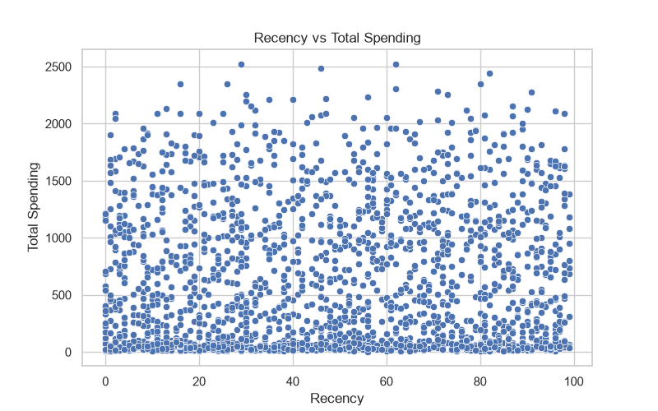
Figure: Recency vs Total Spending Scatter Plot
📌 BUSINESS INSIGHT: 862 customers are classified as inactive (high recency days). These customers require targeted re-engagement campaigns.

Task 7: Marketing Campaign Analysis
Objective: Evaluate the effectiveness and acceptance rate of marketing campaigns.
Campaign Performance Comparison
Campaign Name | Acceptance Rate (%)
Latest Campaign (Response) | 14.91%
Campaign 4 | 7.46%
Campaign 3 | 7.28%
Campaign 5 | 7.28%
Campaign 1 | 6.43%
Campaign 2 | 1.34%

📌 KEY FINDING: The Latest Campaign performed best by a wide margin, achieving a 14.91% acceptance rate, compared to 1.34% - 7.46% for previous campaigns.

Task 8: Customer Complaint Analysis
Objective: Analyze customer complaints and their relationship with spending and income levels.
- Overall Complaint Rate: 0.94% (Very low customer complaint rate).
Complaint vs Non-Complaint Profiles
Customer Type | Customer Count | Average Spending ($) | Average Income ($)
No Complaint | 2,219 | $607.97 | $52,314
Complaint | 21 | $376.43 | $45,242

Task 9: Correlation Analysis
Objective: Study statistical linear relationships between key numerical variables.
Strong Positive Correlations
Variable Pair | Correlation Coefficient
Wine Spending — Total Spending | 0.892
Meat Spending — Total Spending | 0.843
Catalog Purchases — Total Spending | 0.779
Meat Products — Catalog Purchases | 0.724

Strong Negative Correlations
Variable Pair | Correlation Coefficient
Kidhome — Total Spending | -0.557
Income — Website Visits | -0.553
Meat Products — Website Visits | -0.539

Independent Variables with weak correlations include: ID, Recency, AcceptedCmp2, AcceptedCmp3, and Complain.
Task 10: Customer Segmentation
Objective: Identify distinct customer groups based on spending patterns, frequency, and activity.
Customer Segments Breakdown
Segment Name | Customer Count
High Value Customers | 560
Low Value Customers | 1,680
Frequent Buyers | 660
Discount Seekers | 727
Campaign Responders | 463
Loyal Customers | 391
Inactive Customers | 862

High-Value Customer Profile
- Spending & Revenue: Spend significantly more money and purchase high-margin premium items.
- Purchase Channels: Purchase frequently via Catalog and Physical Store channels.
- Demographics: Have higher average household income and fewer young children at home.
- Campaign Responsiveness: Respond far better to promotional marketing campaigns.
Task 11: Business Insights & Marketing Recommendations
Key Business Questions & Answers
- 1. Which customers spend the most? High-value customers spend the most money across categories.
- 2. Highest Revenue Category: Wine products generate the highest total revenue ($680,816).
- 3. Income Influence on Spending: Income positively affects spending with a strong positive correlation of 0.668.
- 4. Most Popular Channel: Store purchases are the most popular (12,970 total transactions).
- 5. Best Performing Campaign: The Latest Campaign achieved the highest acceptance rate at 14.91%.
- 6. Profile of Campaign Responders: Mainly high-value customers, frequent buyers, and active customers.
- 7. Inactive Customer Pool: A total of 862 customers are currently inactive.
- 8. Top Website Visitors: Customer IDs with highest web visits: 6862, 4303, and 5899.
- 9. Impact of Children on Spending: Customers with more children generally spend significantly less (-0.557 correlation).
Actionable Marketing Recommendations
- High Value Customers: Develop exclusive VIP loyalty programs, premium tailored offers, and dedicated concierge rewards.
- Inactive Customers: Launch targeted re-engagement email series, personalized comeback discounts, and win-back offers.
- Discount Seekers: Offer promotional value bundles, volume discount campaigns, and seasonal sales events.
- Campaign Strategy: Adopt the design structure and messaging strategy of the Latest Campaign while leveraging personalized segmentation.
- Product Focus: Focus core marketing and inventory allocation on Wine and Meat products, as they drive the vast majority of overall business revenue.
6. Visualization Summary & Conclusion
The exploratory analysis was supported by a diverse set of data visualizations, including:
- ✅ Histograms & Density Plots: Analyzed continuous distributions for spending and income.
- ✅ Box Plots: Identified spending ranges and visual outliers across product categories.
- ✅ Count Plots & Bar Charts: Compared education, marital status, children count, and channel counts.
- ✅ Pie Charts: Visualized percentage compositions for education and marital status.
- ✅ Scatter Plots: Evaluated relationships like Recency vs Total Spending.
- ✅ Correlation Heatmaps & Pair Plots: Uncovered multi-variable numeric relationships.
Conclusion
This Exploratory Data Analysis provided a comprehensive understanding of customer behavior, purchasing patterns, marketing response, and business opportunities.
The analysis successfully identified high-value customers, inactive customers, profitable product categories, successful campaigns, and important relationships between demographic variables and spending.
The generated insights provide a solid foundation to help the business improve customer retention, optimize marketing campaigns, and maximize revenue through data-driven strategies.

