Module 7: Cluster Evaluation & Customer Profiling
Dataset: Customer Personality Analysis | Final Customer Profiling Report

1. Executive Summary
K-means clustering on the customer base produced two distinct, well-separated segments (Cluster 0 and Cluster 1). Both segments are store-purchase dominant, but Cluster 1 is meaningfully higher-value: higher income, higher total spend across every product category, more purchases through every channel, and a stronger response rate to marketing campaigns. This report profiles each cluster on demographics, spending, channel behavior and campaign engagement, assigns each a business-oriented name, and recommends a differentiated marketing strategy.

2. Cluster Size
Cluster | Customers | Share
0 | 1,234 | 55.1%
1 | 1,003 | 44.9%
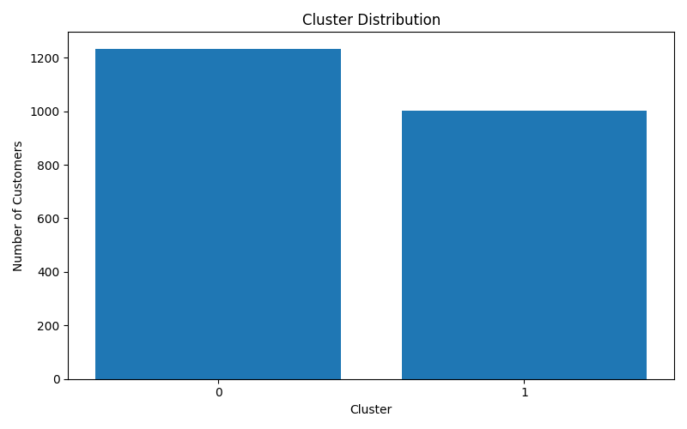

3. Demographic Profile
Cluster | Avg Age | Avg Income | Avg Family Size | Avg Children
0 | 57.6 | $50,204.81 | 3.02 | 1.02
1 | 56.5 | $53,884.83 | 2.87 | 0.87
Cluster 1 skews slightly higher-income with a slightly smaller household, meaning more disposable income per family member — consistent with its higher spending seen below.
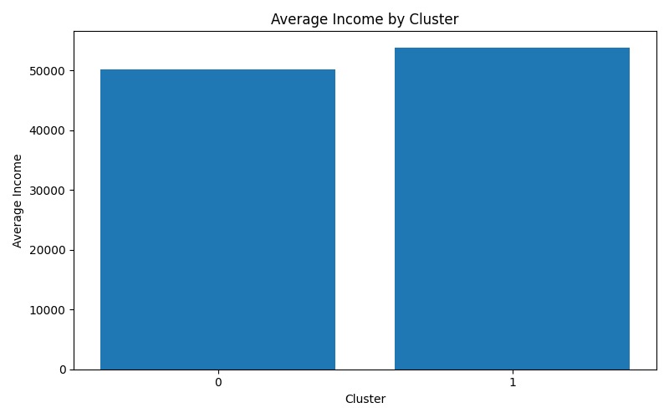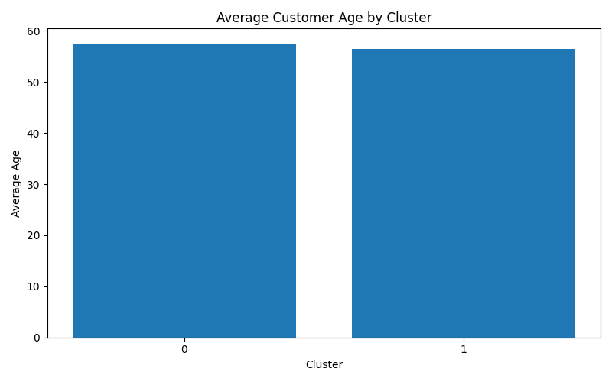

4. Spending Behavior
Cluster | Wine | Fruit | Meat | Fish | Sweets | Gold
0 | 278.82 | 20.15 | 134.60 | 29.81 | 19.80 | 37.28
1 | 330.86 | 23.54 | 170.78 | 34.94 | 24.56 | 42.17
Cluster 1 outspends Cluster 0 on every single product category, most sharply on Meat (+27%) and Wine (+19%). Cluster 1 is the higher-spending / premium-leaning segment; Cluster 0 is the more budget-conscious segment.
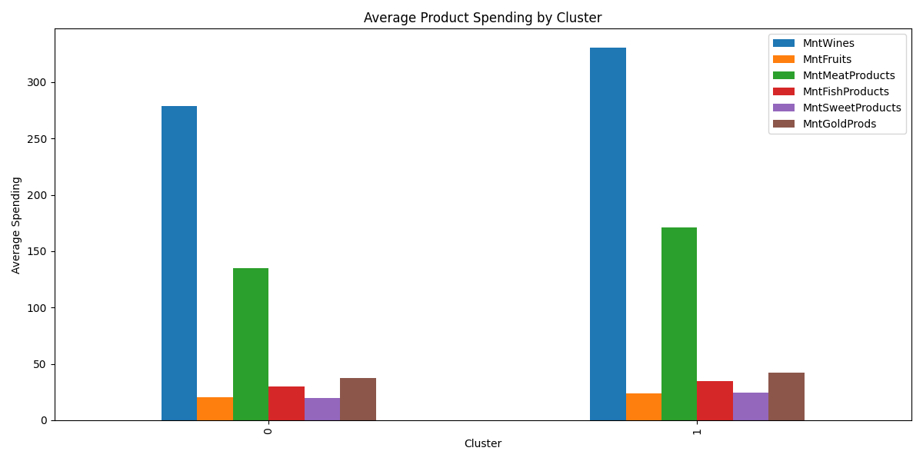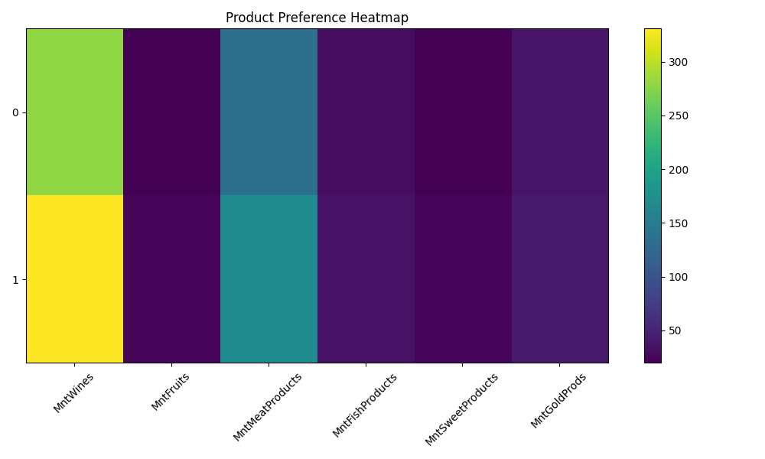

5. Shopping Channel & Engagement
Cluster | Web | Catalog | Store | Deals | Visits/mo | Recency
0 | 3.95 | 2.45 | 5.63 | 2.35 | 5.42 | 49.94
1 | 4.26 | 2.92 | 6.00 | 2.29 | 5.20 | 48.08
Both clusters are Store-Oriented (store purchases are the top channel for each), but Cluster 1 buys more through every channel and returns slightly more recently (48 vs 50 days), indicating a more actively engaged customer base.
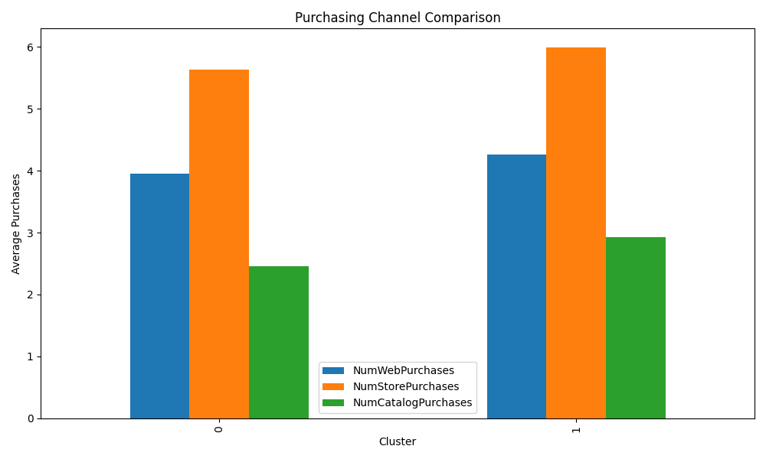

6. Marketing Campaign Response
Cluster | Campaign Score | Final Response Rate | Complaint Rate
0 | 0.417 | 14.2% | 0.9%
1 | 0.485 | 15.9% | 0.9%
Cluster 1 is the campaign-responsive segment (higher acceptance across campaigns and higher final response rate). Cluster 0 is comparatively marketing-resistant and is the priority group for re-engagement offers. Complaint rates are low and essentially identical between segments, so satisfaction is not a differentiator.
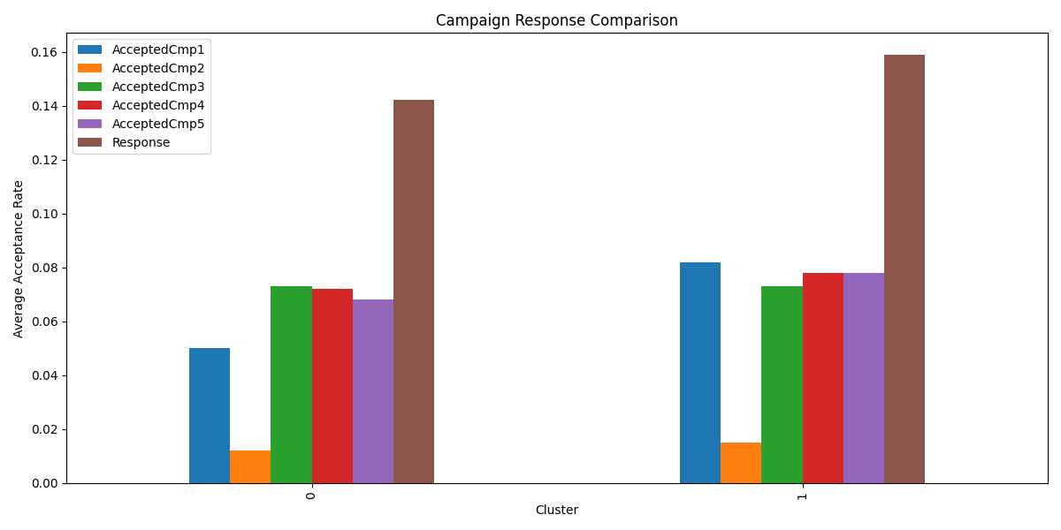

7. Business Segment Names & Strategy
Cluster | Business Segment | Recommended Strategy
0 | Store-Oriented Traditional Customers | Maintain in-store engagement with periodic loyalty incentives; use targeted re-engagement offers to lift the lower campaign response rate.
1 | High-Value Store-Oriented Customers | Increase in-store promotions, loyalty rewards and cross-sell at checkout; this segment already responds best to campaigns, so prioritize premium/upsell offers here.

8. Customer Personas
Attribute | Cluster 0 | Cluster 1
Persona Name | Traditional Store Shopper | Premium Store Shopper
Age Group | Senior Adults | Senior Adults
Income Level | Medium (~$50K) | Medium-High (~$54K)
Family Status | Medium Family (3.0 avg size) | Medium Family (2.9 avg size)
Preferred Channel | Store | Store
Marketing Responsiveness | Lower (14.2% response) | Higher (15.9% response)
Estimated CLV | Medium (~$520 total spend) | Medium-High (~$627 total spend)
Key Challenge | Increase purchase frequency | Sustain engagement, grow basket size
Recommended Strategy | In-store loyalty incentives + re-engagement | In-store promotions, loyalty rewards, cross-sell

9. Conclusion
The two clusters represent a value gradient rather than fundamentally different shopping styles: both are store-first, but Cluster 1 is a higher-value, higher-responsiveness segment worth premium/loyalty investment, while Cluster 0 is a larger but lower-spend, lower-response segment that needs re-engagement and incentive-driven campaigns to lift frequency and response rate.
All supporting tables are provided in MASTER_Module7_Report.xlsx (one sheet per analysis) and all charts are provided in the figures package.

