**FAMER’S FRIEND**

BACKBONE OF AGRICULTURALISTS

**Functional specification document**

BY

**FALCONERS**

Arunmozhi

Sridevi

Veni

Dharanidharan

FARMER’S FRIEND

**Purpose of the Project:**

It is an open discussion portal used for farmers and agricultural students. Any general public can use this system for knowing the information about various crops, and the usage of fertilizers to those crops and in which soil these crops give more yield and the climatic conditions for those crops.

Training is requested by the students, general public. These trainings are scheduled by agricultural officer. Information about major crop markets and their current price for the crop will be published daily. Current prices of the markets are updated daily by the NGO.

**Problems in existing system:**

* Complexity in managing the data related to the agriculture products, soils, fertilizers, mandi/market details.
* Lack of security.
* Category wise classifications of products are not available
* Inefficiency in querying details.
* Periodic Report generation takes lot of time.

**Proposed system:**

The development of this new system contains the following activities, which try to automate the entire process keeping in the view of database integration approach.

* Reduce complexity in managing the data related to the agriculture products, soils, fertilizers, mandi/market details.
* Current system provides different access levels for security.
* Rich user interface is provided in order to interact with application.
* Reports are generated dynamically on a periodic basis.
* Efficiency in querying details.
* User Queries and Answers are maintained.

**Requirement Analysis**

* **Scope:**
  + - Providing accessibility to all users who have a valid userID and password.
    - Generating monthly and daily reports of the market
    - User can post query. They can see answers only after they have logged in.
    - Communication is provided for the user through mails.
* **Users of the system:**
  + - Farmers and agricultural students
    - General public
    - Administrator
    - Agricultural officers

**Specific Requirements**

**Functional and Non- Functional Requirements:**

* **Functional Requirements:**
  + - Individual profile management for all kind of users
    - Basic soil analysis for all regions and suggestions on which fertilizers to use where & how much Which crop, herb or vegetable can be grown where and in which season
    - Online query handlings for all users. Queries can be general or directed to a particular officer.
    - Officers/NGOs can schedule trainings and publish it online. General public, farmers and agriculture students can request training online.
    - Information about major crop markets (mandi) and their current price for crop should be published daily.
* **Non-functional Requirements:**
  + - Secure access of confidential data (user’s details).
    - 24 X 7 availability
    - Better component design to get better performance at peak time
    - Flexible service based architecture will be highly desirable for future extension
* **User Interface Requirements:**
  + - Professional look and feel
    - Browser testing and support for IE.
    - Reports exportable in .XLS or any other desirable format.

**System Requirements**

**Technologies Used:**

* Java script
* J2EE
* Servlets
* JSP
* HTML

**Tools used:**

* Oracle 11G
* Tomcat 8.0
* Visual-Paradigm
* DBDiagram.io

**System Architecture:**

database

Web client

Http servlet request

Http servlet response

Web components

Java bean components

1

2

3

4

5

6

System Architecture

**ADMINSTRATOR:**

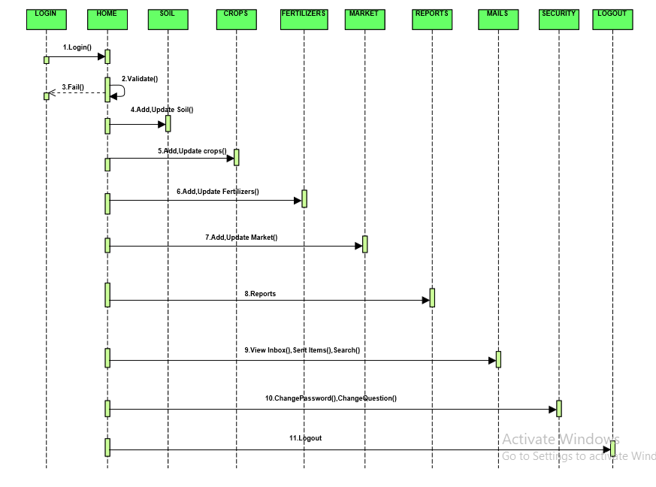

**USER:**

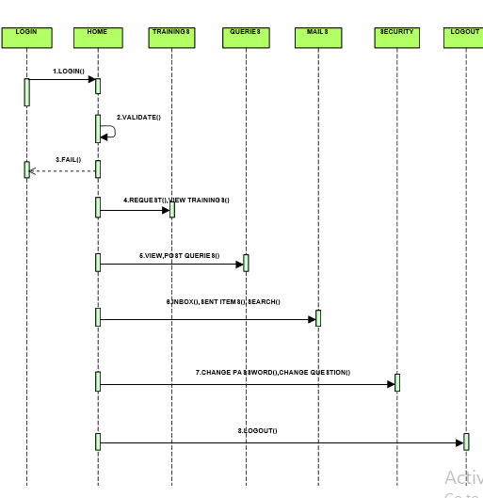

**AGRICULTURAL OFFICER:**

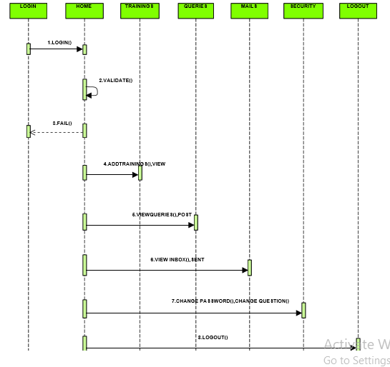

**SCHEMA DIAGRAM:**

