# Comp151 Lab01

Consider an abstract class Money with two subclasses:

* class Coin that represents a coin and
* class Bill that represents a paper bill.

A **paper bill** can have 7 denominations: 1, 2, 5, 10, 20, 50, and 100 dollars with names: WASHINGTON, JEFFERSON, LINCOLN, HAMILTON, JACKSON, GRANT, and FRANKLIN respectively.

A **coin** can have 5 denominations: 1, 5, 10, 25, and 50 cents with names: PENNY, NICKEL, DIME, QUARTER, and HALF_DOLLAR respectively. Denominations and denomination names are stored in respective arrays.

Each coin and bill can either be placed HEADS or TAILS up.

Money constructor generates the denomination randomly and sets the value of heads to false.

The method getValue returns the value of a coin (for example 0.25 for a quarter) or the value of paper bill respectively.

The method toss simulates a money toss in which the coin/paper bill lands either heads up or tails up.

The method isHeads returns true if a coin is heads up.

The class has only one constructor, the secondary constructor, which sets the value of heads to false; the denomination is randomly generated based on the numberOfDenominations passed to it.

Now, you need to have a piggy bank to hold your monies with predefined capacity. The piggy bank holds the monies but gives them no other organization. And it can certainly contain duplicates. The piggy bank is an ADT that has only the following operations:

* check the capacity of the piggy bank,
* you can add money to the piggy bank one at a time, adding fails if there is no more room in the piggy bank (PiggyBankFullException will be thrown that must be handled by the client)
* remove one (you shake the piggy bank, so you have no control over what coin or paper bill falls out),
* see whether the piggy bank is empty,
* see how many coins/paper bills are in the bank,
* see the content of the piggy bank,
* empty the piggy bank and counting how many coins/paper bills landed HEADS

This functionality should be implemented in a class PiggyBank where the piggy bank is represented as an ResizableArrayBag of Money objects.

### Client called CountHeadsGame implements a game where the user and the computer take turn to create the piggy bank with the same capacity and the same initial number of monies (since the monies are randomly generated the denominations will be different for each player) . Each player empties the piggy bank. The player with the larger number of monies landing HEADS wins. The tie is also possible. See the “Sample Runs” below.

### Your Task:

1. Implement the classes as designed in the UML diagram provided below. Use javadoc-style comments to describe the purpose of each method, its parameters and return values.
2. Write a client called CountHeadsGame that only contains main which implements the following by **calling appropriate** methods:
   1. Asks the user to input the number of coins/bills that can fit in the piggy bank
   2. Asks the user to input the number of coins/bills to be added to the piggy bank (this number cannot be greater than the capacity)
   3. Using a loop:
      1. Creates a piggy bank for appropriate player
      2. Prints the content of the piggy bank
      3. Adds one coin
      4. Adds one bill
      5. Empties the piggy bank – counts how many coins/bills landed HEADS and displays the count and the dollar value
   4. Outside of the loop proclaims the winner
3. Make sure that the output is properly formatted as shown in the “Sample Runs” below.

### UML Diagram:

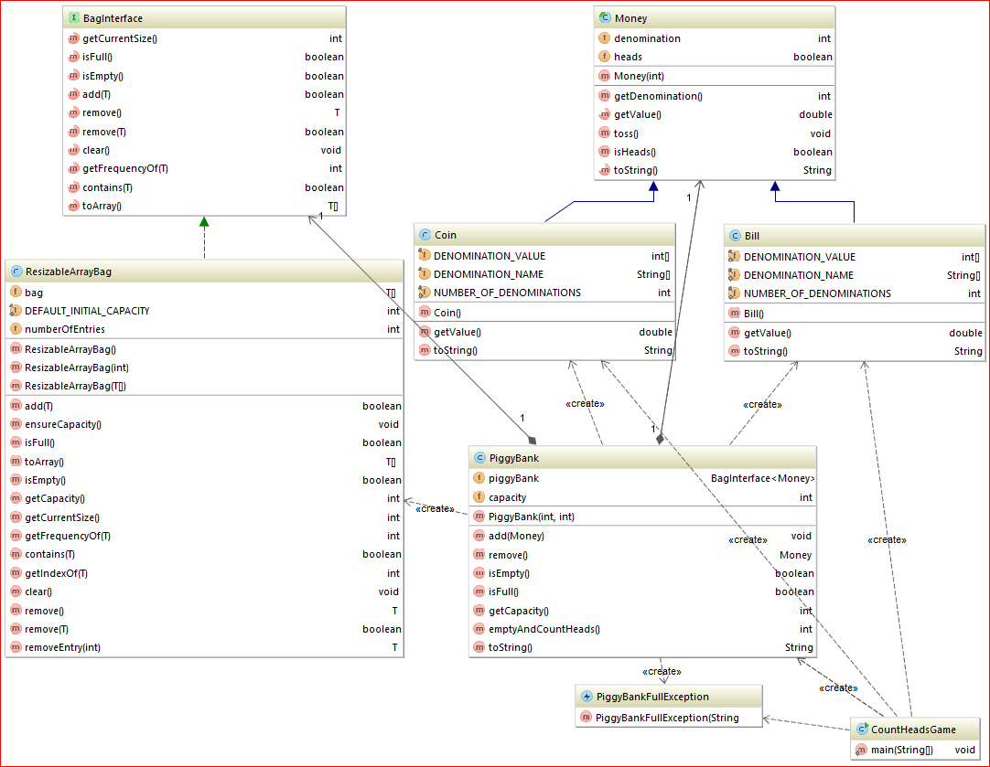

### Sample Runs:

#### Run#1:

How many coins/bills can fit in this piggy bank?

10

How many coins/bills should be put in the piggy bank?

60

How many coins/bills can fit in this piggy bank?

10

How many coins/bills should be put in the piggy bank?

6

******* USER'S TURN *******

Added $0.05 to your piggy bank

Added $0.01 to your piggy bank

Added $5.00 to your piggy bank

Added $5.00 to your piggy bank

Added $0.50 to your piggy bank

Added $0.10 to your piggy bank

There are 6 coins/bills in your piggy bank:[NICKEL landed TAILS, PENNY landed TAILS, LINCOLN landed TAILS, LINCOLN landed TAILS, HALF_DOLLAR landed TAILS, DIME landed TAILS]

The total of $10.66

--> Adding additional monies:

Added $0.50 to your piggy bank

Added $50.00 to your piggy bank

--> Emptying the piggy bank:

GRANT landed TAILS

HALF_DOLLAR landed TAILS

DIME landed HEADS

HALF_DOLLAR landed HEADS

LINCOLN landed TAILS

LINCOLN landed TAILS

PENNY landed HEADS

NICKEL landed TAILS

3 out of 8 coins/bills landed "HEADS"

The total value of "HEADS" is: $0.61

******* COMPUTER'S TURN *******

Added $100.00 to your piggy bank

Added $0.10 to your piggy bank

Added $20.00 to your piggy bank

Added $100.00 to your piggy bank

Added $100.00 to your piggy bank

Added $1.00 to your piggy bank

There are 6 coins/bills in your piggy bank:[FRANKLIN landed TAILS, DIME landed TAILS, JACKSON landed TAILS, FRANKLIN landed TAILS, FRANKLIN landed TAILS, WASHINGTON landed TAILS]

The total of $321.10

--> Adding additional monies:

Added $0.01 to your piggy bank

Added $2.00 to your piggy bank

--> Emptying the piggy bank:

JEFFERSON landed TAILS

PENNY landed HEADS

WASHINGTON landed TAILS

FRANKLIN landed TAILS

FRANKLIN landed TAILS

JACKSON landed TAILS

DIME landed TAILS

FRANKLIN landed TAILS

1 out of 8 coins/bills landed "HEADS"

The total value of "HEADS" is: $0.01

***GAME OVER***

User wins!!!

Process finished with exit code 0

#### Run#2:

How many coins/bills can fit in this piggy bank?

10

How many coins/bills should be put in the piggy bank?

9

******* USER'S TURN *******

Added $0.50 to your piggy bank

Added $20.00 to your piggy bank

Added $2.00 to your piggy bank

Added $0.10 to your piggy bank

Added $10.00 to your piggy bank

Added $2.00 to your piggy bank

Added $0.50 to your piggy bank

Added $5.00 to your piggy bank

Added $100.00 to your piggy bank

There are 9 coins/bills in your piggy bank:[HALF_DOLLAR landed TAILS, JACKSON landed TAILS, JEFFERSON landed TAILS, DIME landed TAILS, HAMILTON landed TAILS, JEFFERSON landed TAILS, HALF_DOLLAR landed TAILS, LINCOLN landed TAILS, FRANKLIN landed TAILS]

The total of $140.10

--> Adding additional monies:

Added $0.25 to your piggy bank

No more room in the piggy bank! - additional monies will not be saved in the piggy bank.

--> Emptying the piggy bank:

QUARTER landed HEADS

FRANKLIN landed TAILS

LINCOLN landed TAILS

HALF_DOLLAR landed HEADS

JEFFERSON landed HEADS

HAMILTON landed TAILS

DIME landed HEADS

JEFFERSON landed TAILS

JACKSON landed TAILS

HALF_DOLLAR landed TAILS

4 out of 10 coins/bills landed "HEADS"

The total value of "HEADS" is: $2.85

******* COMPUTER'S TURN *******

Added $10.00 to your piggy bank

Added $0.25 to your piggy bank

Added $2.00 to your piggy bank

Added $0.05 to your piggy bank

Added $2.00 to your piggy bank

Added $0.05 to your piggy bank

Added $0.05 to your piggy bank

Added $50.00 to your piggy bank

Added $0.10 to your piggy bank

There are 9 coins/bills in your piggy bank:[HAMILTON landed TAILS, QUARTER landed TAILS, JEFFERSON landed TAILS, NICKEL landed TAILS, JEFFERSON landed TAILS, NICKEL landed TAILS, NICKEL landed TAILS, GRANT landed TAILS, DIME landed TAILS]

The total of $64.50

--> Adding additional monies:

Added $0.01 to your piggy bank

No more room in the piggy bank! - additional monies will not be saved in the piggy bank.

--> Emptying the piggy bank:

PENNY landed HEADS

DIME landed HEADS

GRANT landed TAILS

NICKEL landed HEADS

NICKEL landed TAILS

JEFFERSON landed TAILS

NICKEL landed HEADS

JEFFERSON landed HEADS

QUARTER landed HEADS

HAMILTON landed TAILS

6 out of 10 coins/bills landed "HEADS"

The total value of "HEADS" is: $2.46

***GAME OVER***

Computer wins!!!

Process finished with exit code 0

#### Run#3:

How many coins/bills can fit in this piggy bank?

10

How many coins/bills should be put in the piggy bank?

8

******* USER'S TURN *******

Added $5.00 to your piggy bank

Added $20.00 to your piggy bank

Added $0.50 to your piggy bank

Added $50.00 to your piggy bank

Added $5.00 to your piggy bank

Added $0.25 to your piggy bank

Added $20.00 to your piggy bank

Added $100.00 to your piggy bank

There are 8 coins/bills in your piggy bank:[LINCOLN landed TAILS, JACKSON landed TAILS, HALF_DOLLAR landed TAILS, GRANT landed TAILS, LINCOLN landed TAILS, QUARTER landed TAILS, JACKSON landed TAILS, FRANKLIN landed TAILS]

The total of $200.75

--> Adding additional monies:

Added $0.50 to your piggy bank

Added $20.00 to your piggy bank

--> Emptying the piggy bank:

JACKSON landed HEADS

HALF_DOLLAR landed TAILS

FRANKLIN landed HEADS

JACKSON landed TAILS

QUARTER landed TAILS

LINCOLN landed TAILS

GRANT landed HEADS

HALF_DOLLAR landed TAILS

JACKSON landed HEADS

LINCOLN landed HEADS

5 out of 10 coins/bills landed "HEADS"

The total value of "HEADS" is: $195.00

******* COMPUTER'S TURN *******

Added $5.00 to your piggy bank

Added $1.00 to your piggy bank

Added $0.05 to your piggy bank

Added $0.25 to your piggy bank

Added $1.00 to your piggy bank

Added $0.10 to your piggy bank

Added $0.50 to your piggy bank

Added $0.25 to your piggy bank

There are 8 coins/bills in your piggy bank:[LINCOLN landed TAILS, WASHINGTON landed TAILS, NICKEL landed TAILS, QUARTER landed TAILS, WASHINGTON landed TAILS, DIME landed TAILS, HALF_DOLLAR landed TAILS, QUARTER landed TAILS]

The total of $8.15

--> Adding additional monies:

Added $0.01 to your piggy bank

Added $50.00 to your piggy bank

--> Emptying the piggy bank:

GRANT landed TAILS

PENNY landed TAILS

QUARTER landed TAILS

HALF_DOLLAR landed TAILS

DIME landed HEADS

WASHINGTON landed HEADS

QUARTER landed HEADS

NICKEL landed TAILS

WASHINGTON landed HEADS

LINCOLN landed HEADS

5 out of 10 coins/bills landed "HEADS"

The total value of "HEADS" is: $7.35

***GAME OVER***

Its a tie!!!

Process finished with exit code 0