# Comp151 Lab02

Consider a bag as a way to organize data. A grocery bag, for example, contains items in no particular order. Some of them might be duplicate items. The ADT bag, like a grocery bag, is perhaps the simplest of data organizations. It holds objects but does not arrange or organize them further.

The attached BagIterface.java contains java interface that defines all the operations that can be performed on ADT bag. Please note that the interface has been expanded from its definition in Chapter 1; javadoc comments describe operation’s purpose, parameters and return values.

In addition to these basic operations, the following are included:

* **union** - combines the contents of two bags into a third bag (see Exercise 5 in Chapter 1)
* **intersection** - creates a third bag of only those items that occur in both two bags (see Exercise 6 in Chapter 1)
* **difference** - creates a third bag of the items that would be left in the given bag after removing those that also occur in another bag (see Exercise 7 in Chapter 1)
* **getAllLessThan** - creates a bag of all the items that are smaller than the given item
* **removeMax** – removes and returns the largest element from the bag
* **isSubset** - returns true if all the elements of the given bag are also included in the other bag
* **equals** - returns true if the contents of two bags are the same. Note that two equal bags contain the same number of entries, each entry occurs in each bag in the same position in the “collection of objects”
* **display** - outputs the content of the bag

### Your Task:

1. Implement the ADT bag as the class ResizableArrayBag. The class ResizableArrayBag should implement the interface BagInterface. Represent the bag as an array that you can expand dynamically as necessary.
2. Analyze provided interface including javadoc comments that describe the purpose of each method, its parameters and return values. UML diagram is also provided for your reference.
3. Analyze the implementation of the methods provided in the ResizableArrayBag class. Note that the main is also provided for you.
4. Implement the remaining methods that are “stubs” at this moment:
   1. public void display();
   2. public boolean equals(BagInterface <T> other);
   3. public void removeEvery(T anEntry);
   4. public T replace(T replacement);
   5. public BagInterface <T> union(BagInterface <T> other);
   6. public BagInterface <T> intersection(BagInterface <T> other);
   7. public BagInterface <T> difference(BagInterface <T> other);
   8. public boolean isSubset(BagInterface <T> other);
   9. public BagInterface <T> getAllLessThan(T anEntry);
   10. public T removeMax();
5. Make sure that the output is correct (see Sample Run below).

NOTE: Efficiency of your algorithms will also be graded. Even though your method produces correct results it is possible that some points may be deducted if the code is not efficient.

### UML Diagram:

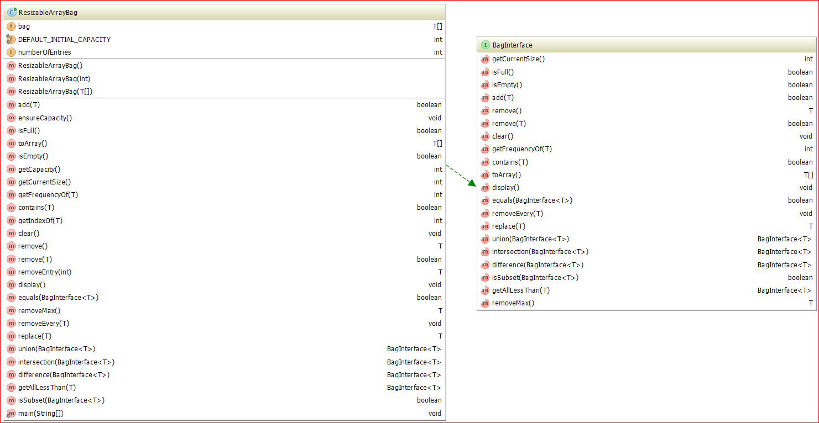

### Sample Run:

RUNNING TEST CASES

***Testing display method***

bag1:

There are 5 element(s): C A A A X

bag2:

There are 0 element(s):

After removing the last element X from bag1, it contains

There are 4 element(s): C A A A

***Testing equals method***

Are bag1 and bag2 equal? --> NO

Are bag2 and bag1 equal? --> NO

bag2:

There are 5 element(s): A A A C X

Are bag1 and bag2 equal? --> NO

Removed X from bag2.

There are 4 element(s): A A A C

Are bag1 and bag2 equal now? --> NO

Created bagCopyOfBag1:

There are 4 element(s): C A A A

Are bag1 and bagCopyOfBag1 equal? --> YES

***Testing union, intersection, difference, removeMax, getAllLessThan and isSubset methods***

bag1:

There are 5 element(s): C A A X A

bag2:

There are 7 element(s): A B B A C C D

***Testing union method***

The union of bag1 and bag2 is

There are 12 element(s): C A A X A A B B A C C D

***Testing removeMax method***

Removed the largest element "X" from the union bag; the current content is:

There are 11 element(s): C A A D A A B B A C C

The bag is empty and removeMax returned null - CORRECT

***Testing intersection method***

The intersection of bag1 and bag2 is

There are 3 element(s): C A A

***Testing difference method***

The difference of bag1 and bag2 is

There are 2 element(s): A X

The difference of bag2 and bag1 is

There are 4 element(s): C B B D

***Testing getAllLessThan method***

The following entries in bag1 are smaller than "Z"

There are 5 element(s): C A A X A

The following entries in bag2 are smaller than "C"

There are 4 element(s): A B B A

***Testing isSubset method***

Is bag1 a subset of bag1 ? --> YES

Is bag1 a subset of bag2 ? --> NO

Is an empty bag a subset of bag2 ? --> YES

Is bag2 a subset of an empty bag ? --> NO

Created bag3:

There are 3 element(s): A B C

Created bag4:

There are 3 element(s): B C A

Is bag3 a subset of bag4 ? --> YES

Is bag3 a subset of bag4 after adding "Z" to it ? --> YES

Is bag4 a subset of bag3 ? --> NO

Adding "Z" to bag 3 twice

bag3:

There are 5 element(s): A B C Z Z

bag4:

There are 4 element(s): B C A Z

Is bag3 a subset of bag4 ? --> NO

***Testing replace method***

bag1:

There are 7 element(s): A A B X A C A

Replacing an element with "X"

Now bag1 contains:

There are 7 element(s): A A B X A C X

***Testing removeEvery method***

bag1:

There are 7 element(s): A A B X A C X

Removing all "Z"

After removing all "Z" bag1 contains:

There are 7 element(s): A A B X A C X

Removing all "A"

After removing all "A" bag1 contains:

There are 4 element(s): X C B X

Removing all "X"

After removing all "X" bag1 contains:

There are 2 element(s): B C

Process finished with exit code 0