Lab11a

# Problem Description

studentsInput.txt file contains students data. Each line represents one student record and each record contains four tokens separated by &:

name&id&password&gpa

Using examples 11.12 and 11.13 write a program that reads data from this file and populates an ArrayList<StudentRecord> with appropriate objects.

Once that list is created the program prints the objects to the console and **also** writes them to another file called studentOutput.txt (see example 11.9 on how to create PrintWriter object and how to use its println method to write to a file). Each line should have **line number** inserted.

See the UML diagram and the sample runs below.

studentInput.txt and studentInputErr.txt are also provided.

# UML Diagram

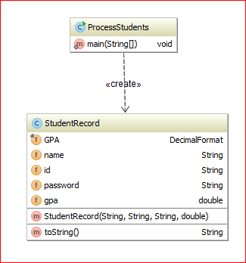

# Sample run#1:

> run ProcessStudents

Reading data from studentsInput.txt

processing record: Mike Apple&mike1&fruit&3.725

processing record: Jill Dill&jill2&herb&4.0

processing record: Jack Pepper&jack3&seasoning&4.3

processing record: Mary Rose&mary4&flower&2.9999

Finished reading the file studentsInput.txt

The size of the ArrayList of StudentRecords is: 4

The student records:

Name: Mike Apple; id: mike1; password: fruit; gpa: 3.72

Name: Jill Dill; id: jill2; password: herb; gpa: 4.00

Name: Jack Pepper; id: jack3; password: seasoning; gpa: 4.30

Name: Mary Rose; id: mary4; password: flower; gpa: 3.00

The produced file studentsOutput.txt contains:

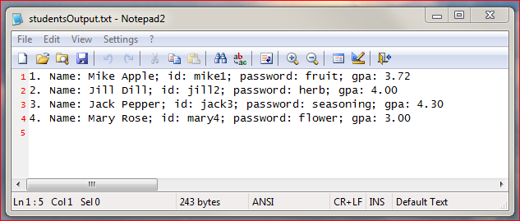

# Sample run#2:

Reading data from studentsInputErr.txt

processing record: Mike Apple&mike1&3.725&fruit

>>>>> Error in student record - incorrect data: Mike Apple&mike1&3.725&fruit; record ignored <<<<<<

processing record: Jill Dill&jill2&herb&4.0

processing record: Jack Pepper&jack3&seasoning&

>>>>> Error in student record - missing data: Jack Pepper&jack3&seasoning&; record ignored <<<<<

processing record: Mary Rose&mary4&flower&2.9999

Finished reading the file studentsInputErr.txt

The size of the ArrayList of StudentRecords is: 2

The student records:

Name: Jill Dill; id: jill2; password: herb; gpa: 4.00

Name: Mary Rose; id: mary4; password: flower; gpa: 3.00

*The produced file studentsOutput.txt contains:*

