CP_Ch11_1
Service class Course has the following attributes: name, description, subject, required, and number of units.
The provided text file courses.txt contains 16 lines each representing a course record. Two of the records are incorrect. The provided CourseScheduleClient calls the CourseOfferings constructor that reads the data from the provided text file and creates appropriate Course objects that are added to the ArrayList called offerings.
The client displays the course offerings and prompts the user for number of units and passes this value to getAllWithNumOfUnits method. The method returns an ArrayList containing all offered courses with the given number of units.
Next, client prompts the user for the list of names of courses the user plans to take; the list is passed to the saveSelectedCourses method along with the name of the file that the courses are to be written to. The method processes the input and saves the courses into the given file, one course per line.
Finally, the client prints the course with the most number of units (calls getCourseWithMostUnits method)
Your task is to implement the service class CourseOfferings class. See the UML diagram and the Sample Runs:

UML Diagram:

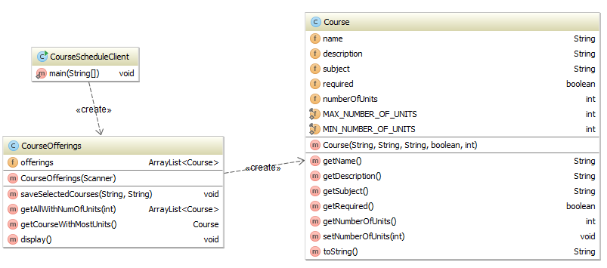

Sample Run #1:

***Reading from the input file***

Comp101;Computer Literacy;CS;false;3

Comp102;Web Development;CS;false;3

Comp105;Computer Programming Intro;CS;false;3

Comp150;Object Oriented Programming;CS;true;4

Comp151;Data Structures & Program Design;CS;true;4

Comp162;Computer Architecture & Assembly Languages;CS;true;3

Comp221;Unix System Programming 1;CS;false;3

Comp232;Programming Languages;CS;true;3

Comp262;Computer Organization & Architecture;CS;true;3

Comp337;Survey of Computer Gaming;CS;false;6

>>> Invalid data in course record: "Comp337;Survey of Computer Gaming;CS;false;6"; record ignored

Comp345;Digital Image Processing;CS;false;3

Comp350;Software Engineering;CS;true;3

Comp362;Operating Systems;CS;true;3

Comp420;Database Theory & Design;CS;false

>>> Missing data in course record: "Comp420;Database Theory & Design;CS;false"; record ignored

Comp424;Computer System Security;CS;false;3

Comp447;Societal Issues in Computing;CS;true;3

Comp490;Special Topic;CS;false;5

***Finished reading from the input file***

15 courses are being offered this semester

The current course offerings:

Course name: Comp101, description: "Computer Literacy", subject: CS, required: false, number of units: 3

Course name: Comp102, description: "Web Development", subject: CS, required: false, number of units: 3

Course name: Comp105, description: "Computer Programming Intro", subject: CS, required: false, number of units: 3

Course name: Comp150, description: "Object Oriented Programming", subject: CS, required: true, number of units: 4

Course name: Comp151, description: "Data Structures & Program Design", subject: CS, required: true, number of units: 4

Course name: Comp162, description: "Computer Architecture & Assembly Languages", subject: CS, required: true, number of units: 3

Course name: Comp221, description: "Unix System Programming 1", subject: CS, required: false, number of units: 3

Course name: Comp232, description: "Programming Languages", subject: CS, required: true, number of units: 3

Course name: Comp262, description: "Computer Organization & Architecture", subject: CS, required: true, number of units: 3

Course name: Comp345, description: "Digital Image Processing", subject: CS, required: false, number of units: 3

Course name: Comp350, description: "Software Engineering", subject: CS, required: true, number of units: 3

Course name: Comp362, description: "Operating Systems", subject: CS, required: true, number of units: 3

Course name: Comp424, description: "Computer System Security", subject: CS, required: false, number of units: 3

Course name: Comp447, description: "Societal Issues in Computing", subject: CS, required: true, number of units: 3

Course name: Comp490, description: "Special Topic", subject: CS, required: false, number of units: 5

Enter the number of units:

4

The following courses have 4 units:

Course name: Comp150, description: "Object Oriented Programming", subject: CS, required: true, number of units: 4

Course name: Comp151, description: "Data Structures & Program Design", subject: CS, required: true, number of units: 4

Enter your course selection (course names separated by ;)

Comp151;Comp162;Comp447

Adding course: Comp151

Adding course: Comp162

Adding course: Comp447

Your course selection has been added to "myCourses.txt" file.

The course with the most units in the collection is: "Comp490"

Process finished with exit code 0

Generated file:
When you open the myCourses.txt file it should have the following content:
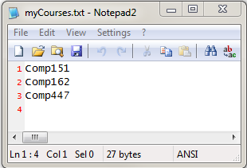

Sample Run #2:

***Reading from the input file***

Comp101;Computer Literacy;CS;false;3

Comp102;Web Development;CS;false;3

Comp105;Computer Programming Intro;CS;false;3

Comp150;Object Oriented Programming;CS;true;4

Comp151;Data Structures & Program Design;CS;true;4

Comp162;Computer Architecture & Assembly Languages;CS;true;3

Comp221;Unix System Programming 1;CS;false;3

Comp232;Programming Languages;CS;true;3

Comp262;Computer Organization & Architecture;CS;true;3

Comp337;Survey of Computer Gaming;CS;false;6

>>> Invalid data in course record: "Comp337;Survey of Computer Gaming;CS;false;6"; record ignored

Comp345;Digital Image Processing;CS;false;3

Comp350;Software Engineering;CS;true;3

Comp362;Operating Systems;CS;true;3

Comp420;Database Theory & Design;CS;false

>>> Missing data in course record: "Comp420;Database Theory & Design;CS;false"; record ignored

Comp424;Computer System Security;CS;false;3

Comp447;Societal Issues in Computing;CS;true;3

Comp490;Special Topic;CS;false;5

***Finished reading from the input file***

15 courses are being offered this semester

The current course offerings:

Course name: Comp101, description: "Computer Literacy", subject: CS, required: false, number of units: 3

Course name: Comp102, description: "Web Development", subject: CS, required: false, number of units: 3

Course name: Comp105, description: "Computer Programming Intro", subject: CS, required: false, number of units: 3

Course name: Comp150, description: "Object Oriented Programming", subject: CS, required: true, number of units: 4

Course name: Comp151, description: "Data Structures & Program Design", subject: CS, required: true, number of units: 4

Course name: Comp162, description: "Computer Architecture & Assembly Languages", subject: CS, required: true, number of units: 3

Course name: Comp221, description: "Unix System Programming 1", subject: CS, required: false, number of units: 3

Course name: Comp232, description: "Programming Languages", subject: CS, required: true, number of units: 3

Course name: Comp262, description: "Computer Organization & Architecture", subject: CS, required: true, number of units: 3

Course name: Comp345, description: "Digital Image Processing", subject: CS, required: false, number of units: 3

Course name: Comp350, description: "Software Engineering", subject: CS, required: true, number of units: 3

Course name: Comp362, description: "Operating Systems", subject: CS, required: true, number of units: 3

Course name: Comp424, description: "Computer System Security", subject: CS, required: false, number of units: 3

Course name: Comp447, description: "Societal Issues in Computing", subject: CS, required: true, number of units: 3

Course name: Comp490, description: "Special Topic", subject: CS, required: false, number of units: 5

Enter the number of units:

1

None of the courses have 1 units.

Enter your course selection (course names separated by ;)

Comp221;Comp232;Comp345;Comp447;Comp424

Adding course: Comp221

Adding course: Comp232

Adding course: Comp345

Adding course: Comp447

Adding course: Comp424

Your course selection has been added to "myCourses.txt" file.

The course with the most units in the collection is: "Comp490"

Process finished with exit code 0

Generated file:
When you open the myCourses.txt file it should have the following content:
