COMP151 Lab11
Your task is to implement a solutions to the following independent projects described below.

Implement ADT set

Problem Description
We want to implement the ADT set. Recall from Chapter 1 that a set is an unordered collection of objects where duplicates are not allowed. The operations that a set should support are:
- Add a given object to the set
- Remove a given object from the set
- See whether the set contains a given object
- Clear all objects from the set
- Get the number of objects in the set
- Return an iterator to the set
- Return a set that combines the items in two sets (the union)
- Return a set of those items that occur in both of two sets (the intersection)
These operations are defined in the provided SetInterface. Define the class Set.java that uses dictionary internally to implement the SetInterface (the skeleton of the Set class is provided). Test your class with the Driver.java that is fully implemented.
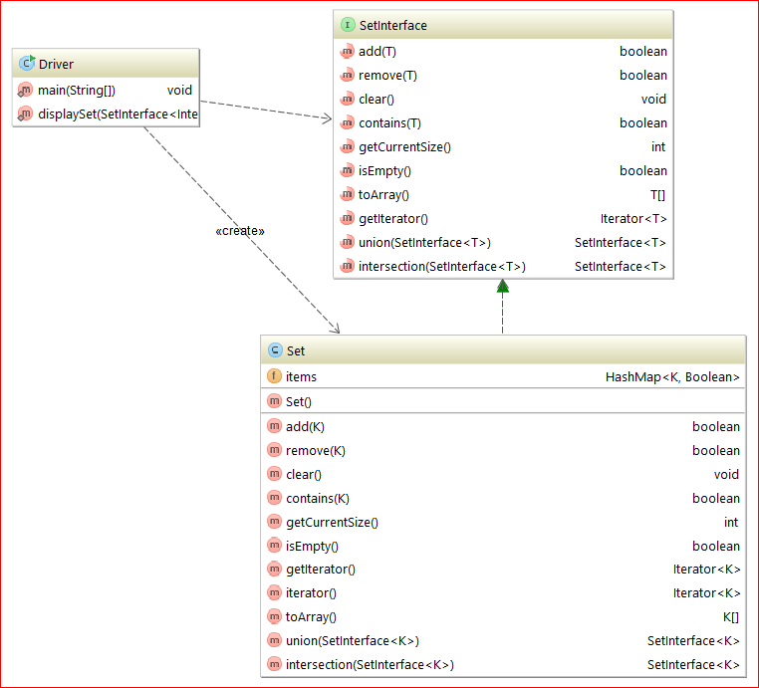

Sample run of the program:
The set has 5 item(s), as follows:
0 -1 1 2 3

Contains for -1 yields true
Contains for -2 yields false
Contains for 3 yields true
Contains for 4 yields false
Added 1 again to the set, should be the same
5 item(s), as follows:
0 -1 1 2 3

Iterating over the set
0
-1
1
2
3
Should just have 0 1 and 2 now
3 item(s), as follows:
0 1 2

Create a second set
The second set has 6 item(s), as follows:
-1 1 2 3 5 8

The union contains 7 item(s), as follows:
0 -1 1 2 3 5 8

The first set should be unchanged; it contains
3 item(s), as follows:
0 1 2

The second set should be unchanged; it contains
6 item(s), as follows:
-1 1 2 3 5 8

The intersection contains 2 item(s), as follows:
1 2

The first set should be unchanged; it contains
3 item(s), as follows:
0 1 2

The second set should be unchanged; it contains
6 item(s), as follows:
-1 1 2 3 5 8

Process finished with exit code 0

Implement Bingo Game

Problem Description
In the game of Bingo, numbers are chosen at random from a set between 1 and 75 inclusive. The numbers in the range:
- 1 to 15 are associated with the letter B
- 16 to 30 are associated with the letter I
- 31 to 45 are associated with the letter N
- 46 to 60 are associated with the letter G
- 61 to 75 are associated with the letter O
The person managing the game (“the caller”) selects a number from the Bingo drum randomly, and then announces the letter and the number. The caller then sets aside that number so that it cannot be used again in that game. All of the players then mark any squares on their card that match the letter and the number called. Once any player has five squares in a row, they announce “BINGO!” and claim their prize.
For this program however, please note that:
- The player can announce “BINGO” as soon as (s)he gets one number for each letter, not necessarily in a row. For example 2 25 31 58 70 would be a winning combination.
- Multiple winners are possible.

The following picture shows a sample bingo card:

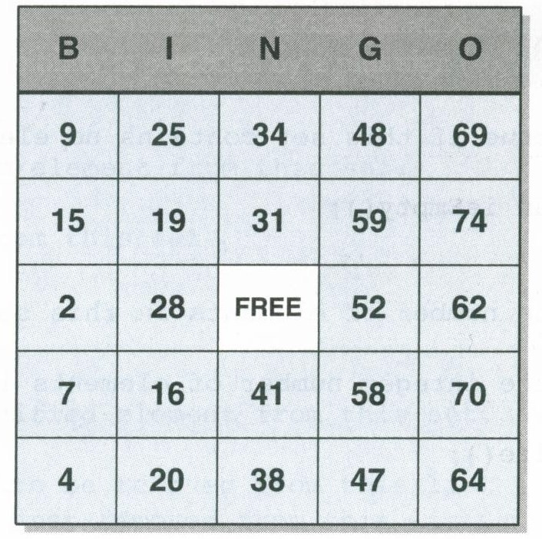
33

Please have a look at the attached UML diagram, it contains five classes. Below are their highlights:

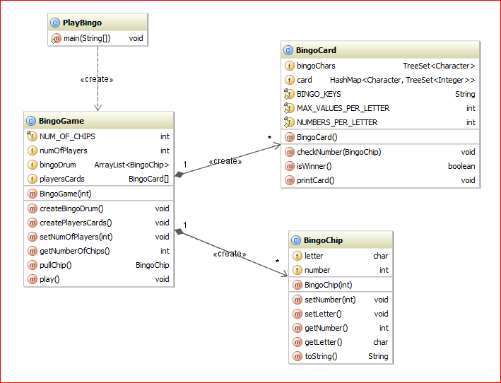

- PlayBingo class has the main method
  - gets user input with the number of players (if negative number is entered 1 is assumed)
  - creates the game object
  - starts the game
- BingoGame class
  - constructor:
    - sets the number of players for the game
    - creates bingoDrum – ArrayList that contains BingoChip objects
    - creates playersCards array of BingoCards one for each player
  - pullChip method – pulls randomly one chip from the bingoDrum
  - play method – plays the game until BINGO is announced:
    - pulls a chip and calls the chip letter and the number
    - for each player checks if the player’s card has the called number
    - prints each player’s card
    - checks each player’s card for the winning combination and announces the BINGO if appropriate
    - once the game is over it prints the number of chips that were called
- BingoCard class
  - constructor
    - creates a card for a player – the structure is a dictionary were the key is a letter and the value is the collection of five unique numbers from the appropriate range
    - prints the created card
  - checkNumber method – checks if the called number is on the card, if it is adds a marker (integer of 0) to the values for the given letter
  - isWinner method – checks if the player had at least one number for each letter
  - printCard method – prints the card (please look at the sample run and note the order )
- BingoChip class
  - constructor
    - sets the number to the given value by calling mutator method
    - based on the given number, sets the letter to the appropriate value (B, I, N, G, or O)

Sample run of the program:
---> Setting up bingo game.
Enter number of players.
4
---> Creating bingo card for Player 1
B 1 4 5 10 14
I 17 20 25 26 27
N 32 35 39 43 45
G 46 48 51 55 56
O 63 66 68 69 71

---> Creating bingo card for Player 2
B 5 6 9 10 15
I 17 20 25 29 30
N 31 32 38 39 43
G 46 47 49 50 57
O 63 70 71 72 74

---> Creating bingo card for Player 3
B 4 6 10 11 15
I 18 19 21 23 29
N 35 36 40 41 42
G 48 50 55 56 57
O 63 67 69 73 74

---> Creating bingo card for Player 4
B 6 11 12 13 15
I 24 25 26 27 28
N 32 33 42 43 45
G 47 52 53 56 59
O 61 62 67 70 74

---> Starting the game with 4 players:
*********************************

---> Calling: O 63
Player's 1 card:
B 1 4 5 10 14
I 17 20 25 26 27
N 32 35 39 43 45
G 46 48 51 55 56
O 0 63 66 68 69 71

Player's 2 card:
B 5 6 9 10 15
I 17 20 25 29 30
N 31 32 38 39 43
G 46 47 49 50 57
O 0 63 70 71 72 74

Player's 3 card:
B 4 6 10 11 15
I 18 19 21 23 29
N 35 36 40 41 42
G 48 50 55 56 57
O 0 63 67 69 73 74

Player's 4 card:
B 6 11 12 13 15
I 24 25 26 27 28
N 32 33 42 43 45
G 47 52 53 56 59
O 61 62 67 70 74

---> Calling: G 54
Player's 1 card:
B 1 4 5 10 14
I 17 20 25 26 27
N 32 35 39 43 45
G 46 48 51 55 56
O 0 63 66 68 69 71

Player's 2 card:
B 5 6 9 10 15
I 17 20 25 29 30
N 31 32 38 39 43
G 46 47 49 50 57
O 0 63 70 71 72 74

Player's 3 card:
B 4 6 10 11 15
I 18 19 21 23 29
N 35 36 40 41 42
G 48 50 55 56 57
O 0 63 67 69 73 74

Player's 4 card:
B 6 11 12 13 15
I 24 25 26 27 28
N 32 33 42 43 45
G 47 52 53 56 59
O 61 62 67 70 74

---> Calling: N 39
Player's 1 card:
B 1 4 5 10 14
I 17 20 25 26 27
N 0 32 35 39 43 45
G 46 48 51 55 56
O 0 63 66 68 69 71

Player's 2 card:
B 5 6 9 10 15
I 17 20 25 29 30
N 0 31 32 38 39 43
G 46 47 49 50 57
O 0 63 70 71 72 74

Player's 3 card:
B 4 6 10 11 15
I 18 19 21 23 29
N 35 36 40 41 42
G 48 50 55 56 57
O 0 63 67 69 73 74

Player's 4 card:
B 6 11 12 13 15
I 24 25 26 27 28
N 32 33 42 43 45
G 47 52 53 56 59
O 61 62 67 70 74

---> Calling: O 71
Player's 1 card:
B 1 4 5 10 14
I 17 20 25 26 27
N 0 32 35 39 43 45
G 46 48 51 55 56
O 0 63 66 68 69 71

Player's 2 card:
B 5 6 9 10 15
I 17 20 25 29 30
N 0 31 32 38 39 43
G 46 47 49 50 57
O 0 63 70 71 72 74

Player's 3 card:
B 4 6 10 11 15
I 18 19 21 23 29
N 35 36 40 41 42
G 48 50 55 56 57
O 0 63 67 69 73 74

Player's 4 card:
B 6 11 12 13 15
I 24 25 26 27 28
N 32 33 42 43 45
G 47 52 53 56 59
O 61 62 67 70 74

---> Calling: I 19
Player's 1 card:
B 1 4 5 10 14
I 17 20 25 26 27
N 0 32 35 39 43 45
G 46 48 51 55 56
O 0 63 66 68 69 71

Player's 2 card:
B 5 6 9 10 15
I 17 20 25 29 30
N 0 31 32 38 39 43
G 46 47 49 50 57
O 0 63 70 71 72 74

Player's 3 card:
B 4 6 10 11 15
I 0 18 19 21 23 29
N 35 36 40 41 42
G 48 50 55 56 57
O 0 63 67 69 73 74

Player's 4 card:
B 6 11 12 13 15
I 24 25 26 27 28
N 32 33 42 43 45
G 47 52 53 56 59
O 61 62 67 70 74

---> Calling: N 35
Player's 1 card:
B 1 4 5 10 14
I 17 20 25 26 27
N 0 32 35 39 43 45
G 46 48 51 55 56
O 0 63 66 68 69 71

Player's 2 card:
B 5 6 9 10 15
I 17 20 25 29 30
N 0 31 32 38 39 43
G 46 47 49 50 57
O 0 63 70 71 72 74

Player's 3 card:
B 4 6 10 11 15
I 0 18 19 21 23 29
N 0 35 36 40 41 42
G 48 50 55 56 57
O 0 63 67 69 73 74

Player's 4 card:
B 6 11 12 13 15
I 24 25 26 27 28
N 32 33 42 43 45
G 47 52 53 56 59
O 61 62 67 70 74

---> Calling: B 5
Player's 1 card:
B 0 1 4 5 10 14
I 17 20 25 26 27
N 0 32 35 39 43 45
G 46 48 51 55 56
O 0 63 66 68 69 71

Player's 2 card:
B 0 5 6 9 10 15
I 17 20 25 29 30
N 0 31 32 38 39 43
G 46 47 49 50 57
O 0 63 70 71 72 74

Player's 3 card:
B 4 6 10 11 15
I 0 18 19 21 23 29
N 0 35 36 40 41 42
G 48 50 55 56 57
O 0 63 67 69 73 74

Player's 4 card:
B 6 11 12 13 15
I 24 25 26 27 28
N 32 33 42 43 45
G 47 52 53 56 59
O 61 62 67 70 74

---> Calling: N 33
Player's 1 card:
B 0 1 4 5 10 14
I 17 20 25 26 27
N 0 32 35 39 43 45
G 46 48 51 55 56
O 0 63 66 68 69 71

Player's 2 card:
B 0 5 6 9 10 15
I 17 20 25 29 30
N 0 31 32 38 39 43
G 46 47 49 50 57
O 0 63 70 71 72 74

Player's 3 card:
B 4 6 10 11 15
I 0 18 19 21 23 29
N 0 35 36 40 41 42
G 48 50 55 56 57
O 0 63 67 69 73 74

Player's 4 card:
B 6 11 12 13 15
I 24 25 26 27 28
N 0 32 33 42 43 45
G 47 52 53 56 59
O 61 62 67 70 74

---> Calling: I 30
Player's 1 card:
B 0 1 4 5 10 14
I 17 20 25 26 27
N 0 32 35 39 43 45
G 46 48 51 55 56
O 0 63 66 68 69 71

Player's 2 card:
B 0 5 6 9 10 15
I 0 17 20 25 29 30
N 0 31 32 38 39 43
G 46 47 49 50 57
O 0 63 70 71 72 74

Player's 3 card:
B 4 6 10 11 15
I 0 18 19 21 23 29
N 0 35 36 40 41 42
G 48 50 55 56 57
O 0 63 67 69 73 74

Player's 4 card:
B 6 11 12 13 15
I 24 25 26 27 28
N 0 32 33 42 43 45
G 47 52 53 56 59
O 61 62 67 70 74

---> Calling: G 50
Player's 1 card:
B 0 1 4 5 10 14
I 17 20 25 26 27
N 0 32 35 39 43 45
G 46 48 51 55 56
O 0 63 66 68 69 71

Player's 2 card:
B 0 5 6 9 10 15
I 0 17 20 25 29 30
N 0 31 32 38 39 43
G 0 46 47 49 50 57
O 0 63 70 71 72 74

Player's 3 card:
B 4 6 10 11 15
I 0 18 19 21 23 29
N 0 35 36 40 41 42
G 0 48 50 55 56 57
O 0 63 67 69 73 74

Player's 4 card:
B 6 11 12 13 15
I 24 25 26 27 28
N 0 32 33 42 43 45
G 47 52 53 56 59
O 61 62 67 70 74

!!! Player 2 says BINGO !!!
10 chips were called.

