Last updated: 12/6/2014

COMP150_1 Fall’14 Final
Your Final is to implement a Candy Machine Application based on the requirements described below and the provided UML diagram. Your work needs to be submitted via Blackboard and must include the following:
- Your version of all the .java files that you worked on:
  - CandyMachineClient.java
  - CandyMachine.java
  - CashRegister.java
  - Item.java
  - ItemWithTax.java
  - ItemNoTax.java
- Output of your program
- Must include your name in each file that you are submitting.
- Use javadoc comments to document the classes you design for this application.

Please note that the fully implemented client, skeletons of the classes and inventory.txt files are provided.
Submit as much as you have done, even if the code is not working. All submitted work must be done individually.
The Final is worth 10% of your final grade. You must receive a passing grade from this project to pass the class.
BEFORE STARTING PLEASE READ THE PROBLEM DESCRIPTION AND THE INSTRUCTIONS CAREFULLY.

Good Luck!
Problem Description
A new candy machine is bought for the cafeteria and a program is needed to make the machine function properly. The machine has a dispenser that is carrying items like: candies, chips, gum, cookies, etc. Create a Java application program for the candy machine, so that it can be put into operation.

The program:
- Shows the customer the different products sold by the candy machine
- Lets the customer make a valid selection
- Shows the customer the cost of the item selected
- Releases the item.
- Repeats the steps 1 – 5
  - If the customer selects “-1” it means that no more selections will be made and the program:
    - prints the receipt that contains all the items purchased by the customer with the cost of each single item and the grand total. The output must be formatted appropriately.
    - prints the final inventory and the current cash balance of the cash register

The inventory is read from a text file: inventory.txt. Each item may be defined as taxable or non-taxable. If the item is taxable the sales tax must be added to the cost of the item.

We need to define the following classes:
- a class to implement the cash register (CashRegister.java)
  - the register has some cash on hand ($50 to start with), and it accepts the cash amount from the customer. The cash register can show the amount of money in the register at any given time.
- an abstract class to implement the items (Item.java), with two subclasses (ItemWithTax.java and ItemNoTax.java)
  - calculateCost is an abstract method that must be implemented in each subclass (it returns the price for not taxable items, or it returns the price with the added tax for the taxable items)
  - toString method is defined in the Item class, and it overridden in the subclasses
- a class to implement the candy machine (CandyMachine.java), see the notes below
- a client class (CandyMachineClient.java) is fully implemented

CandyMachine.java:

CandyMachine has three instance variables: cash register, dispenser that holds all the items, receipt (which holds counts of how many items of each type where bought).

constructor – creates appropriate instance variables. Fills the dispenser with item objects read from the file.

showSelection - displays the necessary information to help the user select and buy a product. Essentially it outputs something like the following:

*** Welcome to Anna's Candy Place ***
To select an item, enter:
0 for Candy @ $4.00 plus sales tax of 7% (inventory of 50)
1 for Chips @ $3.00 plus sales tax of 7% (inventory of 2)
2 for Gum @ $2.00 no sales tax (inventory of 25)
3 for Cookies @ $6.00 plus sales tax of 7% (inventory of 0)
4 for Dark Chocolate @ $10.00 no sales tax (inventory of 10)
5 for Peppermint Pattie @ $3.00 no sales tax (inventory of 100)
-1 to exit

checkInventory – takes the choice given by the user and checks if the choice is valid. For the valid choice checks if the item’s inventory. In case of a problem it gives appropriate message.

sellProduct -
- gets the item’s cost
- requests the money from the customer:
- updates the amount in the cash register
- sells the product – that is, decrements the count for this item by 1
- updates receipt counts accordingly

printReceipt – prints the final receipt that contains all the items that were purchased and the grand total paid, it should look like the following:

** Receipt **
You bought 6 items:
2 Candy @ $4.00 plus sales tax of 7%
1 Gum @ $2.00 no sales tax
2 Dark Chocolate @ $10.00 no sales tax
1 Peppermint Pattie @ $3.00 no sales tax
====================
Grand Total: $33.56

printInventory – prints the closing balance information, see the following:

**** Remaining inventory ****
There is $83.56 in the cash register.
Content of the dispenser:
48 items of Candy
2 items of Chips
24 items of Gum
0 items of Cookies
8 items of Dark Chocolate
99 items of Peppermint Pattie

Development Steps:

- Analyze UML diagram and sample output first
- Implement the application using incremental approach: for example do not start Step2 until you are done with Step1
- Step1: Load the provided java files and put your name in all of them:
- Step2: Based on the UML diagram define instance variables
- Step3: Make sure that the code compiles and the inventory.txt file should be found
- Step4: Proceed with implementation of the methods. Compile the code frequently and test new functionality as you implement it; fix indentations frequently
- Step5: Once your application is completed add javadoc comments

UML Diagram:

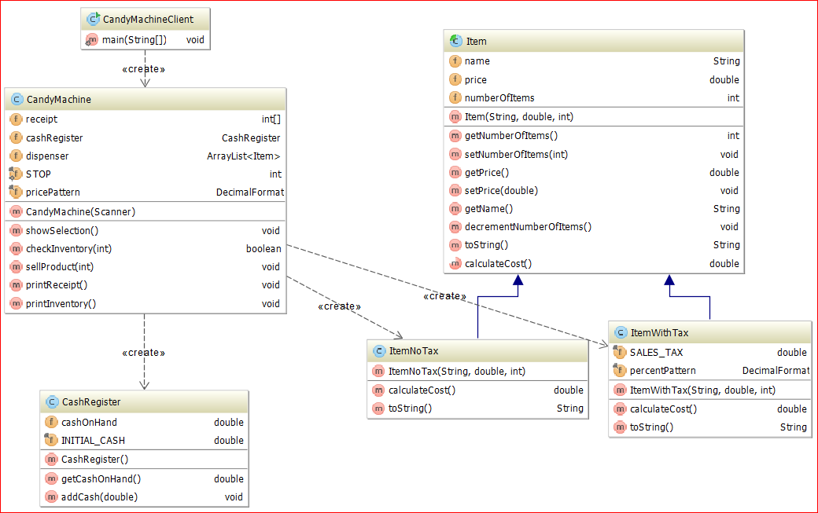

Sample Run (in this sample run the user input is shown in red)

cashRegister has been created with the initial balance of $50.00
dispenser has been created with the initial number of items 0

Reading inventory from the file:
Reading record: true,Candy,4,50
Reading record: true,Chips,3,2
Reading record: false,Gum,2,25
Reading record: true,Cookies,6,0
Reading record: false,Ice Cream,1
>>> Missing data in inventory record:"false,Ice Cream,1" ignoring
Reading record: false,Dark Chocolate,10,10
Reading record: true,Candy Cane,-3,5
>>> Invalid data in inventory record: "true,Candy Cane,-3,5"; record ignored
Reading record: true,Gummy Bears,2,-2
>>> Invalid data in inventory record: "true,Gummy Bears,2,-2"; record ignored
Reading record: false,Peppermint Pattie,3,100
Finished reading the file.

*** Welcome to Anna's Candy Place ***
To select an item, enter:
0 for Candy @ $4.00 plus sales tax of 7% (inventory of 50)
1 for Chips @ $3.00 plus sales tax of 7% (inventory of 2)
2 for Gum @ $2.00 no sales tax (inventory of 25)
3 for Cookies @ $6.00 plus sales tax of 7% (inventory of 0)
4 for Dark Chocolate @ $10.00 no sales tax (inventory of 10)
5 for Peppermint Pattie @ $3.00 no sales tax (inventory of 100)
-1 to exit
2
>>> Please deposit $2.00
>>> Collect your item at the bottom tray and enjoy.

*** Welcome to Anna's Candy Place ***
To select an item, enter:
0 for Candy @ $4.00 plus sales tax of 7% (inventory of 50)
1 for Chips @ $3.00 plus sales tax of 7% (inventory of 2)
2 for Gum @ $2.00 no sales tax (inventory of 24)
3 for Cookies @ $6.00 plus sales tax of 7% (inventory of 0)
4 for Dark Chocolate @ $10.00 no sales tax (inventory of 10)
5 for Peppermint Pattie @ $3.00 no sales tax (inventory of 100)
-1 to exit
3
>>> Sorry, we are out of Cookies

*** Welcome to Anna's Candy Place ***
To select an item, enter:
0 for Candy @ $4.00 plus sales tax of 7% (inventory of 50)
1 for Chips @ $3.00 plus sales tax of 7% (inventory of 2)
2 for Gum @ $2.00 no sales tax (inventory of 24)
3 for Cookies @ $6.00 plus sales tax of 7% (inventory of 0)
4 for Dark Chocolate @ $10.00 no sales tax (inventory of 10)
5 for Peppermint Pattie @ $3.00 no sales tax (inventory of 100)
-1 to exit
4
>>> Please deposit $10.00
>>> Collect your item at the bottom tray and enjoy.

*** Welcome to Anna's Candy Place ***
To select an item, enter:
0 for Candy @ $4.00 plus sales tax of 7% (inventory of 50)
1 for Chips @ $3.00 plus sales tax of 7% (inventory of 2)
2 for Gum @ $2.00 no sales tax (inventory of 24)
3 for Cookies @ $6.00 plus sales tax of 7% (inventory of 0)
4 for Dark Chocolate @ $10.00 no sales tax (inventory of 9)
5 for Peppermint Pattie @ $3.00 no sales tax (inventory of 100)
-1 to exit
0
>>> Please deposit $4.28
>>> Collect your item at the bottom tray and enjoy.

*** Welcome to Anna's Candy Place ***
To select an item, enter:
0 for Candy @ $4.00 plus sales tax of 7% (inventory of 49)
1 for Chips @ $3.00 plus sales tax of 7% (inventory of 2)
2 for Gum @ $2.00 no sales tax (inventory of 24)
3 for Cookies @ $6.00 plus sales tax of 7% (inventory of 0)
4 for Dark Chocolate @ $10.00 no sales tax (inventory of 9)
5 for Peppermint Pattie @ $3.00 no sales tax (inventory of 100)
-1 to exit
4
>>> Please deposit $10.00
>>> Collect your item at the bottom tray and enjoy.

*** Welcome to Anna's Candy Place ***
To select an item, enter:
0 for Candy @ $4.00 plus sales tax of 7% (inventory of 49)
1 for Chips @ $3.00 plus sales tax of 7% (inventory of 2)
2 for Gum @ $2.00 no sales tax (inventory of 24)
3 for Cookies @ $6.00 plus sales tax of 7% (inventory of 0)
4 for Dark Chocolate @ $10.00 no sales tax (inventory of 8)
5 for Peppermint Pattie @ $3.00 no sales tax (inventory of 100)
-1 to exit
0
>>> Please deposit $4.28
>>> Collect your item at the bottom tray and enjoy.

*** Welcome to Anna's Candy Place ***
To select an item, enter:
0 for Candy @ $4.00 plus sales tax of 7% (inventory of 48)
1 for Chips @ $3.00 plus sales tax of 7% (inventory of 2)
2 for Gum @ $2.00 no sales tax (inventory of 24)
3 for Cookies @ $6.00 plus sales tax of 7% (inventory of 0)
4 for Dark Chocolate @ $10.00 no sales tax (inventory of 8)
5 for Peppermint Pattie @ $3.00 no sales tax (inventory of 100)
-1 to exit
9
>>> Wrong selection

*** Welcome to Anna's Candy Place ***
To select an item, enter:
0 for Candy @ $4.00 plus sales tax of 7% (inventory of 48)
1 for Chips @ $3.00 plus sales tax of 7% (inventory of 2)
2 for Gum @ $2.00 no sales tax (inventory of 24)
3 for Cookies @ $6.00 plus sales tax of 7% (inventory of 0)
4 for Dark Chocolate @ $10.00 no sales tax (inventory of 8)
5 for Peppermint Pattie @ $3.00 no sales tax (inventory of 100)
-1 to exit
5
>>> Please deposit $3.00
>>> Collect your item at the bottom tray and enjoy.

*** Welcome to Anna's Candy Place ***
To select an item, enter:
0 for Candy @ $4.00 plus sales tax of 7% (inventory of 48)
1 for Chips @ $3.00 plus sales tax of 7% (inventory of 2)
2 for Gum @ $2.00 no sales tax (inventory of 24)
3 for Cookies @ $6.00 plus sales tax of 7% (inventory of 0)
4 for Dark Chocolate @ $10.00 no sales tax (inventory of 8)
5 for Peppermint Pattie @ $3.00 no sales tax (inventory of 99)
-1 to exit
-1

** Receipt **
You bought 6 items:
2 Candy @ $4.00 plus sales tax of 7%
1 Gum @ $2.00 no sales tax
2 Dark Chocolate @ $10.00 no sales tax
1 Peppermint Pattie @ $3.00 no sales tax
====================
Grand Total: $33.56

**** Remaining inventory ****
There is $83.56 in the cash register.
Content of the dispenser:
48 items of Candy
2 items of Chips
24 items of Gum
0 items of Cookies
8 items of Dark Chocolate
99 items of Peppermint Pattie

Process finished with exit code 0

