Name: Joshua Steward Lab 9

Database Systems November 15, 2017

Preprocessing

* For Lab 9, you will use the LargeCo database, which consists of LargeCo_DDL.sql and LargeCo_Inserts.sql.

**Each question is worth four points.**

1. (T ||F) The files LargeCo_DDL.sql and LargeCo_Inserts.sql provide a complete backup of the LargeCo database. True.
2. The total number of transactions used to complete all inserts for LargeCo is 9.
3. Create a new user for LARGECO. Grant this new user SELECT, UPDATE, DELETE and INSERT privileges on vendor, brand, product and supplies tables. Run SHOW GRANTS for your new user.  
     
   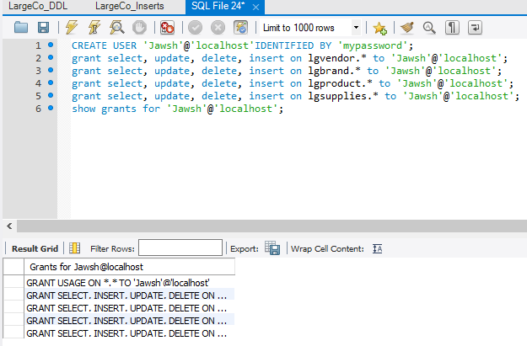
4. Query the data dictionary to return the top 3 largest tables in LargeCo. Show the table names and their sizes in megabytes. Also include fields for your name and the date the query was executed.  
     
   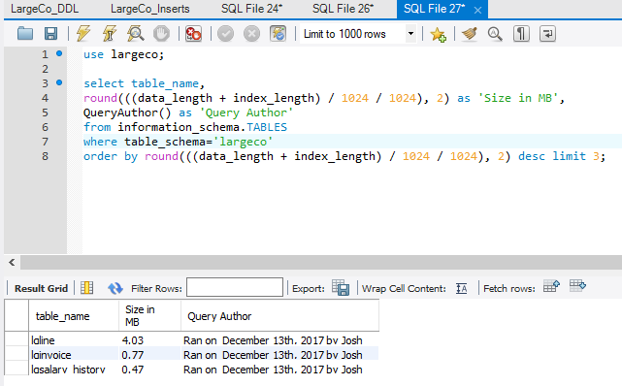
5. Use AES encryption to encrypt the top 5 passwords of 2016 (Be sure to use your own key… I’ll be checking!):
   1. 123456 - Key: key5678 , Value: °È³ç7ìO&‘ØKI—ë
   2. 123456789 - Key: key5678 , Value: Ž¯tÔmGZfªTqýÃvæ¹
   3. qwerty- Key: key5678 , Value: ,*–)èF%2Jõ‑0‹
   4. 111111- Key: key5678 , Value: öf^]jª-10 àDg
   5. 1234567890- Key: key5678 , Value: Ìýó9WG½¸èãñ6Ã—!²
6. The estimated MySQL execution cost for lgemployee is .  
   1. Seconds.  
      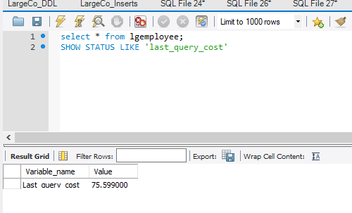
7. (T ||F) Assuming SELECT * with no WHERE clause, the estimated execution cost of joining lgvendor and lgsupplies is greater than the sum of their execution costs running individually.

False; they would have the same execution costs, but the query itself starting it up costs more every time it is started. Also, queries integrating several tables are generally slower.

1. Based on MySQL internals, the number of where-clauses performed in the following select statement is _____.

SELECT * FROM largeco.lgemployee

JOIN largeco.lgdepartment ON lgdepartment.dept_num=lgemployee.dept_num

WHERE dept_name IN ('SALES', 'ACCOUNTING');

363 where clauses are ran. This can be checked by just running the query without the where clause and incrementing the rows.  
  
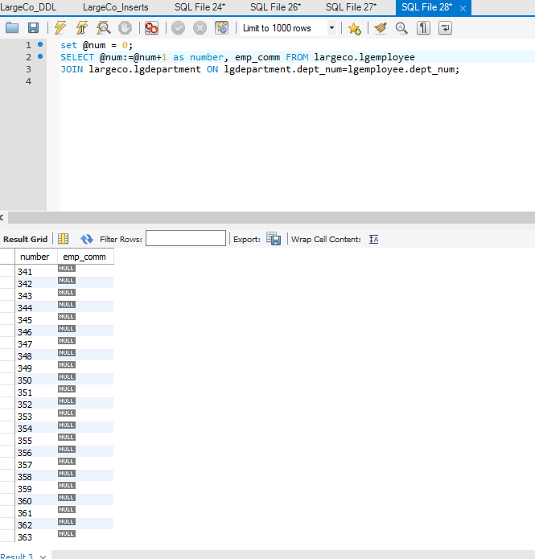

1. Based on MySQL internals, choose the query that will perform faster.
   1. select * from largeco.lgcustomer where cust_lname='HUDSON';
   2. select * from largeco.lgcustomer where cust_code in (86, 644);

B will perform faster because it is just checking for integer comparisons.

1. Based on MySQL internals, choose the query that will perform faster.
   1. select * from largeco.lgcustomer where cust_lname like 'HUD%';
   2. select * from largeco.lgcustomer where cust_lname like 'HUDSON';

A will perform faster because it only needs to check the first 3 characters, not an entire 6 character string.