**BSc in Computing**

**COMP112 Programming I**

**Lab Practice 2: Reading inputs from keyboard**

Your student ID: p2211355

Submission date: Sep 9 2022

|  |
| --- |
| Note for submission via Canvas:  Save your Word file of the lab report named using your Student ID followed by the numbering of the Lab, e.g. P2212345Lab2.docx |

1. **Discussion** (30 marks)
   1. **Description**: What were you required to implement? This might be a word-for-word reiteration of the problem given to you. **[3 marks]**

Enter three numbers to find the average of them.

* 1. **Solution**: A brief description of how your program works. For example, the use of Sytem.out.println to output the answer, etc. **[4 marks]**

Use two import to introduce basic group which make foundation for coming code.

Use System.out.print to ask users enter the numbers.

Use double to define the formula.

Use “%.2f” to change the answer into “2 demical number” form.

* + 1. Write the algorithm for solving this problem. **[4 marks]**

Divide 3 into Number1 plus number2 plus number3.

* + 1. What is the code you used in order to read input from the keyboard? **[4 marks]**

Import java.until.Scanner;

double num = input.nextDouble();

* + 1. With 3 integers as input, how can you have the result (average) with decimal point? **[4 marks]**

Use “double” to change the result into decimal point form.

* + 1. Explain how you can have the result (average) **with 2 decimal points**? **[4 marks]**

Use “System.out.printf(“%.2f”, variable );” to have the result with 2 decimal numbers.

* + 1. Following the question requirement using nextInt() to read the integer inputs from keyboard, what will happen if user inputs a floating-point number as input? Give explanation as well. **[4 marks]**

I use “double” to define my value so I don’t know the answer.

* 1. **Major Implementation Issues**: What were the most difficult parts of your program to implement? **[3 marks]**

Change the result into 2 decimal numbers form.

* 1. **Known Bugs and/or Errors**: List all the known bugs and/or errors of your program, if any.

None.

1. **Attachments:** Include the following attachments to your report. (70 marks)
   1. **Sample Execution:** Paste screen capture of the execution of your running program.
      * Lab2.java: 10 marks for correct output with inputs **2, 3, 15**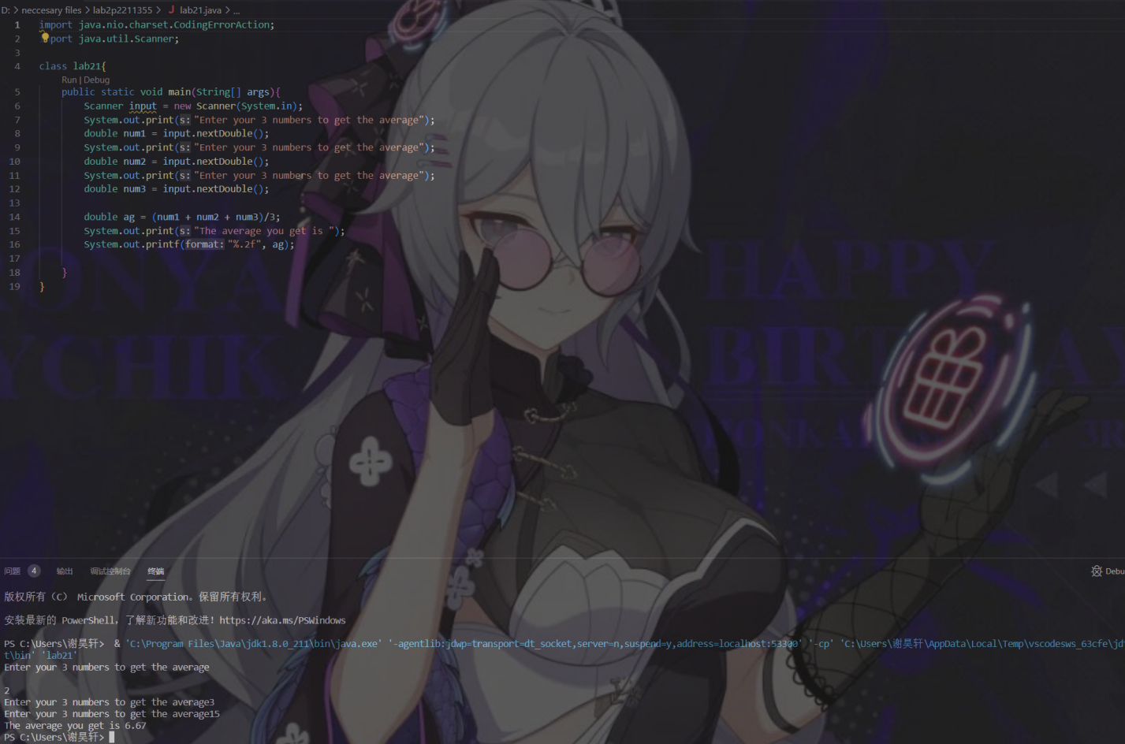
      * Lab2Rect.java: 10 marks for the two correct outputs on area and perimeter with inputs **5.3 and 8.6**
      * 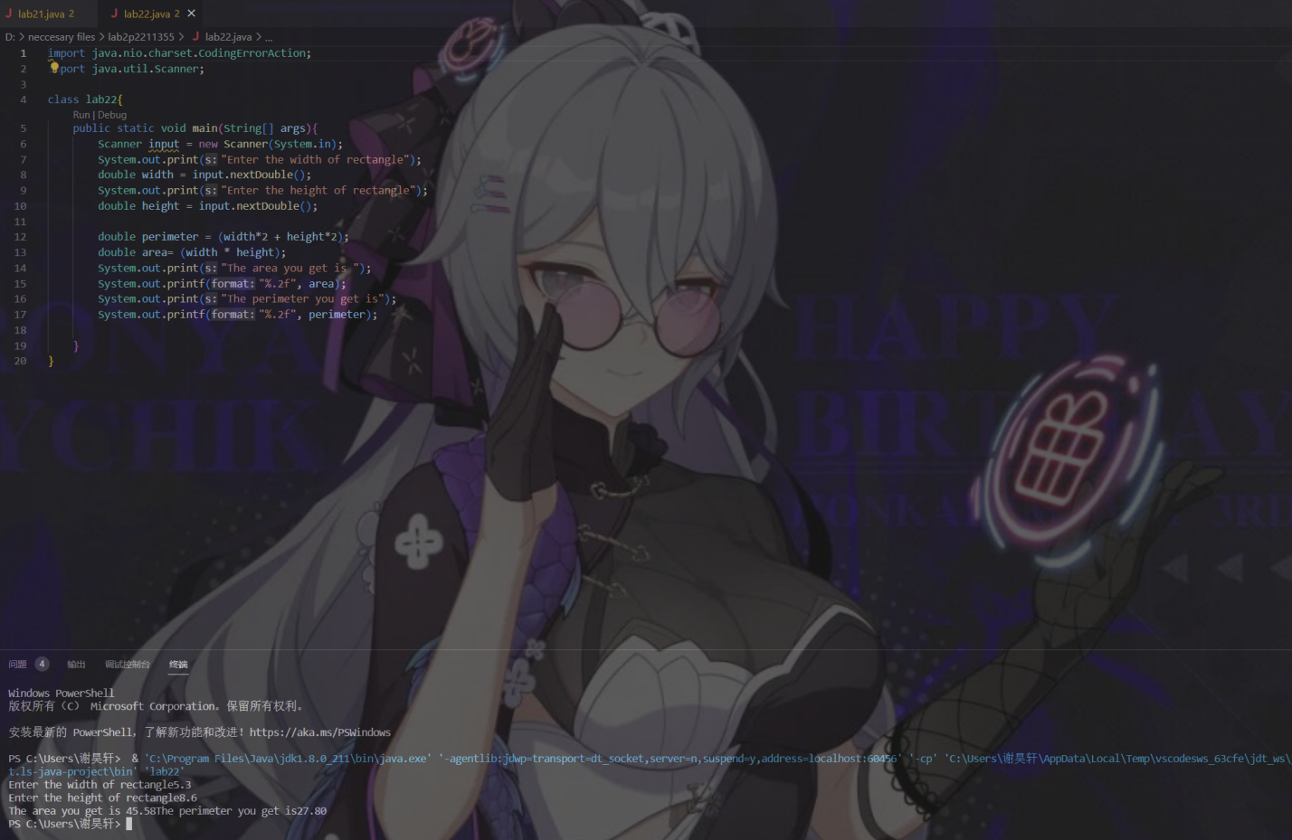
   2. **Source Code:** Copy and paste your source code. 50 marks

* Lab2.java:

import java.nio.charset.CodingErrorAction;

import java.util.Scanner;

class lab21{

    public static void main(String[] args){

        Scanner input = new Scanner(System.in);

        System.out.print("Enter your 3 numbers to get the average");

        double num1 = input.nextDouble();

        System.out.print("Enter your 3 numbers to get the average");

        double num2 = input.nextDouble();

        System.out.print("Enter your 3 numbers to get the average");

        double num3 = input.nextDouble();

        double ag = (num1 + num2 + num3)/3;

        System.out.print("The average you get is ");

        System.out.printf("%.2f", ag);

    }

}

* Lab2Rect.java:

import java.nio.charset.CodingErrorAction;

import java.util.Scanner;

class lab22{

    public static void main(String[] args){

        Scanner input = new Scanner(System.in);

        System.out.print("Enter the width of rectangle");

        double width = input.nextDouble();

        System.out.print("Enter the height of rectangle");

        double height = input.nextDouble();

        double perimeter = (width*2 + height*2);

        double area= (width * height);

        System.out.print("The area you get is ");

        System.out.printf("%.2f", area);

        System.out.print("The perimeter you get is");

        System.out.printf("%.2f", perimeter);

    }

}