Input:

100 high-quality synthetic data from patients. (CSV files)

Output: generate 100 synthetic data; comparing the evaluate matrix.

Step 1: understand the statistical result for all the 100 patients’ activity data.

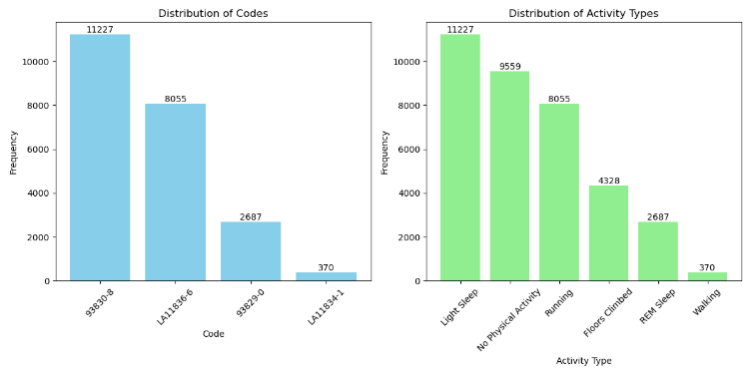

Rules for different activity data:

1. Light Sleep data:
   1. Code: 93830-8; Activity: Light Sleep; Heart rate___beats/minute:X; Sleep duration_minutes: X; Sleep type duration_minutes:X;
2. No Physical Activity:
   1. Code: NaN; Heart rate___beats/minute: X;
3. Running:
   1. Code: LA11836-6; Heart rate___beats/minute: X; Calories burned_kcal: X; Exercise duration_s: X;
4. Floors Climbed:
   1. Code: NaN; Heart rate___beats/minute: X; Floors climbed___floors: X;
5. REM Sleep:
   1. Code: 93829-0; Heart rate___beats/minute:X; Sleep duration_minutes: X; Sleep type duration_minutes:X;
6. Walking:
   1. Code: LA11834-1; Heart rate___beats/minute: X; Calories burned_kcal:X; Exercise duration_s: X;

Light Sleep Data distribution:

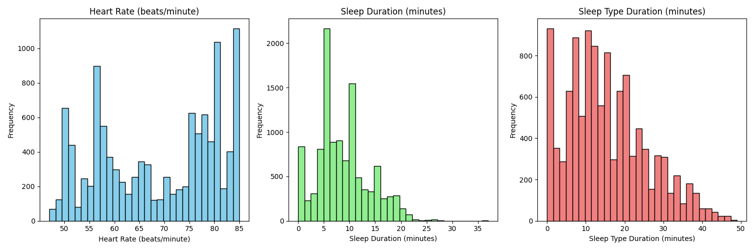

REM Sleep Data distribution:

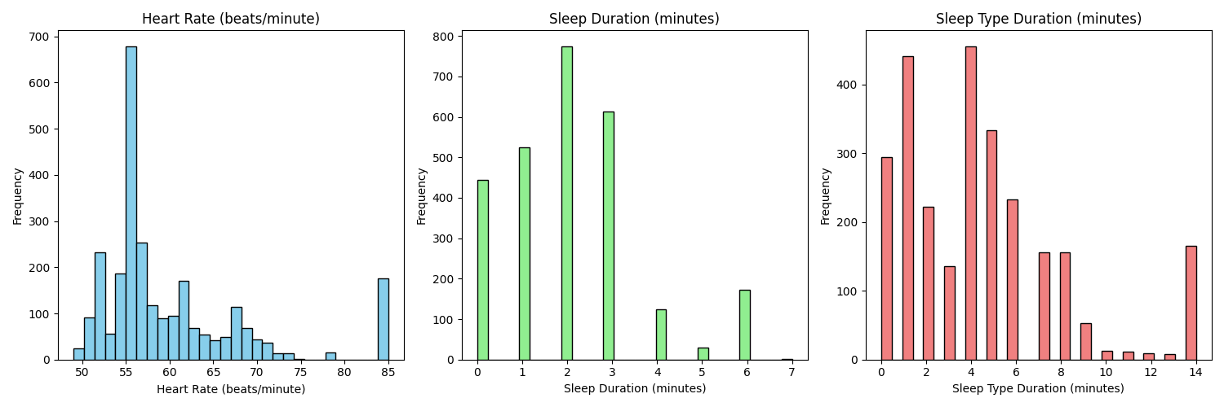

Running Data distribution:

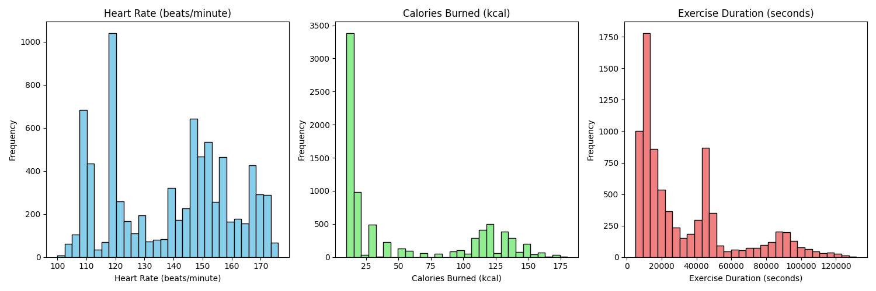

Walking Data distribution:

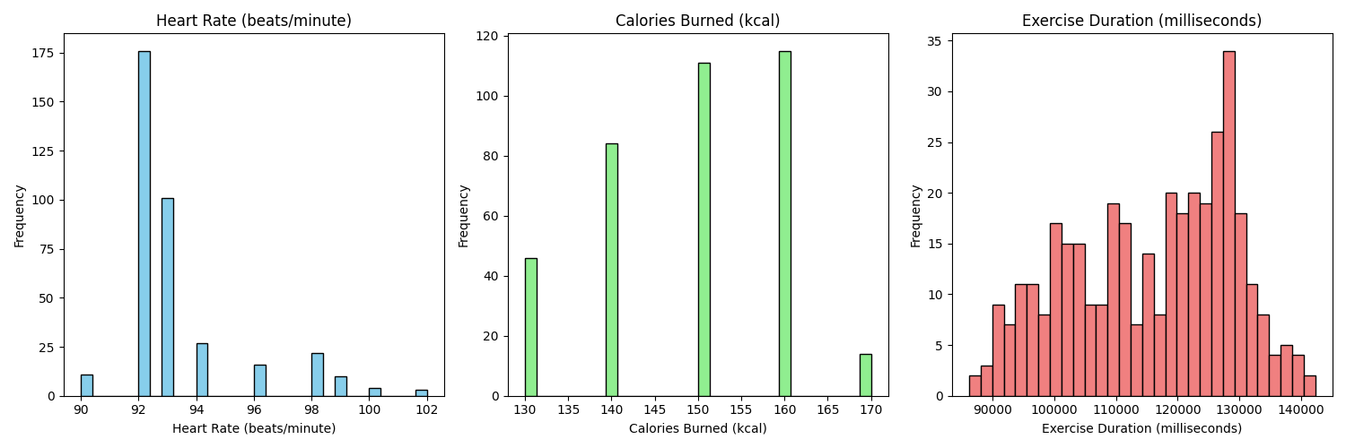

No Physical Activity:

Floors Climbed:

Step 2: explore the strategy to generate the synthetic data.

Step 3: evaluate the synthetic data.

Evaluate matrix implementation:

Wasserstein distance

Kolmogorov-Smirnov (KS) Test

Jensen-Shannon distance

Distance Pairwise Correlation