

**EE308FZ Software Engineering**

**LAB 2 Individual programing work**

**Task**

1.To achieve a program function, it can extract keywords of different levels from the C or C++ code files that are read in.可以读入文字

2. Write a blog to record your work content and process.

**Work Procedure**

1.Create a GitHub repository for the job.创建一个git的仓库

2.Write the program and commit actively.

3.Iteratively update and optimize the code.

4.Complete your work and write a blog.

**Program Requirements（是一个计数并输出的任务）**

1. Basic requirement: output "keyword" statistics

2. Advanced requirement: output the number of "switch case" structures, and output the number of "case" corresponding to each group

3. Uplifting requirement: output the number of "if else" structures

4. Ultimate requirement: output the number of "if, else if, else" structures

Before completing the more difficult requirements, you need to complete the Lower requirements.

**Coding Requirements**

1.Use any of C++, Java, Python to complete the work.

2.Develop appropriate code specifications and conduct tests.

3.Use Git for version control.

**Blog Requirements**

1.Give the PSP form for this work**.写一个PSP表格**

2.Description of problem-solving ideas. This is the process of how to think and how to find information after getting the title at the beginning.解决问题的想法的描述。这是一开始拿到标题后如何思考，如何查找信息的过程。

3.Design and implementation process. The design includes how the code is organized and the flow chart of the key functions.设计和实现过程。设计包括代码的组织和关键功能的**流程图**。

4.Code description. Show the key code of the project and explain the idea.代码描述。展示项目的关键代码并解释想法。

5.Unit test screenshots and description.单元测试截图和描述

6.Unit test coverage optimization and performance testing, performance optimization screenshots and descriptions.单元测试覆盖优化和性能测试，性能优化截图和描述。

7.Summarize this assignment.

**Prerequisites**

**1. github first use**

In order to ensure that your code can help more people, and can be effectively managed and open source shared, please learn how to use GitHub first:

(1).Download Git.

(2).Learn basic Git commands.

(3).Create a repository on GitHub and upload this assignment, complete the requirements, and make at least 10 commits.要上传十次

**2. Code specification development**

In order for other colleagues to read your code easily, please formulate your own code specifications and require that they not deviate from the mainstream code specifications: please refer to

[alibaba-java-style-guide](https://github.com/chjw8016/alibaba-java-style-guide)/[Google-C++-style-guide](https://zh-google-styleguide.readthedocs.io/en/latest/google-cpp-styleguide/contents/)/[Python PEP8](https://www.python.org/dev/peps/pep-0008/), Develop your programming specifications from the following perspectives and write them into Markdown files.

- indentation

- Variable naming

- Maximum number of characters per line

- Maximum number of function lines

- Function and class naming

- constant

- Blank line rule

- Annotation rules

- Space before and after operator

- Other rules

**SAMPLE**

c language test file:

1. #include <stdio.h>
2. **int** main(){
3. **int** i=1;
4. **double** j=0;
5. **long** f;
6. **switch**(i){
7. **case** 0:
8. **break**;
9. **case** 1:
10. **break**;
11. **case** 2:
12. **break**;
13. **default**:
14. **break**;
15. }
16. **switch**(i){
17. **case** 0:
18. **break**;
19. **case** 1:
20. **break**;
21. **default**:
22. **break**;
23. }
24. **if**(i<0){
25. **if**(i<-1){}
26. **else**{}
27. }
28. **else** **if**(i>0){
29. **if** (i>2){}
30. **else** **if** (i==2) {}
31. **else** **if** (i>1) {}
32. **else** {}
33. }
34. **else**{
35. **if**(j!=0){}
36. **else**{}
37. }
38. **return** 0;
39. }

**Format Requirement**

1.Input format: When executing, you need to pass in two parameters to the program. The first parameter is the path of the code file, and the second parameter is the completion level (from low to high as 1, 2, 3, 4 , if you can complete the uplifting requirement , your level is 3)在执行时，需要向程序传递两个参数。第一个参数是代码文件的路径，第二个参数是完成等级(从低到高依次为1、2、3、4，如果你能完成提升要求，你的等级是3)

2. Output format: The code above is used as an example输出格式:以上面的代码为例

**total num: 35**

**switch num: 2**

**case num: 3 2**

**if-else num: 2**

**if-elseif-else num: 2**

**Tips:**

1. TA can’t notice all students. If your blog can impress TA, you can get higher remark.

2. If you have some question, you should ask directly in the QQ group and you’d better not make a private chat with TAs or tutor.

3. Please issue your homework in the section of assignment on CSDN.

**4. The Link of each assignment you would accomplish must be submit to Moodle, or you will lose the score of the assignment.**

**5. Each assignment submitted to CSDN must be completed in English.**

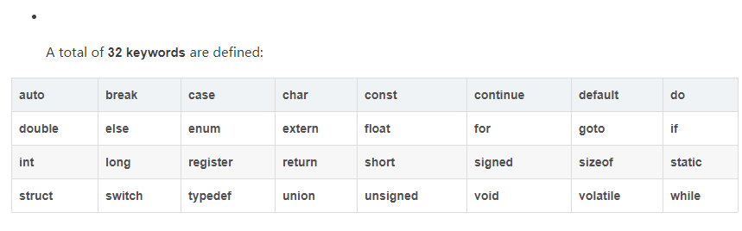

1. **输入地址和四个等级中的一个**
2. **输出给定的要求**

|  |  |  |
| --- | --- | --- |
| **PSP（2021/9/20）** | **Estimated time** | **consumed time** |
| Planning |  |  |
| * **Estimate** | **4~5h** |  |
| Development |  |  |
| * **Analysis** | **1h** |  |
| * **Design Review** | **10min** |  |
| * **Coding Standard** | **10min** |  |
| * **Design** | **20min** |  |
| * **Coding** | **2h+** |  |
| * **Code Review** | **20min** |  |
| * **Test** | **20min** |  |
| Reporting |  |  |
| * Test Report | **20min** |  |
| * Postmortem&Process Improvement | **30min** |  |

**设计思路：**

1. **读懂题目要求：**

**total num: 35，有35个keyword**

**switch num: 2, 两个switch**

**case num: 3 2,分别是3和2**

**if-else num: 2**

**if-elseif-else num: 2**

**2.如何用C++/python读取地址里的文件(假设为txt)**