Fanindra Saini

211b116

B4

**DATABASE SYSTEMS ASSIGNMENT**

***Database-***

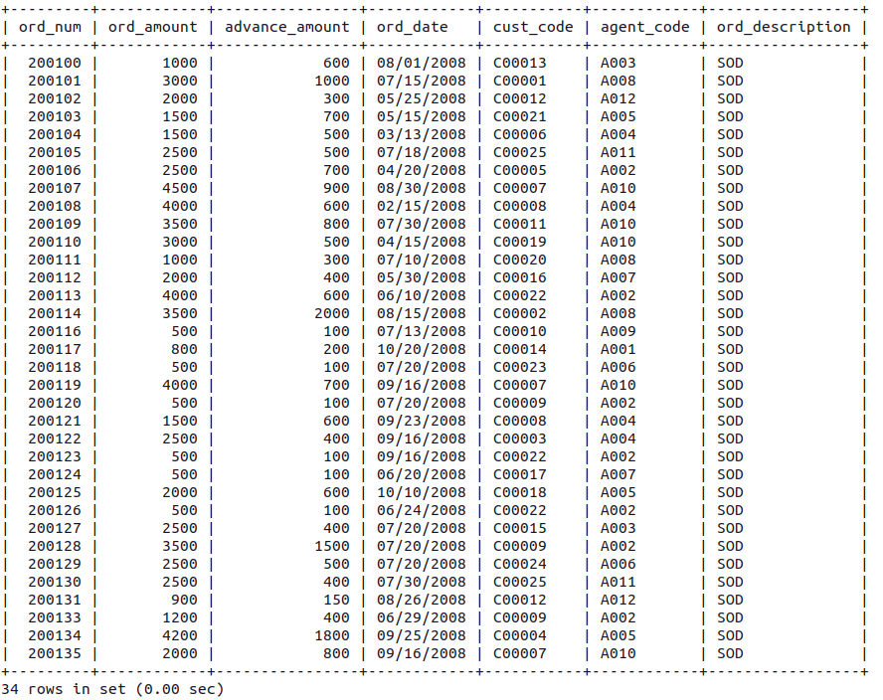1. Orders-

2. Customers-

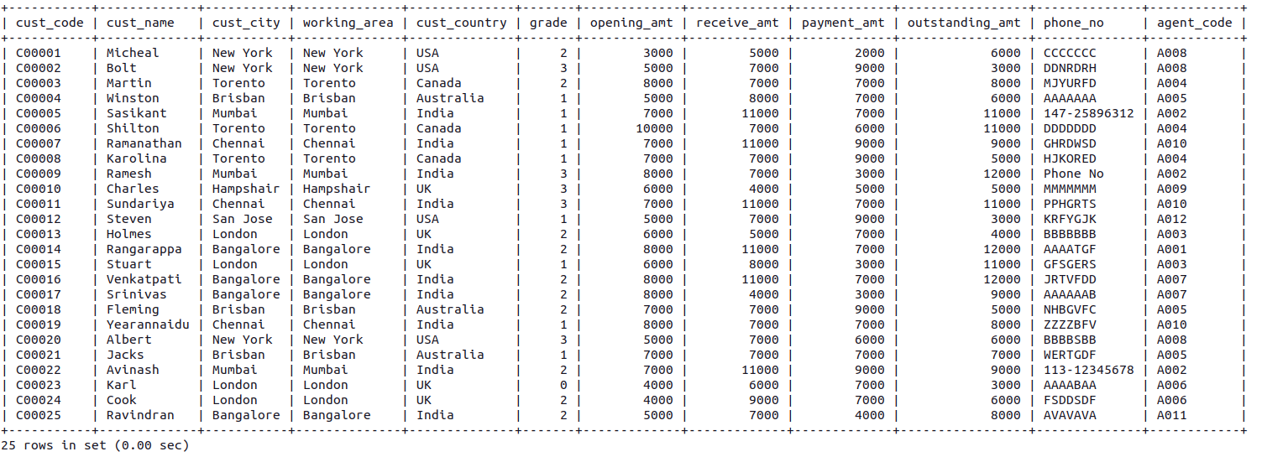

3.Agents-

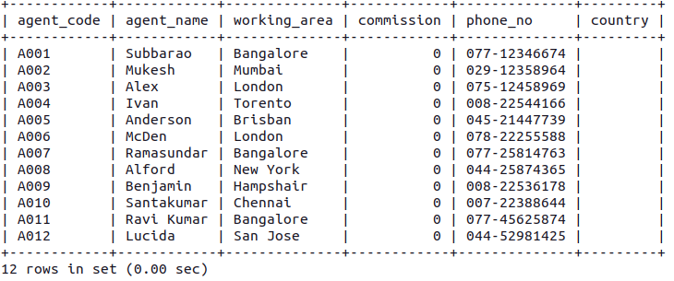

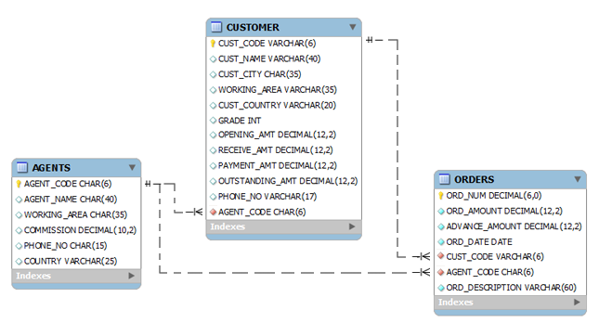

**Queries**

***DDL-***

***//Create***

*1. create database myshop*;

*2. create table agents(agent_code char(6) not null primary key,agent_name char(40),working_area char(35),commission int,phone_no char(15),country varchar(25) );*

***//Drop***

*3. drop database myshop2;*

*4. drop table products;*

***//Alter***

*5. alter table agents add country char(20);*

*6. alter table agents drop country;*

*7. alter table customers modify cust_name varchar(40);*

*8. alter table daily_orders rename to orders;*

*9. alter table orders change column date ord_date;*

*10. alter table agents add constraints unk_acode UNIQUE (agent_code);*

*11. alter table orders add primary key (ord_num);*

*12. alter table orders drop primary key;*

*13. alter table customers add acode_fk foreign key (agent_code) refrences agent(agent_code);*

*14. alter table customers drop foreign key acode_fk;*

*15. alter table orders add constraint chk_adv check(advance_amount<100 and ord_amount>1000);*

*16. alter table customers drop check chk_adv;*

*17. alter table orders alter ord_description set default “SOD”;*

*18. alter table orders alter ord_description drop default ;*

***//Truncate***

*19. truncate table products;*

***DML-***

***//Select-***

*19. select * from customers;*

*20. select ord_num,ord_date,ord_amount from orders;*

*21. select sum(commission) from agents;*

*22. select * from orders where ord_amount>3000;*

23. select * from orders where ord_amount>3000 and advance_amount<1000;

*24. select * from agents where agent_name like "S%";*

*25. select * from agents where agent_name like "%r";*

*26. select * from agents where agent_name like "__n_a%";*

*27. select * from agents where agent_name like "%f%";*

***//Insert***

*28. INSERT INTO agents VALUES ('A007', 'Ramasundar', 'Bangalore', '0.15', '077-25814763', '');*

***//Update***

*29. update customers set ord_amount+1000 where advance_payment<500;*

*30. update customers set ord_amount= where cust_code=200119;*

*31. update orders set ord_amount=ord_amount+100 where advance_amount<200;*

*32. update agents set commission=100 where commission=0;*

***//Delete***

*33. delete from orders where ord_amount<100;*

***//Using aliasis-***

*34. select ord_num,(ord_amount-advance_amount) as Due_Payment,ord_date from orders;*

*35. select distinct c.cust_code,cust_name,cust_city,c.agent_code from customers as c,orders as o where c.agent_code=o.agent_code;*

**//Count-**

36. select count(*) from orders where ord_amount>2000;

37. select count(cust_name) from customers where receive_amt>10000;

21. select count(distinct cust_country) from customers;

**//Group by-**

*38. select advance_amount,count(ord_num) from orders group by advance_amount;*

39. select cust_country, count(*) from customers group by cust_country;

40. select cust_country, max(opening_amt) from customers group by cust_country;

**//Order by**

*41. select cust_code,cust_name,payment_amt from customers order by payment_amt;*

*42. select ord_num, ord_amount, cust_code, ord_date from orders where ord_amount>3000 order by ord_date desc;*

***//Having-***

*43. select sum(outstanding_amt), cust_city from customers group by cust_city having cust_city="London";*

*44. select cust_country, avg(outstanding_amt) from customers group by cust_country having avg(outstanding_amt)>7000;*