**Lab 1**

#1. Install Numpy

import numpy as np

#2. Check the Numpy version installed

print(np.__version__)

1.23.4

#3. Create 1-D Array in numpy:

np_arr1=np.array([1,2,3,4])

#4. Use list to create 1D array (you may also specify data type i.e. dtype=’int16’)

lis=[5,4,3,2,1]

np_arr2=np.array(lis,dtype="int16")

type(np_arr2.dtype)

numpy.dtype[int16]

#5. User tuple to create 1D array

tup=(1,2,3,4,5,6)

#6. Use arange function to create 1D array of int

np_arr2=np.array(tup,dtype="int16")

type(np_arr2.dtype)

numpy.dtype[int16]

#7. Use arange function to create 1D array of float

#dtype = symbols(int->'i', uint->'u',float->'f',double->'d',complex->'D',bool->'b'

np_arr3=np.arange(10,dtype='f')

np_arr3

array([0., 1., 2., 3., 4., 5., 6., 7., 8., 9.], dtype=float32)

#8. Create 1D array of mixed elements int and float, and print the array and see the output

np_arr1=np.array([1,2.3,6,3.1,5,4.33])

print(np_arr1)

[1. 2.3 6. 3.1 5. 4.33]

#9. Create 1D array of mixed elements int, float, and str, then print the array and see the output

np_arr1=np.array(['asf',2.3,6,'l',5,4.33])

print(np_arr1)

['asf' '2.3' '6' 'l' '5' '4.33']

#10. Create a 2D array of dimensions 2x2

np_arr1=np.array([[1,2],[3,4]])

print(np_arr1)

[[1 2]

[3 4]]

#11. Print the shape, size, and memory used by this array in bytes (use itemsize, or nbytes)

print("Shape : ",np_arr1.shape)

print("Size : ",np_arr1.size)

print("ItemSize : ",np_arr1.itemsize)

print("Total Memory : ",np_arr1.size*np_arr1.itemsize)

Shape : (2, 2)

Size : 4

ItemSize : 8

Total Memory : 32

#12. Check the type of any array variable

print(type(np_arr1))

print(type(np_arr1[1][1]))

<class 'numpy.ndarray'>

<class 'numpy.int64'>

#13. Check indexing on array with help of examples

np_arr1[1][1]

4

#14. Using arange function create an 3D array of dimensions = (2,3,4) , first element of this array is 0 and last element is 23 in increasing order, store this array in a variable b.

b=np.arange(24).reshape(2,3,4)

print(b)

[[[ 0 1 2 3]

[ 4 5 6 7]

[ 8 9 10 11]]

[[12 13 14 15]

[16 17 18 19]

[20 21 22 23]]]

#15. What index can produce output:

# array([[ 0, 1, 2, 3],

# [ 4, 5, 6, 7],

# [ 8, 9, 10, 11]])

print(b[0])

[[ 0 1 2 3]

[ 4 5 6 7]

[ 8 9 10 11]]

#16. What index can produce output: 0

print(b[0][0][0])

0

#17. What index can produce output: array([4, 5, 6, 7])

b[0][1]

array([4, 5, 6, 7])

#18. What index can produce output: array([0,12])

b[:,0,0]

array([ 0, 12])

#19. What index can produce output: array([4,6])

b[:1,1,::2]

array([[4, 6]])

#20. Check the output of b[… , 1]

b[..., 1]

array([[ 1, 5, 9],

[13, 17, 21]])

#21. What index can produce output: array( [1, 5, 9] )

b[0,:,1]

array([1, 5, 9])

#22. What index can produce output: array([3,7,11])

b[0,:,3]

array([ 3, 7, 11])

#23. What index can produce output: array([11, 7,3])

b[0,-3:,3]

array([ 3, 7, 11])

#24. What index can produce output: array([3,11])

b[0,::2,3]

array([ 3, 11])

**Lab 2**

import pandas as pd

import numpy as np

#1. Create a simple Pandas Series from a list.

lis=[10,20,30,40,50]

sr=pd.Series(lis)

print(sr)

0 10

1 20

2 30

3 40

4 50

dtype: int64

#2. Return the first and last values of the Series created above

sr[0]

sr[4]

50

#3. Create a simple Pandas Series with your own labels i.e. index

label=['a','b','c','d']

df=pd.DataFrame([1,2,3,4],label)

print(df)

0

a 1

b 2

c 3

d 4

#4. Access the values using your own index and print the value, also try –ve index.

print(df[0][1])

print(df[0][-1])

2

4

#5. Create a simple Pandas Series from a dictionary

dic1={'a':23,'b':12,'c':18,'d':25,'e':18,'f':20,'g':12}

sr=pd.Series(dic1)

print(sr)

a 23

b 12

c 18

d 25

e 18

f 20

g 12

dtype: int64

#6. Create a Series using only calories intake data from user defined indexes "day1","day2", and "day3".

a,b,c=input().split()

dic2={'day1':int(a),'day2':int(b),'day3':int(c)}

sr1=pd.Series(dic2)

print(sr1)

455 656 459

day1 455

day2 656

day3 459

dtype: int64

#7. Create a Series of heterogeneous data types and check the data type of the Series as well as individual items.

dic2={'d':456,2:'hello',6.9:34}

sr2=pd.Series(dic2)

print(sr)

print(type(sr2[2]))

print(type(sr2['d']))

print(type(sr2))

a 23

b 12

c 18

d 25

e 18

f 20

g 12

dtype: int64

<class 'str'>

<class 'int'>

<class 'pandas.core.series.Series'>

#8. Compute min, max, mean values of a Series

print(sr.min())

print(sr.max())

print(sr.mean())

12

25

18.285714285714285

#14.Sort the values of a Series in ascending and descending order and print

print(sr.sort_values(),'\n')

print(sr.sort_values(ascending=False))

b 12

g 12

c 18

e 18

f 20

a 23

d 25

dtype: int64

d 25

a 23

f 20

c 18

e 18

b 12

g 12

dtype: int64

#15.Print the number of occurrences of unique values in a series. (use value_counts)

sr.value_counts()

12 2

18 2

23 1

25 1

20 1

dtype: int64

#16.Create a Series of 10 integers, and later change its dtype to be float (use astype).

sr3=pd.Series(range(10))

sr3=sr3.astype(float)

print(sr3)

0 0.0

1 1.0

2 2.0

3 3.0

4 4.0

5 5.0

6 6.0

7 7.0

8 8.0

9 9.0

dtype: float64

#17.Convert the Series you created above to numpy array (use to_numpy(), or array )

nparr=np.array(sr3)

print(nparr)

print(type(nparr))

[0. 1. 2. 3. 4. 5. 6. 7. 8. 9.]

<class 'numpy.ndarray'>

#18.Delete an item from Series using single index.

sr3.drop(9)

0 0.0

1 1.0

2 2.0

3 3.0

4 4.0

5 5.0

6 6.0

7 7.0

8 8.0

dtype: float64

#19.Find the number of items in a series. (use len or count)

print(len(sr3))

print(sr3.count())

10

10

#20. Append Series by assigning a value to a new index. (S[n]=v)

sr3[9]=33

sr3

0 0.0

1 1.0

2 2.0

3 3.0

4 4.0

5 5.0

6 6.0

7 7.0

8 8.0

9 33.0

dtype: float64

#21.Check if a value is present in a Series. (use type cast to a set or check in values)

print(3 in sr3)

print(53 in sr3)

True

False

#22. Print the index of a Series and also if all indexes appear only once. (use is_unique)

pd.Index(sr2).is_unique

True

#23. Create two Series one with default index, other with index like ‘a’,’b’,’c’,’d’, etc. then access both the Series based on label and position

s1=pd.Series([0,1,2,3,4])

s2=pd.Series(range(0,5), index=['a','b','c','d','e'])

print(s1)

print(s2)

0 0

1 1

2 2

3 3

4 4

dtype: int64

a 0

b 1

c 2

d 3

e 4

dtype: int64

#24. Try function at and iat on above problem and observe the difference in output with respect to loc and iloc.

print(sr2.iat[2])

print(sr2.at[2])

34

hello

**Lab 3**

#Ex:1

import pandas as pd

import numpy as np

df=pd.DataFrame([1,3,5,12,6,8],[10,11,12,20,50,8])

print(df)

0

10 1

11 3

12 5

20 12

50 6

8 8

#Ex:2

df=pd.DataFrame({'A':[1,3,5,12,6,8],'B':[10,11,12,20,50,8]},index=[0,1,2,3,4,5])

print(df)

A B

0 1 10

1 3 11

2 5 12

3 12 20

4 6 50

5 8 8

#1.b. Create a dataframe which looks like the output shown below.

df=pd.DataFrame({'a':[1,2,8,4],'b':[5,6,9,8],'c':[11,12,30,14]},index=[0,1,2,3])

print(df)

a b c

0 1 5 11

1 2 6 12

2 8 9 30

3 4 8 14

#1.b. Create a dataframe which looks like the output shown below.

df=pd.DataFrame({'X':[78,85,96,80,86],'Y':[84,94,89,83,86],'Z':[86,97,96,72,83]},index=[0,1,2,3,4])

print(df)

X Y Z

0 78 84 86

1 85 94 97

2 96 89 96

3 80 83 72

4 86 86 83

#2. Create and display a DataFrame from a specified dictionary data which has the index labels.:

exam_data = {'name': ['Anastasia', 'Dima', 'Katherine', 'James', 'Emily', 'Michael', 'Matthew', 'Laura', 'Kevin', 'Jonas'],

'score': [12.5, 9, 16.5, np.nan, 9, 20, 14.5, np.nan, 8, 19],

'attempts': [1, 3, 2, 3, 2, 3, 1, 1, 2, 1],

'qualify': ['yes', 'no', 'yes', 'no', 'no', 'yes', 'yes', 'no', 'no', 'yes']}

labels = ['a', 'b', 'c', 'd', 'e', 'f', 'g', 'h', 'i', 'j']

df=pd.DataFrame(exam_data,labels)

print(df)

name score attempts qualify

a Anastasia 12.5 1 yes

b Dima 9.0 3 no

c Katherine 16.5 2 yes

d James NaN 3 no

e Emily 9.0 2 no

f Michael 20.0 3 yes

g Matthew 14.5 1 yes

h Laura NaN 1 no

i Kevin 8.0 2 no

j Jonas 19.0 1 yes

#3. Write a python script to display a summary of the basic information about a specified DataFrame and its data. Sample Python dictionary data and list labels:

df.info()

<class 'pandas.core.frame.DataFrame'>

Index: 10 entries, a to j

Data columns (total 4 columns):

# Column Non-Null Count Dtype

--- ------ -------------- -----

0 name 10 non-null object

1 score 8 non-null float64

2 attempts 10 non-null int64

3 qualify 10 non-null object

dtypes: float64(1), int64(1), object(2)

memory usage: 400.0+ bytes

#4. Write a python script to get the first 3 rows of a given DataFrame.

print(df.head(3))

name score attempts qualify

a Anastasia 12.5 1 yes

b Dima 9.0 3 no

c Katherine 16.5 2 yes

#5. Write a python script to select the 'name' and 'score' columns from the following DataFrame. Sample Python dictionary data and list labels:

print(df.iloc[:,[1,3]])

score qualify

a 12.5 yes

b 9.0 no

c 16.5 yes

d 11.5 no

e 9.0 no

f 20.0 yes

g 14.5 yes

h NaN no

i 8.0 no

j 19.0 yes

#8. Write a python script to count the number of rows and columns of a DataFrame. Sample Python dictionary data and list labels:

print(len(df))

print(len(df.columns))

10

4

#9. Write a python script to select the rows where the score is missing, i.e. is NaN.

print(df[df['score'].isna()])

|  | name | score | attempts | qualify |
| --- | --- | --- | --- | --- |
| d | James | NaN | 3 | no |
| h | Laura | NaN | 1 | no |

#10. Write a python script to select the rows the score is between 15 and 20 (inclusive).

print(df[df['score'].between(15,20)])

name score attempts qualify

c Katherine 16.5 2 yes

f Michael 20.0 3 yes

j Jonas 19.0 1 yes

#11. Write a python script to select the rows where number of attempts in the examination is less than 2 and score greater than 15.

print(df[(df['score']>15) * (df['attempts']<2)])

name score attempts qualify

j Jonas 19.0 1 yes

#12. Write a python script to change the score in row 'd' to 11.5.

df.loc[['d'],['score']]=11.5

#13. Write a python script to calculate the sum of the examination attempts by the students.

df['attempts'].sum()

19

#14. Write a python script to calculate the mean score for each different student in DataFrame.

df['score'].mean()

13.333333333333334

#15. Write a python script to append a new row 'k' to data frame with given values for each column. Now delete the new row and return the original DataFrame.

df.loc['k'] = [1, 'Suresh', 'yes', 15.5]

df = df.drop('k')

print(df)

name score attempts qualify

a Anastasia 12.5 1 yes

b Dima 9.0 3 no

c Katherine 16.5 2 yes

d James 11.5 3 no

e Emily 9.0 2 no

f Michael 20.0 3 yes

g Matthew 14.5 1 yes

h Laura NaN 1 no

i Kevin 8.0 2 no

j Jonas 19.0 1 yes

#16.a. Write a python script to sort the DataFrame first by 'name' in descending order.

print(df.sort_values(by='name', ascending=False))

name score attempts qualify

f Michael 20.0 3 yes

g Matthew 14.5 1 yes

h Laura NaN 1 no

i Kevin 8.0 2 no

c Katherine 16.5 2 yes

j Jonas 19.0 1 yes

d James 11.5 3 no

e Emily 9.0 2 no

b Dima 9.0 3 no

a Anastasia 12.5 1 yes

#16.b. Write a python script to sort the DataFrame first by 'qualify' in descending order

print(df.sort_values(by= 'qualify', ascending=False))

name score attempts qualify

a Anastasia 12.5 1 yes

c Katherine 16.5 2 yes

f Michael 20.0 3 yes

g Matthew 14.5 1 yes

j Jonas 19.0 1 yes

b Dima 9.0 3 no

d James 11.5 3 no

e Emily 9.0 2 no

h Laura NaN 1 no

i Kevin 8.0 2 no

**Lab 4**

import pandas as pd

import numpy as np

from sklearn.datasets import fetch_openml

#1

df=pd.read_csv("housing.csv")

#2

print(df.info())

print(df.describe())

<class 'pandas.core.frame.DataFrame'>

RangeIndex: 20640 entries, 0 to 20639

Data columns (total 10 columns):

# Column Non-Null Count Dtype

--- ------ -------------- -----

0 longitude 20640 non-null float64

1 latitude 20640 non-null float64

2 housing_median_age 20640 non-null float64

3 total_rooms 20640 non-null float64

4 total_bedrooms 20433 non-null float64

5 population 20640 non-null float64

6 households 20640 non-null float64

7 median_income 20640 non-null float64

8 median_house_value 20640 non-null float64

9 ocean_proximity 20640 non-null object

dtypes: float64(9), object(1)

memory usage: 1.6+ MB

None

longitude latitude housing_median_age total_rooms \

count 20640.000000 20640.000000 20640.000000 20640.000000

mean -119.569704 35.631861 28.639486 2635.763081

std 2.003532 2.135952 12.585558 2181.615252

min -124.350000 32.540000 1.000000 2.000000

25% -121.800000 33.930000 18.000000 1447.750000

50% -118.490000 34.260000 29.000000 2127.000000

75% -118.010000 37.710000 37.000000 3148.000000

max -114.310000 41.950000 52.000000 39320.000000

total_bedrooms population households median_income \

count 20433.000000 20640.000000 20640.000000 20640.000000

mean 537.870553 1425.476744 499.539680 3.870671

std 421.385070 1132.462122 382.329753 1.899822

min 1.000000 3.000000 1.000000 0.499900

25% 296.000000 787.000000 280.000000 2.563400

50% 435.000000 1166.000000 409.000000 3.534800

75% 647.000000 1725.000000 605.000000 4.743250

max 6445.000000 35682.000000 6082.000000 15.000100

median_house_value

count 20640.000000

mean 206855.816909

std 115395.615874

min 14999.000000

25% 119600.000000

50% 179700.000000

75% 264725.000000

max 500001.000000

#3

print("Number of Rows : ",len(df))

print("Number of Columns : ",len(df.columns))

df.shape

Number of Rows : 20640

Number of Columns : 10

(20640, 10)

#4

y=df["median_house_value"]

#5

print(df.head(5))

print(df.iloc[:5,:])

longitude latitude housing_median_age total_rooms total_bedrooms \

0 -122.23 37.88 41.0 880.0 129.0

1 -122.22 37.86 21.0 7099.0 1106.0

2 -122.24 37.85 52.0 1467.0 190.0

3 -122.25 37.85 52.0 1274.0 235.0

4 -122.25 37.85 52.0 1627.0 280.0

population households median_income median_house_value ocean_proximity

0 322.0 126.0 8.3252 452600.0 NEAR BAY

1 2401.0 1138.0 8.3014 358500.0 NEAR BAY

2 496.0 177.0 7.2574 352100.0 NEAR BAY

3 558.0 219.0 5.6431 341300.0 NEAR BAY

4 565.0 259.0 3.8462 342200.0 NEAR BAY

longitude latitude housing_median_age total_rooms total_bedrooms \

0 -122.23 37.88 41.0 880.0 129.0

1 -122.22 37.86 21.0 7099.0 1106.0

2 -122.24 37.85 52.0 1467.0 190.0

3 -122.25 37.85 52.0 1274.0 235.0

4 -122.25 37.85 52.0 1627.0 280.0

population households median_income median_house_value ocean_proximity

0 322.0 126.0 8.3252 452600.0 NEAR BAY

1 2401.0 1138.0 8.3014 358500.0 NEAR BAY

2 496.0 177.0 7.2574 352100.0 NEAR BAY

3 558.0 219.0 5.6431 341300.0 NEAR BAY

4 565.0 259.0 3.8462 342200.0 NEAR BAY

#6

df.describe()

|  | longitude | latitude | housing_median_age | total_rooms | total_bedrooms | population | households | median_income | median_house_value |
| --- | --- | --- | --- | --- | --- | --- | --- | --- | --- |
| count | 20640.000000 | 20640.000000 | 20640.000000 | 20640.000000 | 20433.000000 | 20640.000000 | 20640.000000 | 20640.000000 | 20640.000000 |
| mean | -119.569704 | 35.631861 | 28.639486 | 2635.763081 | 537.870553 | 1425.476744 | 499.539680 | 3.870671 | 206855.816909 |
| std | 2.003532 | 2.135952 | 12.585558 | 2181.615252 | 421.385070 | 1132.462122 | 382.329753 | 1.899822 | 115395.615874 |
| min | -124.350000 | 32.540000 | 1.000000 | 2.000000 | 1.000000 | 3.000000 | 1.000000 | 0.499900 | 14999.000000 |
| 25% | -121.800000 | 33.930000 | 18.000000 | 1447.750000 | 296.000000 | 787.000000 | 280.000000 | 2.563400 | 119600.000000 |
| 50% | -118.490000 | 34.260000 | 29.000000 | 2127.000000 | 435.000000 | 1166.000000 | 409.000000 | 3.534800 | 179700.000000 |
| 75% | -118.010000 | 37.710000 | 37.000000 | 3148.000000 | 647.000000 | 1725.000000 | 605.000000 | 4.743250 | 264725.000000 |
| max | -114.310000 | 41.950000 | 52.000000 | 39320.000000 | 6445.000000 | 35682.000000 | 6082.000000 | 15.000100 | 500001.000000 |

#6

import matplotlib.pyplot as plt

df.hist(bins=50,figsize=(20,25))

plt.show()

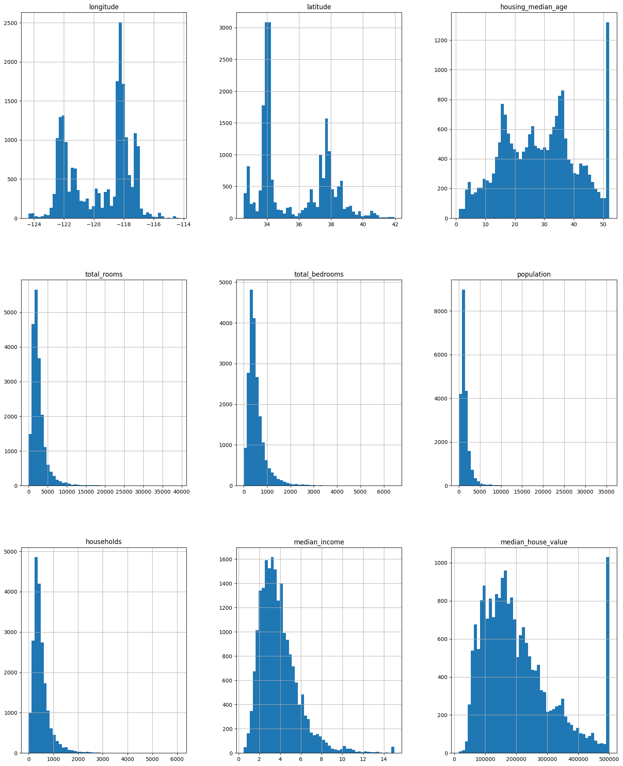

#8

n_val=""

df.isna().sum()

longitude 0

latitude 0

housing_median_age 0

total_rooms 0

total_bedrooms 207

population 0

households 0

median_income 0

median_house_value 0

ocean_proximity 0

dtype: int64

df.value_counts("ocean_proximity")

ocean_proximity

<1H OCEAN 9136

INLAND 6551

NEAR OCEAN 2658

NEAR BAY 2290

ISLAND 5

dtype: int64

df.info()

<class 'pandas.core.frame.DataFrame'>

RangeIndex: 20640 entries, 0 to 20639

Data columns (total 10 columns):

# Column Non-Null Count Dtype

--- ------ -------------- -----

0 longitude 20640 non-null float64

1 latitude 20640 non-null float64

2 housing_median_age 20640 non-null float64

3 total_rooms 20640 non-null float64

4 total_bedrooms 20433 non-null float64

5 population 20640 non-null float64

6 households 20640 non-null float64

7 median_income 20640 non-null float64

8 median_house_value 20640 non-null float64

9 ocean_proximity 20640 non-null object

dtypes: float64(9), object(1)

memory usage: 1.6+ MB

#10

df["total_bedrooms"]=df["total_bedrooms"].fillna(df["total_bedrooms"].mode())

df.info()

<class 'pandas.core.frame.DataFrame'>

RangeIndex: 20640 entries, 0 to 20639

Data columns (total 10 columns):

# Column Non-Null Count Dtype

--- ------ -------------- -----

0 longitude 20640 non-null float64

1 latitude 20640 non-null float64

2 housing_median_age 20640 non-null float64

3 total_rooms 20640 non-null float64

4 total_bedrooms 20433 non-null float64

5 population 20640 non-null float64

6 households 20640 non-null float64

7 median_income 20640 non-null float64

8 median_house_value 20640 non-null float64

9 ocean_proximity 20640 non-null object

dtypes: float64(9), object(1)

memory usage: 1.6+ MB

#11

df["total_bedrooms"].sum()

10990309.0

#12

pd.cut(df["median_income"],bins=[0., 1.5, 3.0, 4.5, 6., np.inf],labels=[1, 2, 3, 4, 5])

0 5

1 5

2 5

3 4

4 3

..

20635 2

20636 2

20637 2

20638 2

20639 2

Name: median_income, Length: 20640, dtype: category

Categories (5, int64): [1 < 2 < 3 < 4 < 5]

#13

df.value_counts("median_income")

median_income

15.0001 49

3.1250 49

2.8750 46

4.1250 44

2.6250 44

..

3.2010 1

3.2015 1

3.2016 1

3.2021 1

3.7569 1

Length: 12928, dtype: int64

#14

df["median_income"].hist()

<Axes: >

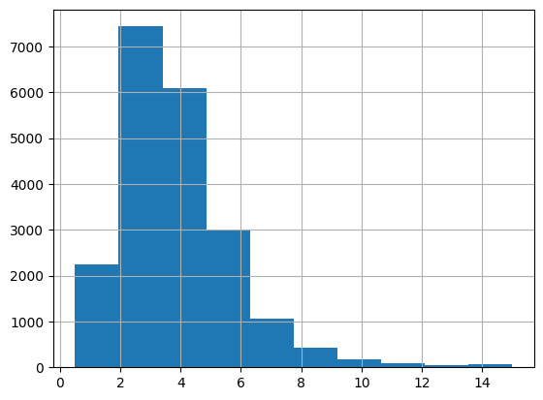

#15

temp_train,temp_test=df[:][:int((80/100)*len(df))],df[:][int((80/100)*len(df)):]

#16

temp_train["median_income"].hist()

temp_test["median_income"].hist()

<Axes: >

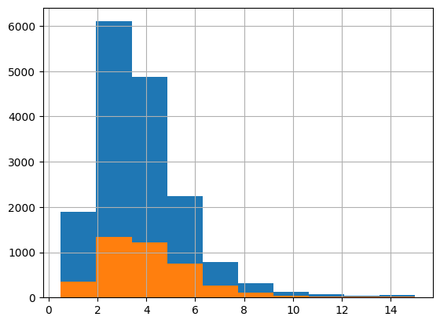

#17

from sklearn.model_selection import StratifiedShuffleSplit

split = StratifiedShuffleSplit(n_splits=1, test_size=0.2, random_state=42)

#for train_index, test_index in split.split(df, df["median_income"]):

# train = df.loc[train_index]

# test = df.loc[test_index]

#18

temp_train["median_income"].hist()

temp_test["median_income"].hist()

<Axes: >



#19

correlation=df.corr()

correlation["median_income"].sort_values()

/tmp/ipykernel_11888/2923073434.py:2: FutureWarning: The default value of numeric_only in DataFrame.corr is deprecated. In a future version, it will default to False. Select only valid columns or specify the value of numeric_only to silence this warning.

correlation=df.corr()

housing_median_age -0.119034

latitude -0.079809

longitude -0.015176

total_bedrooms -0.007723

population 0.004834

households 0.013033

total_rooms 0.198050

median_house_value 0.688075

median_income 1.000000

Name: median_income, dtype: float64

#20

from sklearn.preprocessing import OrdinalEncoder

from numpy import asarray

oe=OrdinalEncoder()

#df_cat_oe =oe.fit_transform(df["median_income"])

df_cat_oe=oe.fit_transform(asarray(df['median_income']).reshape(-1,1))

print(df_cat_oe)

[[12416.]

[12411.]

[11941.]

...

[ 1037.]

[ 1405.]

[ 2752.]]

**Lab 5**

#1.

import matplotlib.pyplot as plt

import pandas as pd

def test_value_on_bar_top():

x=["A","B","C","D"]

y=[1,2,3,4]

plt.bar(x,y)

for index,value in enumerate(y):

plt.text(index,value,str(value))

plt.show()

test_value_on_bar_top()

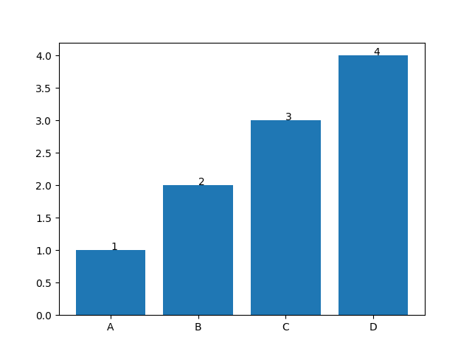

#2. Histplot

import matplotlib.pyplot as plt

import pandas as pd

emp_ages=[22,45,30,59,58,56,57,58,41,45,43,43,50,40,34,33,25,19]

bins=[0,10,20,30,40,50,60]

plt.hist(emp_ages,bins,rwidth=0.8,color="blue")

plt.show()

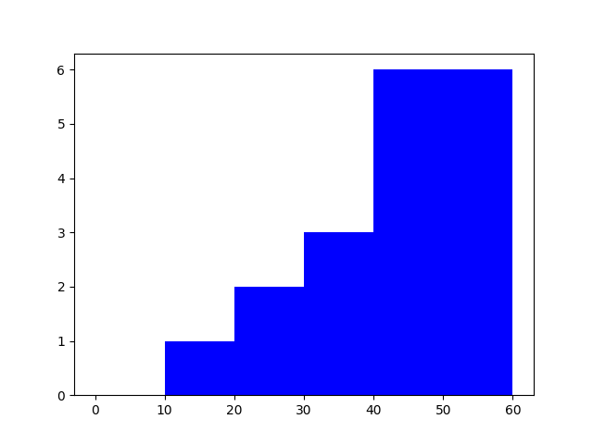

#3 Piechart

import matplotlib.pyplot as plt

import pandas as pd

slices=[15,14,24,16]

dept_name=['sales','production','hr','finance']

colors=['magenta','cyan','brown','gold']

plt.pie(slices,labels=dept_name,colors=colors,startangle=90,explode=(0,0.1,0.2,0.3))

plt.legend(title="Department wise expenditure")

plt.show()

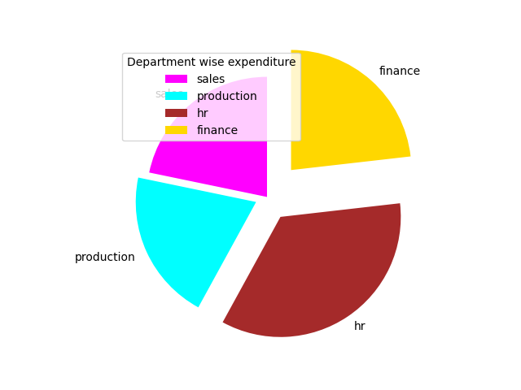

#4

import matplotlib.pyplot as plt

import pandas as pd

x=[2015,2016,2017,2018,2019,2020,2021,2022]

y=[9,10,8.5,8.9,12,7.51,12,8]

plt.plot(x,y,color="green",label="Profit")

plt.title="Company sales"

plt.xlabel="years"

plt.ylabel="Profit"

plt.legend("A")

plt.show()

