Economic Analysis of Peste des Petits Ruminants (PPR) Vaccination Program Across Africa

**Cost Assessment for Continental PPR Eradication Strategy**Analysis Date: September 2025

DRAFT

Prepared by Pilar, Fasina and Bouda

# 1. Introduction

Peste des Petits Ruminants (PPR) is a highly contagious viral disease affecting small ruminants, particularly goats and sheep, causing significant economic losses across Africa. The disease has been identified as a priority for global eradication by the Food and Agriculture Organization (FAO) and the World Organisation for Animal Health (WOAH), with ambitious targets, under the GF-TADs, set for continental elimination by 2030. Understanding the economic implications of large-scale vaccination programs is crucial for policy makers, international donors, and national governments planning PPR control strategies.  
  
This analysis examines the projected costs of implementing a continent-wide PPR vaccination program across 55 African countries, targeting 80% coverage of susceptible small ruminant populations. The study utilizes the VADEMOS tool (REF) forecasting model data combined with regional cost estimates to provide realistic budget projections for different implementation scenarios. The analysis considers variations in delivery mechanisms, ranging from public sector-led programs to private veterinary service delivery, and accounts for regional differences in infrastructure, logistics, and economic conditions that influence vaccination costs per animal.

# 2. Methods and Materials

The analysis was conducted using animal population data from the VADEMOS (Vaccine Demand Estimation and Models) forecasting system, which provides comprehensive livestock population projections for African countries. The dataset included forecasted values for goat and sheep populations, with specific projections for adult animals and second-year newborns across 55 African countries. Population data were aggregated to calculate total animals requiring vaccination under an 80% coverage scenario, representing the minimum threshold recommended by international veterinary authorities for effective disease control.  
  
Cost estimation methodology incorporated a systematic literature review of PPR vaccination program costs across different African regions, supplemented by consultation with regional veterinary authorities and international organizations (REF). Regional cost variations were established based on economic indicators, infrastructure development levels, and historical vaccination program data.

Three cost scenarios were developed: minimum cost (primarily private sector delivery with bulk procurement), average cost (mixed public-private delivery), and maximum cost (public sector delivery with standard procurement). The cost calculation formula applied was:

Total Cost = (Number of Animals × Coverage Rate) × Cost per Animal, where coverage rate was set at 80% and cost per animal varied by region and delivery scenario.

## 2.1 Cost Calculation Parameters

Table 1. References and other input data to be added

|  |  |  |  |
| --- | --- | --- | --- |
| **Region** | **Minimum Cost (USD)** | **Average Cost (USD)** | **Maximum Cost (USD)** |
| North Africa | $0.106 | $0.191 | $0.325 |
| West Africa | $0.106 | $0.191 | $0.325 |
| East Africa | $0.085 | $0.153 | $0.260 |
| Central Africa | $0.095 | $0.171 | $0.291 |
| Southern Africa | $0.127 | $0.229 | $0.389 |

# 3. Results

The comprehensive analysis reveals that implementing a continent-wide PPR vaccination program targeting 80% coverage would require vaccinating approximately 788.3 million small ruminants across 55 African countries. The total program cost is estimated at $141.5 million under the average implementation scenario, with costs ranging from $78.6 million (minimum scenario) to $240.7 million (maximum scenario). The average cost per animal across all regions is $0.180, reflecting the weighted distribution of animal populations and regional cost variations.  
  
Regional analysis demonstrates significant variations in both animal populations and associated costs. West Africa dominates the continental landscape with 415.6 million animals requiring vaccination (52.7% of total) at an estimated cost of $79.4 million, followed by East Africa with 259.1 million animals ($39.6 million cost). The concentration of costs in West Africa reflects both the large small ruminant populations in countries like Nigeria, Chad, and Mali, as well as the relatively higher cost structure compared to East Africa. Country-level analysis identifies Nigeria as requiring the largest investment ($22.4 million), followed by Chad ($15.3 million) and Ethiopia ($13.4 million), collectively representing 36% of the total continental vaccination cost.

## 3.1 Regional Analysis

Figure 1 illustrates the regional distribution of both vaccination costs and animal populations across Africa. West Africa accounts for the majority of both animals and costs, while Central Africa represents the smallest component of the continental program.

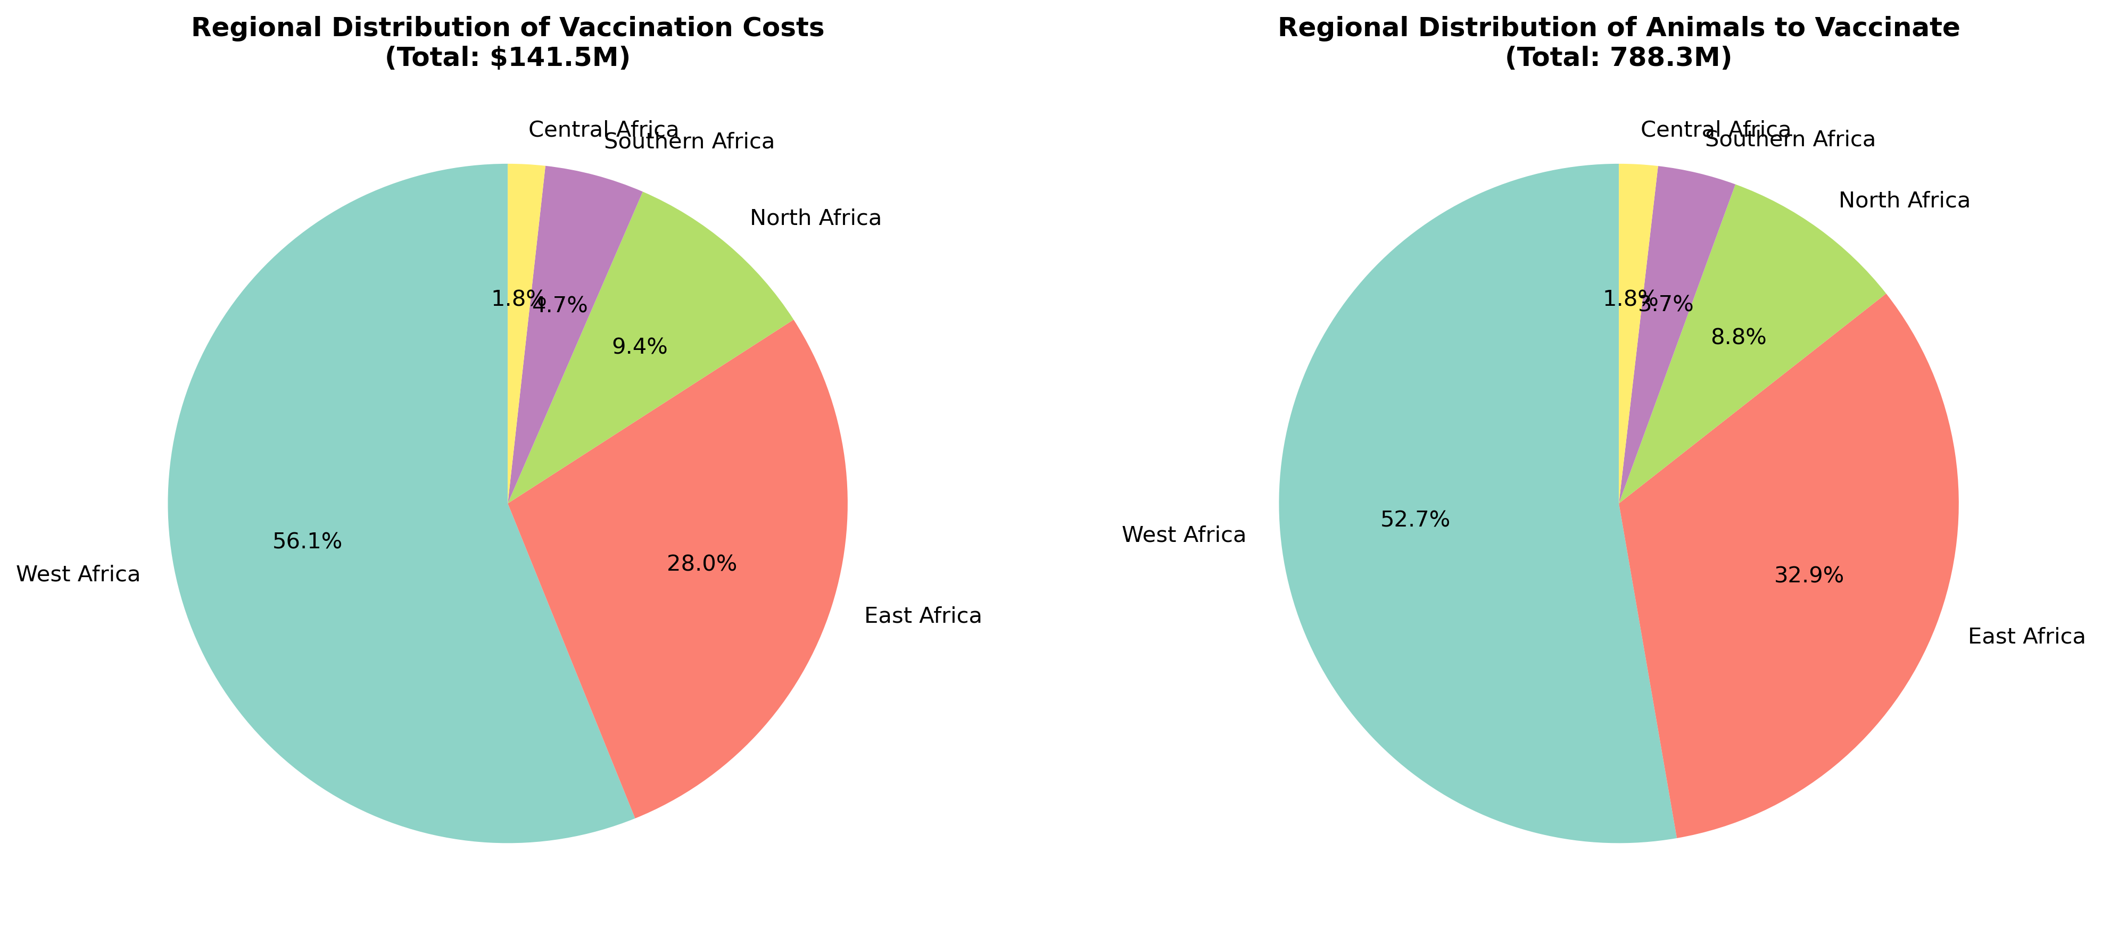

## 3.2 Country-Level Analysis

Figure 2 presents the vaccination costs for the 15 countries with the highest financial requirements. Nigeria leads with over $22 million needed, reflecting its massive small ruminant population of over 117 million animals.

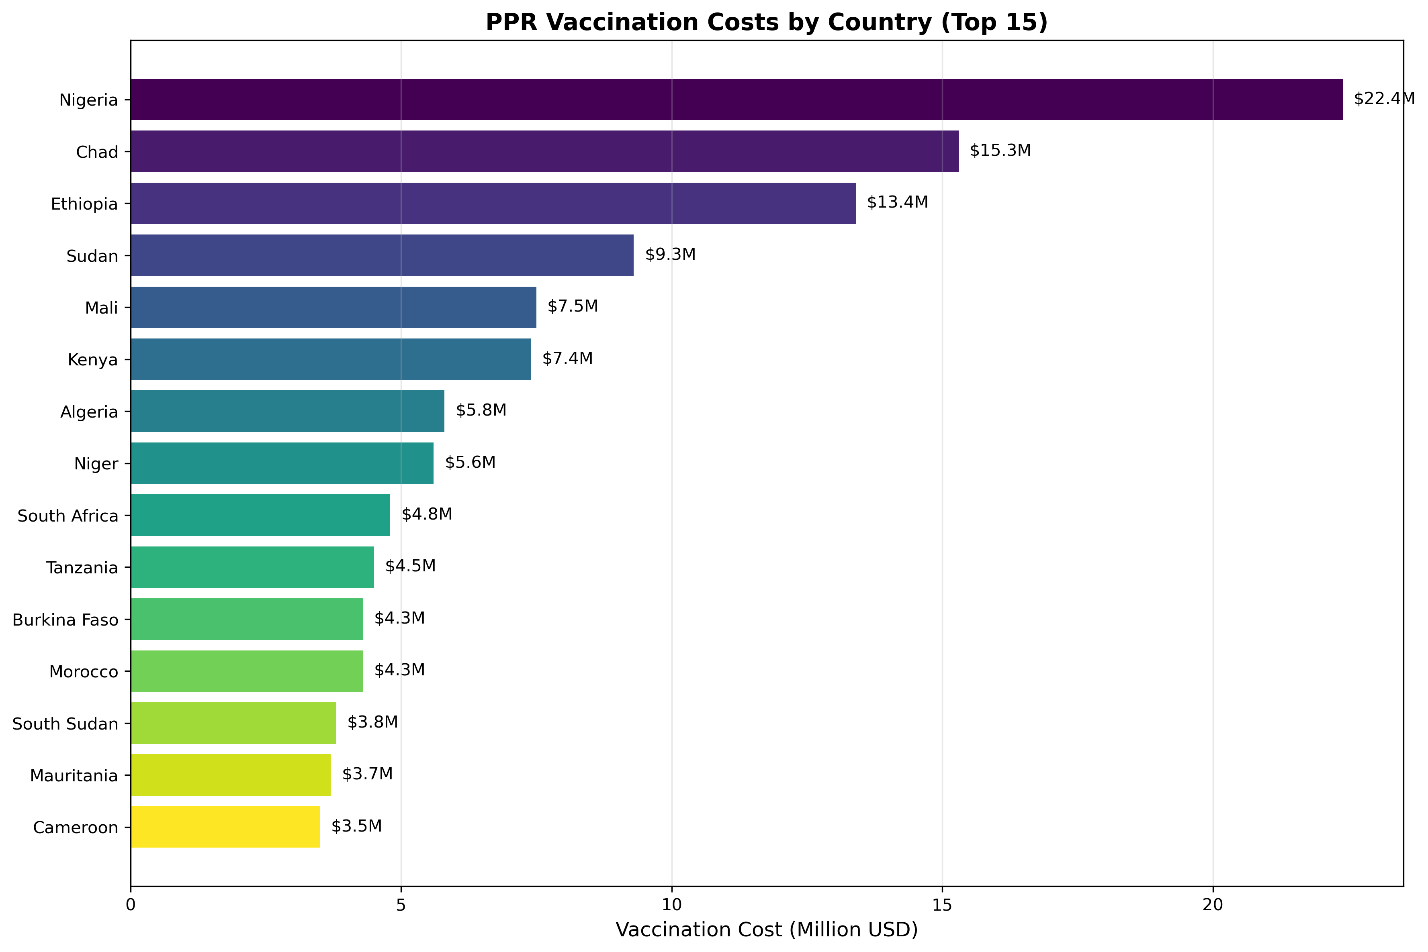

## 3.3 Cost Scenario Analysis

Figure 3 compares the three implementation scenarios, showing how delivery mechanisms significantly impact total program costs. The private sector scenario offers the most cost-effective approach, while public sector delivery represents the highest-cost option.

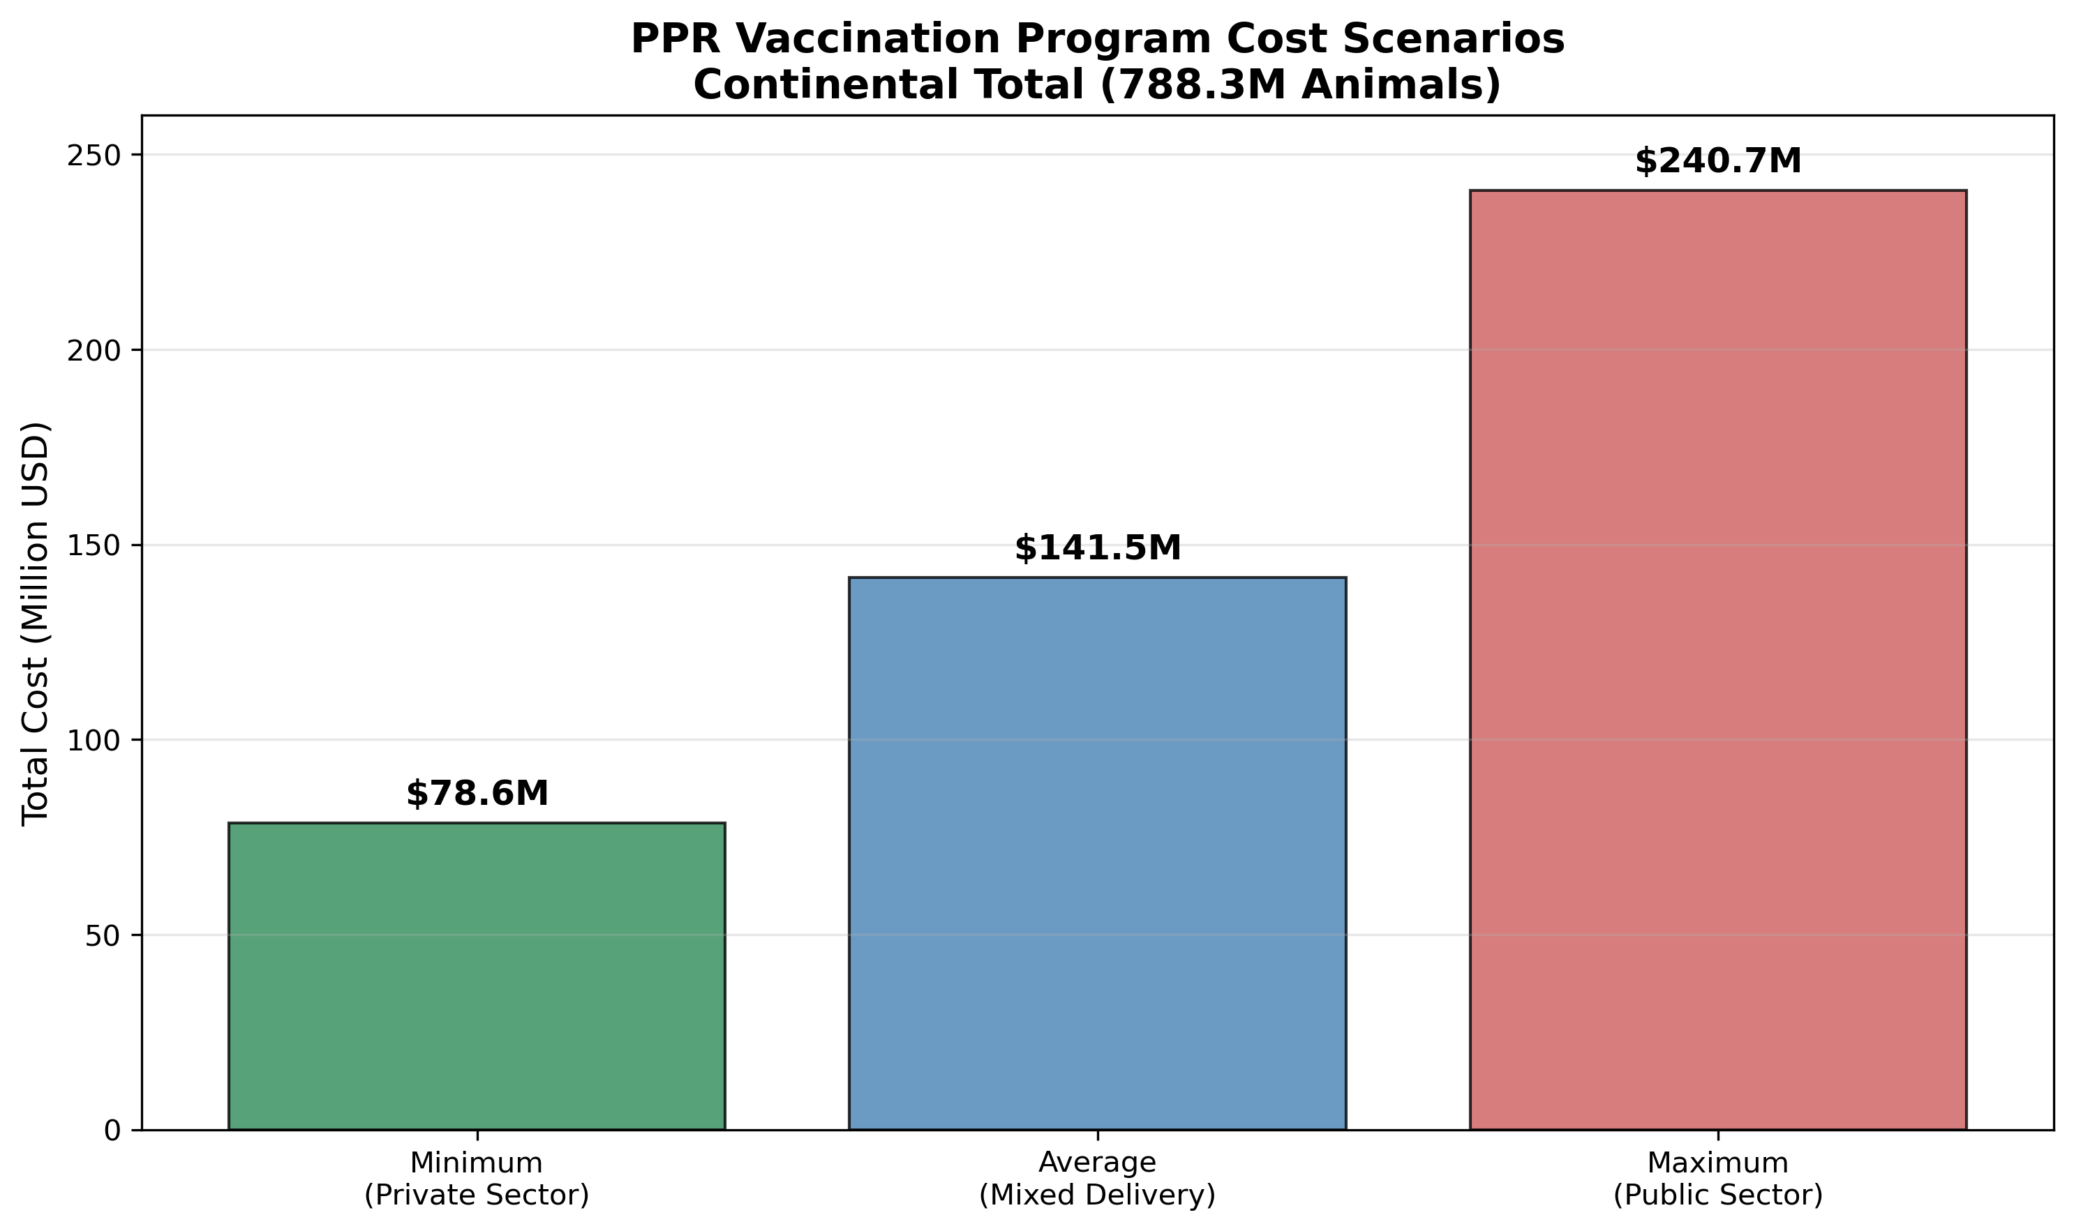

## 3.4 Summary Statistics

Table 1: Regional Summary of PPR Vaccination Program Costs

|  |  |  |  |  |
| --- | --- | --- | --- | --- |
| **Region** | **Countries** | **Animals (Millions)** | **Cost (Million USD)** | **Cost per Animal (USD)** |
| West Africa | 34 | 415.6 | 79.4 | 0.191 |
| East Africa | 8 | 259.1 | 39.6 | 0.153 |
| North Africa | 5 | 69.6 | 13.3 | 0.191 |
| Southern Africa | 4 | 29.4 | 6.7 | 0.229 |
| Central Africa | 4 | 14.5 | 2.5 | 0.171 |
| **TOTAL** | **55** | **788.3** | **141.5** | **0.180** |

# 4. Discussion

The economic analysis of continental PPR vaccination reveals several critical insights for policy planning and resource allocation. The estimated cost of $141.5 million for achieving 80% vaccination coverage across Africa represents a substantial but manageable investment when considered against the potential economic losses from uncontrolled PPR outbreaks. Historical studies have documented PPR-related losses exceeding $2 billion annually across affected regions, suggesting that the vaccination program would achieve a favorable return on investment within the first year of implementation. The regional cost variations, ranging from $0.153 per animal in East Africa to $0.229 per animal in Southern Africa, reflect important differences in veterinary infrastructure, logistics networks, and economic conditions that must be considered in program design.  
  
The concentration of costs in West Africa, representing 56% of total program expenses, highlights the critical importance of this region for continental PPR eradication success. Countries like Nigeria, Chad, and Mali not only harbor the largest small ruminant populations but also face significant logistical challenges that influence vaccination delivery costs. The analysis demonstrates that successful PPR eradication will require coordinated international support, with particular attention to capacity building in high-burden countries. The three-fold difference between minimum and maximum cost scenarios underscores the importance of delivery mechanism selection, suggesting that public-private partnerships and private sector engagement could significantly reduce program costs while maintaining coverage objectives.

# 5. Conclusion

This economic analysis provides essential baseline data for planning continental PPR eradication efforts across Africa. The total investment requirement of $141.5 million to vaccinate 788.3 million small ruminants represents a cost-effective intervention when weighed against the substantial economic losses associated with PPR outbreaks. The analysis reveals significant regional variations in both animal populations and vaccination costs, with West Africa requiring the largest financial commitment due to its extensive small ruminant populations and infrastructure challenges.  
  
The findings support the feasibility of continental PPR eradication from an economic perspective, particularly when considering the long-term benefits of disease elimination. The range of cost scenarios provides flexibility for program planners to optimize delivery mechanisms based on available resources and institutional capacity. Success will require sustained international cooperation, targeted capacity building in high-burden countries, and strategic public-private partnerships to achieve cost-effective vaccine delivery. These results provide a robust foundation for resource mobilization efforts and strategic planning for the ambitious goal of PPR eradication across Africa by 2030.

# Appendix A: Detailed Country-Level Data

Table A1: Complete Country-Level PPR Vaccination Cost Analysis

|  |  |  |  |  |  |
| --- | --- | --- | --- | --- | --- |
| **Country** | **Region** | **Goats (Millions)** | **Sheep (Millions)** | **Total Animals (Millions)** | **Total Cost (Million USD)** |
| Nigeria | West Africa | 58.4 | 58.8 | 117.2 | 22.4 |
| Chad | Central Africa | 40.1 | 39.9 | 80.0 | 15.3 |
| Ethiopia | East Africa | 43.8 | 43.8 | 87.6 | 13.4 |
| Sudan | East Africa | 30.5 | 30.5 | 61.0 | 9.3 |
| Mali | West Africa | 19.6 | 19.6 | 39.2 | 7.5 |
| Kenya | East Africa | 24.2 | 24.2 | 48.4 | 7.4 |
| Algeria | North Africa | 4.2 | 26.0 | 30.2 | 5.8 |
| Niger | West Africa | 14.5 | 14.5 | 29.0 | 5.6 |
| South Africa | Southern Africa | 10.5 | 10.5 | 21.0 | 4.8 |
| Tanzania | East Africa | 15.2 | 15.2 | 30.4 | 4.5 |
| Burkina Faso | West Africa | 11.2 | 11.2 | 22.4 | 4.3 |
| Morocco | North Africa | 2.8 | 19.7 | 22.5 | 4.3 |
| South Sudan | East Africa | 12.4 | 12.4 | 24.8 | 3.8 |
| Mauritania | West Africa | 9.7 | 9.7 | 19.4 | 3.7 |
| Cameroon | Central Africa | 9.1 | 9.1 | 18.2 | 3.5 |
| Senegal | West Africa | 8.5 | 8.5 | 17.0 | 3.2 |
| Somalia | East Africa | 10.5 | 10.5 | 21.0 | 3.2 |
| Ghana | West Africa | 8.2 | 8.2 | 16.4 | 3.1 |
| Libya | North Africa | 0.7 | 7.8 | 8.5 | 1.6 |
| Botswana | Southern Africa | 1.0 | 1.0 | 2.0 | 0.5 |

# Appendix B: Detailed Methodology

The VADEMOS forecasting system utilizes historical livestock census data, demographic models, and economic indicators to project small ruminant populations across African countries. Population projections account for natural growth rates, mortality patterns, and economic factors affecting livestock ownership. The 80% coverage target was selected based on epidemiological modeling indicating this threshold as necessary for effective PPR control and eventual eradication.  
  
Cost estimation incorporated data from multiple sources including FAO vaccination program reports, World Bank livestock development projects, and peer-reviewed studies from Ethiopia, Burkina Faso, Somalia, Nigeria, Ghana, Mali, and Senegal. Regional cost adjustments were applied using purchasing power parity indices, infrastructure development indicators, and veterinary service density metrics. The three cost scenarios reflect different delivery mechanisms: minimum costs assume private sector delivery with bulk vaccine procurement and efficient logistics; average costs represent mixed public-private delivery systems; maximum costs reflect public sector delivery with standard procurement procedures and government logistics networks.