Use Cases For Health Information system
A use case is a description of the ways in which a user interacts with a system or product. A use case may establish the success scenarios, the failure scenarios, and any critical variations or exceptions. A use case can be written or made visual with the help of a use case model tool.

System Description
The HIS is a software platform that is accessible to both patients and healthcare providers and has features such as:
- Telemedicine Platform: where users interacts with doctors via chat and video calls.Patients health records will also be managed efficiently
- Medication management: With this feature patients can track prescriptions given to them and will receive reminders on specific times to take their medication. In addition they will have access to diagnostic information anytime they take labs or consult the doctor.
- Health Data Visualization: Users will have access to view visual representation of health vitals and trends in their diagnoses.

Telemedicine Use Case Diagram
This diagram would include use cases related to remote consultations between patients and healthcare providers such as scheduling appointments, conducting video calls and accessing medical records during consultations.

Scenario: A patient wants to schedule a remote consultation with a healthcare provider using the telemedicine feature of the health information system.
Actors:
1.Patient: The individual seeking medical consultation remotely
2. Doctor: The medical professional providing remote consultations through the HIS.

Use Cases:
- Book Appointment: The patient requests to schedule an appointment for a remote consultation with a healthcare provider.
- Confirm Appointment: The system confirms the appointment and sends a notification to both the patient and the healthcare provider
- Join Video Call: The patient and the healthcare provider join a video call at the scheduled appointment time
- Access Medical Records: Both patient and healthcare provider can access relevant medical records, such as past appointments, medications and lab results during the consultation.
- End Consultation: After the consultation is complete,both parties end the video call.
- Cancel Appointment: The patient or the doctor can cancel an appointment.

Relationships:
- The "Book Appointment" and "Confirm Appointment" use cases involve interactions primarily between the patient and the system.
- The "Join Video Call" use cases involve interactions between both the patient and the healthcare provider and the system.
- The "Access Medical Records" use case involves interactions between both the patient and the healthcare provider and the system, with access to the relevant medical records.
- The “End Consultation”
- The “Cancel appointment”
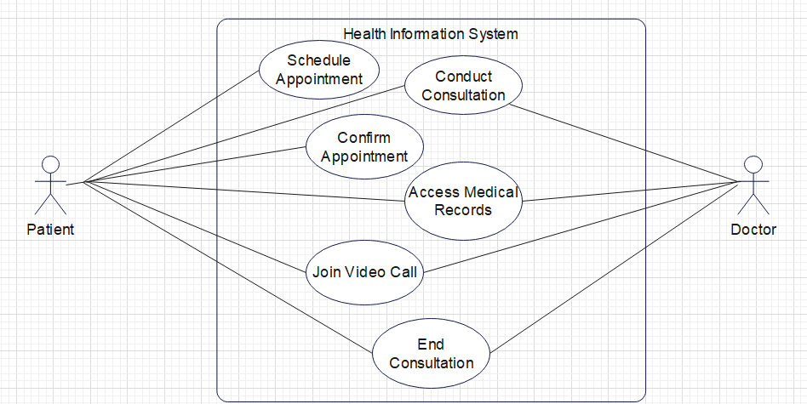

Medication Management Use Case Diagram
This diagram would focus on use cases related to medication management, including tracking prescriptions and setting medication reminders.
Scenario: A patient wants to manage their medication effectively using the Medication Management feature of the Health Information System.
Actors:
- Patient: The individual who needs to manage their medication regimen.
- Doctor: The doctor prescribes medication for the patient.
- System: The Health Information System facilitating medication management functionalities.
Use Cases:
- View Prescriptions: The patient views their current prescriptions within the system.
- Create prescription: The doctor adds a prescription to the patient's prescriptions.
- Cancel prescription: The doctor cancels medication on the patient's current prescription.
- Set Medication Reminders: The medication management system sets up reminders for patients to take drugs for their various prescriptions.
- Receive Medication Alerts: The system sends alerts or notifications to the patient for prescription refills, medication changes, or important updates.
- View Medical record:
- View Medication History: The patient views their medication history, including past prescriptions and adherence patterns.

Relationships:
- The "View Medications" use case involves interactions primarily between the patient and the system.
- The “Create Prescription”
- The “Cancel Prescription”
- The "Set Medication Reminders" use case involves interactions between the patient and the system to set up reminders.
- The "View Medical Record" use case involves interactions between the patient and the system to access the medical record for the particular medication.
- The "View Medication History" use case involves interactions between the patient and the system to view past medication data.
- The "Receive Medication Alerts" use case involves interactions between the system and the patient to send notifications.
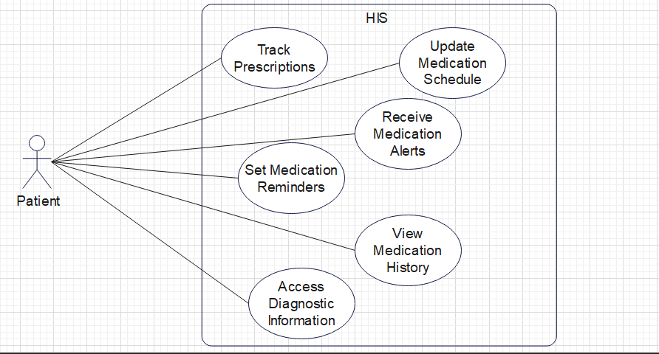

Health Data Management and Visualization Use Case Diagram
This diagram would depict use cases related to managing and visualizing health data and trends, such as viewing charts or graphs of vital signs over time and setting health goals.
Scenario: A patient wants to visualize their health data and trends, such as vital signs over time, and set health goals using the Health Data Visualization feature of the Health Information System.
Actors:
Patient: The individual who wants to monitor and visualize their health data.
Doctor: will attend to the patient and create a medical record.
Nurse: will book patient to doctor in-person appointment.
System: The Health Information System facilitating health data visualization functionalities.
Use Cases:

View Vital Signs Over Time: The patient views charts or graphs displaying their vital signs (e.g., blood pressure, heart rate) over a specified period.
Analyse Trends: The patient analyses trends in their health data to identify patterns or changes.
Set Health Goals: The patient sets specific health goals based on their health data and trends.
Track Progress: The patient tracks their progress towards achieving health goals by monitoring changes in their health data.
Receive Health Insights: The system provides insights or recommendations based on the patient's health data and goals.
Share Data with Healthcare Provider: The patient shares their health data visualization with their healthcare provider for discussion and analysis during consultations.
Relationships:
The "View Vital Signs Over Time" and "Analyse Trends" use cases involve interactions primarily between the patient and the system.
The "Set Health Goals" use case involves interactions between the patient and the system to establish goals.
The "Track Progress" use case involves interactions between the patient and the system to monitor progress towards goals.
The "Receive Health Insights" use case involves interactions between the system and the patient to provide insights or recommendations.
The "Share Data with Healthcare Provider" use case involves interactions between the patient and the system to share health data with healthcare providers.

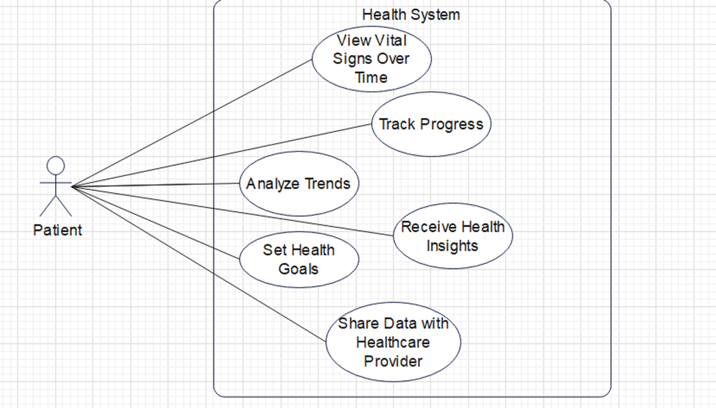

DATA LAYER
HIS uses a multiuser database that has the following features:
· Multi User: supports many users at a time.
· Enterprise: supports more than 50 users at a time.
· Centralized: supports data located at a single site.
· Operational: used for day-to-day operations.
· Semi-structured: stores some data in a structured format and other in the form in which it was collected (raw)

DATABASE DESIGN
In order to build a database structure that will be used to store and manage end user data, we had to focus on several activities which include organization of components that define and regulate the collection, storage, management and use of data within a database environment. This database system consists of hardware, software, people, procedures and data.
Hardware: Hardware in this database system includes physical devices such as computers (PCs, workstations, servers) and storage devices.
Software: To fully function, a database system requires three types of software: operating system software, managing hardware and enabling other software to run; Database Management System (DBMS) software, managing the database itself; and application programs and utilities, used to access and manipulate data and manage the computer environment within the system.
People: In this database system, there are two types of users: system and database administrators and designers, and end users. Each user type has unique and complementary functions, with system administrators overseeing general operations, database administrators managing the DBMS, database designers designing and implementing the database structure and end users using the application programs for daily operations and decision-making.
End-User: End users in this database system are individuals such as doctors or patients who utilize application programs to carry out daily operations within the hospital and at home. They also include high-level end users who leverage the information extracted from the HIS database to make tactical and strategic health decisions.
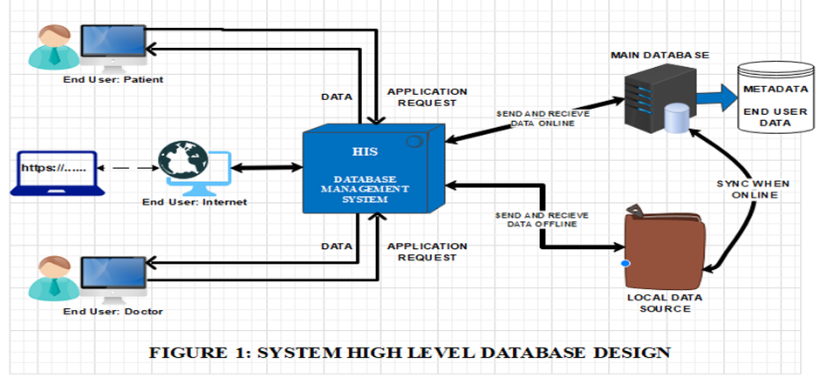

WHY A DATABASE?
A Database system was used due to several reasons including:
· Data dictionary management
· Data storage management
· Data transformation and presentation
· Security management
· Multi User access control
· Backup and recovery management
· Data integrity management.
· Database access languages and application programming interfaces
· Database communication interfaces

Keywords: Data Model, Data Modelling, model, entity, attribute, relationship, constraint, business rule,
DATA MODELING AND DATA MODELS
Data modeling is the first step in designing a database. It is an iterative progressive process which starts with simple understanding of the problem domain and as understanding of the problem domain increases so does the level of detail of the data model and if done properly, the final data model is in effect a blueprint of containing all the instructions to build a database that will meet all end-user requirements. This blueprint is narrative and graphical in nature, meaning that it contains both text descriptions in plain, unambiguous language and clear, useful diagrams depicting the main data elements and it is also an abstraction.
All data models are made up of entities, attributes (their characteristics), relationship (its association with other entities) and constraints (restrictions).
An entity represents a particular type of object in the real world.
ENTITIES
The HMS include entities such as doctor, patient, session, medical record, prescription, diagnosis, Investigation.
RELATIONSHIPS
The HMS at this stage uses two forms of relationships, ONE-TO-ONE (1-1) relationship, ONE-TO-MANY (1-M) relationships.

BUSINESS RULES
After a thorough understanding of what types of data are in the HIS, how the data are used, and in what time frames they are used, the data become meaningful after it reflects properly defined business rules. Business rules, derived from a detailed description of an organization’s operations, help to create and enforce actions within that organization’s environment.
MODEL 1
The various business rules for the HMS system at this stage of the design include:
· A doctor may add one or many patients
· A doctor may have no or many appointments with a patient
· A patient may have no or many appointments with a doctor
· A doctor may create one or many medical records (of a patient)
· A medical record may have no or any Investigations
· A medical record may have one or many prescription
· A medical record may have no or many diagnosis
· A patient can have one or more medical records.
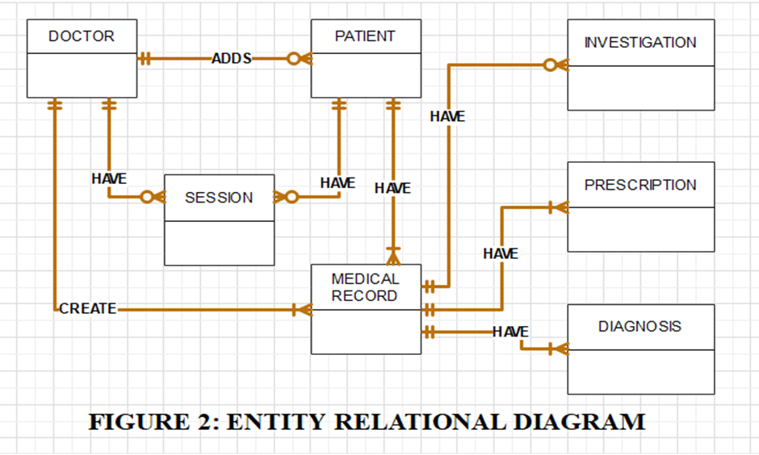

CHALLENGES
· The model does not allow a patient to create an account.
· Model does not allow patient access to the system.
· Model does not capture attributes of the entities
· Model is primitive and does not contain any constraints.
· All functionalities are concentrated on the doctor.
· There is no authentication in this model.
· There are less OOP concepts in this model.
· Model does not capture booking patients for appointments.
· There is no instance of a nurse in this HMS.

MODEL 2
In order to introduce OOP concepts, reduce concentration on the doctor and also capture booking of patients when they visit the hospital, MODEL1 was modified with a different set of rules. MODEL2 identifies every person as a USER who needs to sign up and login to the system, by doing so, will require authentication. The use of the USER object serves as a blueprint for different kinds of people who can interact with the HMS. The USER model is inherited by three types of classes: Doctor class, Patient Class and the Nurse class.
MODEL2 introduces the concept of OOP (inheritance) into the HMS which will make it more structured and independent and also reduces too much concentration on the doctor.
Business rules:
· A User can be a doctor, patient, or nurse
· A doctor attends to a patient
· A doctor can have an appointment with a patient
· A doctor can create a medical record for a patient
· A patient can book an appointment with a doctor
· A nurse can book a patient
· A nurse can register a patient
· A medical record can have an investigation
· A medical record can have a diagnosis
· A medical record has a medication
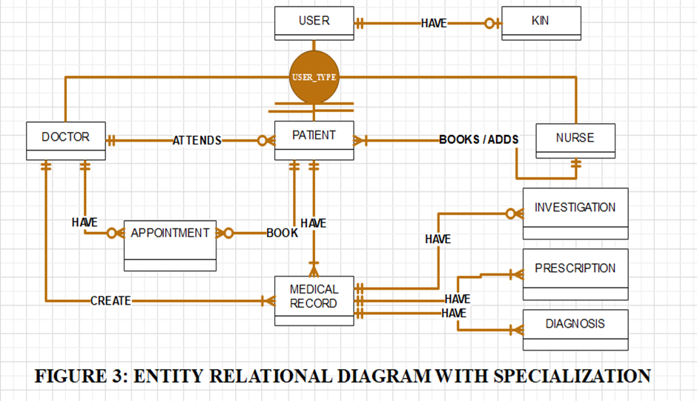

INTRODUCING ATTRIBUTES

