DATA LAYER

HIS uses a multiuser database that has the following features:

* Multiuser: supports many users at a time.
* Enterprise: supports more than 50 users at a time.
* Centralized: supports data located at a single site.
* Operational: used for day-to-day operations.
* Semi-structured: stores some data in a structured format and other in the form in which it was collected (raw)

**DATABASE DESIGN**

In order to build a database structure that will be used to store and manage end user data, we had to focus on several activities which include organization of components that define and regulate the collection, storage, management and use of data within a database environment. This database system consists of hardware, software, people, procedures and data.

**Hardware:** Hardware in this database system includes physical devices such as computers (PCs, workstations, servers) and storage devices.

**Software:** To fully function, a database system requires three types of software: operating system software, managing hardware and enabling other software to run; Data Base Management System (DBMS) software, managing the database itself; and application programs and utilities, used to access and manipulate data and manage the computer environment within the system.

**People:** In this database system, there are two types of users: system and database administrators and designers, and end users. Each user type has unique and complementary functions, with system administrators overseeing general operations, database administrators managing the DBMS, database designers designing and implementing the database structure and end users using the application programs for daily operations and decision-making.

**End-User:** End users in this database system are individuals such as doctors or patients who utilize application programs to carry out daily operations within the hospital and at home. They also include high-level end users who leverage the information extracted from the HIS database to make tactical and strategic health decisions.

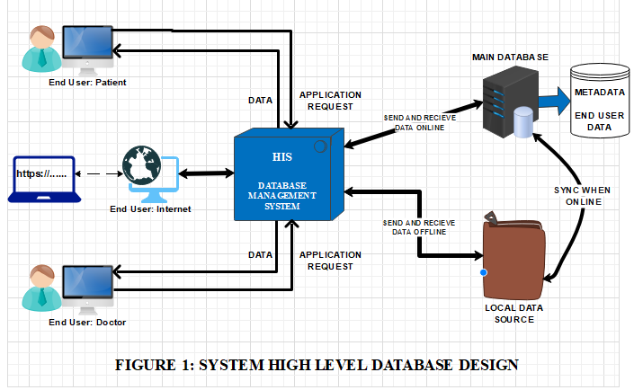

WHY A DATABASE?

A Database system was used due to several reasons including:

* Data dictionary management
* Data storage management
* Data transformation and presentation
* Security management
* Multiuser access control
* Backup and recovery management
* Data integrity management.
* Database access languages and application programming interfaces
* Database communication interfaces

Keywords: Data Model, Data Modelling, model, entity, attribute, relationship, constraint, business rule,

**DATA MODELING AND DATA MODELS**

Data modelling is the first step in designing a database. It is an iterative progressive process which starts with simple understanding of the problem domain and as understanding of the problem domain increases so does the level of detail of the data model and if done properly, the final data model is in effect a blueprint of containing all the instructions to build a database that will meet all end-user requirements. This blueprint is narrative and graphical in nature, meaning that it contains both text descriptions in plain, unambiguous language and clear, useful diagrams depicting the main data elements and it is also an abstraction.

All data models are made up of entities, attributes (their characteristics), relationship (its association with other entities) and constraints (restrictions).

An entity represents a particular type of object in the real world.

ENTITIES

The HMS include entities such as doctor, patient, session, medical record, prescription, diagnosis, Investigation.

RELATIONSHIPS

The HMS at this stage uses two form of relationships, ONE-TO-ONE (1-1) relationship, ONE-TO-MANY (1-M) relationships.

BUSINESS RULES

After a thorough understanding of what types of data are in the HIS, how the data are used, and in what time frames they are used, the data became meaningful after it reflected properly defined business rules. Business rules, derived from a detailed description of an organization’s operations, help to create and enforce actions within that organization’s environment.

**MODEL 1**

The various business rules for the HMS system at this stage of the design include:

* A doctor may add one or many patients
* A doctor may have no or many appointments with a patient
* A patient may have no or many appointments with a doctor
* A doctor may create one or many medical records (of a patient)
* A medical record may have no or any Investigations
* A medical record may have one or many prescription
* A medical record may have no or many diagnosis
* A patient can have one or more medical records.

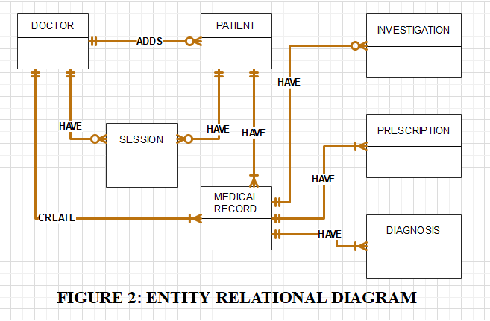

**CHALLENGES**

* The model does not allow a patient to create an account.
* Model does not allow patient access to system.
* Model does not capture attributes of the entities
* Model is primitive and does not contain any constraints.
* All functionalities are concentrated on the doctor.
* There is no authentication in this model.
* There is less OOP concepts in this model.
* Model does not capture booking patients for appointment.
* There is no instance of a nurse in this HMS.

**MODEL 2**

In order to introduce OOP concepts, reduce concentration on the doctor and also capture booking of patients when they visit the hospital, MODEL1 was modified with a different set of rules. MODEL2 identify every person as a USER who need to sign up and login to the system, by so doing, will require authentication. The use of the USER object serves as a blueprint for different kinds of people who can interact with the HMS. The USER model is inherited by three types of classes: Doctor class, Patient Class and the Nurse class.

MODEL2 introduces the concept of OOP (inheritance) into the HMS which will make it more structured and independently and also reduces too much concentration on the doctor.