Lab 5 : Animation and HUD

Lab Overview:
In Lab 4 you made a character that walks, runs, jumps, falls, rolls and collects coins. In this lab you will turn that prototype into something that feels like a real game, in four stages.
First, you will set up a root-motioned Flip animation, bake its movement into the pose, and extend the Animator graph from Lab 4 with a double jump: a second jump in mid-air that plays the flip, using a state with several competing transitions. You will then use an Animation Event to play a sound at an exact moment of the flip. Next, you will build a Start Menu in its own scene and learn how to switch scenes from buttons. Then you will add a small HUD (heads-up display) that shows the score from Lab 4 and a power-up icon with the time remaining. You will turn the double jump into a power-up: a pickup that disappears when collected, unlocks the double jump for 30 seconds, and reappears a few seconds later so it can be collected again. Finally, you will add an End scene that the player reaches at the end of the level, which shows their final score.
By the end of the lab you should be able to explain what root motion is and why we sometimes bake it into the pose, how the Animator chooses between several transitions leaving the same state, how an Animation Event lets a clip call your code at an exact frame, why a trigger parameter sometimes needs to be reset, how SceneManager.LoadScene() and the Build Profiles scene list work together, how a static variable carries a value from one scene to the next, how a UI element is anchored to the screen, and why a coroutine is a good fit for "wait, then do something".

Before You Start:
This lab does not start from your own Lab 4 project. Everyone starts from the same Lab 5 starter repo, which contains a finished version of Lab 4 plus the new Flip animation.
- Get the starter project:
- Open the GitHub Classroom assignment (or the repo) and clone it:
https://github.com/amcnabbbaltar/450_541_Lab6_2026
- Open the project in Unity 6 (the repo was made with 6000.5.7f1), then open Assets/Scenes/SampleScene.
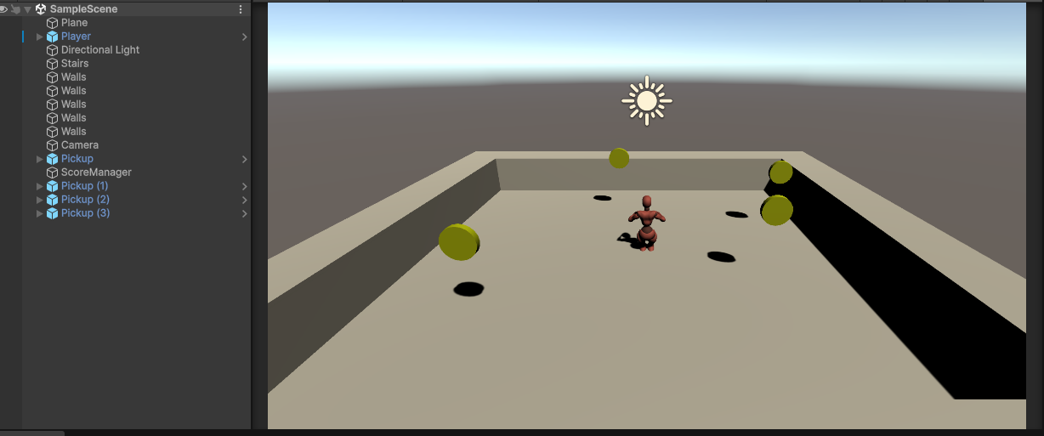
- Look at what you are starting with:
- Assets/Scripts: PlayerMovement, PlayerAnimatorController, RollBehaviour, ScoreManager and ScorePickup, the same scripts you wrote in Lab 4. Put every new script you create in this folder.
- Assets/Character: the Player prefab, the X Bot model and an Animations folder with Idle, Walking, Running, Falling, StandToRoll and the new FrontFlip, plus the PlayerAnimator controller.
- PlayerAnimator has three states, Idle Walk Run, Stand To Roll and Falling, and three parameters, CharacterSpeed, IsGrounded and doRoll.
- Assets/Prefab/Pickup: the coin from Lab 4, with its CoinSpin clip in Assets/CoinAnimation. A ScoreManager object is already in the scene.
- The Player in the scene is tagged Player and already has a Rigidbody, a Capsule Collider, Player Movement and Player Animator Controller.
- Check the Player's Avatar:
- Select the Player in the Hierarchy and look at its Animator component.
- Avatar must be X BotAvatar. If it shows None or Missing, click the circle next to the field and choose X BotAvatar.
- Press Play: the character should walk, run, jump, fall and roll, and coins should print the score in the Console. If the character slides around frozen in one pose, the Avatar is not set.
- 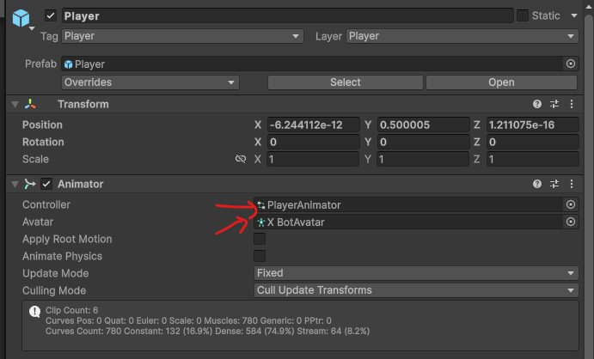
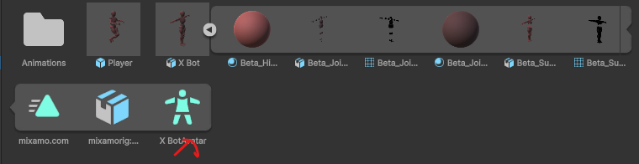
Good to know: The Player in the scene is an instance of a prefab. Components and values you add to it in this lab show up in bold with a blue line in the Inspector. These are called overrides and they are fine.
- Like Lab 4, this lab uses the classic Input Manager (Input.GetAxisRaw, Input.GetButtonDown).

Step-by-Step Solution:Task 1: Configure the Flip Animation and Bake Its Root Motion
This lab adds a double jump that plays a Flip animation. The clip, Flip, is already in the repo, but it is not ready to use: it still has its Mixamo name, and it was made with root motion, which would fight with our PlayerMovement script. In this task you will set the clip up and bake its movement into the animation.
- Find the Flip clip:
- Open Assets/Character/Animations. Select the FrontFlip FBX file, next to Idle, Walking, Running, Falling and StandToRoll.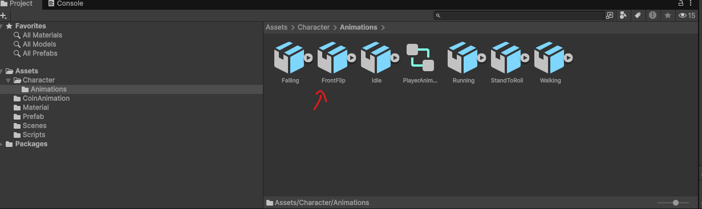
- Check the Rig: Humanoid, using the character's Avatar:
- With FrontFlip selected, open the Rig tab in the Inspector.
- Animation Type should already be Humanoid and Avatar Definition should be Copy From Other Avatar.
- Look at Source. It must be X BotAvatar, the same Avatar the Player uses. If it shows None or Missing, click the circle and choose X BotAvatar.
- Click Apply if you changed anything.
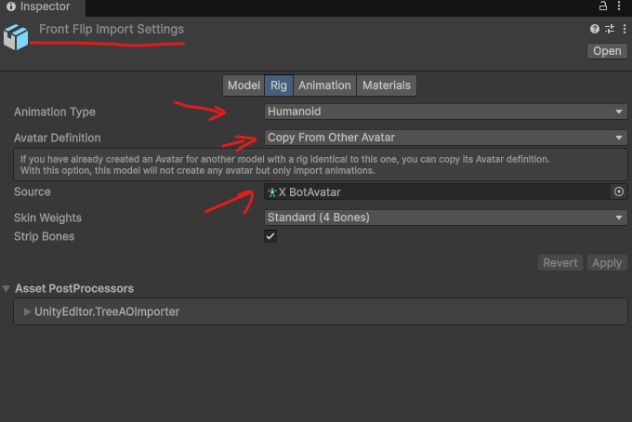
Why copy the Avatar? An Avatar is Unity's map of a humanoid skeleton (where the hips, spine, arms and legs are). When every clip uses the same Avatar, Unity can play any of them on our character without the bones twisting.
- See the root motion for yourself:
- Press the play button in the preview at the bottom of the Inspector and watch the character's position on the grid.
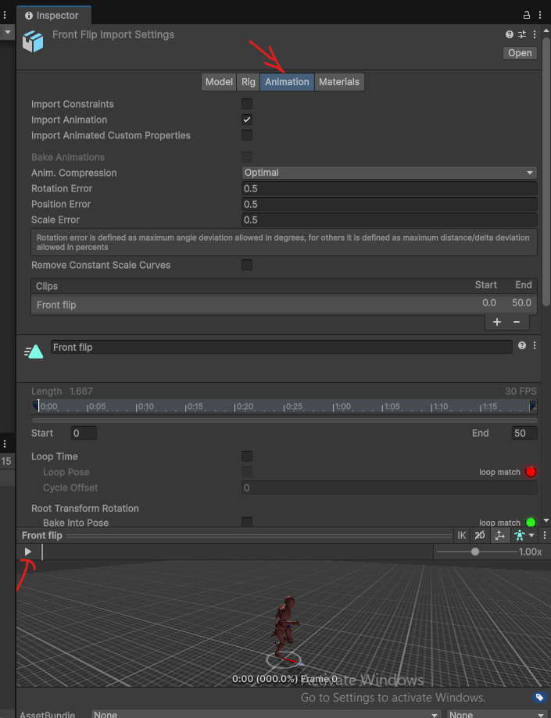

What is root motion? Every humanoid clip has a root: one point that stands for "where the character is". In a root-motioned clip, the animator moved that root, so the animation itself carries the character through the world. That is great when the animation should drive the movement (our roll in Lab 4 does this, through RollBehaviour). It is a problem when a script drives the movement: the Rigidbody and the clip would both be trying to move the player.
Why is it a problem for the double jump? PlayerMovement already decides how high and how far the double jump goes. If the Flip clip also moved the player, the character would drift away from its capsule collider, jump higher than the physics says, or end up facing the wrong way after the spin.
- Bake the root motion into the pose:
Still in the Animation tab, scroll down to the three Root Transform sections. For each one, Bake Into Pose tells Unity: "don't move the GameObject with this part of the motion, keep it inside the animated body instead."
- Make sure Loop Time is unchecked. A flip should play once, not forever.
- Root Transform Rotation: check Bake Into Pose, Based Upon: Original. The spin stays in the body, so the Player object never turns.
- Root Transform Position (Y): check Bake Into Pose, Based Upon: Original. The up-and-down movement stays in the body, so the height of the jump comes only from physics.
- Root Transform Position (XZ): check Bake Into Pose, Based Upon: Original. The forward travel stays in the body, so the horizontal movement comes only from PlayerMovement.
- Look at the small coloured circles next to each section (loop match). They are not important for a clip that doesn't loop.
- Click Apply.
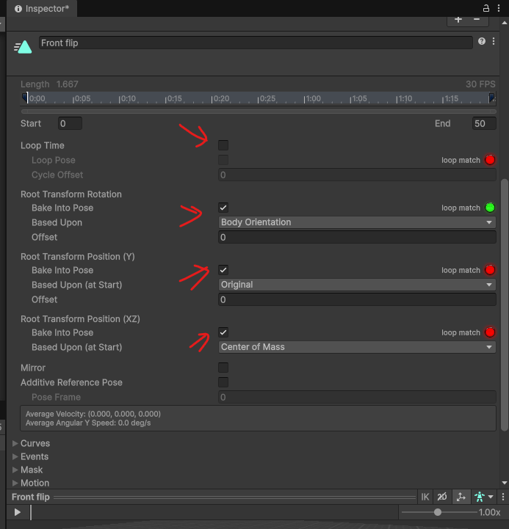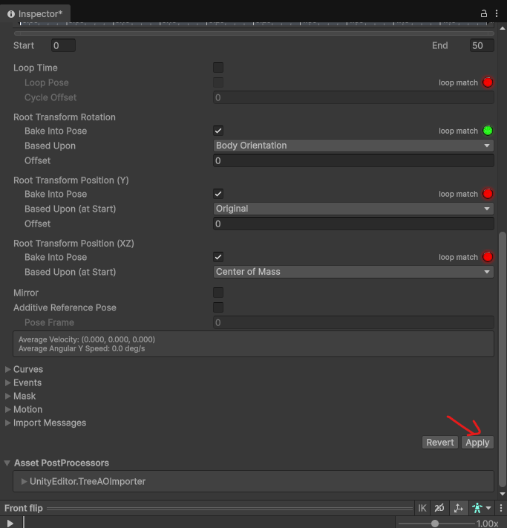
What does Bake Into Pose do? It moves that part of the root motion out of the root and into the pose. The body still spins and tucks on screen, but the root, and so the Player GameObject, stays exactly where our script puts it. With all three boxes checked, the clip has no root motion left.
- Check the result:
- Play the preview again. The character still flips, but the root no longer travels across the grid.
- In the Animator component on the Player, Apply Root Motion should be unchecked. (RollBehaviour only switches it on during the roll.)
- You will see the real result in Task 4: the character's body should stay inside its green capsule collider for the whole flip.
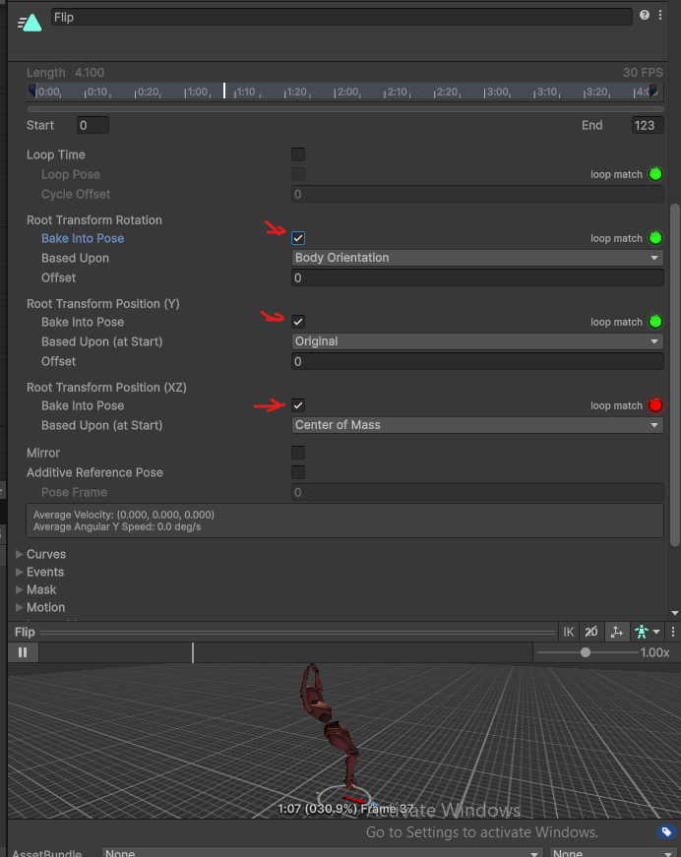
- Check your understanding:
- In your own words, what is the difference between a root-motioned animation and an "in place" animation?

Task 2: Add the Flip State to the Animator
In Lab 4 the Base Layer had three states: Idle Walk Run, Stand To Roll and Falling. You will now add a fourth state, Flip, directly in the Base Layer. It is different from the others in one important way: it can only be reached from Falling, so the Animator itself guarantees the flip never plays on the ground.
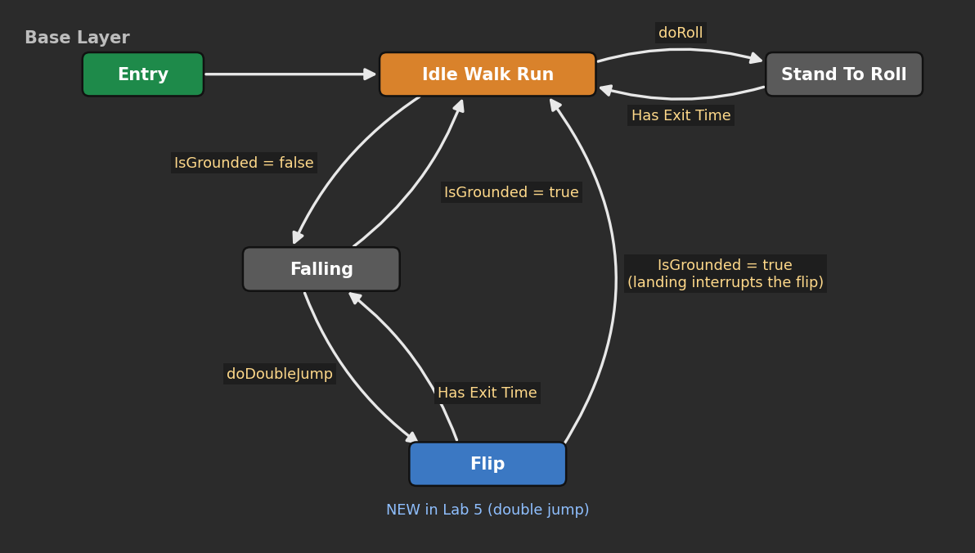
Figure 1: The Base Layer you will have at the end of Task 3
- Open the Animator and check the graph:
- Open the PlayerAnimator controller (double-click it in Assets/Character/Animations).
- You should see Idle Walk Run (orange), Stand To Roll and Falling, connected exactly as in Lab 4. Do not delete or change any of them.
- Check the two Falling transitions still have their conditions: IsGrounded = false going into Falling, and IsGrounded = true coming back.
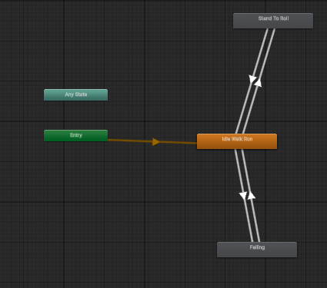
- Add the Flip state:
- Expand the FrontFlip FBX in the Project window (click the small arrow on the file) and drag its Flip clip into an empty area of the Animator, below Falling.
- A new grey state called Flip appears. It has no arrows yet, so the Animator can never reach it.
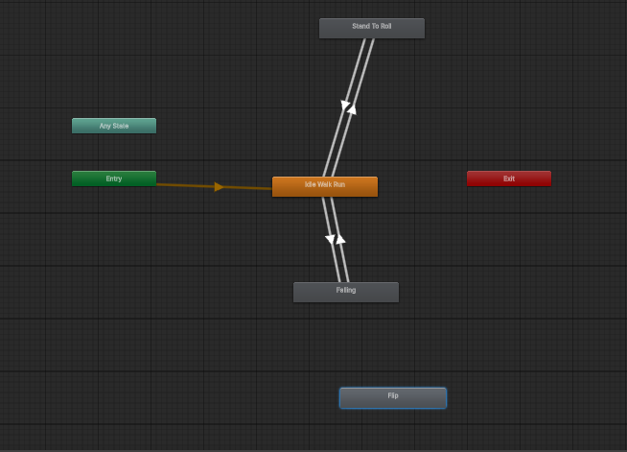
- Add the doDoubleJump parameter:
- In the Parameters tab, click + and add a Trigger called doDoubleJump.
- You should now have four parameters: CharacterSpeed (Float), IsGrounded (Bool), doRoll (Trigger) and doDoubleJump (Trigger).
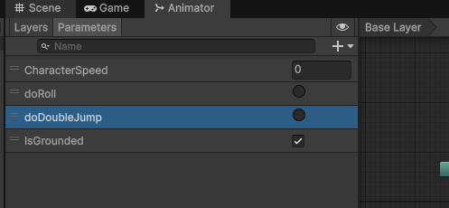

Task 3: Create the Flip Transitions
The rule we want is simple to say: the flip can only start while the player is in the air, and landing always wins. Flip will have one transition coming in and two going out.
- Falling → Flip (start the double jump):
- Right-click Falling > Make Transition > click Flip.
- Condition: doDoubleJump. Uncheck Has Exit Time so the flip starts the moment the button is pressed. Transition Duration: 0.1.
- Because this is the only arrow into Flip, the character must already be in Falling (in the air) for the flip to play.
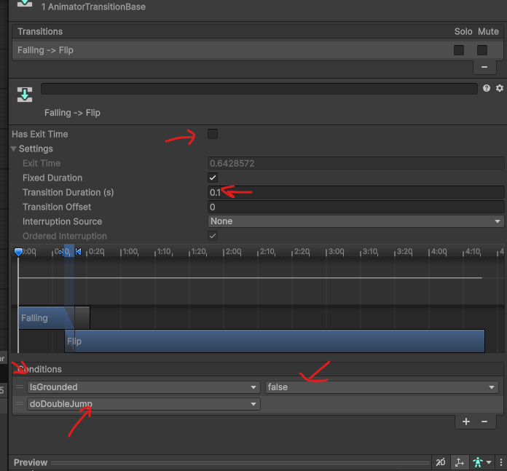

- Flip → Falling (flip finished, still in the air):
- Right-click Flip > Make Transition > click Falling.
- No condition. Leave Has Exit Time checked and set Exit Time to 0.9 and Transition Duration to 0.15.
- This is the same idea as the roll in Lab 4: the flip plays (almost) to the end before returning to Falling.
- 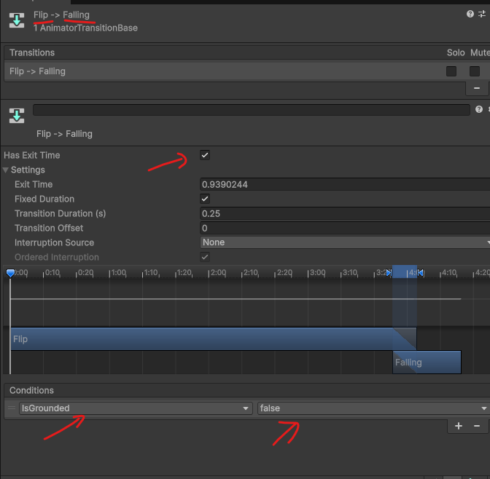

- Flip → Idle Walk Run (landing interrupts the flip):
- Right-click Flip > Make Transition > click Idle Walk Run.
- Condition: IsGrounded = true. Uncheck Has Exit Time. Transition Duration: 0.1.
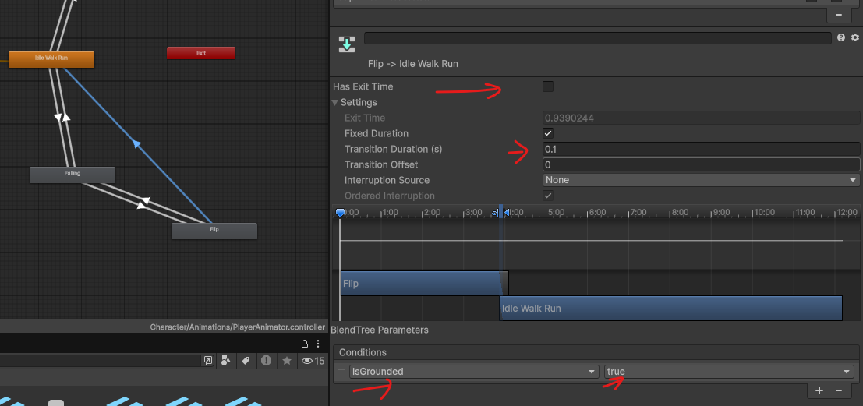
Why two ways out of Flip? If the player is still in the air when the flip ends, Has Exit Time sends it back to Falling. If the player lands in the middle of the flip, the IsGrounded = true transition fires right away, because it doesn't wait for an exit time. Without it, the character would finish flipping while standing on the ground.
Which transition wins? When a state has several outgoing transitions, Unity checks them from top to bottom in the Transitions list of the state's Inspector and takes the first one whose conditions are true. Select Flip and drag the IsGrounded = true transition to the top of that list so landing always has priority.
- Set the playback speed:
- Select the Flip state. In the Inspector, set Speed to 2.
- The clip is 51 frames long (about 1.7 seconds), but a double jump only lasts about a second, so the flip needs to play faster. Speed multiplies the clip's playback rate without changing the clip file itself. You will tune this value once you can test.
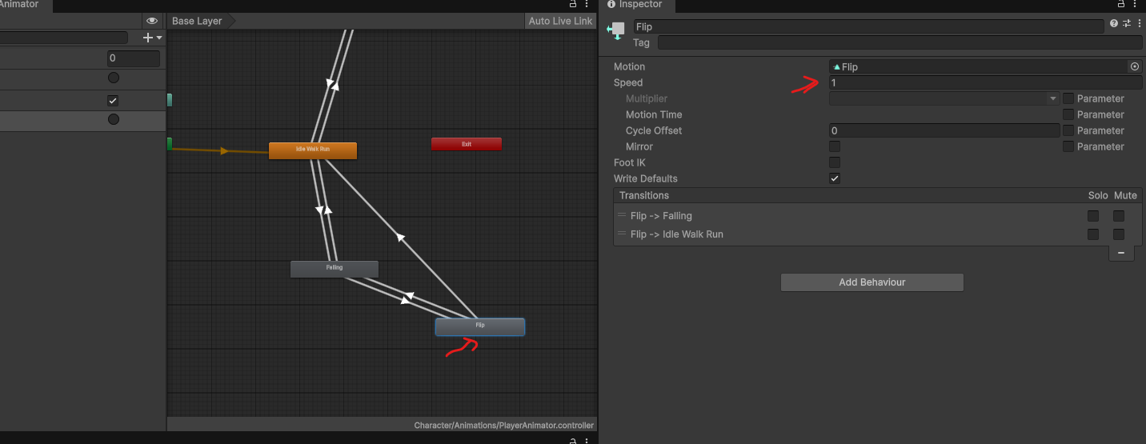

Task 4: Add the Double Jump and Trigger the Flip from Code
The Animator is ready, but nothing sends doDoubleJump yet, and the player can't actually jump twice. In this task you will add a real double jump to PlayerMovement, then update PlayerAnimatorController so the flip plays with it. For now the double jump is always available; in Task 9 you will lock it behind a power-up.
- Add a double jump to PlayerMovement:
The jump code lives in PlayerMovement, so that is where the double jump belongs. Open PlayerMovement (in Assets/Scripts) and make these five changes.
- 1. Under the Movement Settings header, add a force for the second jump:
[SerializeField] private float doubleJumpForce = 4f;
- 2. Next to private bool jumpRequested = false;, add two more flags:
private bool doubleJumpRequested = false; // set in TryDoubleJump()
private bool hasDoubleJumped = false; // one per jump
- 3. In Update(), just below the ground check line, give the double jump back when the player lands:
// Back on the ground: the double jump is available again
if (isGrounded)
{
hasDoubleJumped = false;
}
- 4. Replace FixedUpdate() and Jump() with these versions. Jump now receives the force to use, so the same method works for both jumps:
private void FixedUpdate()
{
MovePlayer();

if (jumpRequested)
{
Jump(jumpForce);
jumpRequested = false;
}

// NEW: the second jump, in mid-air
if (doubleJumpRequested)
{
Jump(doubleJumpForce);
doubleJumpRequested = false;
}
}

private void Jump(float force)
{
rb.linearVelocity = new Vector3(rb.linearVelocity.x, 0f,
rb.linearVelocity.z);
rb.AddForce(Vector3.up * force, ForceMode.VelocityChange);
}
- 5. Add this public method at the bottom of the class:
// Tries to jump a second time in mid-air.
// Returns true if the double jump really happened.
public bool TryDoubleJump()
{
// Not allowed on the ground, or if it was already used
if (isGrounded || hasDoubleJumped) return false;

doubleJumpRequested = true;
hasDoubleJumped = true;
return true;
}
- TryDoubleJump() only sets a flag, exactly like the Space key does with jumpRequested. The physics still happens in FixedUpdate(), where Rigidbody changes belong.
- It returns a bool so the caller knows whether the jump happened. We will use that to play the Flip animation only when the player really jumps.
- Jump() zeroes the vertical velocity first (from Lab 4), so the double jump gains the same height whether the player is still rising or already falling.
- Back in Unity, Double Jump Force appears on the Player Movement component. 4 is a little weaker than the normal jump (5): tune it to taste. ( higher than 5 will make the double jump higher than the first jump )
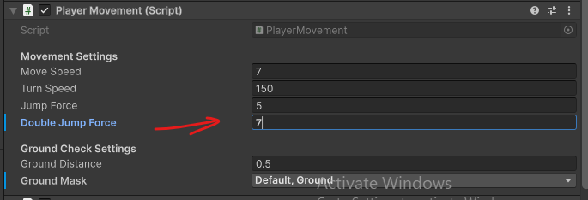
- Update PlayerAnimatorController to send doDoubleJump:
Open PlayerAnimatorController. When the player presses Space again in mid-air, it asks PlayerMovement for a double jump and, if that worked, starts the flip. Replace the whole script with:
using UnityEngine;

// Sends the player's movement to the Animator every frame
// so the right animation plays at the right time.
public class PlayerAnimatorController : MonoBehaviour
{
private Animator animator; // plays the animations
private PlayerMovement movement; // our movement script
private Rigidbody rb; // to read the player's speed

private void Start()
{
animator = GetComponent<Animator>();
movement = GetComponent<PlayerMovement>();
rb = GetComponent<Rigidbody>();
}

private void Update()
{
// Send the current speed to the blend tree
animator.SetFloat("CharacterSpeed", rb.linearVelocity.magnitude);

// On the ground? (controls Falling and ends the flip)
bool grounded = movement.IsGrounded;
animator.SetBool("IsGrounded", grounded);

// When Fire1 (left mouse button / left Ctrl) is released, roll
if (Input.GetButtonUp("Fire1"))
{
animator.SetTrigger("doRoll");
}

if (grounded)
{
// NEW: throw away a double jump request that was never used
animator.ResetTrigger("doDoubleJump");
}
else
{
// NEW: Double jump. Space again in mid-air.
// The flip only plays if PlayerMovement really jumped.
if (Input.GetButtonDown("Jump") && movement.TryDoubleJump())
{
animator.SetTrigger("doDoubleJump");
}
}
}
}
- Input.GetButtonDown("Jump") && movement.TryDoubleJump(): C# only evaluates the right side if the left side is true, so TryDoubleJump() is only called on the frame Space is pressed.
- The jump and the animation can never get out of sync: no jump, no flip.
Why ResetTrigger? A trigger stays "on" until a transition uses it. Imagine the player double jumps while the Animator is in a state with no arrow to Flip, for example after rolling off a ledge. The trigger is never used, so it waits, and the character would flip all by itself the next time it falls. Calling ResetTrigger("doDoubleJump") on the ground cancels any leftover request.
- Test the double jump:
- Press Play. Jump with Space, then press Space again in the air: the player jumps a second time and flips, then falls and lands into Idle Walk Run.
- Press Space a third time in the air: nothing happens. The double jump only works once per jump.
- Try landing on a higher platform in the middle of the flip: the flip should stop cleanly.
- Tune Speed on the Flip state and Double Jump Force until the flip finishes just before landing.
- Select the Player while the game runs and watch the Animator window: you will see the blue progress bar move from Idle Walk Run to Falling, to Flip and back.
Player jumps twice but doesn't flip? Check the Falling → Flip transition uses doDoubleJump with Has Exit Time off, and that the parameter name matches the script exactly (doDoubleJump, lowercase d).
Character keeps flipping after landing? The Flip → Idle Walk Run transition is missing, or it still has Has Exit Time checked.
Player ends up facing another way, or the body leaves the capsule during the flip? The clip still has root motion. Go back to Task 1 and check that Bake Into Pose is ticked for Rotation, Position (Y) and Position (XZ), then click Apply.
- Check your understanding:
- Flip has two outgoing transitions. Which one is taken if the player lands halfway through the flip, and why?

- There is no transition from Idle Walk Run to Flip. What does that guarantee, even if the script sent doDoubleJump by mistake while on the ground?

- TryDoubleJump() only sets doubleJumpRequested = true instead of calling Jump() right away. Why? (Think back to Update() vs. FixedUpdate() in Lab 4.)

- Why does TryDoubleJump() return a bool instead of void? What would go wrong in PlayerAnimatorController without it?

Task 6: Build a Start Menu Scene
Up to now, pressing Play drops you straight into the level. Real games start on a menu. A scene is a separate level file: our menu will live in its own scene called StartMenu, and the level you have been building stays in SampleScene.
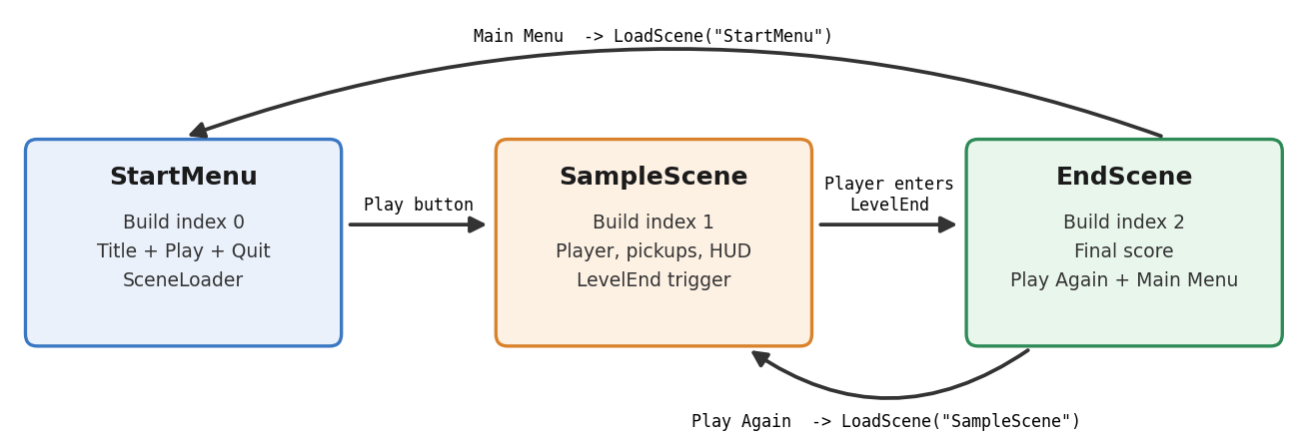
Figure 2: The three scenes you will have by the end of this lab (EndScene is built in Task 10)
- Create the StartMenu scene:
- Save SampleScene first (Ctrl+S).
- In the Project window open the Scenes folder, right-click and choose Create > Scene (in some Unity 6 versions: Create > Scene > Scene). Name it
- 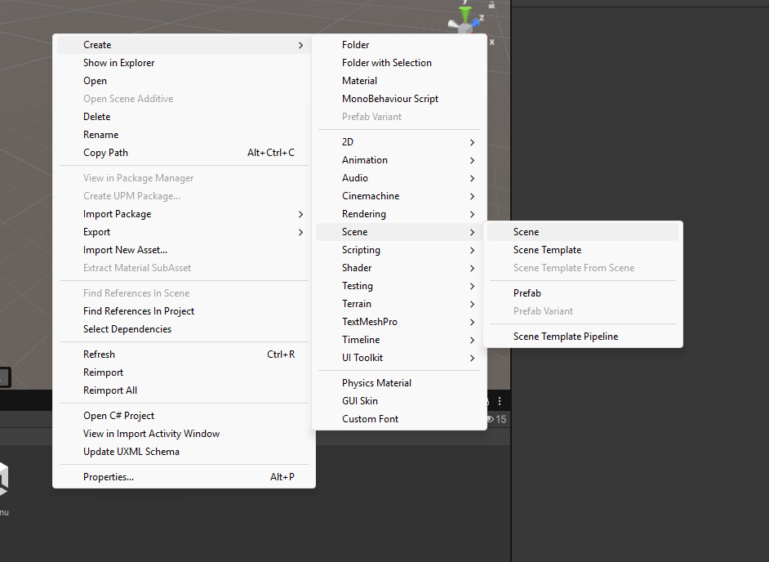StartMenu.
- Double-click StartMenu to open it. It only contains a Main Camera and a Directional Light.
- 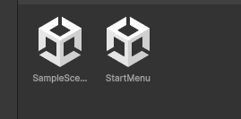
- Create a Canvas:
- In the Hierarchy right-click > UI > Canvas. Unity also creates an EventSystem: this is what lets the mouse click buttons, so don't delete it.
- Select the Canvas. In the Canvas Scaler component set UI Scale Mode to Scale With Screen Size, Reference Resolution to 1920 x 1080, and Match to 0.5.
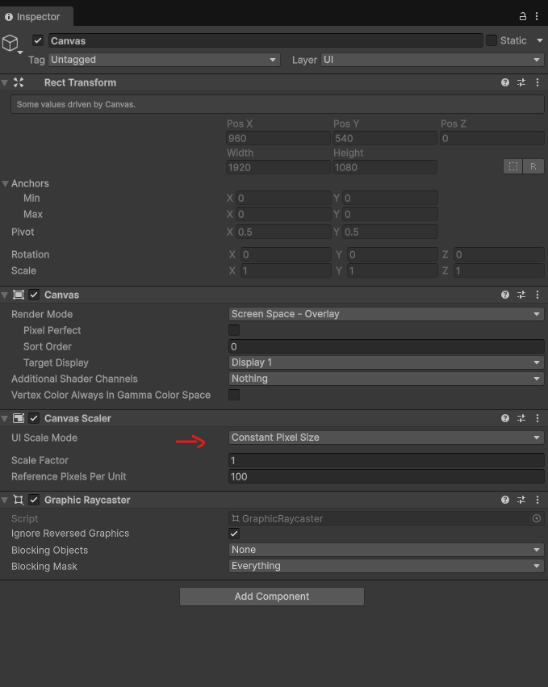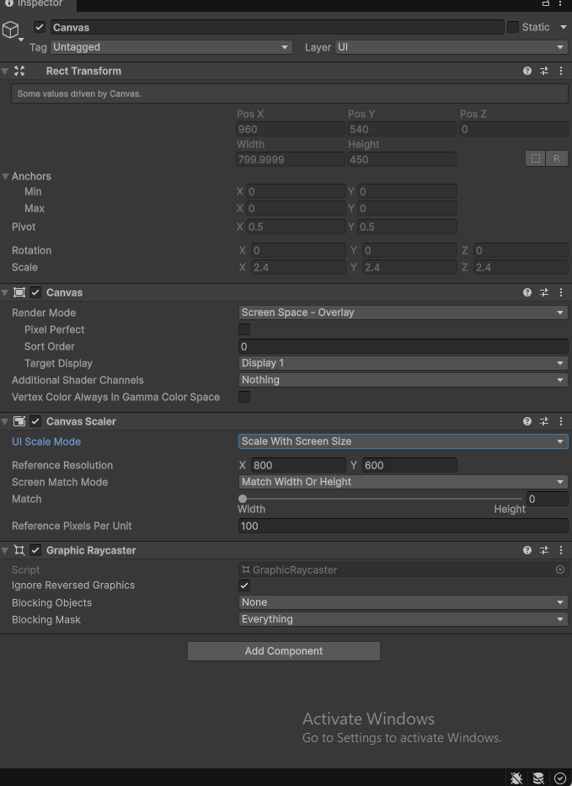
Why Scale With Screen Size? With the default Constant Pixel Size, a button that looks fine at 1920 x 1080 looks tiny on a 4K screen. Scale With Screen Size designs the UI for one reference resolution and scales it up or down for every other screen.
- Add a background and a title:
- Right-click the Canvas > UI > Image. Rename it Background.
- In its Rect Transform, click the anchor preset square, hold Alt and click the bottom-right option (stretch / stretch) so it fills the whole screen. Pick a dark Color.
- 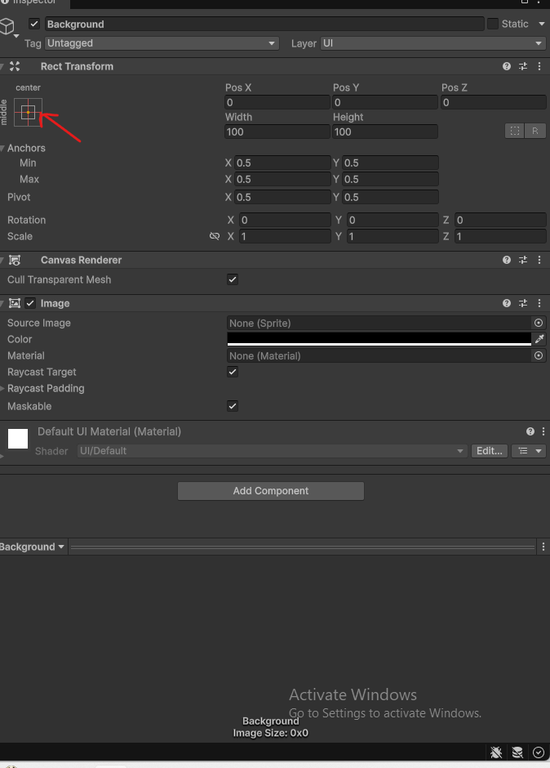
- 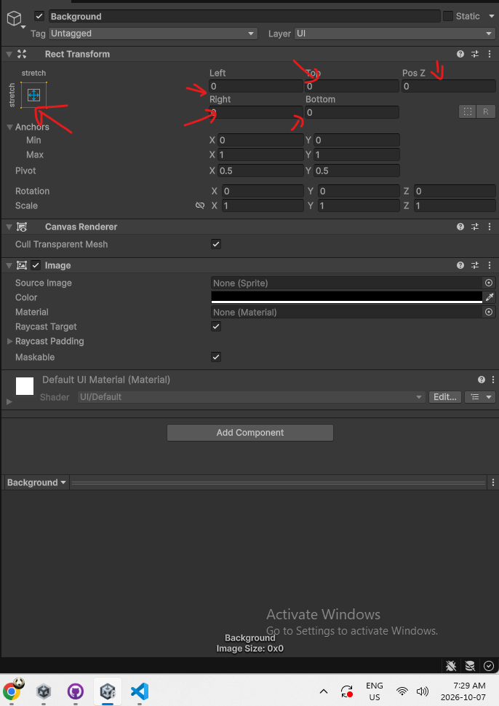
- Right-click the Canvas > UI > Text - TextMeshPro. If Unity asks, click Import TMP Essentials, then close the window.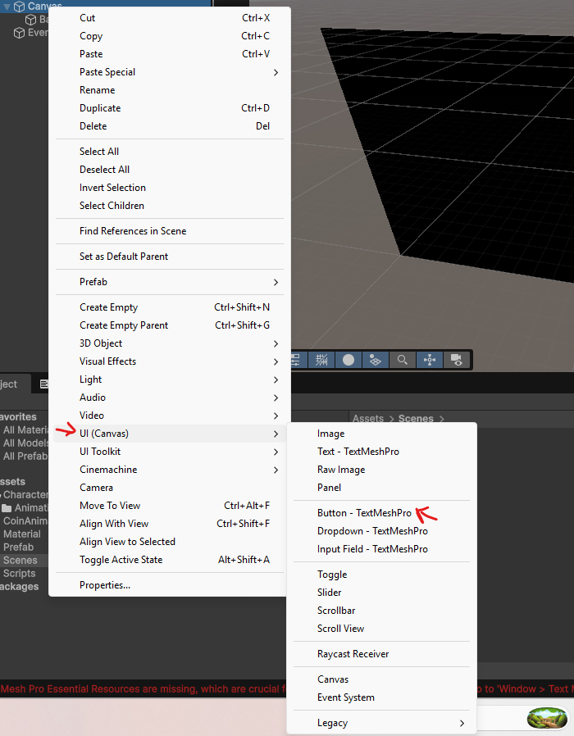
- 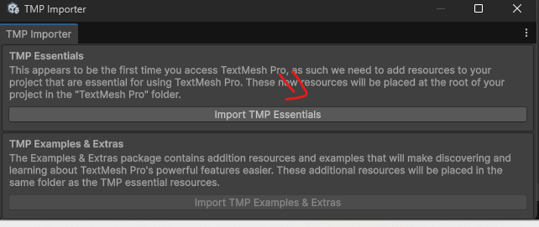
- Rename it TitleText. Type your game's name in the Text box, set Font Size to 96, Alignment to center and make sure Auto Size is off.
- 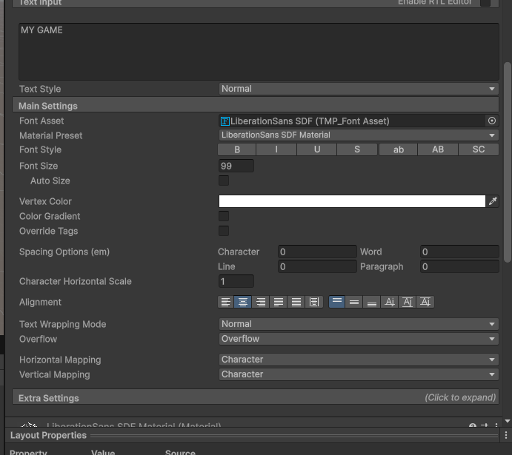
- 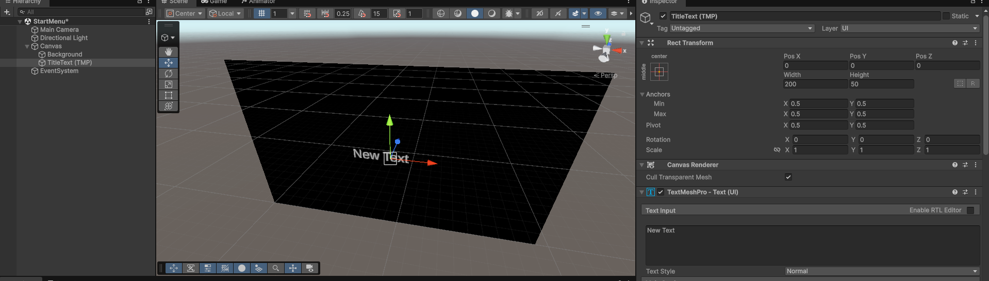
- 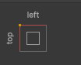
- Anchor preset: hold Alt + Shift and click top-center. Set Pos Y to -200, Width 1400, Height 160.

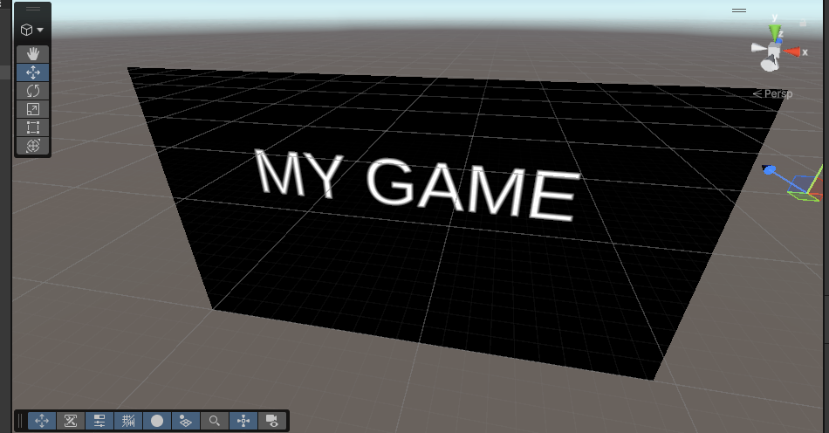
Anchors in one sentence: The anchor is the point of the screen an element is attached to. A title anchored to the top-center stays 200 pixels below the top of the screen no matter how wide or tall the window becomes.
- Add the Play and Quit buttons:
- Right-click the Canvas > UI > Button - TextMeshPro. Rename it PlayButton. Set Width 400, Height 100, Pos X 0, Pos Y 0.
- 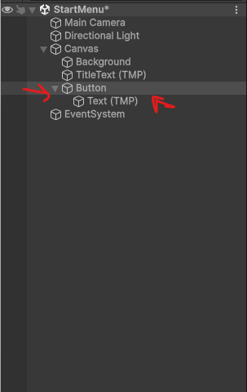
- Expand PlayButton, select its child Text (TMP), change the text to Play and the Font Size to 48.
- 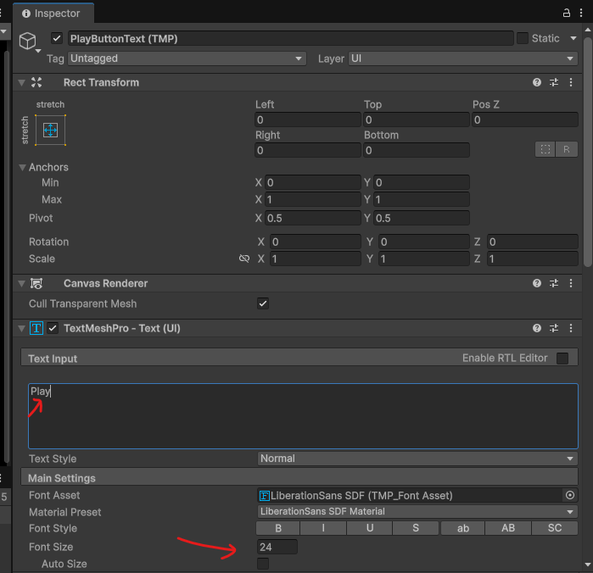
- Select PlayButton and press Ctrl+D to duplicate it. Rename the copy QuitButton, set Pos Y to -150, and change its text to Quit.
- 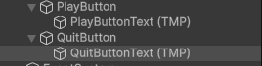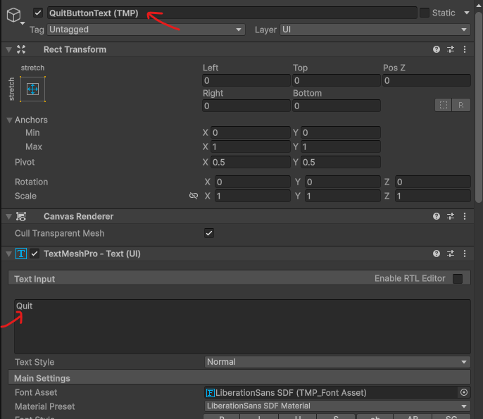
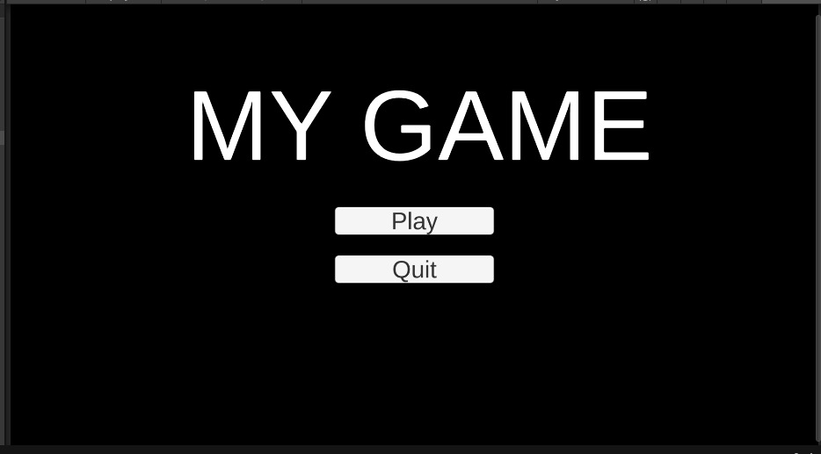

Task 7: Switch Scenes with a SceneLoader Script
Buttons don't do anything on their own. We will write one small, reusable SceneLoader script. The Start Menu uses it now to start the game, and in Task 10 the End scene will use the same script for its Play Again and Main Menu buttons.
The game scene itself (SampleScene) will not have a menu or pause screen. Once the level starts, the only way out is to reach the end of the level.
- Create the SceneLoader script:
- In the StartMenu scene, right-click the Hierarchy > Create Empty, rename it SceneLoader.
- Click Add Component, create a new script called SceneLoader, and replace its contents with:
using UnityEngine;
using UnityEngine.SceneManagement; // needed for SceneManager

// Loads scenes by name. Buttons call LoadScene() and QuitGame()
// from their On Click list.
public class SceneLoader : MonoBehaviour
{
// Public so a Button can call it. The scene must be in the
// Build Profiles scene list or Unity will refuse to load it.
public void LoadScene(string sceneName)
{
SceneManager.LoadScene(sceneName);
}

public void QuitGame()
{
Debug.Log("Quit Game");
// Closes a built game. Does nothing inside the Unity Editor.
Application.Quit();
}
}
- SceneManager.LoadScene() unloads the current scene (destroying every object in it) and loads the new one.
- LoadScene takes a string parameter, so one method works for any scene: the button decides which name to send.
- Application.Quit() closes the game once it is built. Inside the Unity Editor it is ignored, which is why we also print Quit Game with Debug.Log: the Console message proves the button works.
- Hook up the buttons:
- Select PlayButton. At the bottom of the Button component, find On Click () and click +.
- 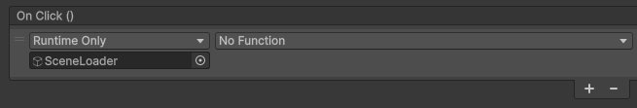
- Drag the SceneLoader GameObject from the Hierarchy into the empty object slot.
- In the function dropdown choose SceneLoader > LoadScene (string). A text box appears: type SampleScene exactly (it must match the scene file name).
- 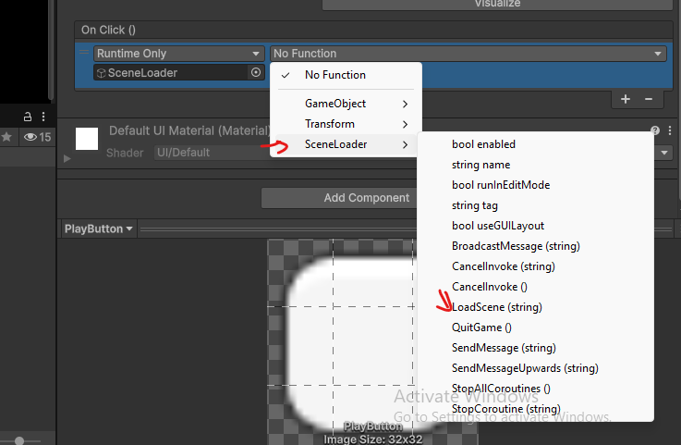
- 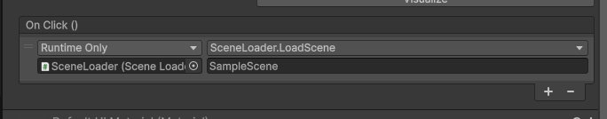
- Select QuitButton, add an On Click entry the same way, and choose SceneLoader > QuitGame ().
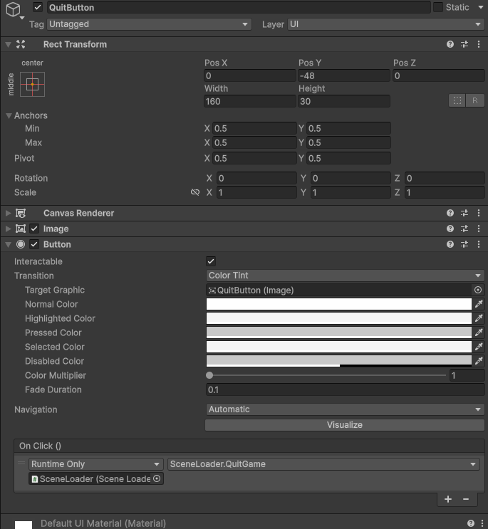

- Add the scenes to the Build Profiles scene list:
- Open File > Build Profiles (Unity 2022 and older: File > Build Settings).
- 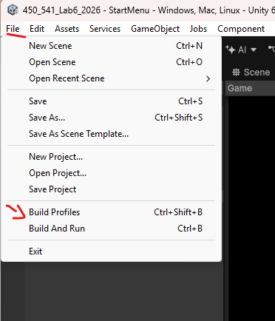
- In the Scene List, make sure both scenes are listed and checked. With StartMenu open, click Add Open Scenes, or drag scenes in from the Project window.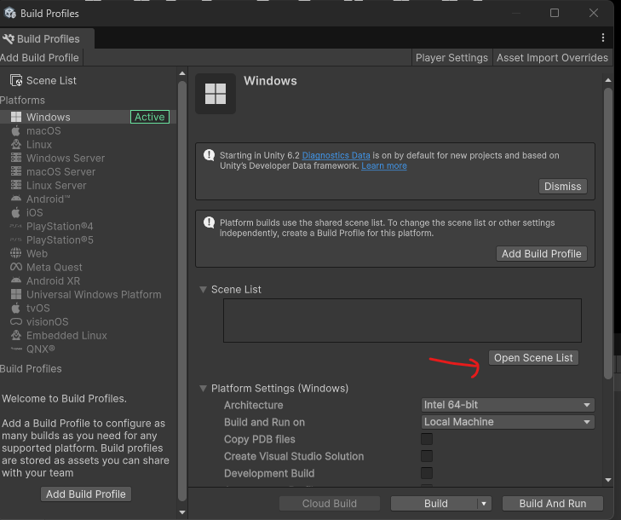
- 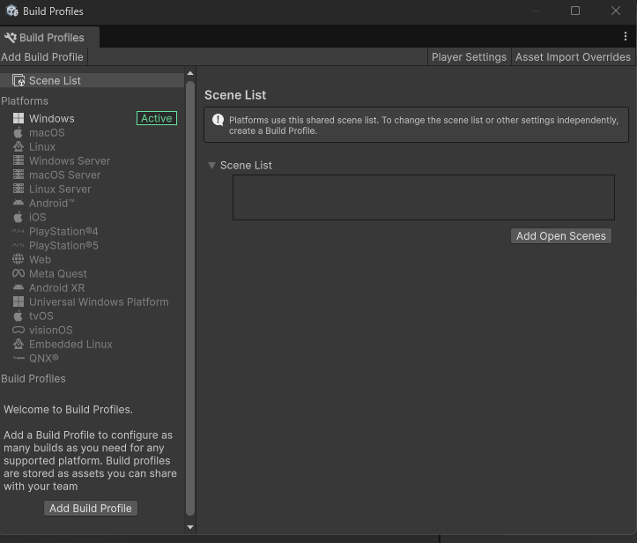
- 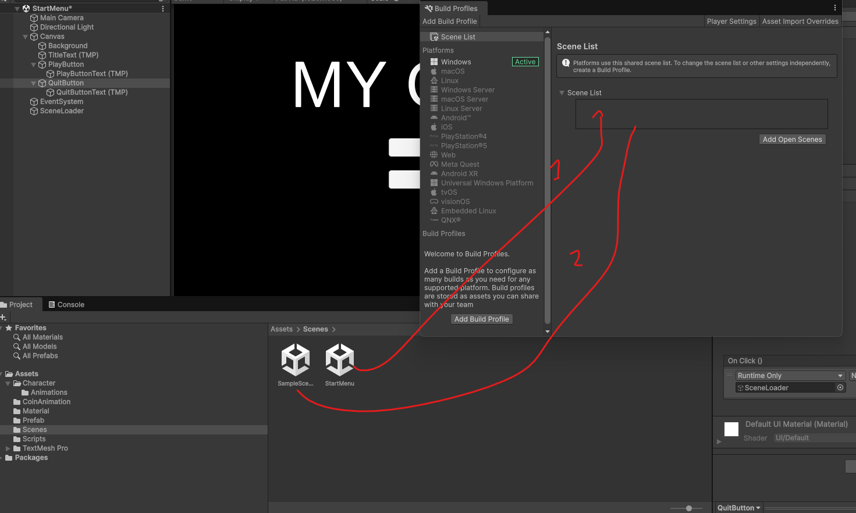
- Drag StartMenu to the top so it is index 0, and SampleScene is index 1. Scene 0 is the one a built game opens first. (You will add the End scene as index 2 in Task 10.)
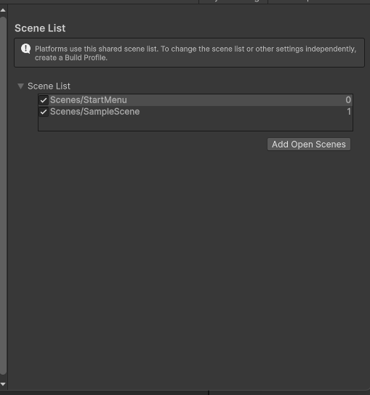
Error "couldn't be loaded because it has not been added to the build settings"? The scene isn't in the Scene List, or the name typed in the button doesn't match the file name exactly (capital letters count).
- Test the scene flow:
- Open StartMenu and press Play. Click Play: the level should load. Stop, press Play again, open the Console and click Quit: the Console should show Quit Game. (The game only really closes in a build.)
Level looks darker after loading it from the menu? This only happens in the Editor. Open SampleScene, go to Window > Rendering > Lighting and click Generate Lighting. Unity then saves the scene's lighting data so it looks the same however it is loaded.
- Check your understanding:
- What happens to every GameObject in the StartMenu scene (the Canvas, the buttons, the SceneLoader) when SceneManager.LoadScene("SampleScene") runs?

- Why is it better to give LoadScene a string parameter than to write separate methods like LoadGame() and LoadMenu()?

Task 8: Add a HUD
A HUD (heads-up display) is the UI drawn on top of the game while you play. A good HUD stays out of the way. Ours shows only two things in the top-left corner: the score from Lab 4, and a small double jump icon with the time remaining that only appears while the double jump power-up is active (you will create the power-up in Task 9).
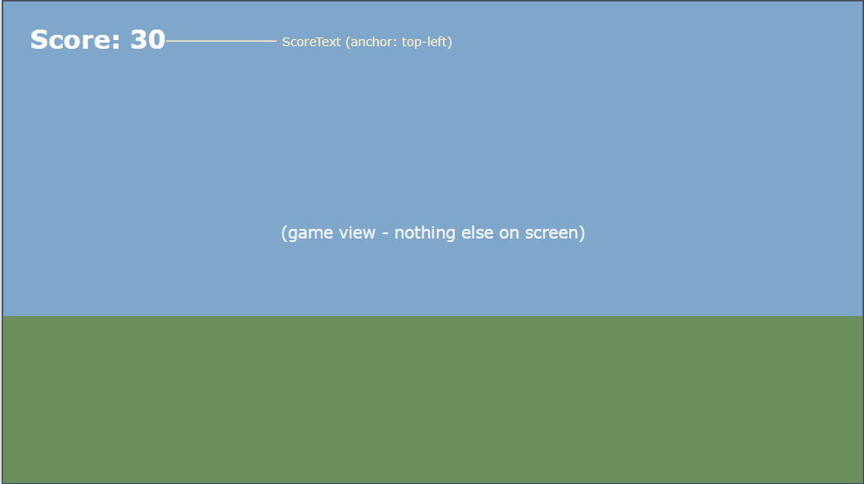
Figure 3: HUD layout.
- Create the HUD Canvas:
- Open SampleScene. Right-click the Hierarchy > UI > Canvas and rename it HUD.
- Set its Canvas Scaler exactly like the menu: Scale With Screen Size, 1920 x 1080, Match 0.5.
- Add the score text:
- Right-click HUD > UI > Text - TextMeshPro, rename it ScoreText.
- Anchor preset: hold Alt + Shift and click top-left. Set Pos X 40, Pos Y -40, Width 500, Height 80.
- Set the text to Score: 0, Font Size 56, Bold.

- Create the HUDController script:
- Select HUD, click Add Component, create a script called HUDController and replace its contents with:
using UnityEngine;
using TMPro; // TMP_Text

// Updates the HUD every frame from the ScoreManager and PlayerPowerUps.
public class HUDController : MonoBehaviour
{
[Header("Score")]
[SerializeField] private TMP_Text scoreText;

private void Update()
{
UpdateScore();
}

private void UpdateScore()
{
// The Score property from Lab 4: anyone can read it
scoreText.text = "Score: " + ScoreManager.Instance.Score;
}

}
- In Lab 4, ScoreManager's comment said Score was public "for a UI later". This is that UI. Thanks to the singleton, the HUD can read ScoreManager.Instance.Score without any reference in the Inspector.

Task 9: Add an End Scene that Shows the Score
Every game needs an ending. We will put a LevelEnd zone at the end of the level. When the player walks into it, the game switches to an EndScene that shows the final score, with buttons to play again or return to the Start Menu.
There is one problem to solve first. When SampleScene unloads, the ScoreManager is destroyed along with its Score, so the End scene can't ask it for the score. The fix is a static variable.
- Save the final score in ScoreManager:
- Open ScoreManager. Add this property and method inside the class (for example just below AddScore):
// "static" means this value belongs to the ScoreManager CLASS,
// not to one ScoreManager object. Objects are destroyed when a
// new scene loads, but static values stay in memory.
public static int FinalScore { get; private set; }

// Called just before we leave the level
public void SaveFinalScore()
{
FinalScore = Score;
}
Static vs. instance: Score is stored inside the ScoreManager object, so it disappears with that object. FinalScore is stored on the class itself, so any scene can read it with ScoreManager.FinalScore, even a scene that has no ScoreManager in it. You already used this idea for Instance in Lab 4.
- Build the LevelEnd zone:
- In SampleScene, right-click the Hierarchy > Create Empty, rename it LevelEnd, and place it at the far end of your level.
- Right-click LevelEnd > 3D Object > Cylinder, rename it Visuals, set Scale to 2, 0.05, 2 and give it a green material so it looks like a finish pad. Remove its Capsule Collider.
- Select LevelEnd (the parent), add a Box Collider, check Is Trigger, and set Size to 2, 2, 2 and Center Y to 1.
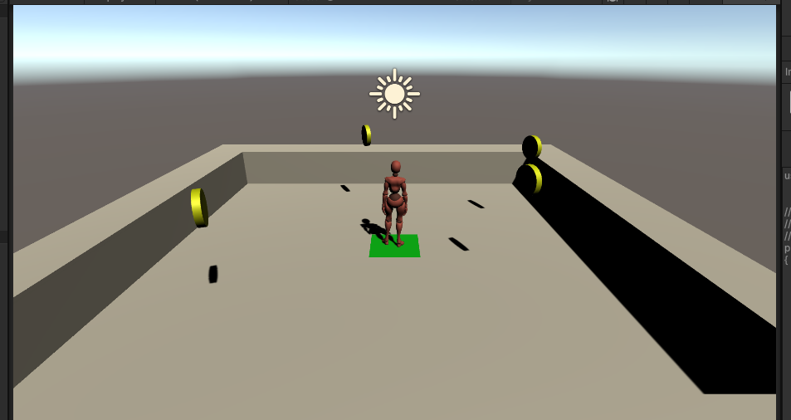
- Create the LevelEndTrigger script:
- Select LevelEnd, click Add Component, create a script called LevelEndTrigger and replace its contents with:
using UnityEngine;
using UnityEngine.SceneManagement;

// Put on a trigger at the end of the level.
// When the player enters it, save the score and load the End scene.
public class LevelEndTrigger : MonoBehaviour
{
[SerializeField] private string endSceneName = "EndScene";

private void OnTriggerEnter(Collider other)
{
// Only the player can finish the level
if (!other.CompareTag("Player")) return;

// Save the score BEFORE loading: the ScoreManager is about
// to be destroyed together with the rest of SampleScene
ScoreManager.Instance.SaveFinalScore();

SceneManager.LoadScene(endSceneName);
}
}
- Create the EndScene:
- Save SampleScene. In the Scenes folder create a new scene called EndScene and open it.
- Build its UI the same way as the Start Menu (Task 6): a Canvas with Scale With Screen Size (1920 x 1080, Match 0.5) and a full-screen Background Image.
- Add a UI > Text - TextMeshPro called TitleText anchored top-center, Pos Y -200, with the text Level Complete! and Font Size 96.
- Add another TextMeshPro called FinalScoreText anchored middle-center, Pos Y 80, Width 1000, Height 120, Font Size 72, centered. Type Final Score: 0 as placeholder text.
- Add two Button - TextMeshPro objects: PlayAgainButton (Pos Y -100, text Play Again) and MainMenuButton (Pos Y -250, text Main Menu), each 400 x 100.
- 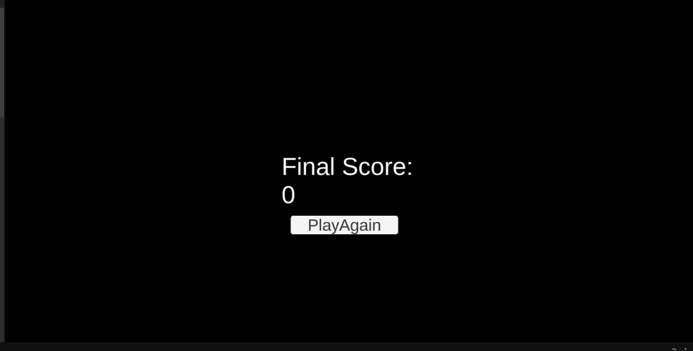
- Show the score with an EndScreen script:
- Create an empty GameObject called EndScreen, add a new script called EndScreen and replace its contents with:
using UnityEngine;
using TMPro;

// Shows the score the player finished the level with.
public class EndScreen : MonoBehaviour
{
[SerializeField] private TMP_Text finalScoreText;

private void Start()
{
// No ScoreManager object exists in this scene, but we can
// still read the static FinalScore through the class name
finalScoreText.text = "Final Score: " + ScoreManager.FinalScore;
}
}
- Drag FinalScoreText into the Final Score Text slot.
- Hook up the buttons:
- Create an empty GameObject called SceneLoader and add your SceneLoader script from Task 7. Reusing it is exactly why we gave LoadScene a string parameter.

- PlayAgainButton > On Click () > SceneLoader > LoadScene (string) > type SampleScene.
- MainMenuButton > On Click () > SceneLoader > LoadScene (string) > type StartMenu.
- 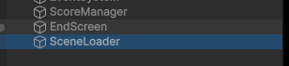
- 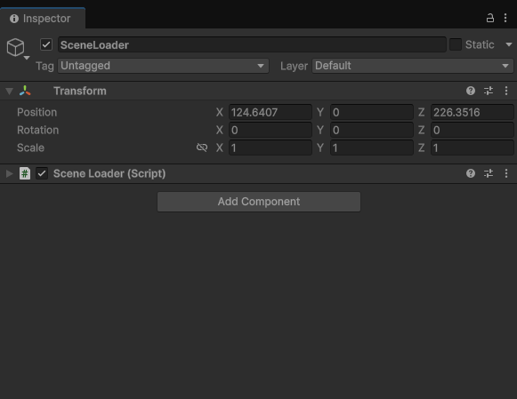
- 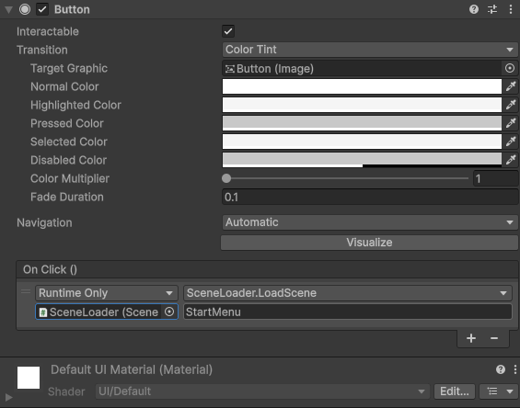
- 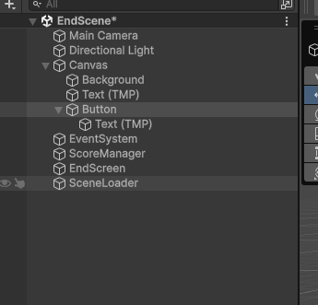
- Add EndScene to the Build Profiles scene list:
- Open File > Build Profiles and add EndScene so the list reads 0 StartMenu, 1 SampleScene, 2 EndScene.
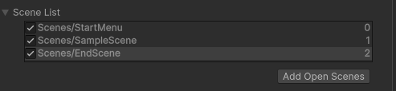
- Test the full game loop:
- Open StartMenu and press Play. Click Play, collect a few coins, then walk onto the LevelEnd pad.
- The End scene should show Final Score with the number from your HUD.
- Click Play Again: the level reloads with the score back at 0. Finish again, then click Main Menu to return to the Start Menu.
Final Score always shows 0? Check that SaveFinalScore() is called before SceneManager.LoadScene in LevelEndTrigger, and that the Player's tag is Player.
Nothing happens on the pad? The Box Collider on LevelEnd must have Is Trigger ticked, and it must be big enough for the player's capsule to enter.
- Check your understanding:
- Why can the End scene read ScoreManager.FinalScore but not ScoreManager.Instance.Score?

- If you open EndScene directly in the Editor and press Play, what score does it show? Why?

Final Steps:
- Test Your Project:
- Open StartMenu and press Play. Click Play to load the level.
- Check that everything from the starter project still works: walking and running, jump, fall, roll and coins.
- The HUD shows the score.
- Walk onto the LevelEnd pad: the End scene shows your final score. Play Again restarts the level and Main Menu returns to the Start Menu, where Quit prints Quit Game in the Console (and closes the game in a build).
- Keep the Animator window open on the Player while testing: watch Falling and Flip light up live.
- Submission:
- Save your fork of the repo.
- Submit your Assets folder zipped with this document filled in and saved in the assets folder.
- Github: https://github.com/FARASHAAFG/450_541_Lab6_2026

