

MD. JANNATUL ADON

22-46887-1



AMERICAN INTERNATIONAL UNIVERSITY BANGLADESH

Faculty of Science and Technology (FST) CSE DEPARTMENT

INTRODUCTION TO DATABASE

Faculty: Argho Das

***BLOOD BANK MANAGEMENT SYSTEM***



DONATE BLOOD SAVE LIFE



***GROUP MEMBERS***



FARDIN-AL-SEZAN

22-46868-1



REMON KUMAR

22-46957-1

MD. MEHEDI HASAN 22-46322-1



Blood is an important factor that is very essential in the life of very organism living on this earth. Without blood there cannot be any existence of even a small organism on this earth. Humans can’t live without blood. Without blood, the body’s organ couldn’t get the oxygen and nutrients they need to survive. Patients will come to the doctor for treatment. The patient has own p_id, p_name, age, address, p_phone. Patient will take treatment from doctor on the other hand the doctor has also an own d_id, d_name, degree, d_phonnumber. Hospital has also addresses, Hos_name, contact_info. The hospital’s doctor suggests the patient needs blood then hospital order by blood bank. ‘Blood bank Management System’ automates the distribution of blood. The banks then group the blood which they receive according to the blood groups. This database consists of thousands of records of each blood bank. Blood bank has a b_id, b_type, phn_number and gmail. Generally, we know that the people who donate blood are called ‘Blood Donor’ so some people donate blood in this blood bank. Donor donates blood through different cost, b_type, b_codes. Donors send blood request in blood bank. Blood request has also e_name,e_id, addresses, e_phone. Blood will store in blood bank. Receptionists work in the blood bank. Donor will register with receptionist. Every receptionist has their own r_id, r_name, address, r_phnnumber. Receptionists will register with the blood donor through their d_code, dates and d_blood , sex, d_name,d_phonnumber. Blood banks manages by manager. The manager has also m_name, m_id, m_phnnumber and g-mail. At last, Hospital will deliver blood to the patient. That’s safe life. So, well management system is first preferred for a Blood bank.



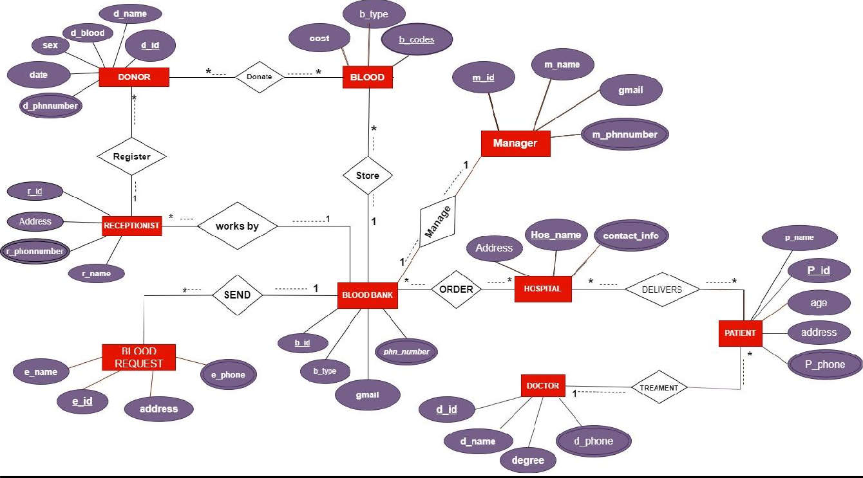



**Treatment**

## UNF:

1st: P-id , p_name ,address, age, p_phone, d-id, d_name, degree,d_phone.

## 1NF:

1st: p-phone , d-phone ,P-id , p_name ,address, age, d-id, d_name, degree. (p_phone ,d_phone is multipul attributes)

## 2NF

1st: P-id ,p_name, address, age, p_phncode . 2rd: d-id, d_name, degree, d_phncode.

3rd: : P-id, d_id.

4th: : p-phone ,p_phncode, d_phone, d_phncode,

## 3NF:

1st: P-id ,p_name, address, age, p_phncode . 2rd: d-id, d_name, degree,d_phncode.

3rd: : P-id, d_id.

4th: : p-phone ,p_phncode, d_phone, d_phncode,

## DELIVERS :

**UNF:**

1st:P-id , p_name ,address, age, p_phone, Hos-name ,contact_info,Address.

## 1NF:

1st: p-phone , ,P-id , p_name ,address, age , Hos-name ,contact_info,Address.

(p_phone ,d_phone is multipul attributes)

## 2NF:

1st: P-id ,p_name, address, age, p_phncode . 2nd: Hos-name ,contact_info,Address.

3rd: P-id , Hos_name.

4th: p-phone ,p_phncode.

## 3NF:

1st: P-id ,p_name, address, age, p_phncode . 2nd: Hos-name ,contact_info,Address.

3rd: P-id , Hos_name.

4th: p-phone ,p_phncode.

## ORDER:

**UNF:**

1st: Hos-name ,contact_info,Address , phn_number,b-id, b_type,gmail.

## 1NF:

1st: phn-number , Hos-name ,contact_info,Address ,b-id, b_type,gmail. (phn-number is multipul attributes)

## 2NF:

1st: Hos-name ,contact_info,Address. 2nd: b-id ,phn_code, b_type, gmail.

3rd: b-id ,Hos_name.

4th: phn-number , phn_code.

## 3NF:

1st: Hos-name ,contact_info,Address. 2nd: b-id ,phn_code, b_type, gmail.

3rd: b-id ,Hos_name.

4th: phn-number , phn_code.

## MANAGE :

**UNF:**

1st: b-id, phn_number ,b_type, gmail, m-id, m_name, m_phnnumber,gmail .

## 1NF:

1st: m-phnnumber, phn-number b-id, b_type, gmail, m-id, m_name, ,gmail ( m_phnnumber,phn_number is multipul attributes).

## 2NF:

1st: b-id, phn_code ,b_type, gmail.

2nd: m-id, m_name, m_phncode,gmail . 3rd: b-id, m_id.

4th: phn-number , phn_code ,m_phnnumber, m_phncode.

## 3NF:

1st: b-id, phn_code ,b_type, gmail.

2nd: m-id, m_name, m_phncode,gmail . 3rd: b-id, m_id.

4th: phn-number , phn_code ,m_phnnumber, m_phncode.

## STORE :

**UNF:**

1st: b-id, phn_number ,b_type, gmail, b-code , b_type, cost.

## 1NF:

1st: phn-number , b-id ,b_type, gmail, b-code , b_type, cost. (phn_number is multipul attributes).

## 2NF:

1st: b-id, phn_code ,b_type, gmail. 2nd: b-code , b_type, cost.

3rd: b-id, b_code.

4th: phn-number ,phn_code.

## 3NF:

1st: b-id, phn_code ,b_type, gmail. 2nd: b-code , b_type, cost.

3rd: b-id, b_code.

4th: phn-number ,phn_code.

## DONATE :

**UNF:**

1st: d-id,d_name, d_phnnumber ,date,sex,d_blood, b-code , b_type, cost.

## 1NF:

1st: d-phnnumber, d-id,d_name,date,sex,d_blood, b-code , b_type, cost.. (d_phnnumber is multipul attributes).

## 2NF:

1st: d-id,d_name, d_phncode ,date,sex,d_blood. 2nd: b-code , b_type, cost.

3rd: d-id, b_code.

4th: d-phnnumber, d_phncode.

## 3NF:

1st: d-id,d_name, d_phncode ,date,sex,d_blood. 2nd: b-code , b_type, cost.

3rd: d-id, b_code.

4th: d-phnnumber, d_phncode.

## REGISTER :

**UNF:**

1st: d-id,d_name, d_phnnumber ,date,sex,d_blood, r-id , r_name , Address,r_phonnumber. 1NF:

1st: d-phnnumber , r-phonnumber, d-id,d_name,date,sex,d_blood, r-id , r_name , Address. (d_phnnumber, r_phnnumber is multipul attributes).

## 2NF:

1st: d-id,d_name, d_phncode ,date,sex,d_blood. 2nd: r-id , r_name , Address,r_phncode.

3rd: d-id, r_id.

4th: d-phnnumber , d_phncode, r_phnnumber, p_phncode.

## 3NF:

1st: d-id,d_name, d_phncode ,date,sex,d_blood. 2nd: r-id , r_name , Address,r_phncode.

3rd: d-id, r_id.

4th: d-phnnumber , d_phncode, r_phnnumber, p_phncode.

## WORKBY :

**UNF:**

1st: r-id , r_name , Address,r_phonnumber , b-id , b_type , phn_number , gmail.

## 1NF:

1st: r-phonnumber , phn-number, r-id , r_name , Address, b-id , b_type, gmail. ( r_phnnumber,phn_number is multipul attributes).

## 2NF:

1st: r-id , r_name , Address,r_phncode. 2nd: b-id , b_type , phn_code , gmail. 3rd: b-id ,r_id.

4th: r-phonnumber, r_phncode ,phn_number, phn_code.

## 3NF:

1st: r-id , r_name , Address,r_phncode. 2nd: b-id , b_type , phn_code , gmail. 3rd: b-id ,r_id.

4th: r-phonnumber, r_phncode ,phn_number, phn_code.

## SEND :

**UNF:**

1st: b-id , b_type , phn_number , gmail ,e-id ,e_name ,address,e_phone.

## 1NF:

1st: phn-number , e-phone, b-id , b_type , gmail ,e-id ,e_name ,address. ( phn_number , e_phone is multipul attributes).

## 2NF:

1st: b-id , b_type , phn_code , gmail. 2nd: e-id ,e_name ,address,e_phncode. 3rd: b-id , e_id.

4th: phn-number , phn_code, e_phone, e_phncode.

## 3NF:

1st: b-id , b_type , phn_code , gmail. 2nd: e-id ,e_name ,address,e_phncode. 3rd: b-id , e_id.

4th: phn-number , phn_code, e_phone, e_phncode.

FINAL TABLE

1st: P-id ,p_name, address, age, p_phncode, d_id - **PATIENT**

2rd: d-id, d_name, degree, d_phncode. - **DOCTOR**

3rd: p-phncode ,p_phone. **– PATIENT_INFO**

4th:d-phncode, d_phone. **– DOCTOR _INFO**

5th: Hos-name ,contact_info,Address **– HOSPITAL**

6th: P-id , Hos_name- **HOSPITAL_1**

7th: b-id ,phn_code, b_type, gmail- **BLOOD_BANK**

8th: b-id ,Hos_name- **BLOOD_BANK_1**

9th: phn-code , phn_number. - **BLOOD_INFO**

10th: b-id, phn_code ,b_type, gmail,m_id.- **BLOOD_BANK_2**

11th: m-id, m_name, m_phncode, gmail -**MANAGER** 12th: m-phncode ,m_phnnumber -**MANAGER_INFO.**

13th: b-id, phn_code ,b_type, gmail, b-code .- **BLOOD_BANK_3**

14th: b-code , b_type, cost -**BLOOD**

15th: d-id,d_name, d_phncode ,date,sex,d_blood – **DONOR**

16th: d-id, b_code. - **DONOR_1**

17th: d-phncode ,d_phnnumber – **DONOR_INFO**

18th d-id,d_name, d_phncode ,date,sex,d_blood, r_id - **DONOR_2**

19th: r-id , r_name , Address,r_phncode - **RECEPTIONIST**

20th: r-phncode ,r_phnnumber- **RECEPTIONIST_INFO**

21st: r-id , r_name , Address,r_phncode,b_id -**RECEPTIONIST_2** 22th: e-id ,e_name ,address,e_phncode, b_id.- **BLOOD_REQUEST** 23th: e_phncode,e_phone.**-EMPLOYE_INFO**



## Table 1: PATIENT

CREATE TABLE PATIENT (P_NAME VARCHAR2(20)NOT NULL,AGE INT, ADDRESS VARCHAR2(30),P_PHONCODE INT, D_ID, P_ID, INT CONSTRAINT PATIENT_PK PRIMARY KEY);

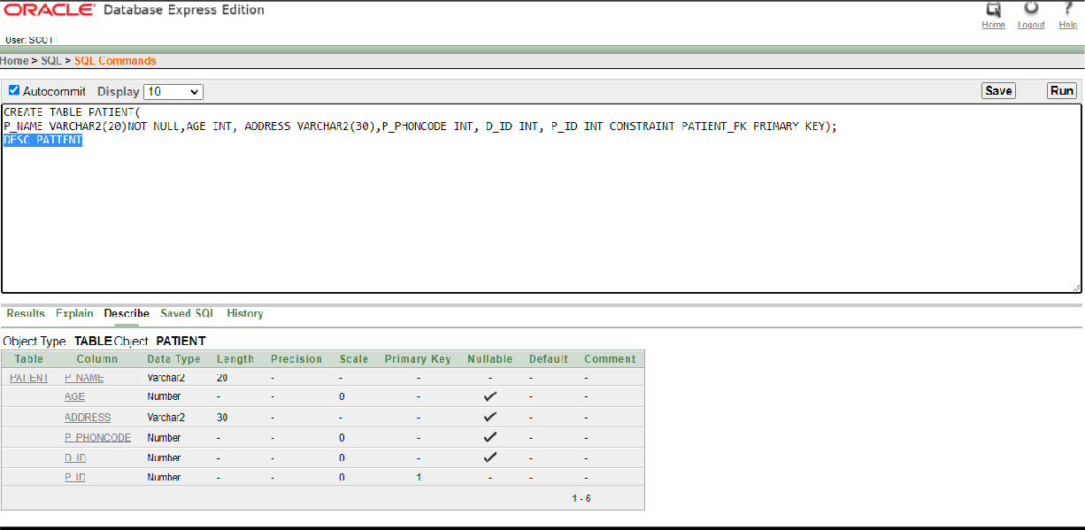

## TABLE 2: DOCTOR

CREATE TABLE DOCTOR(

D_NAME VARCHAR2(30), DEGREE VARCHAR2 (18), D_PHONCODE NUMBER(11), D_ID INT CONSTRAINT DOCTOR_PK PRIMARY KEY);

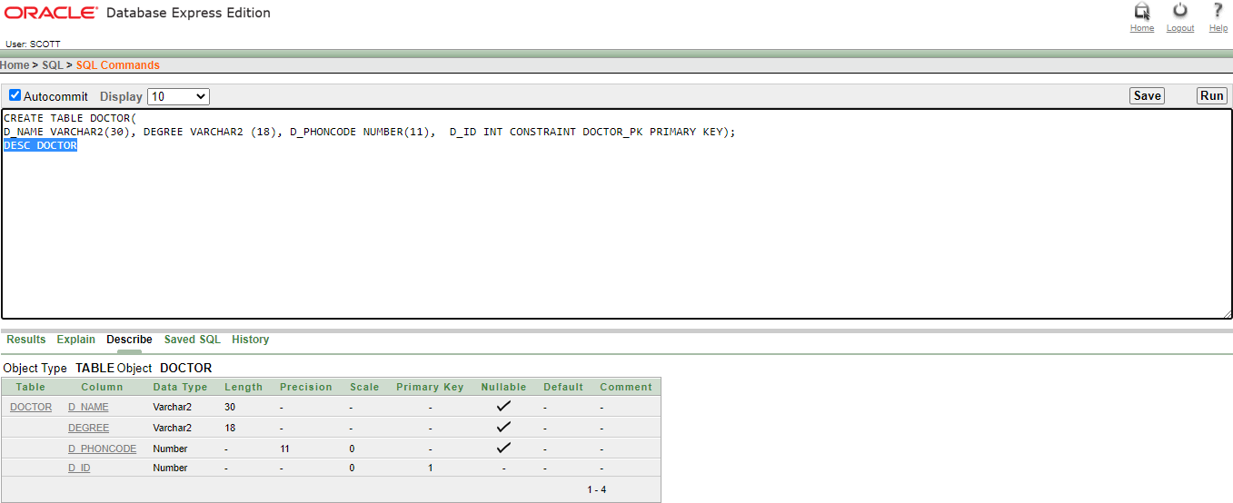

## TABLE 3: PATIENT_INFO

CREATE TABLE PATIENT_INFO(

P_PHONE NUMBER (11) , P_PHNCODE NUMBER (11) CONSTRAINT PATEINT_INFO_PK PRIMARY KEY);

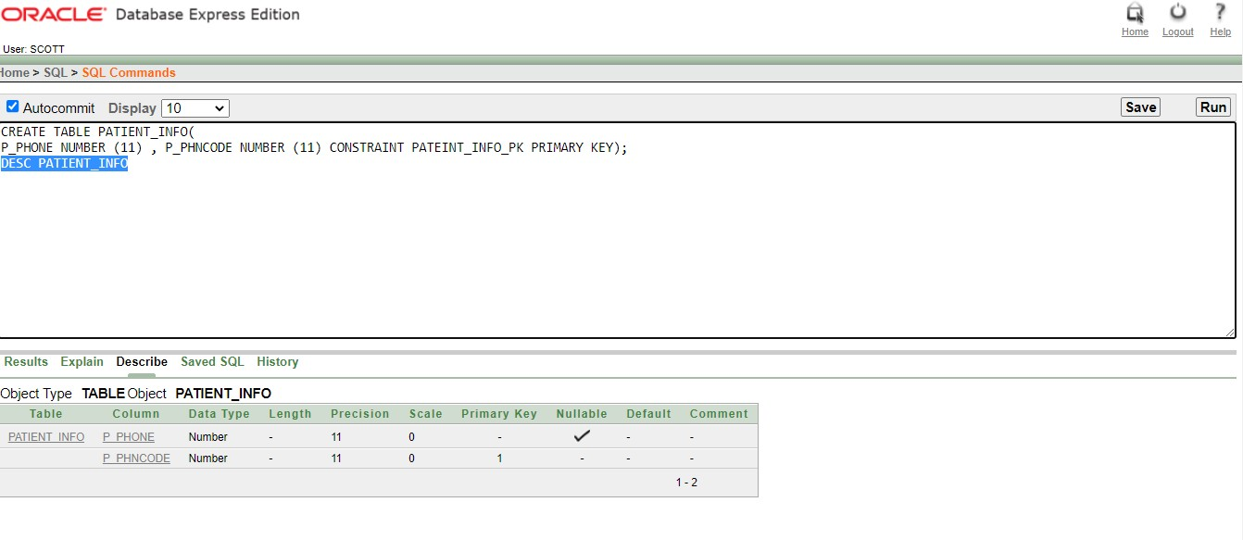

## TABLE 4: DOCTOR_INFO

CREATE TABLE DOCTOR_INFO(

D_PHN NUMBER (11), D_PHNCODE NUMBER(11) CONSTRAINT DOCTOR_INFO_PK PRIMARY KEY);

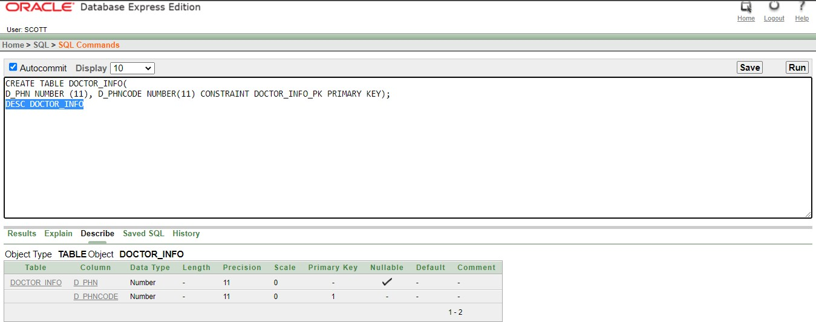

## TABLE 5: HOSPITAL

CREATE TABLE HOSPITAL(

ADDRESS VARCHAR2(30), CONTACT_INFO NUMBER (11), HOS_NAME VARCHAR2(40) CONSTRAINT HOSPITAL_PK PRIMARY KEY);

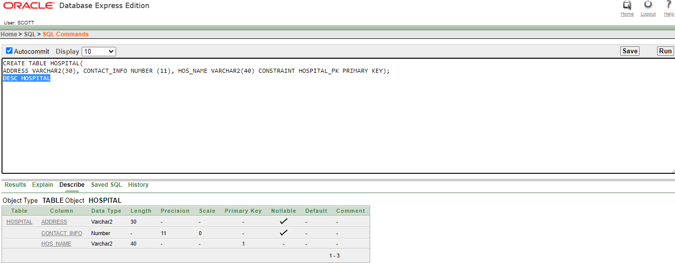

**TABLE 6: HOSPITAL_1**

CREATE TABLE HOSPITAL_1(

HOS_NAME VARCHAR2 (30), P_ID INT CONSTRAINT HOSPITAL_1_PK PRIMARY KEY);

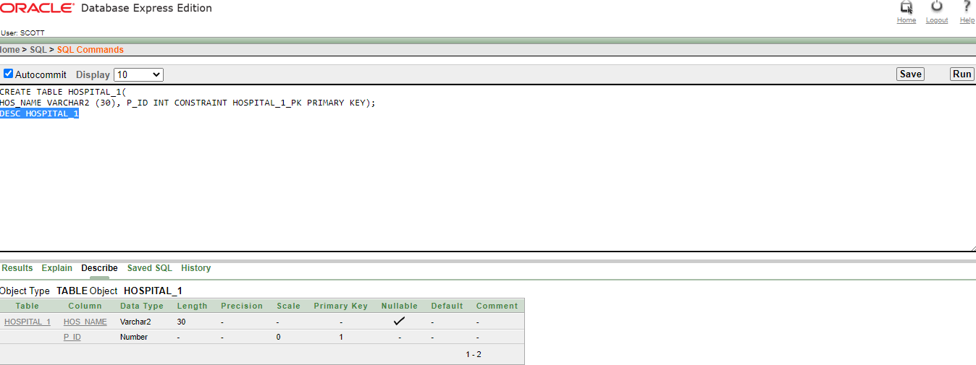

**TABLE 7: BLOOD_BANK**

CREATE TABLE BLOOD_BANK(

B_TYPE VARCHAR2 (3), GMAIL VARCHAR2(30), PHN_CODE NUMBER (11), B_ID INT CONSTRAINT BLODD_BANK_PK PRIMARY KEY);

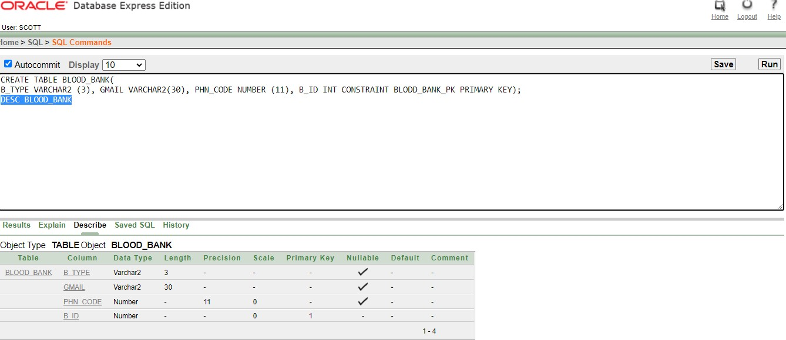

**TABLE 8: BLOOD_BANK_1**

CREATE TABLE BLOOD_BANK_1(

HOS_NAME VARCHAR2(20), B_ID INT CONSTRAINT BLOOD_BANK_1_PK PRIMARY KEY);

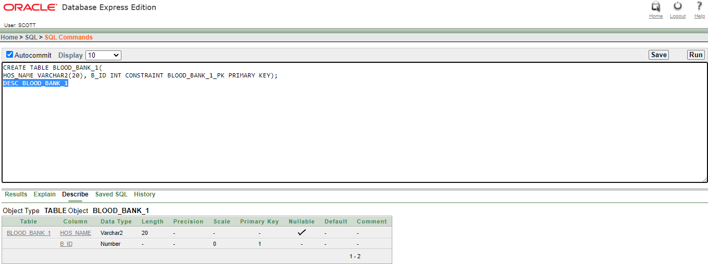

**TABLE 9: BLOOD_INFO**

CREATE TABLE BLOOD_INFO(

PHN_NUMBER NUMBER (11) , PHN_CODE INT CONSTRAINT BLOOD_INFO_PK PRIMARY KEY);

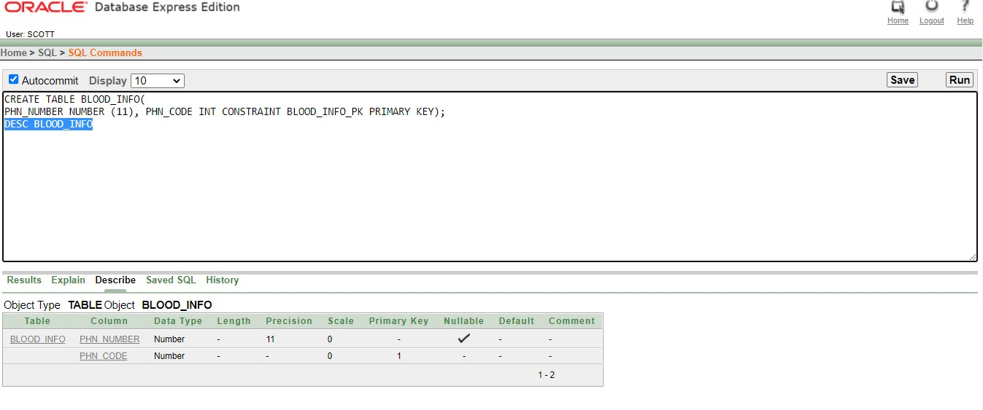

**TABLE 10: BLOOD_BANK_2**

CREATE TABLE BLOOD_BANK_2(

PHN_CODE NUMBER (11), B_TYPE VARCHAR2(3), GMAIL VARCHAR2(29), M_ID INT, B_ID INT CONSTRAINT BLOOD_BANK_2_PK PRIMARY KEY);

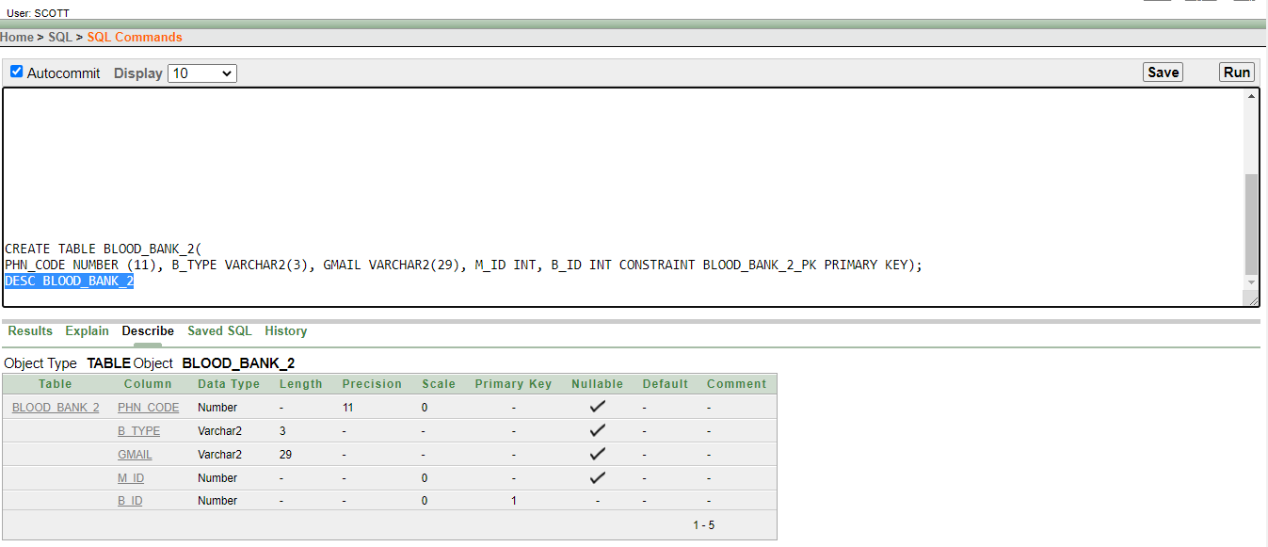

**TABLE 11: MANAGER**

CREATE TABLE MANAGER(

M_NAME VARCHAR2(16), GMAIL VARCHAR2(29), M_PHNCODE NUMBER (11), M_ID INT CONSTRAINT MANAGER_PK PRIMARY KEY);

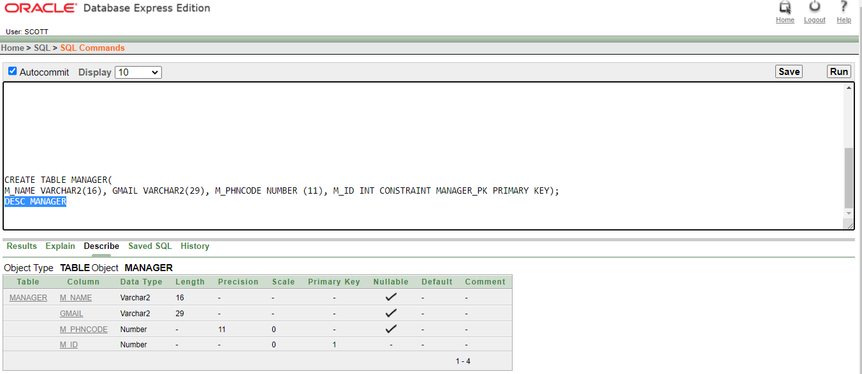

## TABLE 12: MANAGER_INFO

CREATE TABLE MANAGER_INFO(

M_PHNNUMBER NUMBER (11), M_PHNCODE INT CONSTRAINT MANAGER_INFO_PK PRIMARY KEY);

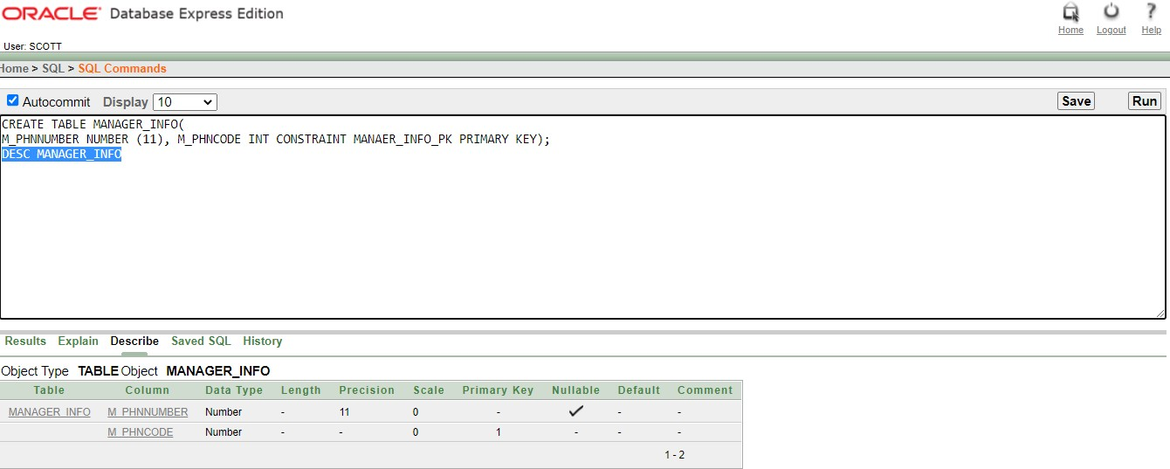

## TABLE 13: BLOOD_BANK_3

CREATE TABLE BLOOD_BANK_3(

PHN_CODE NUMBER(11), B_TYPE VARCHAR2 (4), GMAIL VARCHAR2(29), B_CODE INT, B_ID INT CONSTRAINT BLOOD_BANK_3_PK PRIMARY KEY);

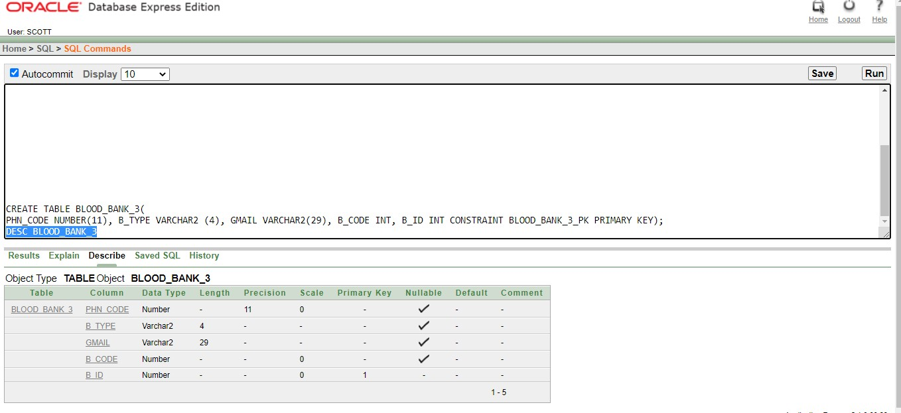

## TABLE 14: BLOOD

CREATE TABLE BLOOD(

B_TYPE VARCHAR2(14), COST INT , B_CODE INT CONSTRAINT BLOOD_PK PRIMARY KEY);

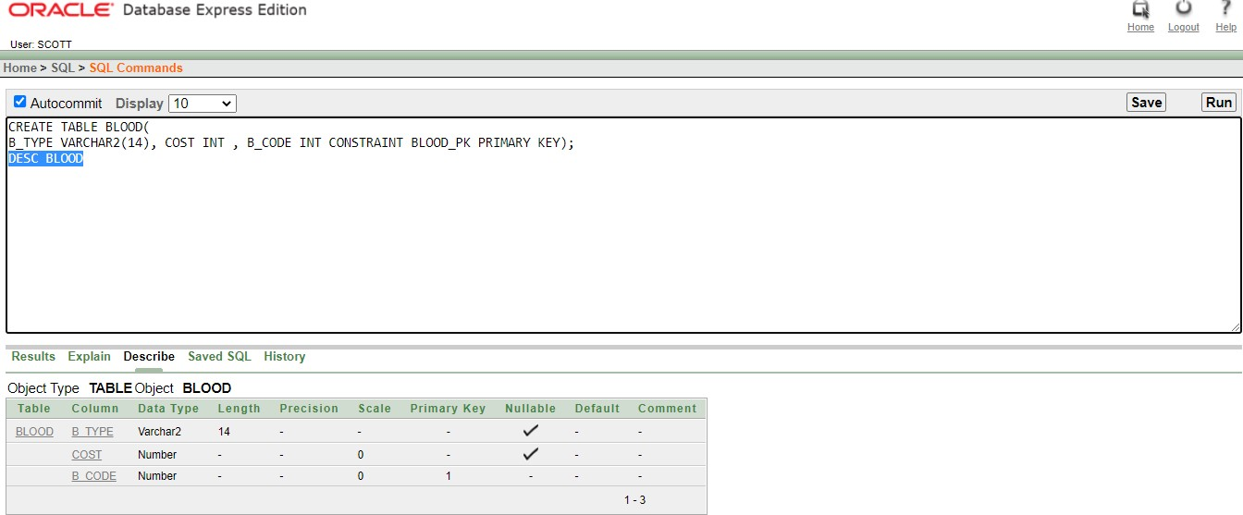

## TABLE 15: DONOR

CREATE TABLE DONOR(

D_NAME VARCHAR2(16),D_BLOOD VARCHAR2(3), D_DATE VARCHAR2(13), SEX VARCHAR2(17), D_PHNCODE NUMBER(11), D_ID INT CONSTRAINT DONOR_PK PRIMARY KEY);

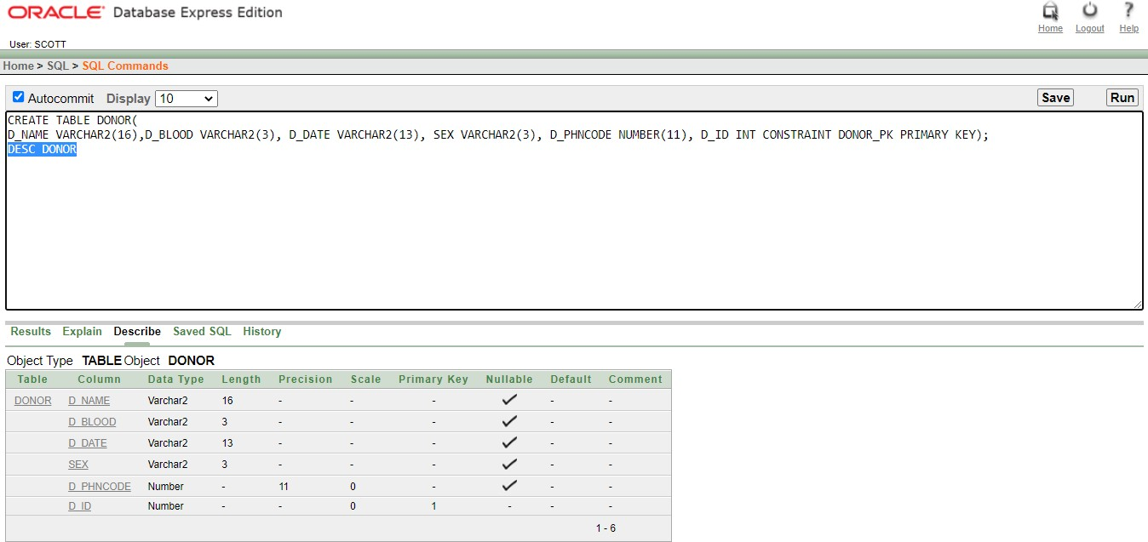

## TABLE 16: DONOR_1

CREATE TABLE DONOR_1(

B_CODE INT, D_ID INT CONSTRAINT DONOR_1_PK PRIMARY KEY);

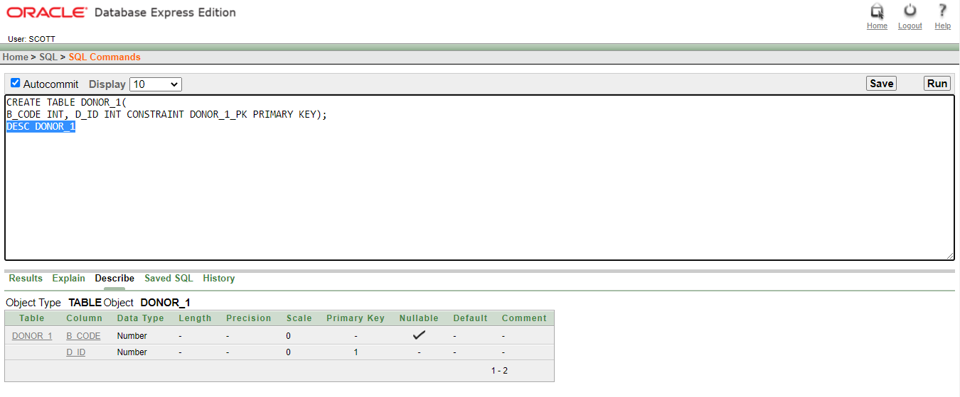

## TABLE 17: DONOR_INFO

CREATE TABLE DONOR_INFO(

D_PHNNUMBER NUMBER (11) , D_PHONCODE INT CONSTRAINT DONOR_INFO_PK PRIMARY KEY);

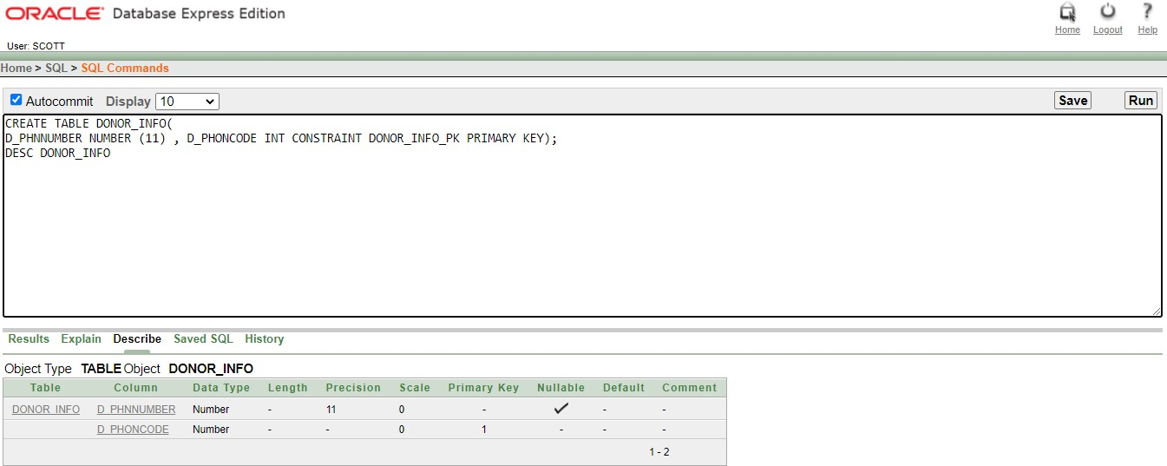

## TABLE 18: DONOR_2

CREATE TABLE DONOR_2(

D_NAME VARCHAR2(14), D_PHNCODE NUMBER (11), D_DATE VARCHAR2(14), D_BLOOD VARCHAR2(3), SEX VARCHAR2(8), R_ID INT, D_ID INT CONSTRAINT DONOR_2_PK PRIMARY KEY);

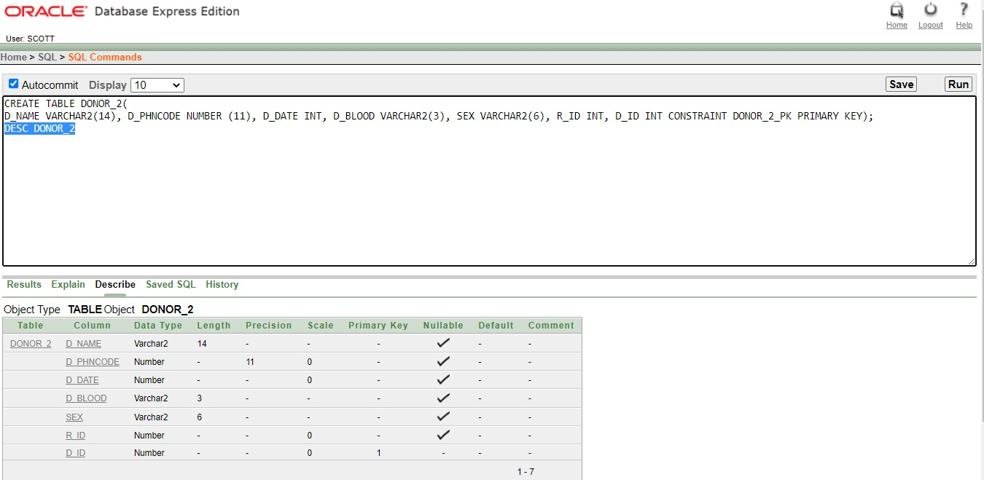

## TABLE 19: RECEPTIONIST

CREATE TABLE RECEPTIONIST(

ADDRESS VARCHAR2(13), R_PHONCODE NUMBER (11), R_NAME VARCHAR2(13), R_ID INT CONSTRAINT RECEPTIONIST_PK PRIMARY KEY);

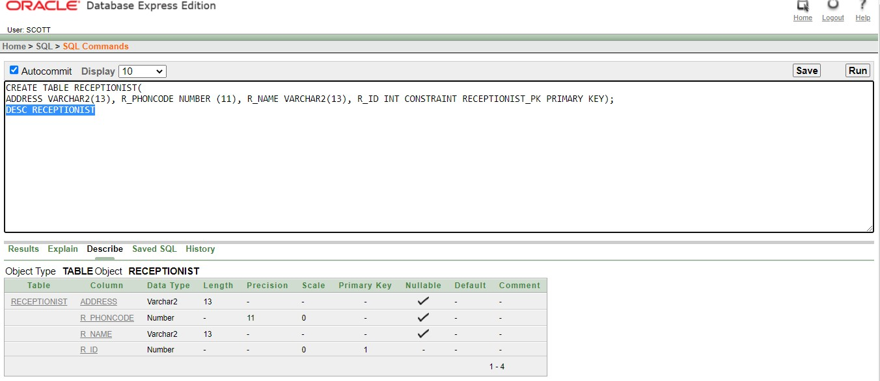

## TABLE 20: RECEPTIONIST_INFO

CREATE TABLE RECEPTIONIST_INFO(

R_PHNNUMBER NUMBER (11), R_PHNCODE INT CONSTRAINT RECEPTIONIST_INFO_PK PRIMARY KEY);

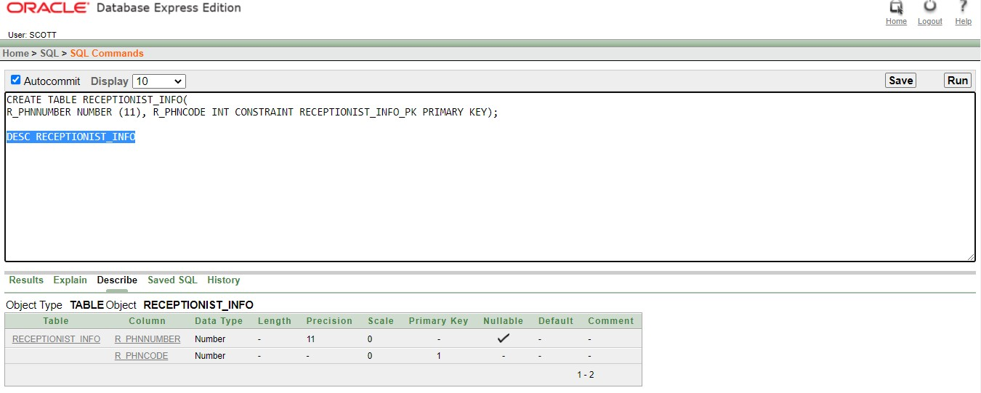

## TABLE 21: RECEPTIONIST_2

CREATE TABLE RECEPTIONIST_2(

R_NAME VARCHAR2(16), ADDRESS VARCHAR2(14), R_PHNCODE INT, B_ID INT, R_ID INT CONSTRAINT RECEPTIONIST_2_PK PRIMARY KEY);

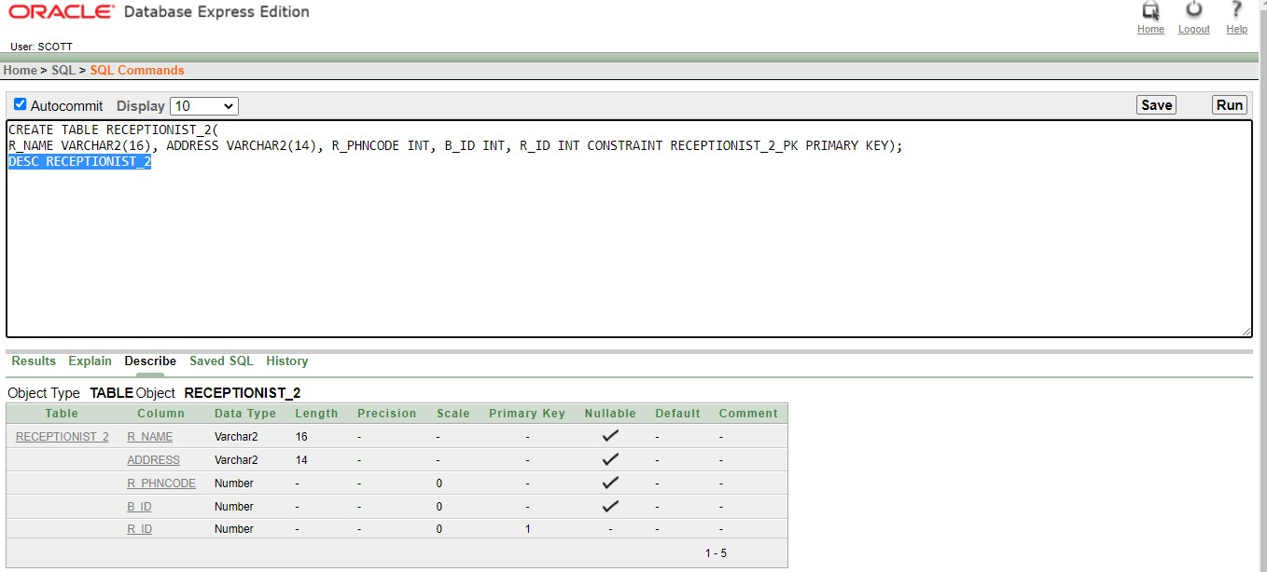

## TABLE 22: BLOOD_REQUEST

CREATE TABLE BLOOD_REQUEST(

E_NAME VARCHAR2(14), ADDRESS VARCHAR2(13), E_PHONECODE INT, B_ID INT, E_ID INT CONSTRAINT BLOOD_REQUEST_PK PRIMARY KEY);

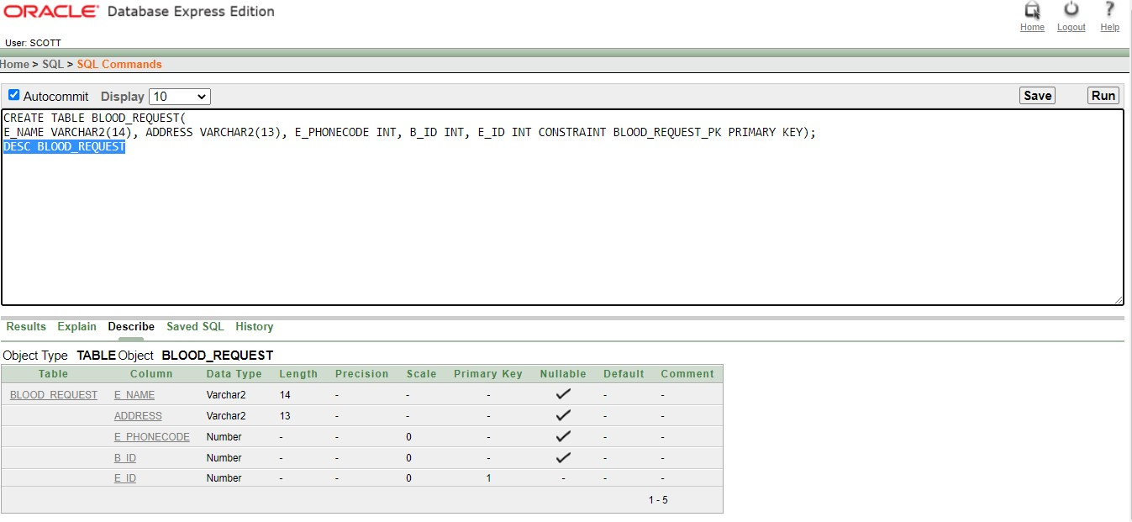

## TABLE 23: EMPLOYE_INFO

CREATE TABLE EMPLOYE_INFO(

E_PHONE NUMBER(11), E_PHNCODE INT CONSTRAINT EMPLOYE_INFO_PK PRIMARY KEY);

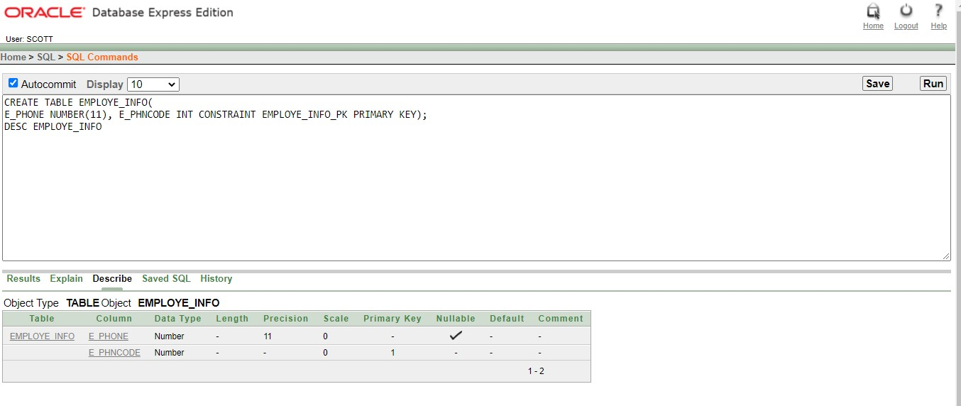

# :



## FOR TABLE 1 ( PATIENT ) ↆ

INSERT INTO PATIENT VALUES('MD HASAN',23,'KHILKHET',175,501,1201); INSERT INTO PATIENT VALUES('MD ADNAN',21,'RANGPUR',178,502,1202); INSERT INTO PATIENT VALUES('AL FARDIN',20,'PABNA',187,503,1203); INSERT INTO PATIENT VALUES('RIMON KHAN',25,'BIRAMPUR',185,504,1204); INSERT INTO PATIENT VALUES(' MD REJOWAN',23,'JAMALPUR',162,505,1205); INSERT INTO PATIENT VALUES(' MD SAGOR',22,'KUMILLA',174,506,1206);

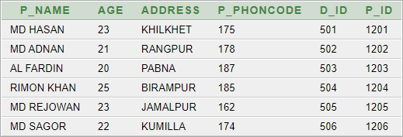

**FOR TABLE 2 ( DOCTOR ) ↆ**

INSERT INTO DOCTOR VALUES('MD. MEHADI','MBS',0157,501); INSERT INTO DOCTOR VALUES('MD. FARDIN','BSC',0158,502); INSERT INTO DOCTOR VALUES('DR. IMRAN','MBS',0159,503); INSERT INTO DOCTOR VALUES('DR.RIMON ','MSC',0152,504); INSERT INTO DOCTOR VALUES('DR.SAMIYA','DDM',0153,505);

INSERT INTO DOCTOR VALUES('DR.BITHI ','BCS',0156,506);

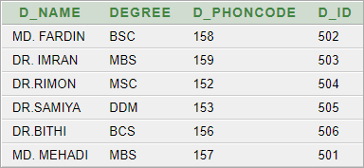

## FOR TABLE 3 ( PATIENT_INFO ) ↆ

INSERT INTO PATIENT_INFO VALUES(175,1750467); INSERT INTO PATIENT_INFO VALUES(178,1785622); INSERT INTO PATIENT_INFO VALUES(187,1878811); INSERT INTO PATIENT_INFO VALUES(185,1856790); INSERT INTO PATIENT_INFO VALUES(162,1642750); INSERT INTO PATIENT_INFO VALUES(174,1745622);

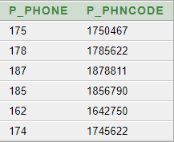

**FOR TABLE 4 ( DOCTOR_INFO) ↆ**

INSERT INTO DOCTOR_INFO VALUES(157,1570467); INSERT INTO DOCTOR_INFO VALUES(158,1585622); INSERT INTO DOCTOR_INFO VALUES(149,1498811); INSERT INTO DOCTOR_INFO VALUES(152,1526790); INSERT INTO DOCTOR_INFO VALUES(153,1532750); INSERT INTO DOCTOR_INFO VALUES(156,1562002);

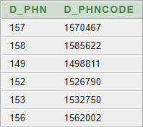

## FOR TABLE 5 ( HOSPITAL ) ↆ

INSERT INTO HOSPITAL VALUES('KURMITOLA',1750467,'KURMITOLA GENERAL HOSPITAL');

INSERT INTO HOSPITAL VALUES('BASHUNDHARA',1785622,'APOLLO HOSITAL'); INSERT INTO HOSPITAL VALUES('KHILKHET',1878811,'KHIDMAD HOSPITAL'); INSERT INTO HOSPITAL VALUES('MIRPUR',1856790,'SQUARE HOSPITAL');

INSERT INTO HOSPITAL VALUES('NEWMARKET',1642750,'NATIONAL HOSPITAL'); INSERT INTO HOSPITAL VALUES('SAVAR',1745622,'SAMOLI HOSPITAL'**);**

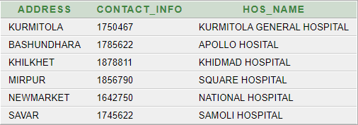

**FOR TABLE 6 ( HOSPITAL_1 ) ↆ**

INSERT INTO HOSPITAL_1 VALUES('KURMITOLA GENERAL HOSPITAL',175); INSERT INTO HOSPITAL_1 VALUES('APOLLO HOSITAL',178);

INSERT INTO HOSPITAL_1 VALUES('KHIDMAD HOSPITAL',187); INSERT INTO HOSPITAL_1 VALUES('SQUARE HOSPITAL',185); INSERT INTO HOSPITAL_1 VALUES('NATIONAL HOSPITAL',162); INSERT INTO HOSPITAL_1 VALUES('SAMOLI HOSPITAL',174);

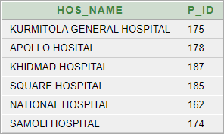

## FOR TABLE 7 (BLOOD_BANK) ↆ

INSERT INTO BLOOD_BANK VALUES('O+','rana@gamil.com',882,5051); INSERT INTO BLOOD_BANK VALUES('A+','sagor@gamil.com',883,5052); INSERT INTO BLOOD_BANK VALUES('B+','rahim@gamil.com',884,5053); INSERT INTO BLOOD_BANK VALUES('AB+','fardin@gamil.com',885,5054); INSERT INTO BLOOD_BANK VALUES('AB-','shihab@gamil.com',886,5055); INSERT INTO BLOOD_BANK VALUES('O+','anik@gamil.com',887,5056);

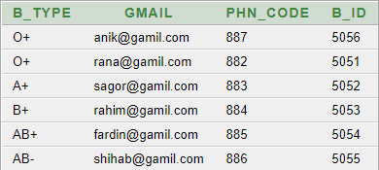

**FOR TABLE 8 ( BLOOD_BANK_1) ↆ**

INSERT INTO BLOOD_BANK_1 VALUES('KURMITOLA HOSPITAL',5051); INSERT INTO BLOOD_BANK_1 VALUES('APOLLO HOSITAL',5052); INSERT INTO BLOOD_BANK_1 VALUES('KHIDMAD HOSPITAL',5053); INSERT INTO BLOOD_BANK_1 VALUES('SQUARE HOSPITAL',5054); INSERT INTO BLOOD_BANK_1 VALUES('NATIONAL HOSPITAL',5055); INSERT INTO BLOOD_BANK_1 VALUES('SAMOLI HOSPITAL',5056);

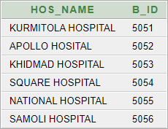

## FOR TABLE 9 (BLOOD_INFO) ↆ

INSERT INTO BLOOD_INFO VALUES(8824659,882); INSERT INTO BLOOD_INFO VALUES(8839566,883); INSERT INTO BLOOD_INFO VALUES(8849598,884); INSERT INTO BLOOD_INFO VALUES(8854669,885); INSERT INTO BLOOD_INFO VALUES(8864659,886); INSERT INTO BLOOD_INFO VALUES(8879659,887);

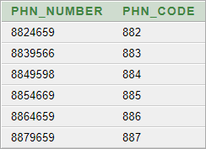

**FOR TABLE 10 ( BLOOD_BANK_2 ) ↆ**

INSERT INTO BLOOD_BANK_2 VALUES(478,'O+','rana@gamil.com',8051,5052); INSERT INTO BLOOD_BANK_2 VALUES(477,'A+','sagor@gamil.com',8051,5051); INSERT INTO BLOOD_BANK_2 VALUES(476,'B+','rahim@gamil.com',8051,5053); INSERT INTO BLOOD_BANK_2 VALUES(475,'AB+','fardin@gamil.com',8051,5054); INSERT INTO BLOOD_BANK_2 VALUES(474,'AB-','shihab@gamil.com',8051,5055); INSERT INTO BLOOD_BANK_2 VALUES(473,'O+','anik@gamil.com',8051,5056);

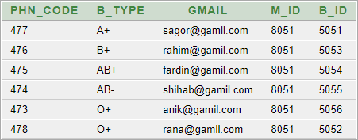

## FOR TABLE 11 ( MANAGER ) ↆ

INSERT INTO MANAGER VALUES('MEHEDI','mahidi22@gmail.com',789,8051);



**FOR TABLE 12 ( MANAGER_INFO) ↆ**



INSERT INTO MANAGER_INFO VALUES(789658,789);

## FOR TABLE 13 (BLOOD_BANK_3) ↆ

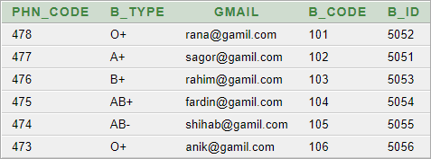

INSERT INTO BLOOD_BANK_3 VALUES(478,'O+','rana@gamil.com',101,5052); INSERT INTO BLOOD_BANK_3 VALUES(477,'A+','sagor@gamil.com',102,5051); INSERT INTO BLOOD_BANK_3 VALUES(476,'B+','rahim@gamil.com',103,5053); INSERT INTO BLOIOD_BANK_3 VALUES(475,'AB+','fardin@gamil.com',104,5054); INSERT INTO BLOOD_BANK_3 VALUES(474'AB-','shihab@gamil.com',105,5055); INSERT INTO BLOOD_BANK_3 VALUES(473,'O+','anik@gamil.com',106,5056);

**FOR TABLE 14 (BLOOD) ↆ**

INSERT INTO BLOOD VALUES('O+',800, 101); INSERT INTO BLOOD VALUES('A+',1000, 102); INSERT INTO BLOOD VALUES('AB+',500, 103); INSERT INTO BLOOD VALUES('AB-',850, 104); INSERT INTO BLOOD VALUES('B+',1100, 105); INSERT INTO BLOOD VALUES('B-',900, 106);

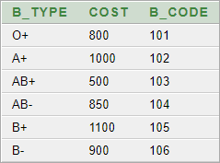

## FOR TABLE 15 (DONOR) ↆ

INSERT INTO DONOR VALUES( 'KORIM','O+','12-6-2022','MALE',459,601); INSERT INTO DONOR VALUES( 'SAGOR','A+','14-6-2022','MALE',458,602); INSERT INTO DONOR VALUES( 'SADIYA','AB+','20-6-2022','FEMALE',457,603); INSERT INTO DONOR VALUES( 'SHIHAB','AB-','18-7-2022','MALE',456,604); INSERT INTO DONOR VALUES( 'ABDILLA','B+','16-8-2022','MALE',455,605); INSERT INTO DONOR VALUES( 'NOYON','B+','12-9-2022','MALE',454,606);

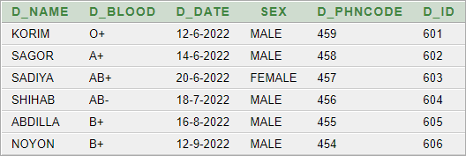

**FOR TABLE 16 (DONOR_1) ↆ**

INSERT INTO DONOR_1 VALUES(101,601); INSERT INTO DONOR_1 VALUES(102,602); INSERT INTO DONOR_1 VALUES(103,603); INSERT INTO DONOR_1 VALUES(104,604); INSERT INTO DONOR_1 VALUES(105,605); INSERT INTO DONOR_1 VALUES(106,606);

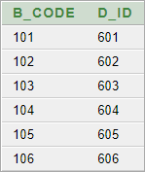

## FOR TABLE 17 (DONOR_INFO) ↆ

INSERT INTO DONOR_INFO VALUES(4596856, 459); INSERT INTO DONOR_INFO VALUES(4586952, 458); INSERT INTO DONOR_INFO VALUES(4572681, 457); INSERT INTO DONOR_INFO VALUES(4569231, 456); INSERT INTO DONOR_INFO VALUES(4559646, 455); INSERT INTO DONOR_INFO VALUES(4549281, 454);

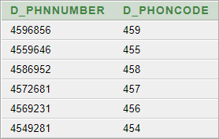

**FOR TABLE 18 (DONOR_2) ↆ**

INSERT INTO DONOR_2 VALUES( 'KORIM',459,'14-6-2022','O+','MALE',3001,601); INSERT INTO DONOR_2 VALUES( 'SAGOR',458,'14-8-2022','A+','MALE',3002,602); INSERT INTO DONOR_2 VALUES( 'SADIYA',457,'24-6-2022','AB+','MALE',3003,603); INSERT INTO DONOR_2 VALUES( 'SHIHAB',456,'18-7-2022','AB-','MALE',3004,604); INSERT INTO DONOR_2 VALUES( 'ABDUILLA',455,'16-8-2022','B+','MALE',3005,605); INSERT INTO DONOR_2 VALUES( 'NOYON',454,'12-9-2022','B+','MALE',3006,606);

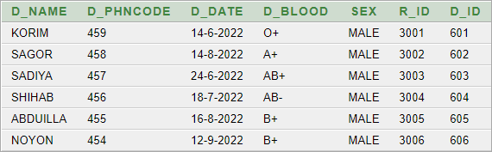

## FOR TABLE 19 (RECEPTIONIST) ↆ

INSERT INTO RECEPTIONIST VALUES('KHILKHET',398, 'MEHEDI',901); INSERT INTO RECEPTIONIST VALUES('KURIL',397, 'RAHIN',902); INSERT INTO RECEPTIONIST VALUES('BONANI',396, 'RUNA',903); INSERT INTO RECEPTIONIST VALUES('MIRPUR',395, 'FARHAN',904); INSERT INTO RECEPTIONIST VALUES('SAVAR',394, 'SAJID',905); INSERT INTO RECEPTIONIST VALUES('TEJGONG',393, 'EMON',906);

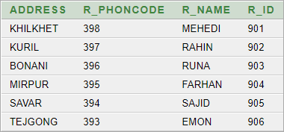

**FOR TABLE 20 (RECEPTIONIST_INFO) ↆ**

INSERT INTO RECEPTIONIST_INFO VALUES(398596,398); INSERT INTO RECEPTIONIST_INFO VALUES(397566,397); INSERT INTO RECEPTIONIST_INFO VALUES(396596,396); INSERT INTO RECEPTIONIST_INFO VALUES(395596,395); INSERT INTO RECEPTIONIST_INFO VALUES(394599,394); INSERT INTO RECEPTIONIST_INFO VALUES(393592,393);

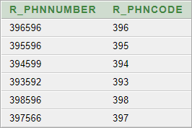

## FOR TABLE 21 (RECEPTIONIST_2) ↆ

INSERT INTO RECEPTIONIST_2 VALUES('KHILKHET', 'MEHEDI',398,5051,901); INSERT INTO RECEPTIONIST_2 VALUES('KURIL', 'RAHIN',397,5052,902); INSERT INTO RECEPTIONIST_2 VALUES('BONANI', 'RUNA',396,5053,903); INSERT INTO RECEPTIONIST_2 VALUES('MIRPUR', 'FARHAN',395,5054,904); INSERT INTO RECEPTIONIST_2 VALUES('SAVAR', 'SAJID',394,5055,905); INSERT INTO RECEPTIONIST_2 VALUES('TEJGONG', 'EMON',393,5056,906);

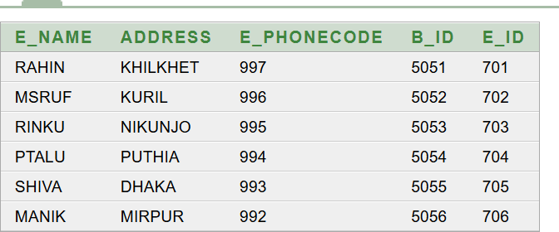

**FOR TABLE 22 (BLOOD_REQUEST) ↆ**

INSERT INTO BLOOD_REQUEST VALUES('RAHIN','KHILKHET',997,5051,701); INSERT INTO BLOOD_REQUEST VALUES('MSRUF','KURIL',996,5052,702); INSERT INTO BLOOD_REQUEST VALUES('RINKU','NIKUNJO',995,5053,703); INSERT INTO BLOOD_REQUEST VALUES('PTALU','PUTHIA',994,5054,704); INSERT INTO BLOOD_REQUEST VALUES('SHIVA','DHAKA',993,5055,705); INSERT INTO BLOOD_REQUEST VALUES('MANIK','MIRPUR',992,5056,706);

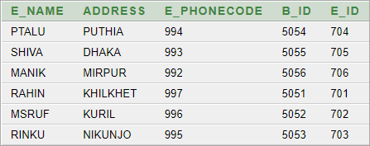

**FOR TABLE 23 (EMPLYE_INFO) ↆ**

INSERT INTO EMPLOYE_INFO VALUES(99756988,997); INSERT INTO EMPLOYE_INFO VALUES(99655556,996); INSERT INTO EMPLOYE_INFO VALUES(99556954,995); INSERT INTO EMPLOYE_INFO VALUES(99456956,994); INSERT INTO EMPLOYE_INFO VALUES(99356956,993); INSERT INTO EMPLOYE_INFO VALUES(99256987,992);

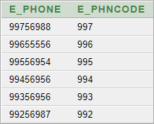



# Equijoins:

Equijoins table between (Patient – Doctor)

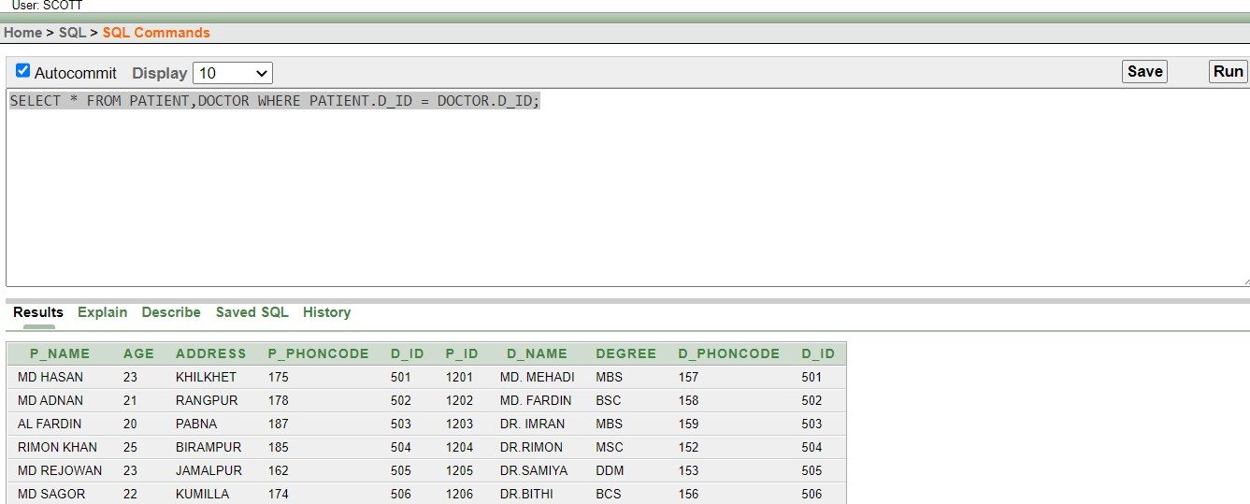

Equijoins table between (Receptionist_2 – Blood_bank_1)

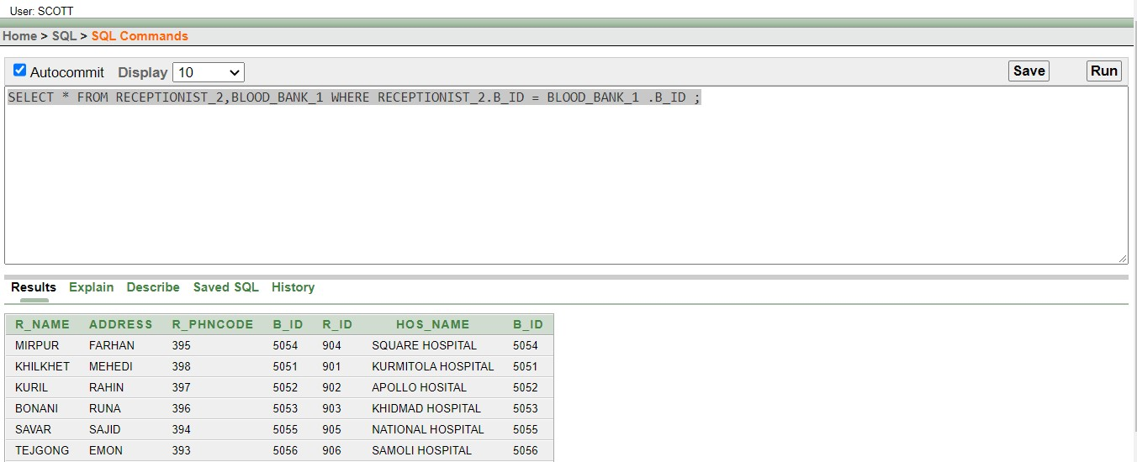



## SELECT P_NAME,AGE,P_PHONCODE,P_ID FROM PATIENT WHERE P_PHONCODE>(SELECT P_PHONCODE FROM PATIENT WHERE p_ID=1205);

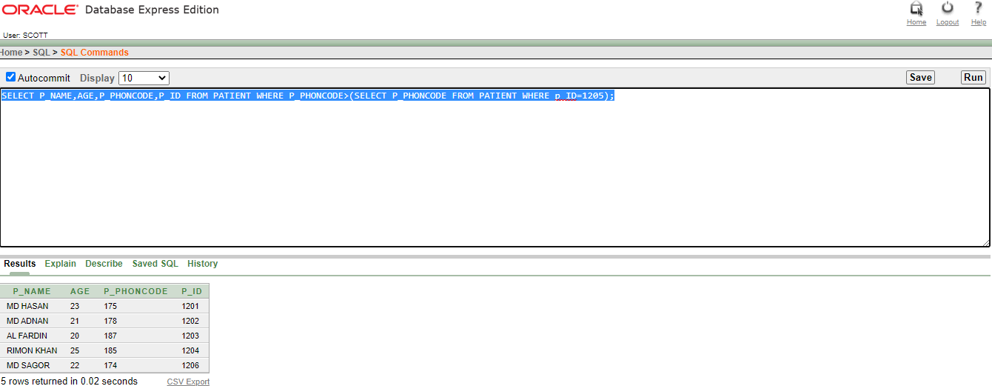

* 1. **SELECT P_NAME,AGE,P_PHONCODE,P_ID FROM PATIENT WHERE P_PHONCODE>(SELECT P_PHONCODE FROM PATIENT WHERE p_ID=1201);**

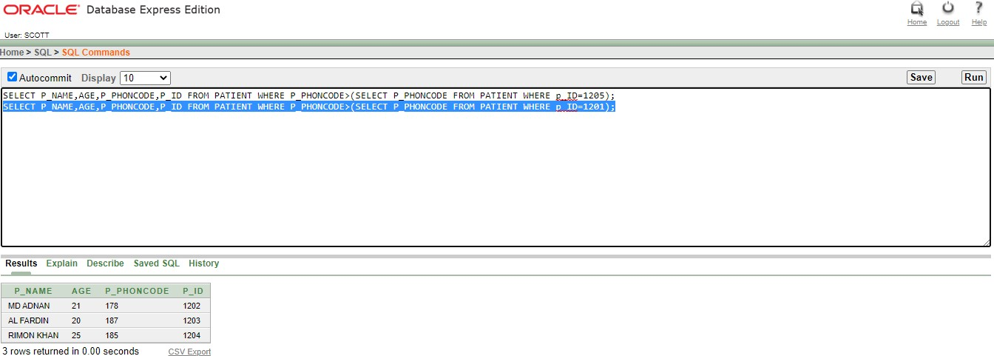



1. **##**CREATE PATIENT VIEW AS PATIENT_VIEW .

CREATE VIEW PATIENT_VIEW AS SELECT P_NAME PATIENT_NAME,P_ID PATIENT_ID,ADDRESS PATIENT_ADDRESS , AGE PATIENT_AGE FROM PATIENT;

SELECT *FROM PATIENT_VIEW;

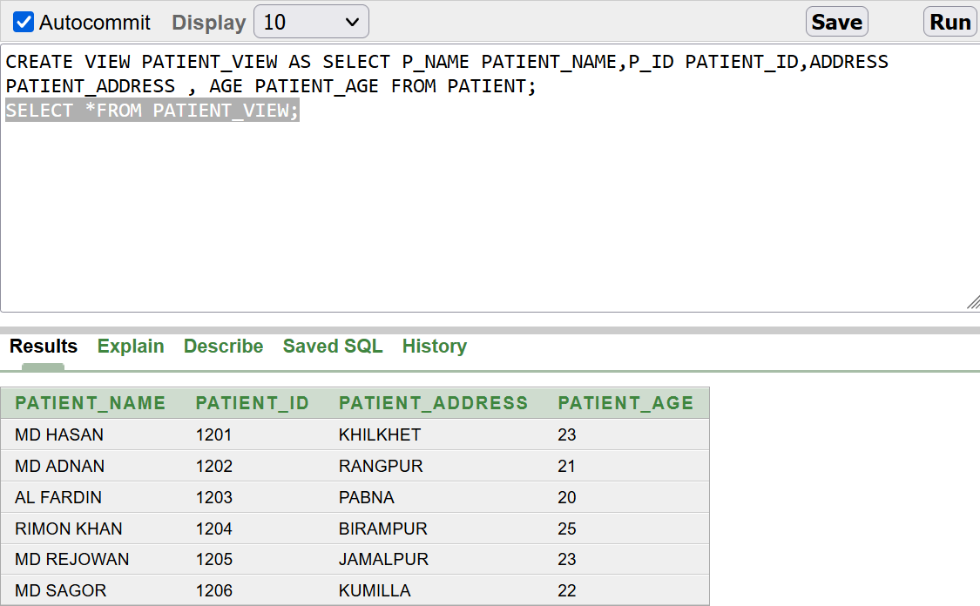

1. ##CREATE DOCTOR VIEW AS DOCTOR_VIEW

CREATE VIEW DOCTOR_VIEW AS SELECT D_NAME DOCTOR_NAME,D_ID DOCTOR_ID, DEGREE DOCTOR_DEGREE FROM DOCTOR WHERE D_ID BETWEEN 501 AND 505;

SELECT*FROM DOCTOR_VIEW

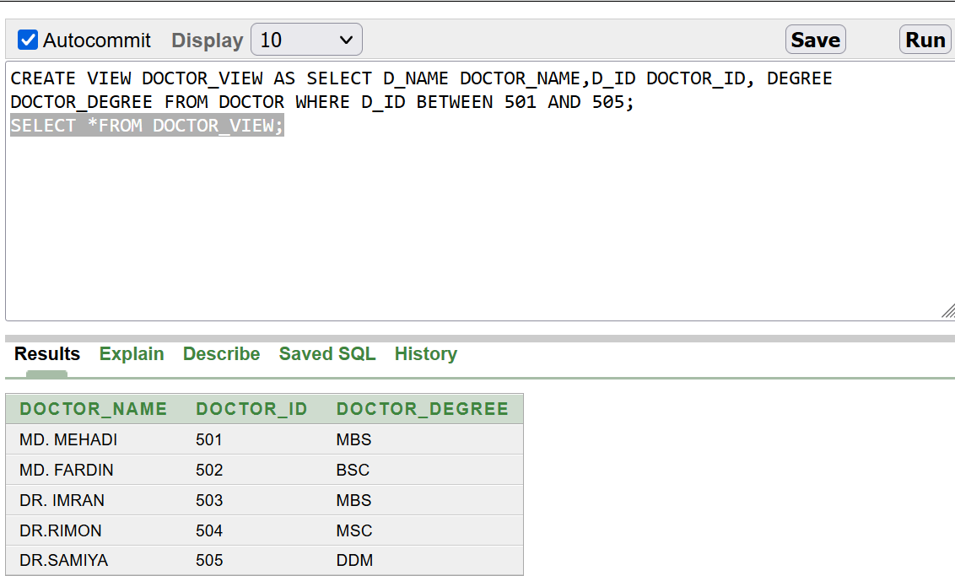

1. ##CREATE DONOR VIEW AS DONOR_VIEW

CREATE VIEW DONOR_VIEW AS SELECT D_NAME DONOR_NAME,D_ID DONOR_ID, D_BLOOD DONAR_BLOOD FROM DONOR WHERE D_ID BETWEEN 601 AND 605;

SELECT *FROM DONOR_VIEW;

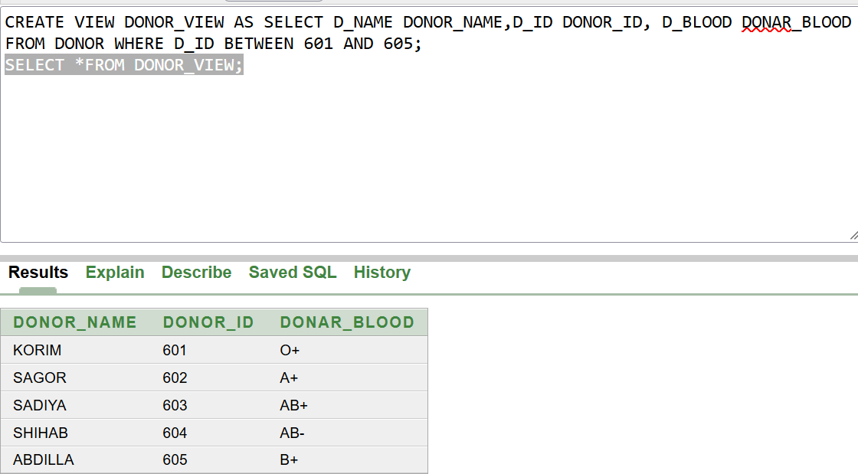

1. ##CREATE HOSPITAL VIEW ASS HOSPITAL_VIEW

CREATE VIEW HOSPITAL_VIEW AS SELECT HOS_NAME HOSPITAL_NAME,CONTACT_INFO HOSPITAL_CONTACTNUM, ADDRESS HOSPITAL_ADDRESS FROM HOSPITAL ;

SELECT *FROM HOSPITAL_VIEW ;

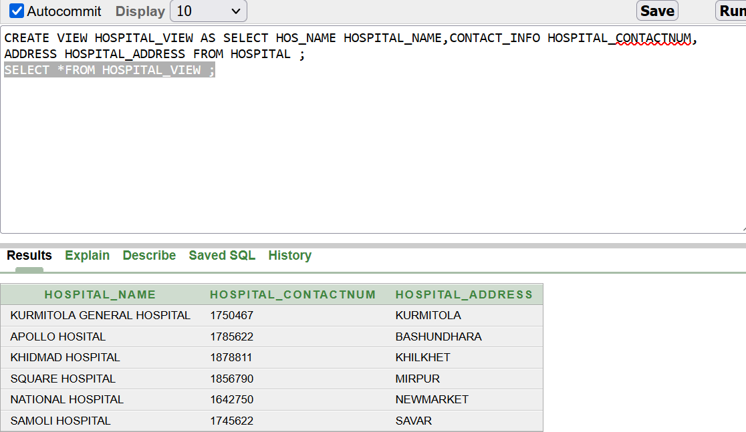



**TABLE NAME: BLOOD**

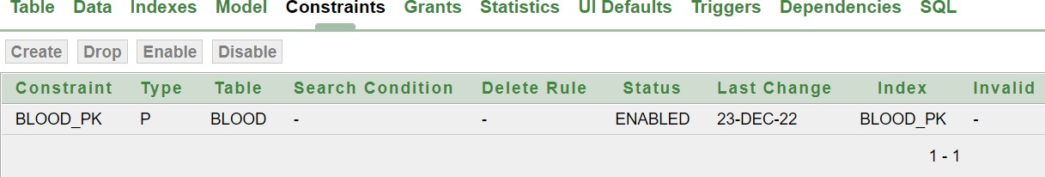

**TABLE NAME: BLOOD_1**

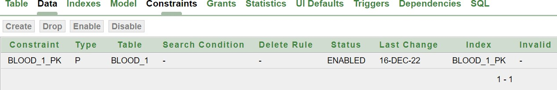

**TABLE NAME: BLOOD_REQUEST**

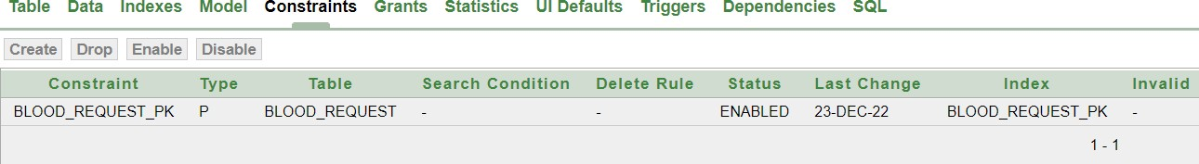

**TABLE NAME: BLOOD_BANK**

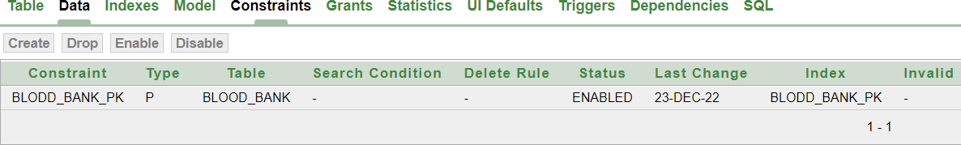

**TABLE NAME: EMPLOYEE_INFO**

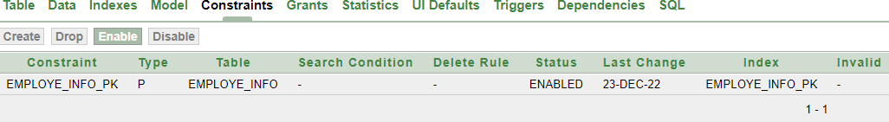

**TABLE NAME: HOSPITAL**

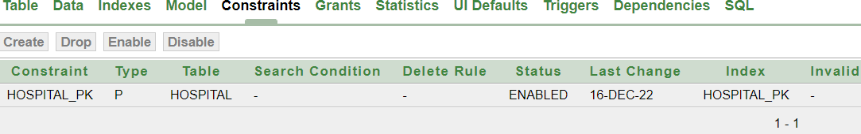

**TABLE NAME: HOSPITAL_INFO**

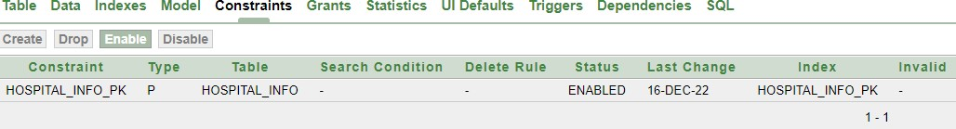

**TABLE NAME: PATIENT**

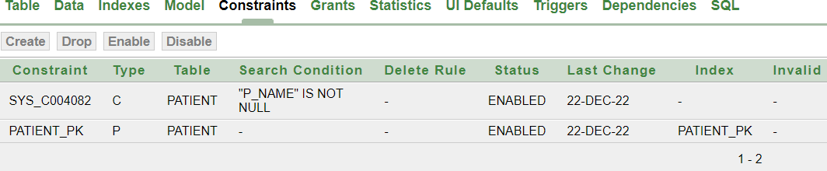

**TABLE NAME: RECEPTIONIST**

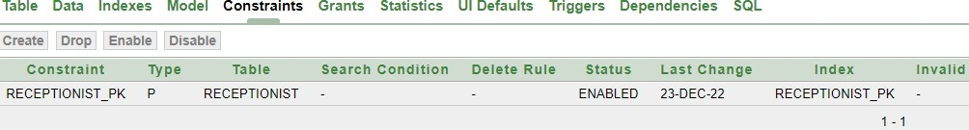

**TABLE NAME: RECEPTIONIST_INFO**

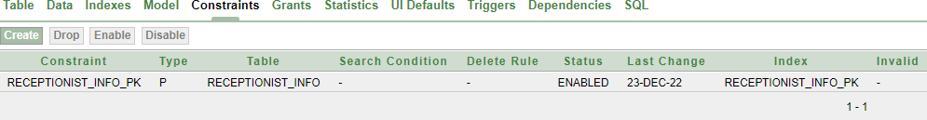

**TABLE NAME: DONOR**

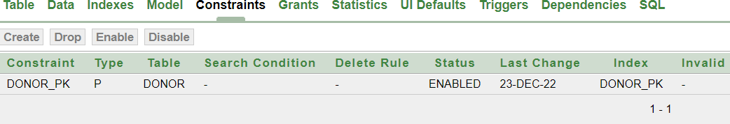

**TABLE NAME: DONOR_1**

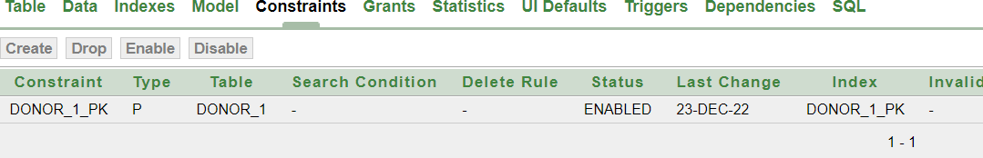

**TABLE NAME: DONOR_2**

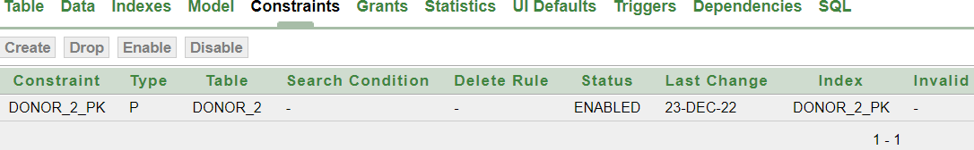

**TABLE NAME: DONOR_INFO**

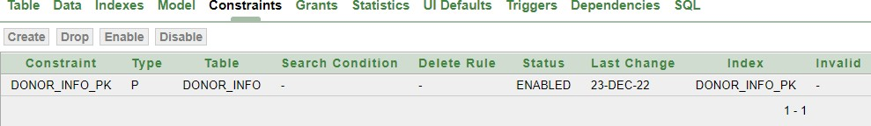

**TABLE NAME: MANAGER**

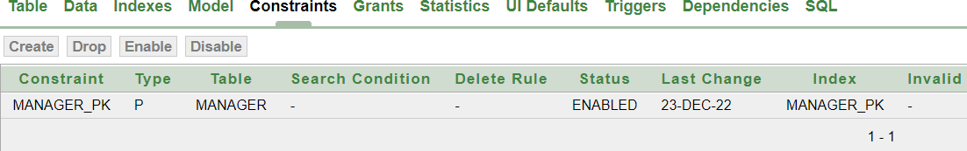

**TABLE NAME: MANAGER_1**

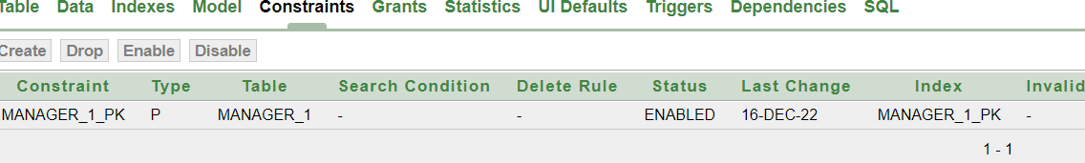

**TABLE NAME: MANAGER_INFO**

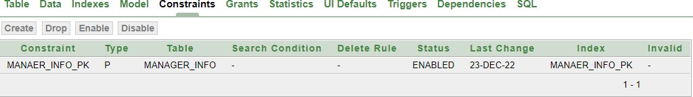

**TABLE NAME: RECEPTIONIST_1**

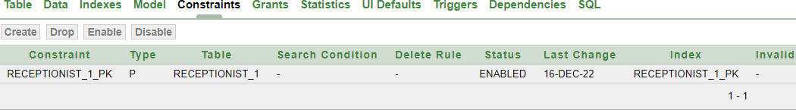

**TABLE NAME: RECEPTIONIST_2**

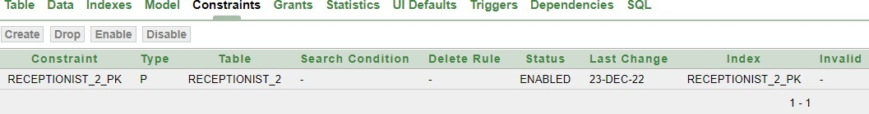

**TABLE NAME: PATIENT_INFO**

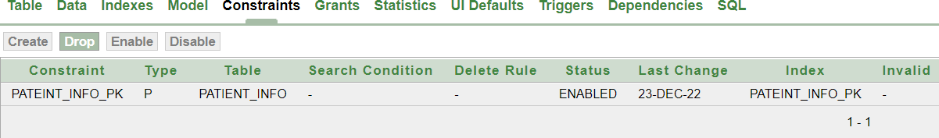



1. SELECT * FROM BLOOD_BANK ;
2. SELECT P_NAME ||' '||'ID IS'||' '||P_ID AS PATIENT_ID FROM PATIENT;
3. SELECT P_NAME AS PATIENT_NAME,P_ID PATIENT_ID,AGE PATIENT_AGE FROM PATIENT;
4. SELECT D_NAME,DEGREE,D_PHONCODE,D_ID FROM DOCTOR WHERE DEGREE LIKE 'MBS';
5. SELECT D_NAME,DEGREE,D_PHONCODE,D_ID FROM DOCTOR WHERE D_ID IN (502,503,505);
6. SELECT D_NAME,DEGREE,D_PHONCODE,D_ID FROM DOCTOR WHERE D_PHONCODE = 159;
7. SELECT B_TYPE,GMAIL,PHN_CODE,B_ID FROM BLOOD_BANK WHERE B_ID BETWEEN 5052 AND 5055;
8. SELECT D_NAME,DEGREE,D_PHONCODE,D_ID FROM DOCTOR WHERE UPPER(D_NAME) = 'DR.SAMIYA';
9. SELECT PHN_CODE,B_TYPE,GMAIL,M_ID,B_ID FROM BLOOD_BANK_2 WHERE B_ID

<> 5054;

1. SELECT * FROM PATIENT,DOCTOR WHERE PATIENT.D_ID = DOCTOR.D_ID;