**Final ER-Diagram:**

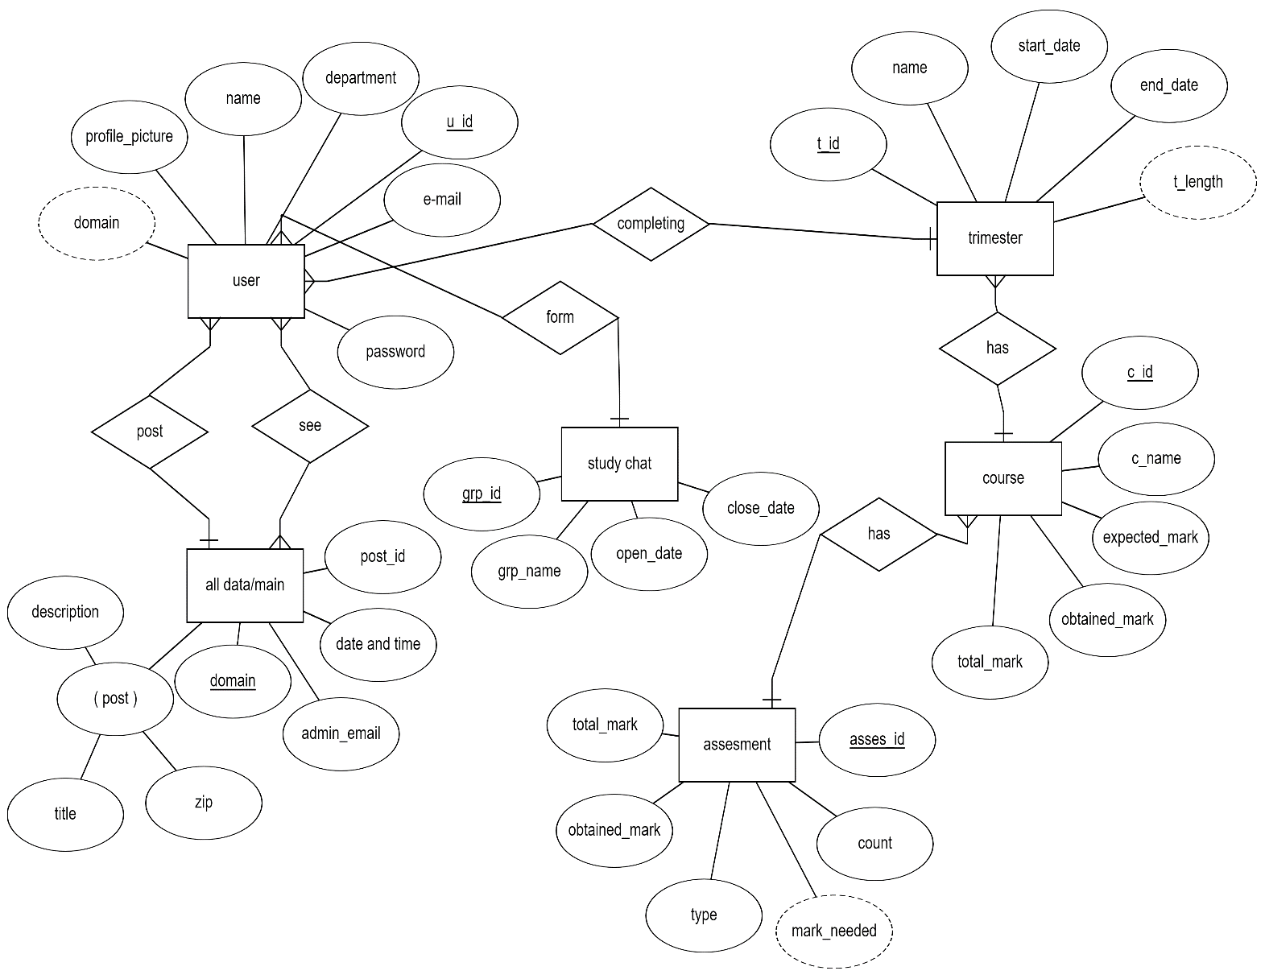

**Final Relational Schema:**

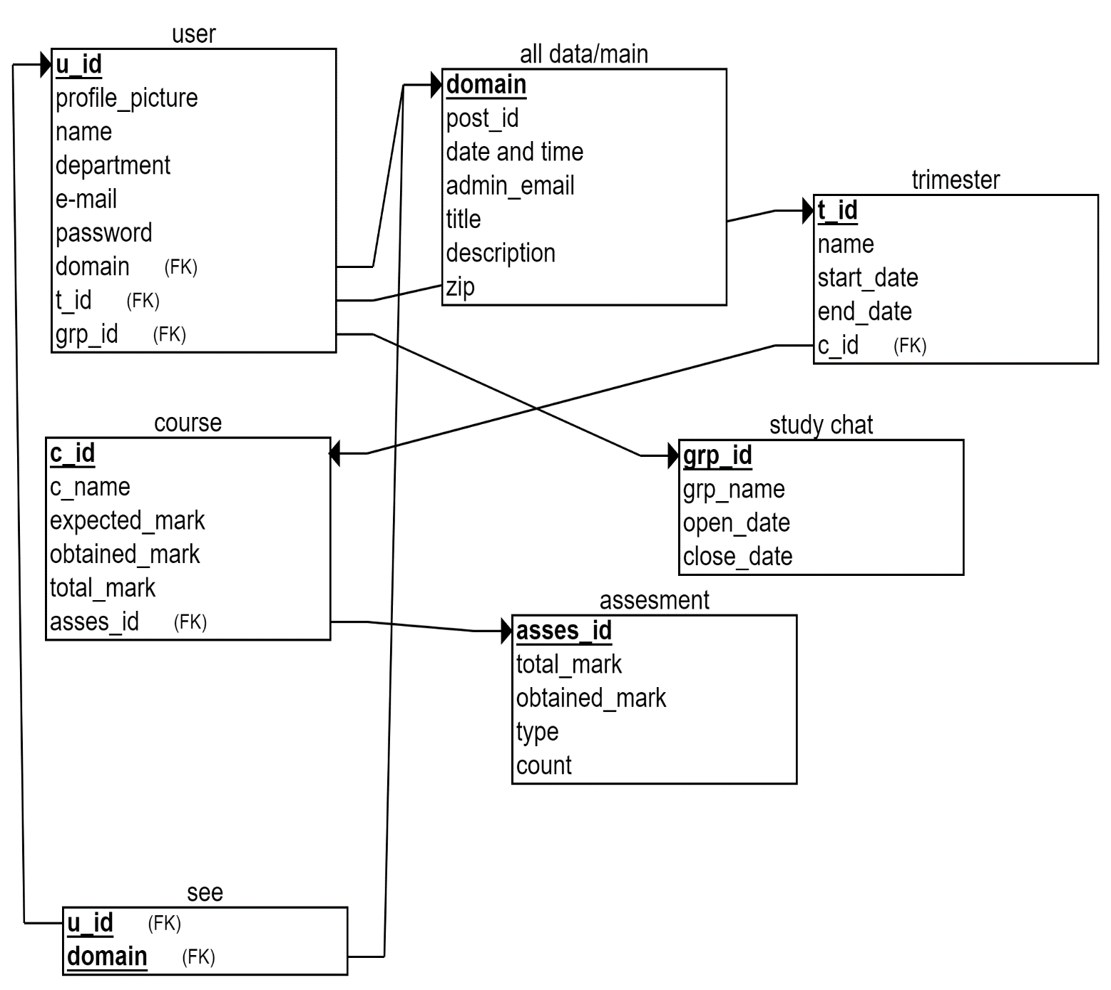

**Features:**

**1.Login:**

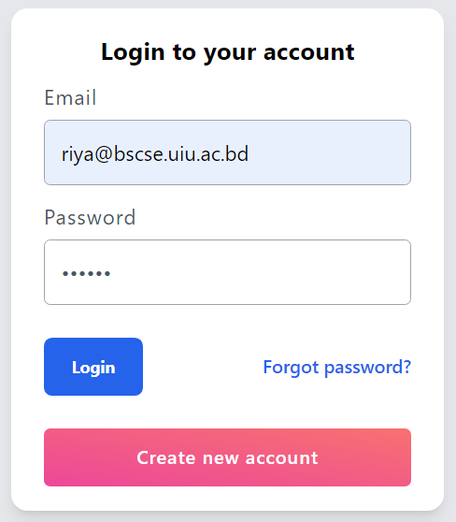

**Sql For Login:**

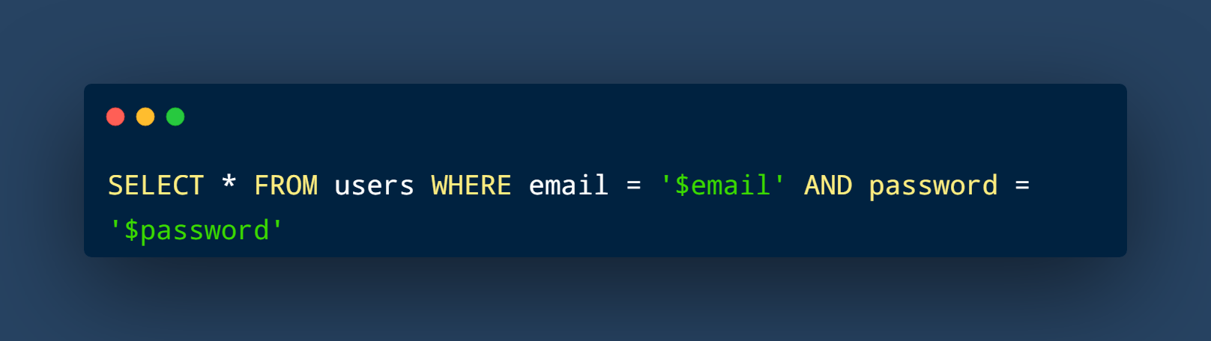

login.php

**Create Post:**



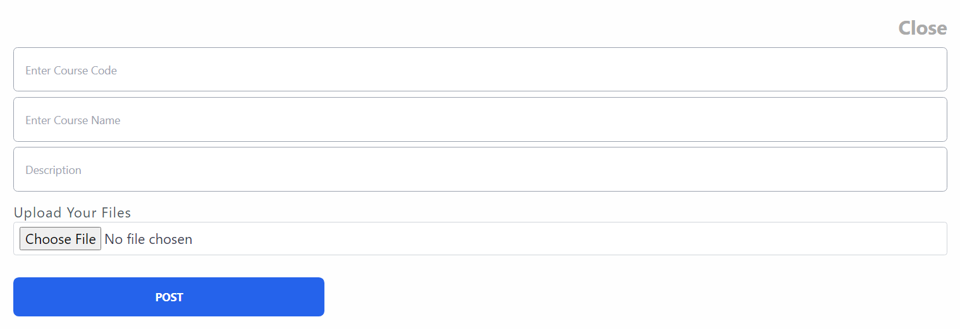

**Sql for create post:**

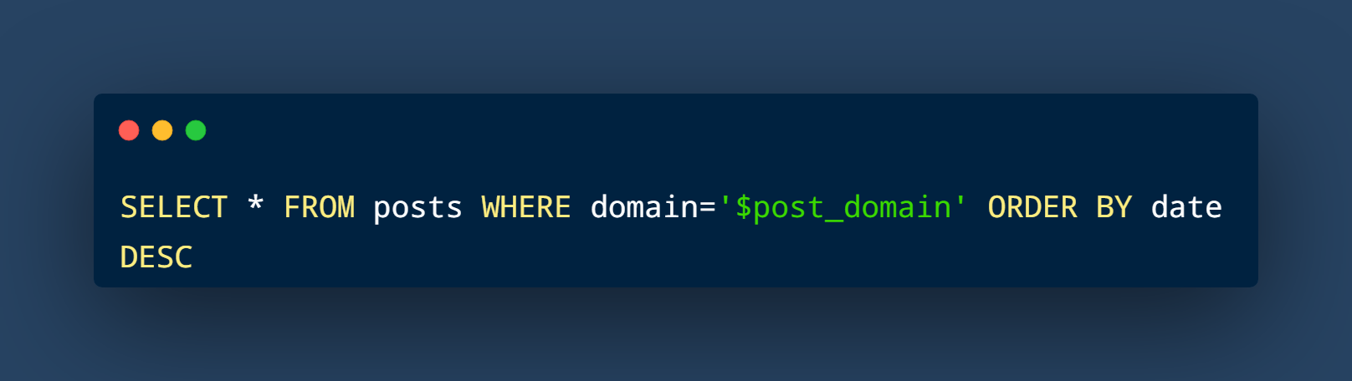

Function view_post



Function display_data_by_id

**Private Chat:**



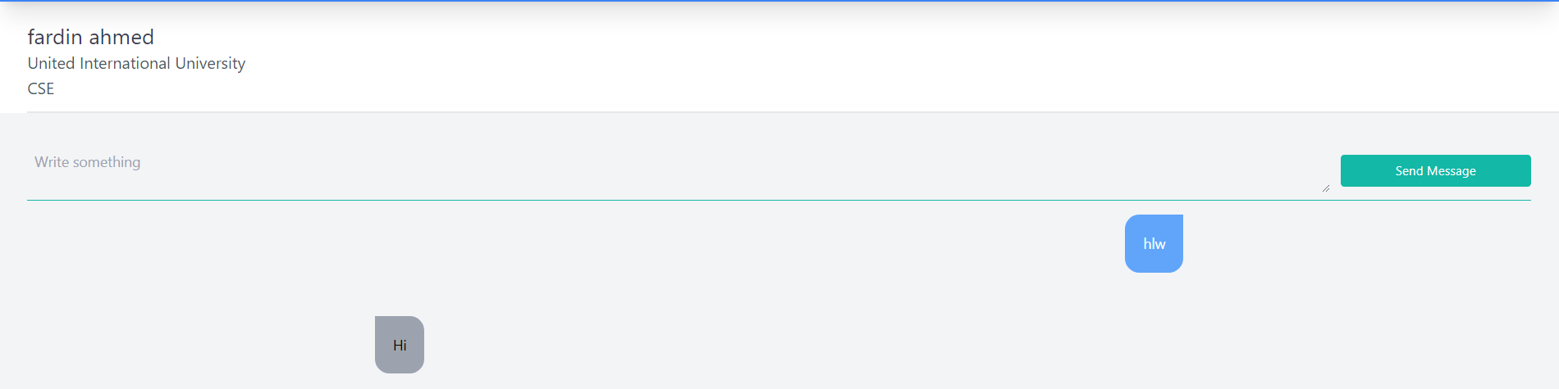

**Sql for private chat:**

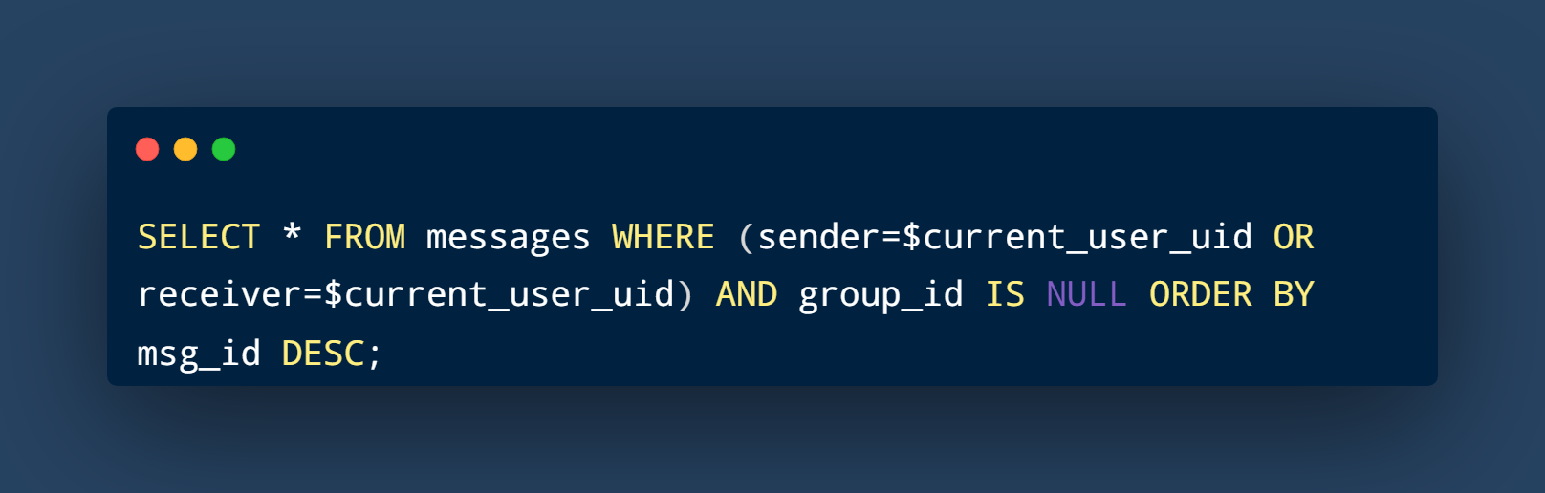

Chat/index.php

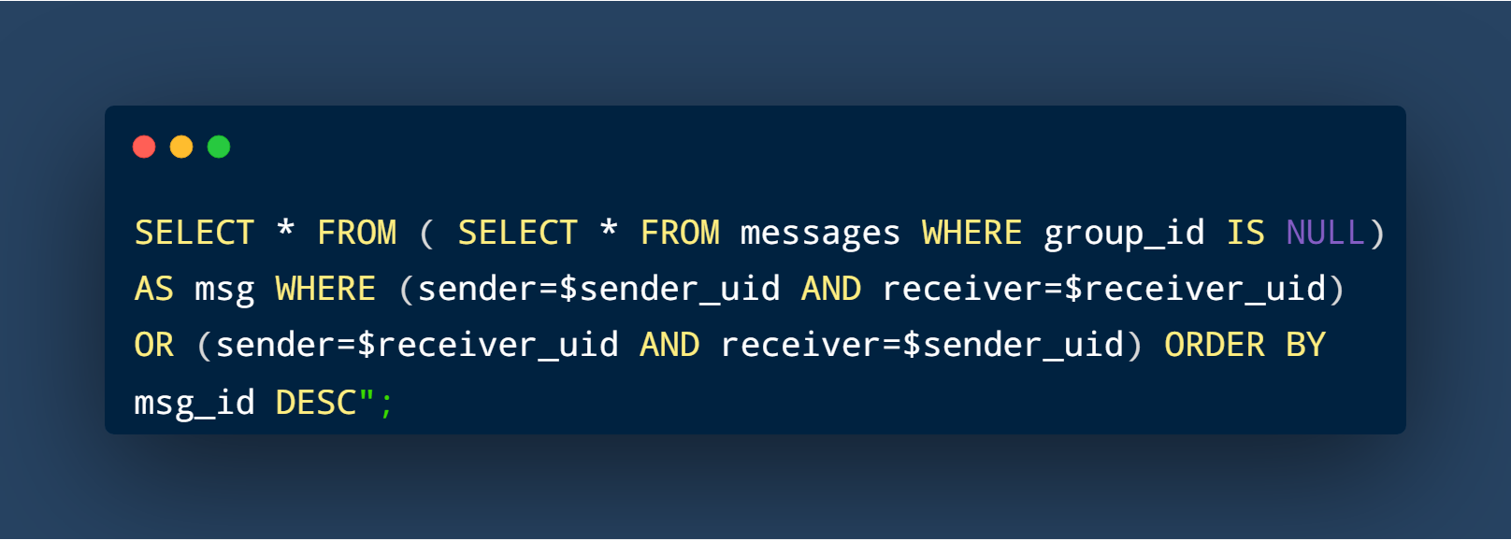

Private.php



Private.php

**Future Plan:**

We will deploy our web site globally in near future after adding more feature. However, there are lots of scope of improvement. Many bugs needed to be solved