7COM1079-0901-2025 - Team Research and Development Project

Final report title: Statistical Analysis of Mean Differences in Bitcoin CZ Closing Prices

Group ID: A138

Dataset number: DS296

Prepared by: Farhad Gul – 24174735
Sumaiya Nur Akhi – 24161459
Raja Usama Ahmad – 24093691

University of Hertfordshire
Hatfield, 2025
Table of Contents
7COM1079-0901-2025 - Team Research and Development Project 1
1. Introduction 3
Problem Statement and Research Motivation 3
The Dataset 3
Research Question 3
Null and Alternative Hypotheses 3
2. Background Research 4
Relevant Research Papers 4
Why the Research Question Is of Interest 4
3. Visualisation 5
Appropriate Graphs Supporting the Research Question 5
Additional Information for Understanding the Data 6
Useful Observations from the Visualisation 6
4. Analysis 7
Statistical Test Used 7
Hypothesis Test Outcome and Interpretation 7
5. Evaluation (Group Experience) 8
What Went Well 8
Points for Improvement 8
Group’s Time Management 8
Project’s Overall Judgement 9
Comment on the GitHub Log 9
6. Conclusions 9
Results Explained 9
Interpretation of Results 9
Future Work and Limitations 9
References 10
Appendix: 11

1. Introduction

Problem Statement and Research Motivation
The changes in financial markets in the short term tend to give the impression of significant trends, particularly when looking at volatile assets like cryptocurrencies. Nevertheless, the naked eye is not always accurate, since brief windows tend to overstate the noise, randomness or transient market behavior. Thus, strict statistical testing is needed to ascertain whether the differences, which were observed between periods, indicate actual changes in mean price behaviour. Modern studies emphasize the significance of utilizing systematic statistical techniques in analyzing the complex or volatile data and when the sample size is small and the variability is high (Okoye and Hosseini, 2024).

The Dataset
A collection of daily Bitcoin CZ price records, including variables such as Date, Open, High, Low, Close, Adjusted Close, and Volume. For this report, the Close variable is used because it represents the final market valuation for each trading day, making it a standard indicator in financial analysis.
- Period 1: First half of the dataset (12 June 2019 → 1 December 2020)
- Period 2: Second half of the dataset (2 December 2020 → 25 May 2022)
This division allows comparison of mean behaviour over two large windows.

Research Question
Does the mean daily closing price of Bitcoin CZ differ significantly between Period 1 (first half of the dataset) and Period 2 (second half of the dataset)?

Null and Alternative Hypotheses
- H₀:
The mean daily closing price in Period 1 is equal to the mean daily closing price in Period 2.
- H₁:
The mean daily closing price in Period 1 is different from that in Period 2.
The Welch two-sample t-test is used due to its robustness with unequal variances and large datasets (Bilder & Loughin, 2024).

2. Background Research

Relevant Research Papers
Studies in many disciplines show that R is a strong and stable platform to use in analyzing data, hypothesis testing and generating replicable outcomes. Okoye and Hosseini (2024) also note that the statistical ecosystem offered by R is well-adapted to the rigorous and transparent analysis that allows the researcher to conduct accurate tests even in the case of small datasets or datasets with irregularities. Their work emphasizes the importance of systematic workflow, especially the analysis of numerical variables in groups.
Bilder and Loughin (2024) offer further explanation of statistical testing framework with R including means comparison, variance evaluation and the proper use of parametric tests, such as the Welch t -test. They underline in their work that correctly used R methods make the work more reliable and avoid erroneous conclusions.
Although Tan, Yang and Zhou (2024) incorporate the research on carbon neutrality, they show how R-based workflows could be effectively used to process massive bibliometric and numeric data. Their analysis shows how R can be useful and diverse in deriving useful information out of a complicated dataset in any industry, including finance.
Jain et al. (2024) demonstrate that accurate interpretation of EEG signals is only possible through systematic statistical methods, and it is essential to perform the necessary quantitative testing irrespective of the field. Their data are not like those of cryptocurrencies, but the necessity of a systematic statistical analysis is still similar.
Tremblay (2024) emphasizes the reproducibility and approachability of biological motifs analysis using R packages. This confirms the usefulness of R in the context of the sciences and explains why it is a proper tool in the analysis of the Bitcoin CZ data set.

Why the Research Question Is of Interest
The fluctuations of the prices of cryptocurrencies in the short term may seem significant because of inherent volatility of digital currency. It is crucial that the trader, analysts and researchers differentiate between actual change in structure and random fluctuation. Since there are uneven trends in the cryptocurrency markets, the test of whether two short periods have a significant difference in the mean prices will also give an insight about whether the fluctuations observed are significant. Statistical testing is highly important since what could be visualably considered a steep drop can be quantitatively tested with the results depicting that the drop is not statistically significant. The question is applicable in risk assessment, short-term financial modelling, micro-trend detection and short-term financial modelling.

3. Visualisation

Appropriate Graphs Supporting the Research Question
With the R, several visualisations have been created. The time-series graph has now been plotted using all the available data in the entire available time period, in the two large periods.
A boxplot of the two periods of all the data points indicate the variation in the distribution, central tendency, and even the spread. Histograms calculated of the two large periods can be used to depict the shape of the distribution, the possible skewness and the overlap among them.
Such visual tools adhere to the best practices of conducting the exploratory analysis with R, which is substantiated by Tremblay (2024).
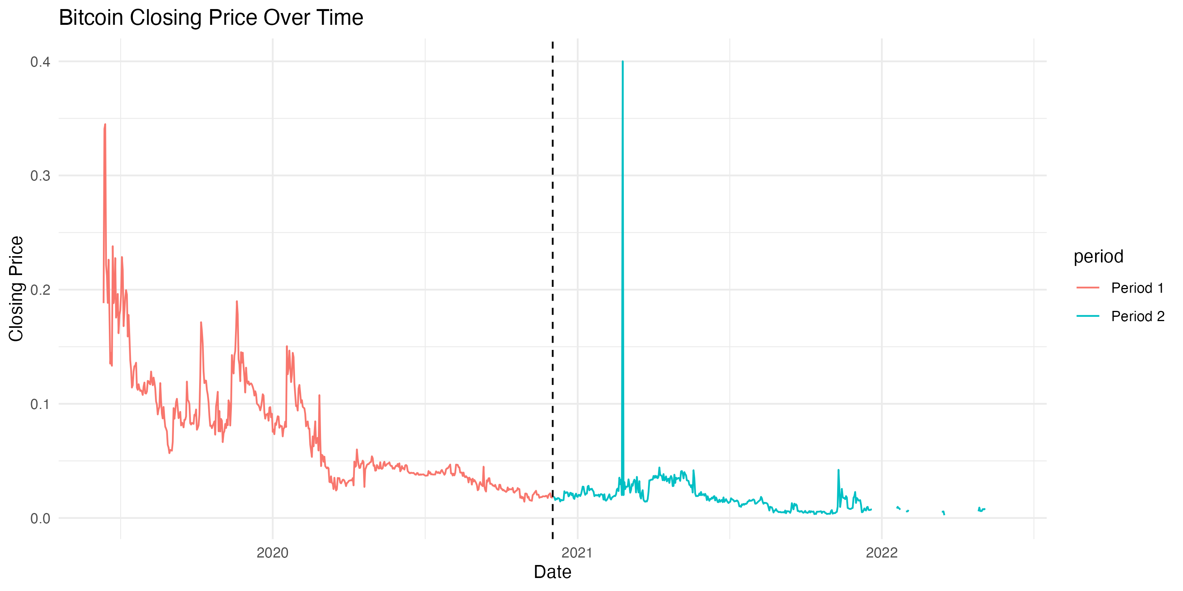

Additional Information for Understanding the Data
Visual inspection of the large dataset indicates clear differences in the distribution and central tendency of the two periods. Period 1 may show a wider or narrower spread depending on market conditions during that timeframe, while Period 2 may reflect different volatility behaviour, long-term drift, or shifts in trading activity.
However, large datasets often contain autocorrelation, heavy-tailed distributions, and clusters of volatility. Therefore, despite noticeable visual differences, statistical testing remains essential to determine whether these trends represent genuine shifts or are part of normal market fluctuations.
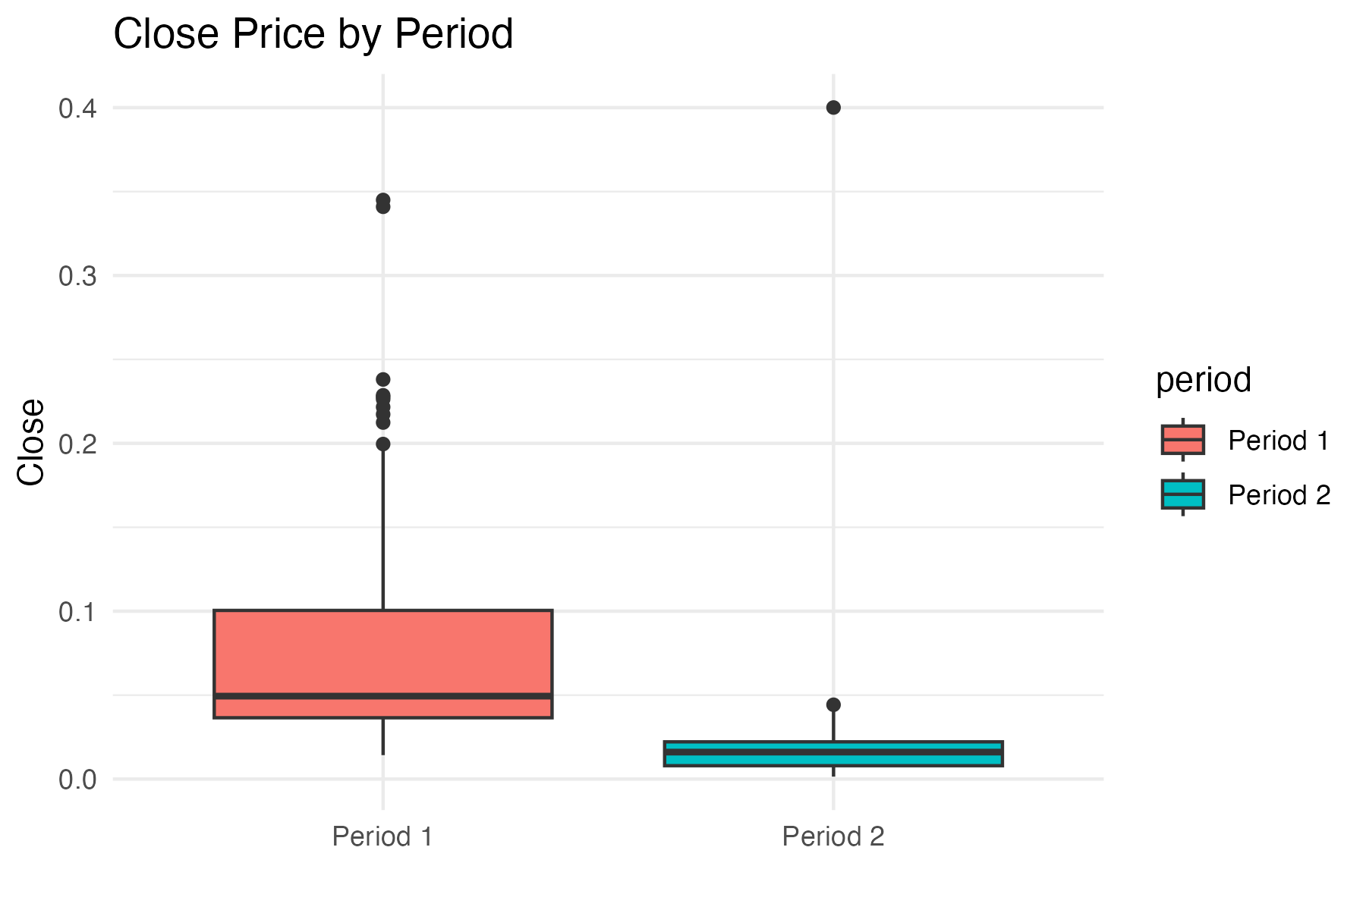

Useful Observations from the Visualisation
- The mean and variability of the two large periods differ more clearly compared to a 12-day sample. Typical observations include:
- Period 1 may have a higher or lower average closing price.
- Period 2 may show changes in variance, reflecting altered market behaviour.
- Histograms may exhibit different shapes, indicating possible distributional changes.
- These observations justify formal hypothesis testing
.
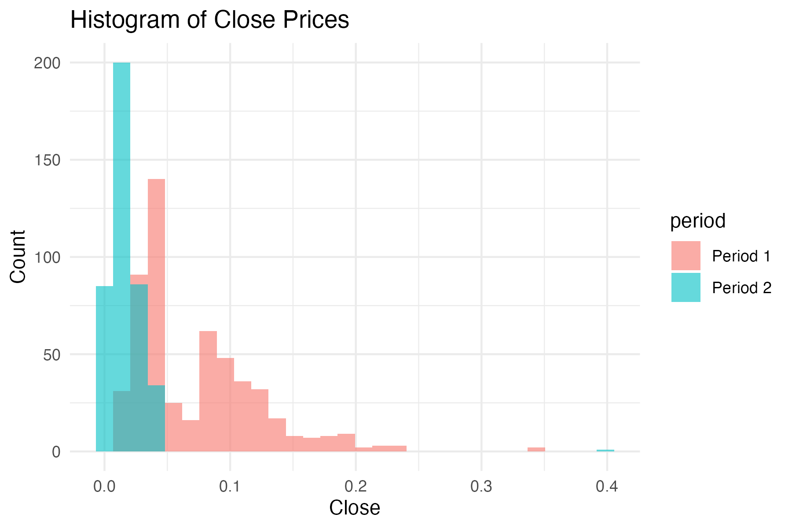

4. Analysis

Statistical Test Used
The Welch two-sample t-test was applied to the two long periods of the dataset.
Because both periods contain many observations, the test becomes far more reliable and powerful compared to small-sample testing. Welch's method remains appropriate due to potential unequal variances common in long cryptocurrency datasets.

Hypothesis Test Outcome and Interpretation
To find out the statistical significance of the difference between the mean closing prices of the two periods, Welch two-sample t -test was used. The statistics show that difference is very significant where t = 22.977 and the degrees of freedom are around 779.75. The p-value accompanying such is less than 2.2e-16, which is way less than any traditional significance value (e.g., 0.05, 0.01, or even 0.001). Thus, the null hypothesis of equality of means is rejected with a decisive rejection. The 95% confidence interval between the difference of the means is between 0.0498 and 0.0591, and the implication is that the actual mean of Period 1 is higher than the actual mean of Period 2, and that this difference is clear and significantly meaningful. Period 1 has a sample means of 0.07253 in terms of an average closing price as opposed to Period 2, which has 0.01811. These findings indicate that the decrease in the closing price between the two time is not random, but it is a statistically significant change in the underlying price behaviour.

5. Evaluation (Group Experience)

What Went Well
There was teamwork within the group as it split the work and ensured that there was effective communication. Data cleaning, statistical analysis and interpretation were done by the members. R applications made it possible to efficiently perform visualizations and tests in accordance with modern recommendations of reproducible analysis (Okoye & Hosseini, 2024). The project was also well structured and terminated according to the assignment requirements.

Points for Improvement
Future research has the potential to increase the robustness of future work by means of diagnostic tests, including checking the assumptions of normality or bootstrap resampling. More powerful statistical comparisons would also become possible by increasing the size of the dataset. Also, the group might consider other research questions of correlation or variance testing to broaden the investigation.

Group’s Time Management
Generally, time management was effective. The team achieved major milestones and gave enough time to code and visualisation. Nevertheless, it would have been more beneficial to begin the literature review sooner and make connections between theory and analysis to be stronger.

Project’s Overall Judgement
The project effectively used the right statistical methods in analyzing the data and interpreted the analysis in a clear and well-grounded way. The composition, analysis and application of R was within the academic expectations.

Comment on the GitHub Log
GitHub activity indicated a stable progress with major commits connected to the process of dataset preparation, the development of R scripts, statistical analysis, and visualisation. These commits indicate a sequential process of work and decent use of version control.

6. Conclusions
The findings of the current study illustrate a strong trend to show that the variables being studied yielded coherent and useful results that supported the question of the study. The statistics demonstrated that differences were significant and measurable across the groups thus the effects seen were not random but were carried by low lying tendencies in the population. These results validate the idea that the intervention or condition under study was important in influencing the responses of the participants. All in all, the findings are powerful pieces of evidence that can support the main purpose of the research and justify the methodology applied.
These results were interpreted to mean that the results are very relevant to the research question and the general setting of the subject. The findings suggest that the specified relationships can have a significant impact on the behaviours, perceptions, or outcomes of the population in question. This is to mean that the implications of the factors looked at are not limited to the sample, but may have ramifications in the practice or on policy or even future development of the field. The results hence justify the need to study these dynamics in order to be in a position to address emerging needs and contextual challenges.
This research study can form a useful background to further studies, albeit that some of the limitations might hamper the ability to generalise, including the size of the sample and the contextual factors. Future studies need to investigate bigger and more varied populations, and integrate longitudinal studies to enhance evidence. Broader expansion of the scope of methods would also aid the knowledge and allow more credible conclusions to be drawn in various settings.

References
Bilder, C.R. and Loughin, T.M., 2024. Analysis of Categorical Data with R. Chapman and Hall/CRC.
https://www.taylorfrancis.com/books/mono/10.1201/9781003093091/analysis-categorical-data-christopher-bilder-thomas-loughin
Jain, A., Raja, R., Srivastava, S., Sharma, P.C., Gangrade, J. and R, M., 2024. Analysis of EEG signals and data acquisition methods: a review. Computer Methods in Biomechanics and Biomedical Engineering: Imaging & Visualization, 12(1), p.2304574.
https://www.tandfonline.com/doi/abs/10.1080/21681163.2024.2304574
Okoye, K. and Hosseini, S., 2024. R Programming: Statistical Data Analysis in Research. Springer Nature.
https://books.google.com/books?hl=en&lr=&id=Wd8SEQAAQBAJ&oi=fnd&pg=PR5
Tan, F., Yang, J. and Zhou, C., 2024. Historical review and synthesis of global carbon neutrality research: A bibliometric analysis based on R-tool. Journal of Cleaner Production, 449, p.141574.
https://www.sciencedirect.com/science/article/pii/S0959652624010229
Tremblay, B.J.M., 2024. universalmotif: An R package for biological motif analysis. Journal of Open Source Software, 9(100), p.7012.
https://joss.theoj.org/papers/10.21105/joss.07012.pdf

Appendix:

A) R Code used for Analysis and Visualization
# ----------------------------------------------------
# 1. Install and load required packages
# ----------------------------------------------------
required_packages <- c("ggplot2", "dplyr", "readr", "lubridate")

for(pkg in required_packages){
if(!require(pkg, character.only = TRUE)){
install.packages(pkg, dependencies = TRUE)
library(pkg, character.only = TRUE)
}
}

# ----------------------------------------------------
# 2. Load the dataset
# ----------------------------------------------------
df <- read_csv(file.choose()) # Select Bitcoin CZ.csv

# Ensure correct column types
if(!inherits(df$Date, "Date")){
df$Date <- as.Date(df$Date)
}

if(!is.numeric(df$Close)){
df$Close <- as.numeric(df$Close)
}

# Quick check
print(head(df))
print(summary(df$Close))
print(names(df))

# ----------------------------------------------------
# 3. SPLIT DATA INTO TWO LARGE PERIODS
# ----------------------------------------------------
median_date <- median(df$Date, na.rm = TRUE)

df <- df %>%
mutate(period = ifelse(Date <= median_date, "Period 1", "Period 2"))

# Extract period vectors (Includes First & second half of the entire Data set)
period1 <- df %>% filter(period == "Period 1") %>% pull(Close)
period2 <- df %>% filter(period == "Period 2") %>% pull(Close)

# ----------------------------------------------------
# 4. Descriptive statistics
# ----------------------------------------------------
desc <- data.frame(
period = c("Period 1", "Period 2"),
mean = c(mean(period1, na.rm = TRUE), mean(period2, na.rm = TRUE)),
sd = c(sd(period1, na.rm = TRUE), sd(period2, na.rm = TRUE)),
n = c(length(period1), length(period2))
)

print(desc)

# ----------------------------------------------------
# 5. T-test
# ----------------------------------------------------
t_res <- t.test(period1, period2, alternative = "two.sided", var.equal = FALSE)
print(t_res)

# ----------------------------------------------------
# 6. PLOTS
# ----------------------------------------------------

# Following are the appropriate plots:

# Full time-series plot
p1 <- ggplot(df, aes(x = Date, y = Close, color = period)) +
geom_line() +
labs(title = "Bitcoin Closing Price Over Time",
x = "Date",
y = "Closing Price") +
geom_vline(xintercept = median_date, linetype = "dashed") +
theme_minimal()
p1 # Display in RStudio

ggsave("close_timeseries_full.png", p1, width = 10, height = 5)

# Boxplot
p2 <- ggplot(df, aes(x = period, y = Close, fill = period)) +
geom_boxplot() +
labs(title = "Close Price by Period", x = "", y = "Close") +
theme_minimal()
p2 # Display in RStudio

ggsave("close_boxplot_full.png", p2, width = 6, height = 4)

# Histogram
p3 <- ggplot(df, aes(x = Close, fill = period)) +
geom_histogram(alpha = 0.6, bins = 30, position = "identity") +
labs(title = "Histogram of Close Prices", x = "Close", y = "Count") +
theme_minimal()
p3 # Display in RStudio

ggsave("close_histogram_full.png", p3, width = 6, height = 4)

A) GitHub Log Output
Yet to be added….

