

EAAs play a pivotal role in more than just your health. In this article you'll learn the benefits of EAAs, why you need them, and how they play a fundamental role in athletic performance.

When [protein](https://www.muscleandstrength.com/expert-guides/protein-supplements) is metabolized, it’s broken down into its simplest form, essential amino acids. Essential amino acids ([EAAs)](https://www.muscleandstrength.com/store/category/bcaas/eaas.html) play a pivotal role in your human health as well as your athletic performance. EAAs increase the biological process of muscle protein synthesis, helping build and rebuild [lean muscle mass](https://www.muscleandstrength.com/workouts/6-week-workout-program-to-build-lean-muscle).

We’re going to talk more about the benefits of essential amino acids, why you need them, and how they play a fundamental role in your athletic [performance](https://www.muscleandstrength.com/articles/5-benefits-beta-alanine).

What Are Essential Amino Acids (EAAs)

Often referred to as the building blocks of protein, when protein is metabolized, it’s broken down into its simplest form - [amino acids](https://www.muscleandstrength.com/articles/the-importance-of-amino-acids.html). This is the fundamental reason why you are told to supplement with a [protein shake](https://www.muscleandstrength.com/store/category/protein.html) after your workout.

There are 20 common amino acids that play numerous roles within your human biology, 9 which are essential and 11 that are non-essential. Amino acids are composed of an amino group and a carboxyl group which is acidic, hence the name amino acid.

Essential amino acids are those that the human body cannot synthesize and create on its own. These amino acids must be obtained exogenously through food or from supplementation.

Leucine, isoleucine, valine, lysine, histidine, threonine, tryptophan, methionine, and phenylalanine are all considered essential amino acids.

Each amino acid is separately, or in combination responsible for various functions in your body. EAAs are supplemented, however, due to their anabolic and muscle-building effects.

[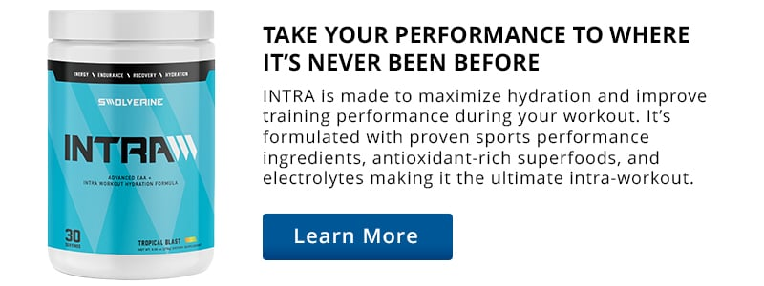](https://www.muscleandstrength.com/store/swolverine-intra.html)

Benefits Of EAA Supplementation

1. Increased Muscle Mass

Perhaps the most well-known and sought-after benefit of EAA supplements is the muscle-building effects. Your body must be in what’s known as a positive amino acid balance to build more skeletal muscle mass. This is also called, being in an “[anabolic](https://www.muscleandstrength.com/expert-guides/anabolic-diet) state”.

Your body is in a constant state of protein turnover with amino acids, utilizing them for energy, forming protein cells, repairing muscle tissue, and performing hundreds of other vital biological functions.

Supplementing with EAAs can ensure that you maintain this muscle-building state to properly achieve more muscle growth and increase mass. This is especially important for those participating in prolonged endurance activity, [high-intensity functional fitness](https://www.muscleandstrength.com/workout/6-week-high-intensity-functional-training-workout) protocols, or those with [bodybuilding](https://www.muscleandstrength.com/workouts/5-day-high-intensity-functional-bodybuilding-workout) aspirations. Several studies have shown that ingesting EAAs in addition to resistance training protocols will increase fat-free muscle mass.1

2. Muscle Recovery

Essential amino acids (EAAs) also support and benefit the muscle recovery process. A large body of evidence has shown that EAAs decrease markers of muscle damage and soreness.2

Simply put, through increased EAA availability, your body has more access to a more robust anabolic environment. Recovery is enhanced in part by the anti-catabolic effects of decreasing muscle degradation or breakdown following intense exercise or resistance training.

Essential amino acids are also composed of the three branched-chain amino acids, ([BCAAs](https://www.muscleandstrength.com/store/category/bcaas.html)) leucine, isoleucine, and valine. Studies have shown that BCAAs elicit similar intra-cellular signaling that occurs in response to ingesting whey protein, inhibiting muscle mass breakdown.3

Related: [BCAA Supplements Guide: Types, Benefits & Dosing](https://www.muscleandstrength.com/expert-guides/bcaas)

3. Enhanced Strength

With an increase and improvement in muscle mass, strength will also follow. EAAs facilitate the biological process of [muscle protein synthesis](https://www.muscleandstrength.com/articles/protein-synthesis-muscle-growth-training-frequency), thereby increasing skeletal muscle mass and strength.4

The School of Kinesiology at Auburn University in Alabama performed a ten-week randomized double-blind controlled study to examine the effects of BCAA supplementation with trained cyclists on select body composition, performance, and immune health over a 10-week training season. 18 trained cyclists were administered 12g of BCAAs per day or a maltodextrin placebo. The results showed a 19% increase in peak power performance and mean power.

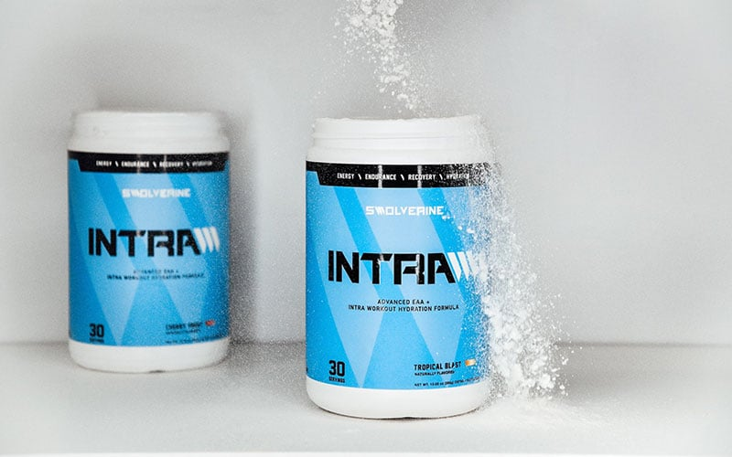

EAA Supplement Dosage

The recommended dose of EAA or BCAA supplementation ranges between 4-10g, twice daily.

The most optimal times are to supplement EAAs closer to your workout or training times to increase overall athletic performance, recovery, and muscle mass.

EAA Benefits: Takeaway

Supplementing with EAAs can greatly benefit your overall fitness and athletic goals, improving strength, increasing [lean muscle](https://www.muscleandstrength.com/workouts/muscle-mania-10-week-muscle-growth-workout) mass, and optimizing workout [recovery](https://www.muscleandstrength.com/articles/5-recovery-tips-help-you-build-muscle-faster).

If you already consume a high-protein [diet](https://www.muscleandstrength.com/diet-plans), EAAs may not be as beneficial as compared to someone who does not get enough protein. EAAs will help improve muscle anabolism, keeping your body in a muscle-building state.

EAAs can be a great addition to those that partake in a [vegan](https://www.muscleandstrength.com/diet-plans/vegan-vegetarian-pescatarian-diet), or plant-based diet, as EAAs will be harder to obtain without the consumption of [animal protein](https://www.muscleandstrength.com/articles/whats-difference-between-plant-protein-vs-animal-protein). EAAs will also greatly benefit endurance athletes, improving energy levels, helping achieve greater gains in strength, and enhancing overall athletic performance.

If you’re looking for a high-quality EAA to complement your training, check out Swolverine’s [INTRA – EAA and Hydration](https://www.muscleandstrength.com/store/swolverine-intra.html) formula.