

Lacking gym equipment? Don't let that stop you from making gains. These home gym hacks can help you expand your home training options.

In recent years, there have been many people opting to start working out at home for a variety of reasons. The upside is that you can train how you want and when you want without having to rush to beat the gym staff locking the door.

The downside is that it’s on you to provide the equipment. There are many people that have to work with limited equipment due to limited budgets.

With that in mind. We're going to provide a few common remedies that can help you continue to progress until you’re able to buy new equipment and expand your home gyms. These aren’t just vague tips, either. I’ve applied all of them because I’ve been training from home for eight years now. I’ve put them into practice, and I think they will help you as well. They won’t be as reliable as the real thing, but they will serve you well until you can get the equipment you need.

1. No Flat Bench? No Problem. Use the Floor

Some of our programs for [chest](https://www.muscleandstrength.com/workouts/chest), [shoulders](https://www.muscleandstrength.com/workouts/shoulders), and [triceps](https://www.muscleandstrength.com/workouts/triceps) involve using a flat bench. However, some people don’t have access to one. The good news is that you can do flat exercises anytime you like if you have a floor. Simply lying flat on the floor can help you perform flat [dumbbell presses](https://www.muscleandstrength.com/exercises/dumbbell-floor-press.html), [dumbbell flys](https://www.muscleandstrength.com/exercises/dumbbell-flys.html), and [lying tricep extensions](https://www.muscleandstrength.com/exercises/lying-dumbbell-extension.html).

Yes, it will affect the range of motion because your arms stop on the floor before you reach the bottom of some movements. In this case, fold up a blanket, or even two, and lay them on the floor where you intend to exercise. This will help increase the range of motion a little bit. If this isn’t enough for you, then it may be time to start looking for that bench.

Recommended: [3 Dumbbell and Bodyweight Chest Workouts (No Bench Needed!)](https://www.muscleandstrength.com/workouts/dumbbell-bodyweight-chest-workout)

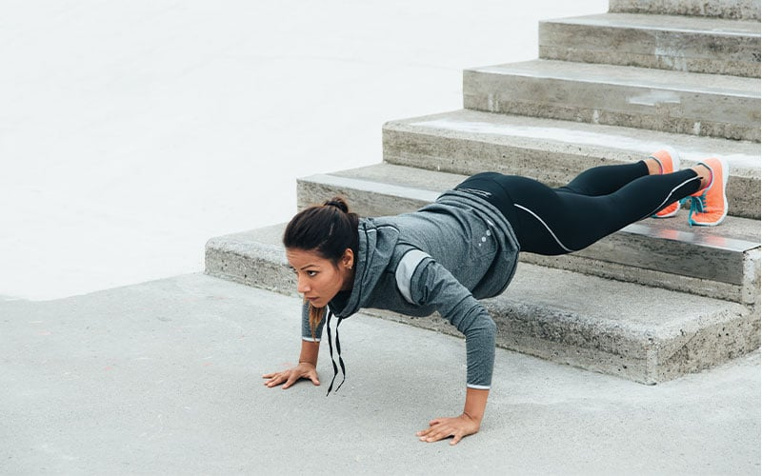

2. Need an Incline? Swap in Elevated Pushups

The first hack solves the flat bench problem, but what about inclines? There are two ways you can work around this. One most people should be able to do, and the other could benefit some of you.

The first one is by making a change. If you have to do [incline presses](https://www.muscleandstrength.com/exercises/incline-dumbbell-bench-press.html) or [incline flys](https://www.muscleandstrength.com/exercises/incline-dumbbell-flys.html), then substitute these movements with [elevated pushups](https://www.muscleandstrength.com/exercises/incline-push-ups.html). Place your feet up on a higher surface. This shifts the focus of the movement to the [upper pecs](https://www.muscleandstrength.com/articles/8-tips-to-maximize-your-upper-chest-training) and the front [delts](https://www.muscleandstrength.com/articles/4-shoulder-supersets-to-torch-your-delts). No, it isn’t a [dumbbell](https://www.muscleandstrength.com/workouts/3-day-full-body-dumbbell-workout) exercise, but it beats nothing.

If you have flys on your program, then simply use a slightly lower platform for your feet and place your hands wider for the pushups. The wider hand position will help provide the stretch that you would achieve with the fly.

Now, if you have steps, you can place pillows or steps on the steps and lie back on them with your weights for incline work. Of course, this is provided that you have the room on your staircase. Some of you may not. If you can, try it.

Recommended: [5 Day Minimal Equipment Home Workout Routine](https://www.muscleandstrength.com/workouts/limited-equipment-home-workout)

3. Dumbbells Too Light? Slow the Sets Down

[Dumbbells](https://www.muscleandstrength.com/workouts/5-day-dumbbell-only-workout-split) can be a great tool to have in the fitness toolbox until you get so strong that the weights aren’t challenging anymore. Then you have to either buy heavier weights, more plates for your handles or start looking for another option.

Here’s something you can do to make your sets harder until you do get those heavier weights: Make your reps last longer. This extends the time of the set, which is going to be more challenging than your traditional work time.

Start by squeezing each contraction (when the muscle is flexed) for three seconds. Count to three, then perform [three-second negatives](https://www.muscleandstrength.com/articles/how-to-add-eccentric-training-to-your-workout). Once you reach the bottom, hold the stretch for an additional three seconds. The one-second lift, plus each three-second segment I just described makes each rep ten seconds long. That will make any ten-rep set more intense.

If you get to the point that this is too easy, then add [supersets](https://www.muscleandstrength.com/workouts/fast-mass-program) to the plan. Take two exercises that you see in the program and combine them. How you do this is up to you, as long as it pushes you to make progress, that’s all that matters.

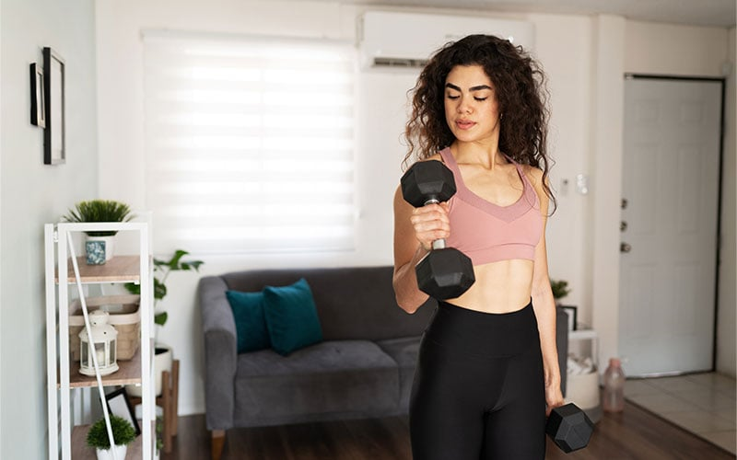

4. Add More Volume

Just because the workout calls for three sets of 10 to 12 reps or 4 sets of 8 doesn’t mean you’re locked into that regimen. If you’re finishing quicker than you thought and you feel you can handle the extra workload, add a set of each exercise or push yourself to do five more reps on each set. Thanks to the compound effect, those small bricks can lead to a bigger building over time.

Recommended: [Effective Training Volume: A Scientific Approach to Muscle Growth](https://www.muscleandstrength.com/articles/increase-effective-volume)

5. Use Items Around the House

You may not have barbells, dumbbells, and a pull-up handle, but you do have items in your own home that can be used as a part of your workout. If you’re supposed to do a seated exercise, such as a seated concentration curl, simply use a chair in your house. You can use it for seated dumbbell presses as well. This may be one of those that seem obvious, but you’d be surprised how many people don’t consider things like this.

Need different weights but only have one set of dumbbells? Did you know that a full-gallon jug is eight pounds? It even has a handle on it. When I was a teenager, I filled empty gallon jugs with water and used them for my [front raises](https://www.muscleandstrength.com/exercises/alternate-standing-dumbbell-front-raise.html), [lateral raises](https://www.muscleandstrength.com/exercises/dumbbell-lateral-raise.html), and even for squats by holding one in each hand and pretending they were dumbbells.

Furniture sliders can be a big help as well. For legs, you can swap leg curls by placing your heels on these sliders and lifting your hips. Pull the legs in and you’re doing a leg curl like you would with an exercise ball.

Here’s one more that will take your back day to a new level. Get on your hands and knees, and place the sliders out as far as you can reach. Place your hands on them. Once you're secure, keep your arms straight and try to pull the sliders in towards your knees. Congrats! You just did a bodyweight pullover. There is no negative to this. You simply push the sliders back and repeat.

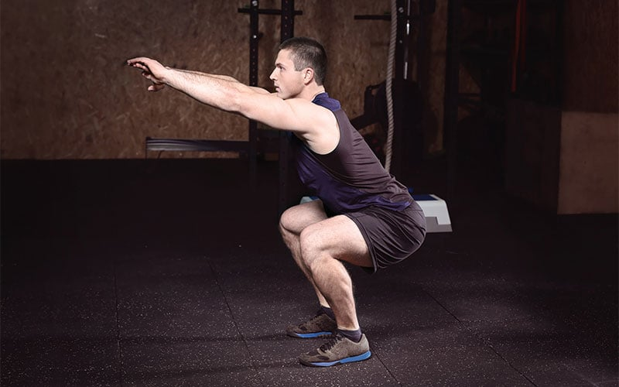

6. Add Bodyweight Training

We have plenty of [dumbbell-only](https://www.muscleandstrength.com/workouts/dumbbell-only-upper-lower-workout-routine) workouts here at M&S, but that doesn’t mean you’re limited to using dumbbells and nothing else. You can use [bodyweight](https://www.muscleandstrength.com/workouts/bodyweight) exercises as well. For push exercises, throw in pushups or dips with your hands behind you on a step or chair and perform comparable sets and reps. You could superset those as well.

Need lower body training options? [Squat jumps](https://www.muscleandstrength.com/exercises/prisoner-jump-squat), [walking lunges](https://www.muscleandstrength.com/exercises/bodyweight-walking-lunge.html), and elevated [split squats](https://www.muscleandstrength.com/exercises/split-squat) by lifting the back leg on that same chair can all be game changers on leg day. Your legs will be sure to grow and get stronger by using these simple strategies.

Conclusion

Keep in mind that these aren’t going to be permanent solutions to your [home gym](https://www.muscleandstrength.com/articles/7-pieces-of-equipment-for-your-home-gym) worries. Eventually, it will be time to pull the trigger and order new equipment for your home gym. However, these simple tips could at least breathe new life into a previously stale home workout routine. Regardless of the goal you have in mind, you could still make progress and stay inspired to keep training.