

When combined with proper diet and training, these key supplements can help you break that physique plateau or finally help you achieve your weight loss goals.

Athletes, fitness-minded people, and folks that need to [lose weight](https://www.muscleandstrength.com/expert-guides/fat-loss) are always looking for the next big thing that can help them reach their goals faster. The biggest searches may be for the best fat-burning [supplements](https://www.muscleandstrength.com/store/category/fat-loss.html) or ingredients. Anything that can make the diet a little easier, the [workouts](https://www.muscleandstrength.com/workouts/fat-loss) a little better, or help burn more calories is going to be a hit.

As with many other aspects of life, the new thing may not be the best thing. Some of the supplements that have been around for a while are still around because they’re still successful. We have five such supplements below that can help you break that plateau or finally help you achieve your weight loss goals.

Recommended: Need help losing fat? [Take our free fat loss course!](https://www.muscleandstrength.com/flcourse)

A Big “But” Before We Begin

But, the key word to be acknowledged is “supplement.” In other words, these [supplements](https://www.muscleandstrength.com/articles/supplements) can be used as a supplement to a proper [nutrition plan](https://www.muscleandstrength.com/diet-plans) and successful [training routine](https://www.muscleandstrength.com/workout-routines). They will not replace something you don’t want to do, make up for a [cheat meal](https://www.muscleandstrength.com/articles/how-to-incorporate-cheat-meals-into-diet) you shouldn’t have had, and they can’t be used on their own. Check out our [Fat Loss Guide](https://www.muscleandstrength.com/expert-guides/fat-loss) to learn more about how to [eat properly](https://www.muscleandstrength.com/articles/set-up-fat-loss-diet-plan) to lose weight, and then find one of our awesome [training plans](https://www.muscleandstrength.com/workouts/12-week-fat-destroyer) to follow before adding these into the mix.

1. L-Carnitine

[L-carnitine](https://www.muscleandstrength.com/store/category/amino-acids/carnitine.html) is one of the 20 amino acids that make up protein. It’s also one of the nine essential [amino acids](https://www.muscleandstrength.com/articles/the-importance-of-amino-acids.html) that you may have read about when it comes to the [intra-workout](https://www.muscleandstrength.com/articles/4-benefits-of-intra-workout-supplements) drink. However, it can be found in many of the meat and dairy products you have in your nutrition program such as meat, poultry, fish, and milk.

It can also be used in supplement form, and a 2020 study determined that it can play a supportive role in your fat loss efforts.1

“L-carnitine supplementation provides a modest reducing effect on body weight, BMI and fat mass, especially among adults with overweight/obesity,” the study concluded. Most of your popular l-carnitine supplements are offered within a range of 500-2,000 milligrams. The study had participants use 2,000 milligrams a day, which is a safe amount for most people.

Recommended Products:

* [AllMax Nutrition Liquid L-Carnitine 1,200mg](https://www.muscleandstrength.com/store/liquid-l-carnitine.html)
* [Nutrex Lipo-6 Carnitine capsules](https://www.muscleandstrength.com/store/nutrex-lipo-6-carnitine.html)
* [Ronnie Coleman Signature Series Liquid L-Carnitine 3,000mg](https://www.muscleandstrength.com/store/rcss-l-carnitine.html)



2. Caffeine

This is the most popular one of all, and a lot of people really like their [caffeine](https://www.muscleandstrength.com/store/category/energy-boosters/caffeine.html) – whether it’s in the form of coffee, [energy drinks](https://www.muscleandstrength.com/store/category/ready-to-drink.html), or [pre-workout](https://www.muscleandstrength.com/store/category/pre-workout.html) supplements. Yes, it can help with energy, and it’s believed to help increase [metabolism](https://www.muscleandstrength.com/articles/metabolic-conditioning-workouts-leaner-physique), which can help you burn calories. But will it actually promote weight loss?

Related: [Calculate your Basal Metabolic Rate with our BMR calculator!](https://www.muscleandstrength.com/tools/bmr-calculator)

In 2018, researchers determined that caffeine could potentially be a great ally in reducing weight, fat mass, and Body Mass Index (BMI).2  That statement could be made so long as the person taking the caffeine was following a sound nutrition plan and exercising regularly. So, as we mentioned before, it can’t replace bad [habits](https://www.muscleandstrength.com/articles/7-habits-effective-bodybuilders), but it could possibly serve as a conjunction to forming new good habits.

If you’re new to taking caffeine, starting on the low end of the dosages would be recommended. Amounts as little as 100 milligrams a day could serve you well. If you’re a traditional coffee or tea drinker, keep that in mind when you determine the amount for you. Having your morning cup of Joe followed by an energy drink later may prove to be too much.

Recommended Products:

* [AllMax Nutrition Caffeine](https://www.muscleandstrength.com/store/allmax-caffeine.html)
* [MuscleTech Platinum 100% Caffeine](https://www.muscleandstrength.com/store/platinum-100-caffeine.html)
* [USN Caffeine](https://www.muscleandstrength.com/store/usn-caffeine.html)

3. 5-HTP

You may not have had this one on your fat loss bingo card, but it could be the key that starts your weight loss engine. 5-hydroxytryptophan, better known as 5-HTP, may not help you in the weight room or during your [cardio run](https://www.muscleandstrength.com/workouts/coconut-cardio), but it would be tremendous support at the dining room table.

As you lose weight, your body may increase production of hormones that will make you feel hungry more often. That hunger feeling is what curtails many people’s weight loss efforts. Supplementing with 5-HTP can counteract this, as proven by a study of 25 participants in 1998.3 The participants were given 750 milligrams of 5-HTP a day or a placebo, making it a double-blind study. The people that had the 5-HTP would eventually reduce their carbohydrate and fat intakes, thus reducing their overall bodyweight.

Your most popular 5-HTP supplements on the market are traditionally available in 200-500 milligrams servings, which on the high end is slightly less than what the participants used. 5-HTP can also be found in food sources such as turkey, chicken, potatoes, pumpkin, collard greens, and even seaweed. Taking the supplement form would obviously be more convenient.

Recommended Products:

* [NOW Foods 5-HTP](https://www.muscleandstrength.com/store/now-5htp.html)

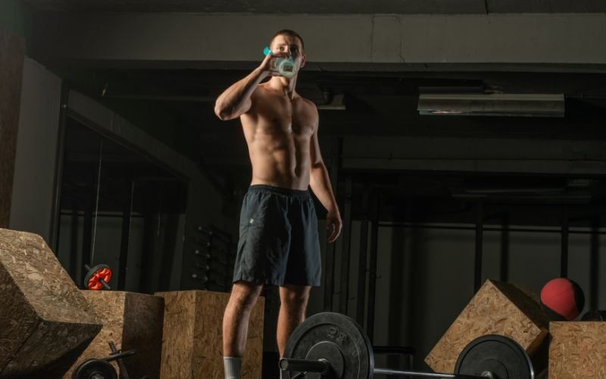

4. Protein

Yes, believe it or not, your [protein shake](https://www.muscleandstrength.com/store/category/protein.html) can be a big factor in how much weight and bodyfat you lose. We need to discuss this in detail because some weight loss focused folks are concerned that [protein](https://www.muscleandstrength.com/expert-guides/protein-supplements) will make them bigger.

It can help them increase muscle size, but high protein diets are a game changer for fat loss. A 1998 study proved that a high protein diet “is a safe method for losing weight while preserving FFM; it is thought to also prevent obesity and obesity-related diseases, such as metabolic syndrome, non-alcoholic fatty liver disease, type 2 diabetes, and cardiovascular diseases."4

So, the benefits go beyond the way you look. It can change the course of your overall health and wellness. It’s worth noting that the subjects in this research consumed 1.07 - 1.6 grams of protein per kilogram of bodyweight. That may be hard to achieve on a daily basis with food alone, which is why the shakes can come in handy. There are a variety of protein powders available, including [whey](https://www.muscleandstrength.com/store/category/protein/whey-protein.html), soy, pea, beef, and [casein](https://www.muscleandstrength.com/store/category/protein/casein-protein.html).

Older adults should consider eating more protein on a daily basis as well, and not just for weight loss. It can help prevent bone loss and protect fat free mass, the study determined. What’s better than building muscle or burning fat? Both.

Recommended Products:

* [MuscleTech Nitro-Tech](https://www.muscleandstrength.com/store/nitro-tech-performance.html)
* [Dymatize ISO100](https://www.muscleandstrength.com/store/dymatize-iso-100.html)
* [BPI Sports ISO HD](https://www.muscleandstrength.com/store/bpisports-isohd-whey-protein.html)

5. Ginger

You want to not only change your weight but your shape as well? Get your hands on some ginger. A group of 14 studies were analyzed and the experts determined that 1-3 grams a day of regular ginger intake reduced not only body weight, but waist to hip ratio as well.5 You can either supplement with ginger roots, herbs, drink [ginger tea](https://www.muscleandstrength.com/store/now-ginger-mint-comfort-tea.html), or in supplement form. Supplement form may be the best and simplest option. The US Food and Drug Administration determined that up to 4 grams a day is safe.

Related: [How to Reduce Inflammation With These Foods and Supplements](https://www.muscleandstrength.com/articles/reducing-inflammation)

Conclusion

The research and science speaks for itself, but ultimately you are responsible for what you take and have in your programs. That’s why you should consider speaking to your doctor before you start using any or all of these supplements. Should you be healthy and able to take these supplements, you can work them into your program slowly and monitor your progress throughout your weight loss journey.