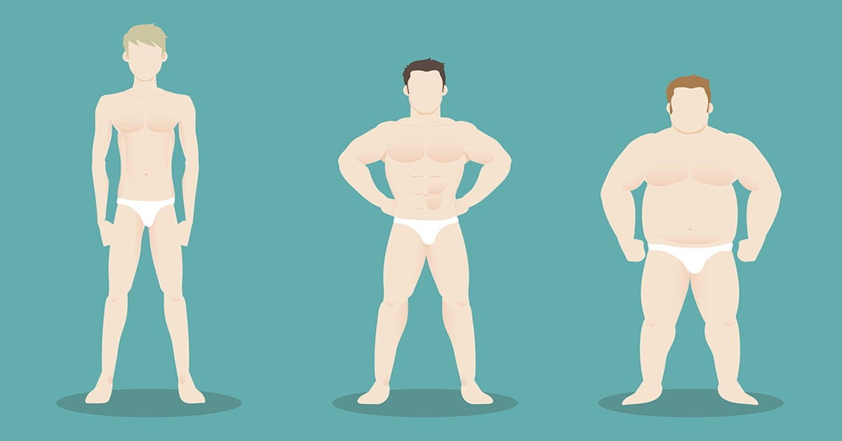

Your body type can influence how you respond to different types of workouts and diet plans. This guide helps you understand your body type (ectomorph, mesomorph or endomorph) and how you can structure your workout and diet for success.

When I first got into the muscle building scene I was overwhelmed by the amount of different training programs, [bodybuilding supplements](https://www.muscleandstrength.com/store/), diets, articles and information there was out there. There were so many conflicting diets and training programs available and I had no idea what I “should” be doing. The result of this was about 6 months in the gym with little gains and almost no motivation to workout anymore.

I was at a complete loss and about to throw in the towel and give up. Then a guy in the gym gave me a magazine and told me to read the article in there about body types. So I did and it opened my eyes up to the reason why I wasn’t making any gains in the gym.

I am a true ectomorph (classic hardgainer) and my bodyweight was 60.2kg (132.5lbs) when I first walked into a gym. I had no idea about body types back then. I assumed (like most beginners do) that the more I worked out the bigger I would get. Thinking that “more was better” I started following a program designed for an elite bodybuilder. This resulted in gains of about 1.7kg in 6 months.

After reading the body type article in that magazine I started to understand more about how my body type worked, my metabolism, and gaining weight. Being an ectomorph I need to focus on calorie intake, long rest periods, and minimum cardio. It was only then I started making some real gains and I’ve never looked back.

So it’s important to be able to identify and understand your body type. Different body types require different training methods and diet plans. So listed below are the 3 male body types: ectomorph, mesomorph and endomorph, along with their characteristics.

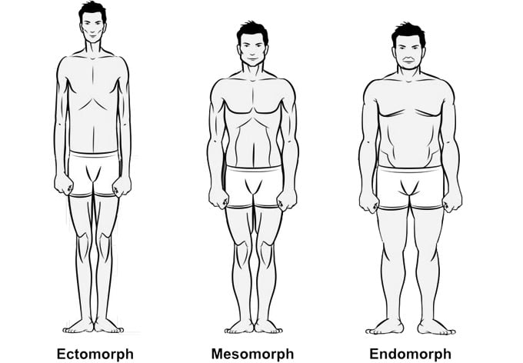

Ectomorph Body Type

An ectomorph is a typical skinny guy. Ecto’s have a light build with small joints and lean muscle. Usually ectomorph’s have long thin limbs with stringy muscles. Shoulders tend to be thin with little width.

Typical traits of an Ectomorph: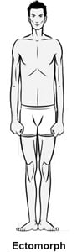

* Small “delicate” frame and bone structure
* Classic “hardgainer”
* Flat chest
* Small shoulders
* Thin
* Lean muscle mass
* Finds it hard to gain weight
* Fast metabolism

Ectomorphs find it very hard to gain weight. They have a fast metabolism which burns up calories very quickly. Ecto’s need a huge amount of calories in order to gain weight. Workouts should be short and intense focusing on big muscle groups. Supplements are definitely recommended. Ectomorphs should eat before bed to prevent muscle catabolism during the night. Generally, ectomorphs can lose fat very easily which makes cutting back to lean muscle easier for them.

Mesomorph Body Type

A mesomorph has a large bone structure, large muscles and a naturally athletic physique. Mesomorphs are the best body type for bodybuilding. They find it quite easy to gain and lose weight. They are naturally strong which is the perfect platform for building muscle.

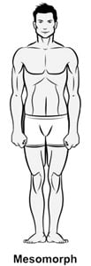Typical traits on a Mesomorph:

* Athletic
* Generally hard body
* Well defined muscles
* Rectangular shaped body
* Strong
* Gains muscle easily
* Gains fat more easily than ectomorphs

The mesomorph body type responds the best to weight training. Gains are usually seen very quickly, especially for beginners. The downside to mesomorphs is they gain fat more easily than ectomorphs. This means they must watch their calorie intake. Usually a combination of weight training and cardio works best for mesomorphs.

Endomorph Body Type

The endomorph body type is solid and generally soft. Endomorphs gain fat very easily. Endo’s are usually of a shorter build with thick arms and legs. Muscles are strong, especially the upper legs. Endomorphs find they are naturally strong in leg exercises like the squat.

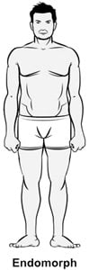Typical traits of an Endomorph:

* Soft and round body
* Gains muscle and fat very easily
* Is generally short
* "Stocky" build
* Round physique
* Finds it hard to lose fat
* Slow metabolism
* Muscles not so well defined

When it comes to training endomorphs find it very easy to gain weight. Unfortunately, a large portion of this weight is fat not muscle. To keep fat gain to a minimum, endomorphs must always train cardio as well as weights. Usually supplements may not be needed as long as the person has a high protein intake in their diet.

A Combination of Body Types

These body types aren’t set in stone. In fact, most guys have a combination of two body types. These combinations are either ectomorph/mesomorph or mesomorph/endomorph. It is not uncommon to find a pure mesomorph that gains weight like an endomorph for example.

So which body type are you?

Given the information above you should be able to identify your body type. You may also want to optimize your diet and training to suit your body type.

One final point I want to mention is that no matter what your body type you can build a big, ripped, muscular physique. Even the skinniest of guys can bulk up. Yes, it’s harder but if you’re willing to put in the hard work it can be done. I have about the skinniest natural build possible and at the time of writing this article I have gained about 30kg (66lbs) of lean muscle mass.