

In this article, you'll learn what active recovery is and why it's important for achieving your fitness goals. Plus 3 effective workouts to try on your next rest day.

Many people have a love/hate relationship with rest days because they want to relax and recover from the grind of the workout week, but then they get that little itchy feeling that they must do something or they’re going to regress. It also may be that they simply like being active and want to do more than chill out on the couch watching Netflix.

To be clear, there is nothing wrong with taking a complete day off as it can help you move closer to your goals if you do so every once in a while. However, a little activity can be beneficial as well, and if it will mentally serve you well to get something done, then you should do it without pushing yourself too hard.



What Is Active Recovery?

[Active recovery days](https://www.muscleandstrength.com/articles/rest-days-active-recovery-vs-passive-recovery), also known as active rest days, are days when you don’t have a weight training session scheduled (think: non-lifting days) but still want to engage in some low-intensity physical activity.

Active recovery can take many forms, but the key is to keep movement and impact lighter than your normal training load. Whatever activity you choose to do should be shorter in time than your usual training training sessions, and should leave you feeling recovered, not as though you just finished a workout.

Active recovery days can be as simple as going on a hike, a bike ride around the neighborhood, basic yoga or Pilates, or even a walk and stretching session. Active recovery workouts can be completed on scheduled rest days as written in your workout of choice, or as needed.

Related: [A Beginner's Guide to Zone 2 Cardio](https://www.muscleandstrength.com/articles/beginners-guide-to-zone-2-cardio)



Benefits of Active Recovery Days

A recovery day promotes blood flow to your joints and muscles and allows your body to slowly release lactic acid, thus minimizing post-workout stiffness and reducing inflammation. These can all boost the [recovery](https://www.muscleandstrength.com/expert-guides/workout-recovery) and adaptation process.

Related: [3 Simple Recovery Methods to Train Harder Than Ever Before](https://www.muscleandstrength.com/articles/3-simple-recovery-methods)

3 Active Recovery Workouts to Try

The following workouts can be completed as individual workouts depending on what would benefit your body or your goals. They can also be completed as a series of movements in one day which allows you to hit [bodyweight](https://www.muscleandstrength.com/workouts/bodyweight) movement, more advanced movement, and even some stretching all in one.

Active Recovery Workout 1: Bodyweight Only

Basic bodyweight exercises and movements can help you work the muscles and tendons, lubricate the joints with synovial fluid, and even burn a few extra calories. If you’re a [beginner](https://www.muscleandstrength.com/workouts/beginner) or want something simple, then a basic routine may look like this. These are all bodyweight exercises, and the only item you will need is something to hold onto for the rack lat stretch. It can be a pillar, pole, or solid object you can maintain a good grip on.

* [Bodyweight Calf Raises](https://www.muscleandstrength.com/exercises/bodyweight-standing-calf-raise.html) - 10 reps
* [Bodyweight Jump Squa](https://www.muscleandstrength.com/exercises/bodyweight-jump-squat.html)t – 10 reps
* [Bodyweight Single Leg Deadlift](https://www.muscleandstrength.com/exercises/bodyweight-single-leg-deadlift) – 10 reps per leg
* [Rocking Frog Stretch](https://www.muscleandstrength.com/exercises/rocking-frog-stretch) – 10 reps
* [Side Crunch](https://www.muscleandstrength.com/exercises/side-crunch.html) – 10 reps per side
* [Ab Crunch](https://www.muscleandstrength.com/exercises/ab-crunch) – 10 reps
* [Lying Floor Leg Raise](https://www.muscleandstrength.com/exercises/lying-floor-leg-raise.html) – 10 reps
* [Push Up](https://www.muscleandstrength.com/exercises/push-up.html) – 10 reps
* [Rack Lat Stretch](https://www.muscleandstrength.com/exercises/rack-lat-stretch) – 10 seconds per side
* [Arm Circles](https://www.muscleandstrength.com/exercises/arm-circles) – 10 reps

You can do this workout in one of two ways. Either you can perform all ten exercises in a row with minimal rest between each exercise and repeat for two rounds, or you can do two sets of each with 30 seconds of rest between sets. This is up to you.

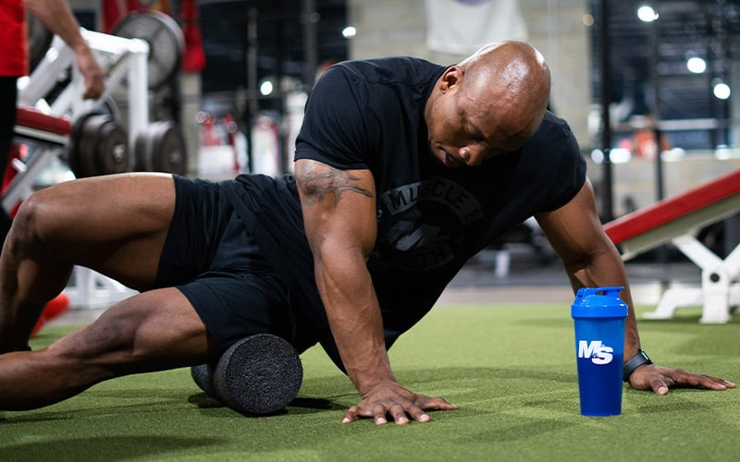

Active Recovery Workout 2: More Advanced Movement

The purpose of this next workout is not only to [maximize your recovery](https://www.muscleandstrength.com/articles/3-principles-maximize-muscle-recovery) day but also to help you find potential weaknesses to work on and improve your recovery even more. All you need for the movements below is a [lacrosse ball](https://www.muscleandstrength.com/store/360-athletics-lacrosse-ball.html) and a foam roller.

* [Cradle Walk to Forward Lunge](https://www.muscleandstrength.com/exercises/cradle-walk-to-forward-lunge) -15 reps per leg
* [90/90 Hip Crossover](https://www.muscleandstrength.com/exercises/90-90-hip-crossover) - 15 reps per leg
* [Side Plank with Hip Dip](https://www.muscleandstrength.com/exercises/side-plank-with-hip-dip) -15 reps per leg
* [Plank](https://www.muscleandstrength.com/exercises/hover.html) – Failure or Up to 2 minutes
* [Rock Back Extension Rotation](https://www.muscleandstrength.com/exercises/rock-back-extension-rotation) – 15 reps per side
* [Push Up with Feet Elevated](https://www.muscleandstrength.com/exercises/decline-push-up) – 15 reps
* [Plantar Fascia Lacrosse Ball](https://www.muscleandstrength.com/exercises/plantar-fascia-lacrosse-ball) – As Needed
* [IT Band Foam Rolling](https://www.muscleandstrength.com/exercises/foam-rolling-it-band) – As Needed
* [Hip Flexor Foam Rolling](https://www.muscleandstrength.com/exercises/foam-rolling-hip-flexor) – As Needed

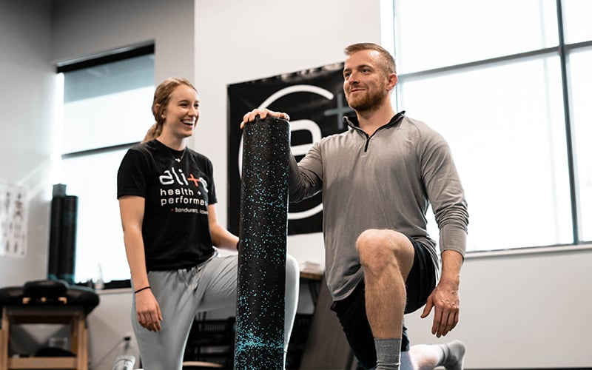

Active Recovery Workout 3: Stretching

The list below is of suggested movements that you can find in the M&S Exercises section. You can add more to this or take one or two away based on your individual needs and abilities. Either way, perform a routine like this at least once. You can do this up to two times in a row if desired. Give yourself 30 seconds of rest between sets if you opt for the second round.

* [Prone Quad Stretch](https://www.muscleandstrength.com/exercises/prone-quad-stretch) – 15-30 seconds per side
* [Figure 4 Glute Stretch](https://www.muscleandstrength.com/exercises/figure-4-glute-stretch) – 15-30 seconds per side
* [Inchworm](https://www.muscleandstrength.com/exercises/inchworm) – 2-5 reps
* [Superman](https://www.muscleandstrength.com/exercises/superman) – 15-30 seconds
* [Hollow Body Hold](https://www.muscleandstrength.com/exercises/hollow-body-hold) – 15-30 seconds
* [World’s Greatest Stretch](https://www.muscleandstrength.com/exercises/worlds-greatest-stretch) – 15 seconds per side
* [Rack Pec Stretch](https://www.muscleandstrength.com/exercises/rack-pec-stretch) – 15-30 seconds per side

Final Thoughts

As we mentioned before, this is only a suggested guide for you to consider. There are many other ways to enjoy active recovery days. You can play sports such as tennis or basketball, incorporate activities and games with the family into the mix, and even add breathing exercises into this plan.

If you try any of these workouts or you have your own rest day ideas, let us know in the comments section down below. Your experience and ideas may help newer readers and beginners as they work towards achieving their goals.