**SDA**

**DOCUMENTATION FOR PROJECT**

**PROJECT**: Hotel Chain Management System

**GROUP MEMBERS:** Farhan Ahmed, Ali Ahmad, Muneeb

**SECTION:** E

**DEPARTMENT:** BS CS

**USE CASES:**

**Use Case 1:**

**Adding New Hotels**

**Scope:**

Hotel Chain Management System

**Level:**

User Goal

**Primary Actor:**

Admin

**Stakeholders and Interests:**

1. **Admin:** Wants a streamlined process to add hotels to the chain.
2. **Hotel Management:** Requires accurate data entry for operational purposes.

**Preconditions:**

1. The admin is authenticated and has access to the "Add Hotel" functionality.
2. Required hotel information is available.

**Postconditions:**

1. The new hotel is added to the database.
2. The hotel is visible in the hotel list for customers.

**Main Success Scenario:**

1. Admin selects the "Add Hotel" option.
2. Admin enters the hotel details (name, address, amenities, etc.).
3. The system validates the data.
4. The system saves the hotel details to the database.
5. Confirmation is displayed to the admin.

**Extensions:**

1. **If data validation fails:**
   * Notify the admin of missing or incorrect fields.
2. **If database connection fails:**
   * Display an error message and prompt retry.

**Use Case 2:**

**Removing Hotels**

**Scope:**

Hotel Chain Management System

**Level:**

User Goal

**Primary Actor:**

Admin

**Stakeholders and Interests:**

1. **Admin:** Wants to remove outdated or discontinued hotels from the system.
2. **Hotel Management:** Ensures no residual data conflicts.

**Preconditions:**

1. The admin is authenticated and has access to the "Remove Hotel" functionality.
2. The hotel to be removed is identified.

**Postconditions:**

1. The selected hotel is removed from the database.
2. Bookings for the removed hotel are canceled.

**Main Success Scenario:**

1. Admin selects the "Remove Hotel" option.
2. Admin identifies the hotel to be removed.
3. The system checks if there are active bookings.
4. The admin confirms removal.
5. The system removes the hotel from the database and updates related records.

**Extensions:**

1. **If there are active bookings:**
   * Notify the admin and prompt for booking cancellation.
2. **If the hotel cannot be found:**
   * Display an error message.

**Use Case 3:**

**Managing Customer Feedback**

**Scope:**

Hotel Chain Management System

**Level:**

User Goal

**Primary Actor:**

Admin

**Stakeholders and Interests:**

1. **Admin:** Needs access to all feedback for quality control.
2. **Customer:** Wants their feedback acknowledged and addressed.

**Preconditions:**

1. Feedback data is stored in the system.
2. Admin is authenticated.

**Postconditions:**

1. Feedback is reviewed and flagged if necessary.
2. Improvements are planned based on feedback trends.

**Main Success Scenario:**

1. Admin selects the "View Feedback" option.
2. The system displays all feedback, sorted by date or hotel.
3. Admin reviews feedback and marks it as resolved or flagged.
4. The system updates feedback status.

**Extensions:**

1. **If feedback data is missing:**
   * Display a "No Feedback Available" message.

**Use Case 4:**

**Handling Booking Requests**

**Scope:**

Hotel Chain Management System

**Level:**

User Goal

**Primary Actor:**

Customer

**Stakeholders and Interests:**

1. **Customer:**  
   Wants a smooth and efficient booking process with confirmation.
2. **Admin:**  
   Requires accurate and automated request tracking.
3. **Hotel Management:**  
   Aims to maximize occupancy while ensuring proper resource allocation.

**Preconditions:**

1. The customer must have selected a hotel and room type.
2. The room availability must be confirmed.

**Postconditions:**

1. Booking details are saved in the database.
2. The room is marked as reserved.
3. The customer receives a booking confirmation.

**Main Success Scenario:**

1. Customer selects hotel and room type.
2. The system checks room availability.
3. Customer provides booking details (dates, guest count, etc.).
4. The system calculates the price based on room type and duration.
5. Customer confirms booking and initiates payment.
6. Payment is processed successfully.
7. The system updates room availability and marks it as booked.
8. Booking confirmation is displayed to the customer.

**Extensions:**

1. **If room is unavailable:**
   * Display an alternate option or suggest a new date.
2. **If payment fails:**
   * Inform the customer and allow retry.
3. **If customer cancels booking during the process:**
   * Exit and reset booking information.

**Use Case 5:**

**Processing Customer Payments**

**Scope:**

Hotel Chain Management System

**Level:**

User Goal

**Primary Actor:**

Customer

**Stakeholders and Interests:**

1. **Customer:** Wants a smooth payment experience with security.
2. **Hotel Management:** Requires accurate payment records.

**Preconditions:**

1. The booking request must be confirmed.
2. Payment gateway must be functional.

**Postconditions:**

1. Payment is processed, and the receipt is generated.
2. Booking status is updated to "Confirmed."

**Main Success Scenario:**

1. Customer selects the payment option for their booking.
2. The system displays payment details.
3. Customer enters payment information.
4. Payment is processed successfully.
5. Receipt is generated, and the system updates booking status.

**Extensions:**

1. **If payment fails:**
   * Notify the customer and allow retry.
2. **If the system cannot connect to the payment gateway:**
   * Display an error message and log the issue.

**Use Case 6:**

**Room Rate Management**

**Scope:**

Hotel Chain Management System

**Level:**

User Goal

**Primary Actor:**

Admin

**Stakeholders and Interests:**

1. **Admin:** Wants to ensure competitive and accurate room pricing.
2. **Hotel Management:** Requires room rates to be updated for customer bookings.

**Preconditions:**

1. Admin is authenticated.
2. Room rate data must be accessible.

**Postconditions:**

1. Room rates are updated in the system.
2. Updated rates are displayed for customer bookings.

**Main Success Scenario:**

1. Admin selects the "Manage Room Rates" option.
2. The system displays the current room rates.
3. Admin updates the rates for specific room types.
4. The system validates the changes and saves them.
5. Confirmation of updated rates is displayed.

**Extensions:**

1. **If invalid rate is entered:**
   * Notify admin of the issue and reject the update.

**Use Case 7:**

**Feedback Submission**

**Scope:**

Hotel Chain Management System

**Level:**

User Goal

**Primary Actor:**

Customer

**Stakeholders and Interests:**

1. **Customer:** Wants to share their experience with the hotel.
2. **Admin:** Uses feedback to enhance services.

**Preconditions:**

1. Customer has completed their stay.

**Postconditions:**

1. Feedback is recorded in the database.

**Main Success Scenario:**

1. Customer selects the "Submit Feedback" option.
2. The system displays a feedback form.
3. Customer enters their feedback and submits it.
4. The system validates and stores the feedback.
5. Confirmation is displayed to the customer.

**Extensions:**

1. **If form is incomplete:**
   * Prompt customer to fill all required fields.

**Use Case 8:**

**Price Calculation for Booked Rooms**

**Scope:**

Hotel Chain Management System

**Level:**

User Goal

**Primary Actor:**

System

**Stakeholders and Interests:**

1. **Customer:** Wants an accurate price for their stay.
2. **Admin:** Requires consistency in pricing.

**Preconditions:**

1. Room type and duration of stay must be provided.

**Postconditions:**

1. The total price is calculated and displayed.

**Main Success Scenario:**

1. Customer selects room type and duration of stay.
2. The system retrieves the room rate.
3. The system calculates the total price.
4. The total price is displayed to the customer.

**Extensions:**

1. **If room rate is unavailable:**
   * Notify admin and display an error.

**Use Case 9:**

**Session Management**

**Scope:**

Hotel Chain Management System

**Level:**

User Goal

**Primary Actor:**

System

**Stakeholders and Interests:**

1. **Customer/Admin:** Wants uninterrupted access to the system.

**Preconditions:**

1. The user must be actively interacting with the system.

**Postconditions:**

1. The session is maintained or ended gracefully.

**Main Success Scenario:**

1. User performs actions in the system.
2. The system monitors activity and extends session as needed.
3. If inactivity is detected, the system ends the session.

**Extensions:**

1. **If session timeout occurs:**
   * Notify user and log them out.

**Use Case 10:**

**Request Handling**

**Scope:**

Hotel Chain Management System

**Level:**

User Goal

**Primary Actor:**

Admin

**Stakeholders and Interests:**

1. **Customer:** Wants requests to be resolved efficiently.
2. **Admin:** Handles and resolves requests.

**Preconditions:**

1. A customer or system-generated request must exist.

**Postconditions:**

1. The request is resolved or flagged for further action.

**Main Success Scenario:**

1. Admin views incoming requests.
2. Admin selects a request to address.
3. The system provides relevant details.
4. Admin resolves the request and marks it complete.

**Extensions:**

1. **If request cannot be resolved:**
   * Notify the customer and escalate.

**Use Case 11:**

**Hotel Performance Monitoring**

**Scope:**

Hotel Chain Management System

**Level:**

User Goal

**Primary Actor:**

Admin

**Stakeholders and Interests:**

1. **Admin:** Wants to analyze hotel performance metrics.
2. **Hotel Management:** Uses insights for strategic planning.

**Preconditions:**

1. Performance data is recorded in the system.

**Postconditions:**

1. Performance insights are displayed.

**Main Success Scenario:**

1. Admin selects a hotel to monitor.
2. The system retrieves performance metrics.
3. Metrics are displayed in a user-friendly format.

**Extensions:**

1. **If data retrieval fails:**
   * Notify admin and log the issue.

**SYSTEM SEQUENCE DIAGRAMS**

**USE CASE:** Handling Booking Requests

**SSD:**

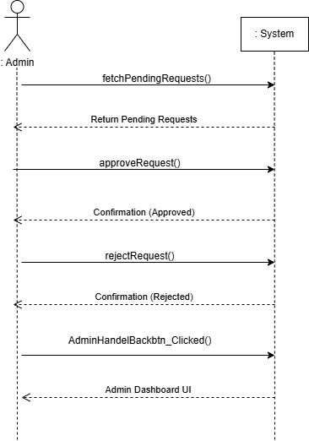

**USE CASE:** Processing Customer Payments

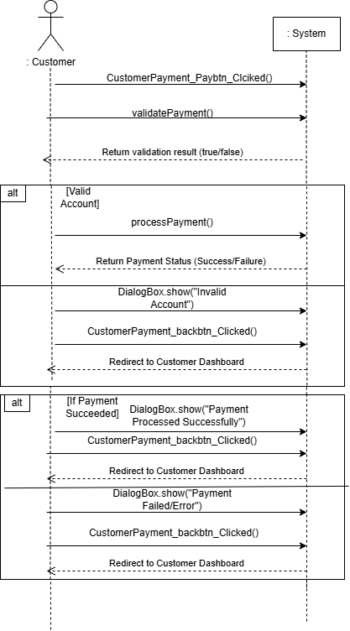

**SEQUENCE DIAGRAMS**

**USE CASE:** Adding new hotels

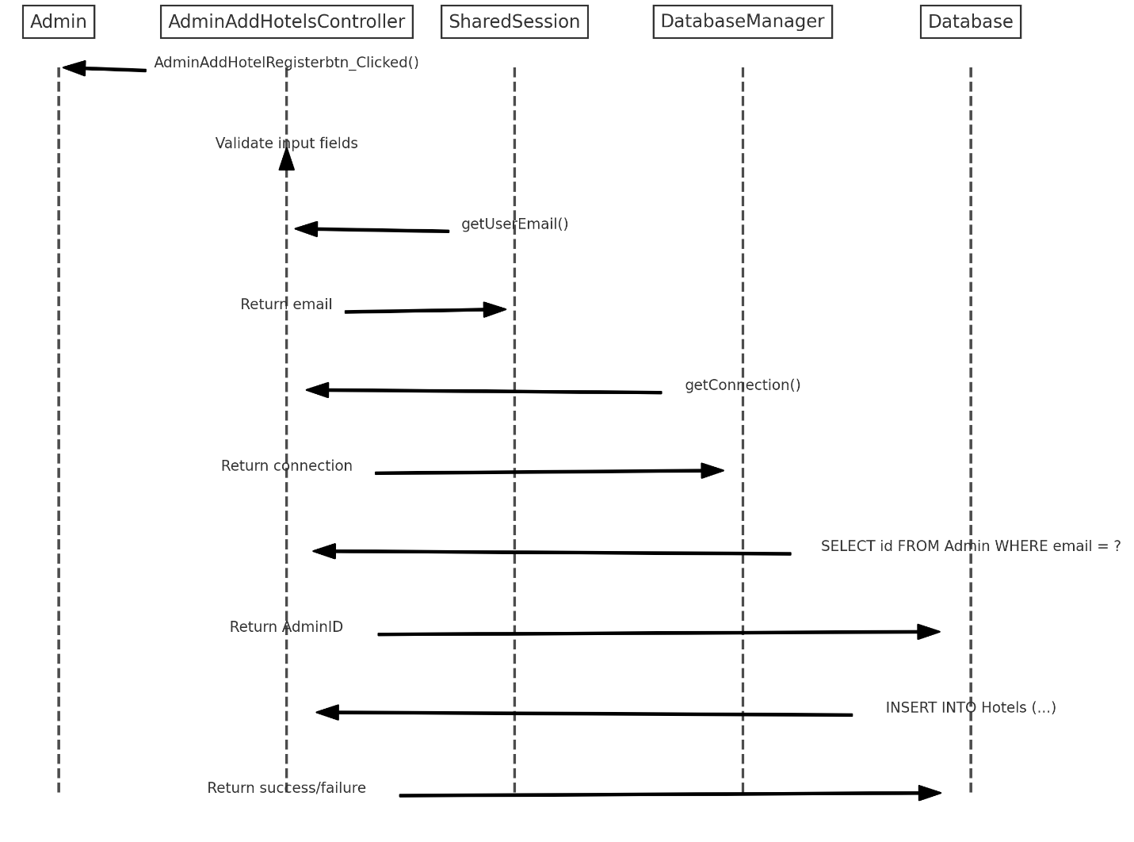

**USE CASE:** Removing hotels

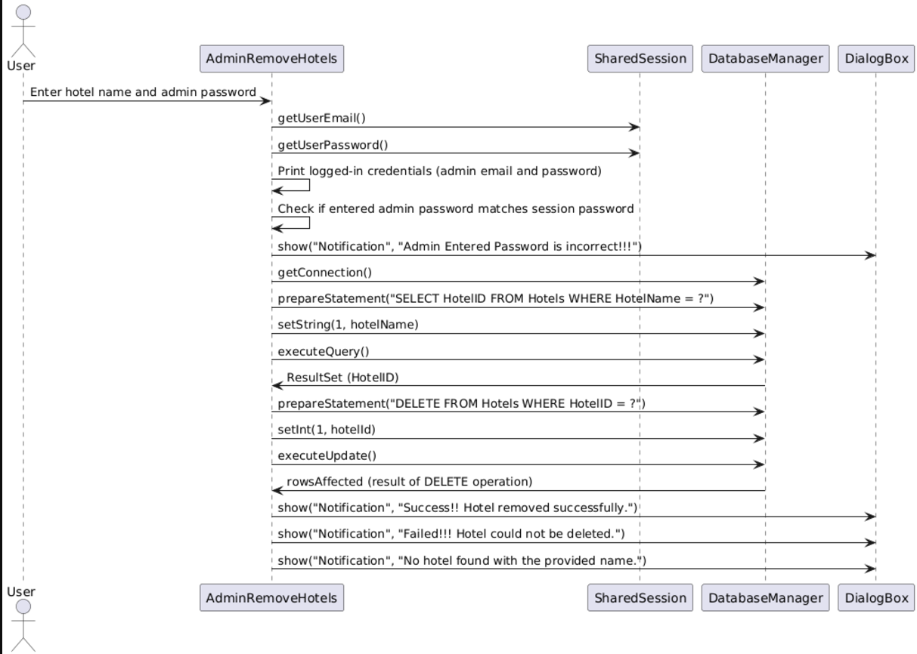

**USE CASE:** Price Calculation for Booked Rooms

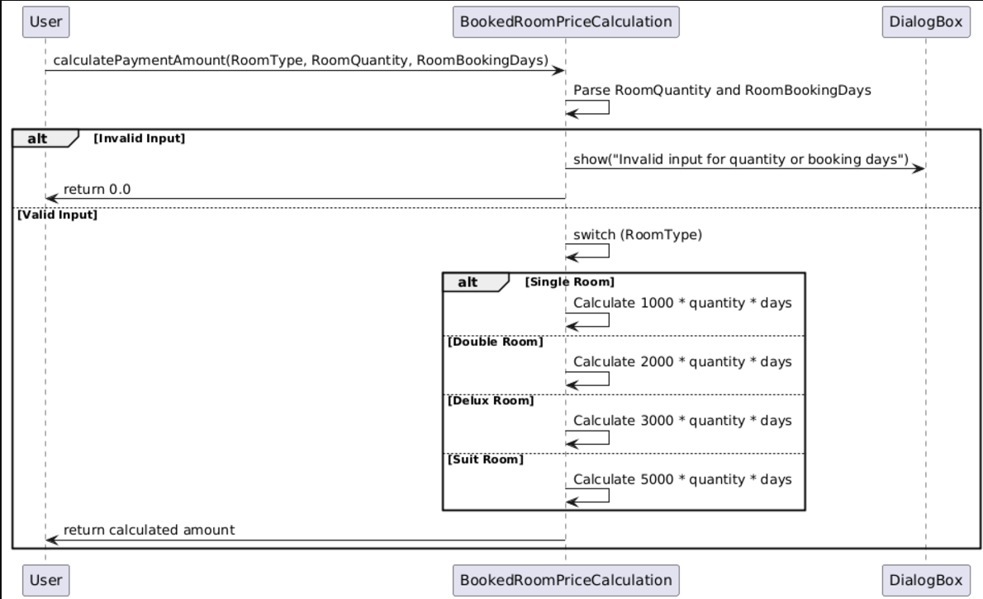

**COMPONENT DIAGRAM:**

