

**LAGOOZ SCHOOLS**

**FIRST TERM**

**LEARNER’S E-NOTE**

**SUBJECT: FURTHER MATHS**

**CLASS: SS2**

Scheme of Work (First Term)

1. Differentiation

i. Limits of a function

ii. Differentiation from first principle

iii. Differentiation of polynomials.

iv. Differentiation of transcendental function such as sin x, eax, log 3x

v. Rules of differentiation

vi. Product rule

vii. Quotient rule

viii. Function of function

ix. Higher derivatives

x. Differentiation of implicit functions

2. Differentiation 2

i. Application of differentiation to

a. rate of change

b. gradient

c. maximum and minimum values

d. equation of motion

.

3. Binomial Expansion

i. Pascal triangle

ii. Binomial expression of (a+b)n where n is +ve integer, -ve integer or fractional value

iii. Finding nth term

iv. Application of binomial expansion

4-5. Conic Section: The Circle

i. Definition of circle

ii. Equation of circle given centre and radius

iii. General equation of a circle

a. finding centre and radius of a given circle

b. finding equation of a circle given the end point of the diameter

c. equation of a circle passing through three points.

iv. Equation of tangent to a circle

v. Length of tangent to a circle

6. Permutation and combination

i. Permutation on arrangement

ii. Cyclic permutation

iii. Arrangement of identical object.

iv. Arrangements in which repetitions are allowed

v. Introduction to combination on selection.

a). Conditional arrangements and selection

b). Probability arrangement problem involving arrangement and selection.

7. Dynamics

i. Newton laws of motion

ii. Motion along inclined plane

i. Motion of connected particles

ii. Work, Energy and Power

iii. Impulse and Momentum

8. Dynamics 2

i. Projectiles

ii. Trajectory of projectiles

iii. Projection along inclined plane.

9-10. Inventory modeling

i. Concept of inventory

ii. Definitions of important terms in inventory.

iii. Holding list

iv. Ordering list etc. computation of optimal quantity [EOQ model].

Replacement model

i. Concept of replacement

ii. Individual replacement of sudden failure item

iii. Replacement of items that wear out gradually.

11. Revision

12. Examination.

Week: One

Period: Three

Duration: 45 minutes per period

Subject: Further Mathematics

Class: SS2

Topic: Differentiation

Subtopic: Limits of a function

Learning Objectives: At the end of the lesson, learners should be able to:

1. explain the concept of a derivative;

2. differentiate explicit functions; and

3. differentiate implicit functions.

Instructional Materials: A chart of standard differentials

Reference Materials: New Further Mathematics Project, Book 2.

Content

Period 1

--------------------------------------------------------------------------------------------------------------------------------------------------------------------------------------------------------------------------------------------------------------------------------------------------------------------------------------------------------------------------------

Table 1.1

|  |  |
| --- | --- |
| x | f(x) |
| 2.1 | 4.41 |
| 2.01 | 4.0401 |
| 2.001 | 4.004001 |
| 2.0001 | 4.00040001 |
| 2.00001 | 4.0000400001 |
| 2.000001 | 4.000004000001 |

You will observe that the sequence of numbers 2.1, 2.01, 2.001, 2.0001, …2 +  gets closer and closer to 2 so the sequence of numbers 4,41, 4.0401, 4.004001, 4.00040001, etc gets closer and closer to 4.

Consider again the above function at the values x = 1.9, 1.99, 1.999, 1.9999 and 1.99999.

Table 1.2

|  |  |
| --- | --- |
| x | f = (x) |
| 1.9 | 3.61 |
| 1.99 | 3.9601 |
| 1.999 | 3.996001 |
| 1.9999 | 3.99960001 |
| 1.99999 | 3.9999600001 |

Again, you will notice that the sequence of numbers 1.9, 1.99, 1.999, 1.9999 and 1.99999 gets closer and closer to 2 so the sequence of numbers 3.61, 3.6901, 3.996001, 3.99960001 and 3.9999600001 gets closer and closer to 4. The sequence 2.1, 2.01, 2.001, 2.0001, 2,0000 … is said to approach 2 from the right. In the same way, the sequence 1.9, 1.99, 1.999, 1.9999 and 1.99999, … also approaches 2 from the left.

We also say that the limiting value of f(x) = x2 as x approaches 2 (either from the right or from or from the left) is 4.

To differentiate between the statement ‘the limiting value of f(x) as x approaches 2 from the right and the statement the limiting value of f(x) as x gets closer and closer to 2 from the left, we introduced a notation:



Is the notation for the limiting value of f(x) as x approaches 2 from the right. It is called the right hand limit of f(x) as x tends to 2. Similarly,



Is the notation for the limiting value of f(x) as x approaches 2 from the left. It is called the left hand limit of f(x) as x tends to 2.

Properties of Limits

**Property 1:**

*Limit of sum of two functions is the sum of limits of both the functions.*

*+**g*

**Property 2:**

*Limit of difference of two functions is the difference of limits of both the functions.*

*-**g*

**Property 3:**

*Limit of product of two functions is the product of limits of both the functions.*

*.**g*

**Property 4:**

*Limit of quotient of two functions is the quotient of limits of both the functions provided the quotient is not equal to zero.*



**Property 5:**

Limit of a constant is the constant itself.

k = k

Example 1

Evaluate 

Solution

 = 9 - 3+ 5

= 9 – 0 + 0 – 0 = 9

Example 2

Evaluate: 

Solution

=

= = 

Example 3

Evaluate 

Solution

=

= = 3+3 = 6

Example 4

Evaluate: 

Solution

We know that 

= 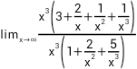

=  = 3

Class Work

Find the limit of the following:

1. 

2. . 

3. Suppose that .  and . Calculate the limit

.

Ticket Out

Evaluate 

Period 2

The Derivative of a function

If , then the derivative of the function is written as



The derivative of y= f(x) is also known as the differential of y with respect to x written as  read as ‘dee y dee x’.

Differentiation From First Principle

The derivative function is the guide to differentiating from first principle. This is illustrated by the examples below:

Example 1

Find the derivative of  from first principle.

Solution



 (a small change in x causes a small change in y)

 (expanding the RHS)

 (subtracting y from both sides but in terms of x)









Therefore .

Example 2

Find the derivative of  from first principle.

Solution











Hence 

Example 3

Find the derivative of  from first principle, where k is a constant.

Solution











Hence 

The derivative of any constant is equal to zero.

NB: If  , then .

Therefore, if , then 

Example 4

Find the derivative of the following:

(a)  (b)  (c) 

Solution

(a) 



(b) 

= 

(c) 

 = 

Class work

From first principle, find the derivative of 

Ticket Out

Find the derivatives of the following:

1. 

2. 

3. 

Period 3

Function of the function

If y is a function of u, written as  and u is a function of x, written as , then to find , we write:  
 .

This is called function of function or chain rule. This can be extended to composite functions with more than three variables. For example

 , then,



Example

Find the derivatives of the following:

(a) 

 

Solution

(a) let  then 

 and 

Thus 

(b) 

Let u = 

Then 







 



Product Rule

The derivative of  ,where u and v are functions of x, is given below:



Example

Find the derivatives of the following:

(a) 

(b) 

Solution

(a) 

Let  and 

 and 









(b) 

Let  and 

 and 





Quotient Rule

Let , where u and v are functions of x and v .

Then 

Example

Find the derivatives of each of the following:

(a) 

 

Solution

(a) 

Let  and  

 and 









(b) 

Let  and 

 and 

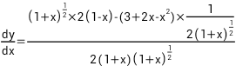







Implicit Differentiation

Implicit functions contain two or more variables that are not explicitly defined. For example,  is an implicit function.

In differentiating  , y is treated as if it is a function of x and the rules of differentiation are applied in the appropriate manner. The process of differentiating implicit functions is called implicit differentiation.

Example

Differentiate each of the following implicitly:

(a) 

(b) 

Solution

(a) 

Differentiating term by term with respect to :





(b) 





Derivatives of Trigonometric Functions

The table below shows the derivatives of standard trigonometric ratios:

|  |  |
| --- | --- |
|  |  |
|  |  |
|  |  |
|  |  |
|  |  |
|  |  |
|  |  |

Example

Find the derivatives of each of the following:

(a)  (b)  (c) 

Solution

(a) 

Let 

Then 

 and 



(b) 

Let  and 

 and 

 

(c) 

Let  and 

 and 



The Derivative of Inverse Functions

If , then 



Example

If , find 

First method









Second method









Derivative of Logarithmic Functions

If  then 

Replacing the base of the logarithm by Euler’s constant, we have:

 .

Example

Find the derivatives of the following:

(a)  (b) 

Solution

(a) 

Let











(b) 

Let , then 







Derivative of Exponential Functions

If  then, =

Example

Find the derivatives of the following:

(a)  (b)  (c) 

Solution

(a) 

Let 









(b) 

Let 









(c) 



Differentiate with respect to x





Higher Derivatives

Given that ,  is called the first derivative of y with respect to x.

is the second derivative of y with respect to x.

is the third derivative of y with respect to x.

In general  is the nth derivative of y with respect to x.

Example

Find the first, second and third derivatives of each of following:  
(a) 3 (b) 

Solution

(a) Let 

Then 





(b) Let 







Class Work

New Further Mathematics Project

Page162, Exercise 9B, no. 2 , a and b, no. 3, a and c,

Ticket Out

New Further Mathematics Project

Page162, Exercise 9B, no.6 and no. 8 a and b.

Week: Two

Period: Three

Duration: 45 minutes per period

Subject: Further Mathematics

Class: SS2

Topic: Differentiation

Subtopic: Application of Differentiation

Learning Objectives: At the end of the lesson, learners should be able to apply differentiation to solving problems on:

1. rate of change

2. gradient

3. maximum and minimum values and

4. equation of motion

Reference Materials: New Further Mathematics Project, Book 2.

Content

Period 1: Tangents and Normals to Curves

For any curve,  is the gradient function. At any point on curve,  at that point, gives the gradient of the tangent at the point. The derivative of y with respect to x at x = x1 is denoted

x=x1

Recall that the equation of the line of gradient m through  is .

From this above equation, we can easily obtain the equation of the tangent.

If  is the gradient of the normal to the tangent and  is the gradient of the tangent, then:



So at the point  the equation of the normal is .

Example 1: Find the equation of the tangent and the normal to the curve  at the point .

Solution

Given that 



x=x1 = 6 – 2+ 3 = 7

If m is the gradient of the tangent at  then 

At the point , 

The equation of the tangent at the point x = 1 is







If m’ =  hence the equation of the normal at x = 1, is







Increasing and decreasing functions

If  is an increasing function at a given interval, then .

Also, if  is an decreasing function at a given interval, then .

Example 2

Find the range of values of  or which each of the following is increasing:

(a) 

(b) 

Solution

(a) Let 



 is increasing if 



or 

(b) Let 



 is increasing when 



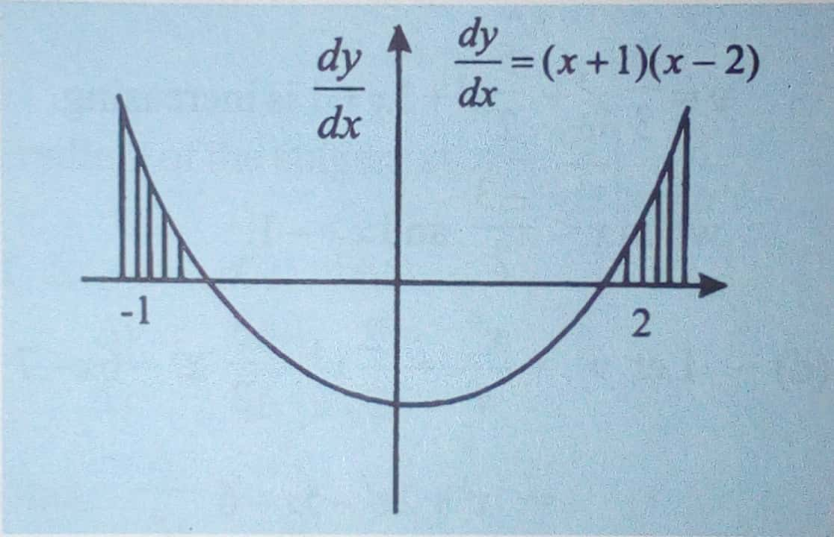

 when 

Evaluation: Pg. 194, Ex. 10, no. 1, 2, 3 and 4, a for each.

Ticket Out: Pg. 194, Ex. 10, no. 1, 2, 3 and 4, b for each.

Period 2:

Rate of Change

If ,  can sometimes be interpreted as rate at which y is changing with respect to x. If y increases as x,  while if y decreases as x decreases, 

Example 3:

The radius of a circle is increasing at the rate of 0.01cm/s. Find the rate at which the area is increasing when the radius of the circle is 5cm.

Solution

Let  be the area of the circle of radius 





By the chain rule:





when 









Example 4:

Water is leaking from a hemispherical bowl of radius 20cm at the rate of 0.5. Find the rate at which the surface area of water is decreasing when the water level is half-way from the top.

Solution

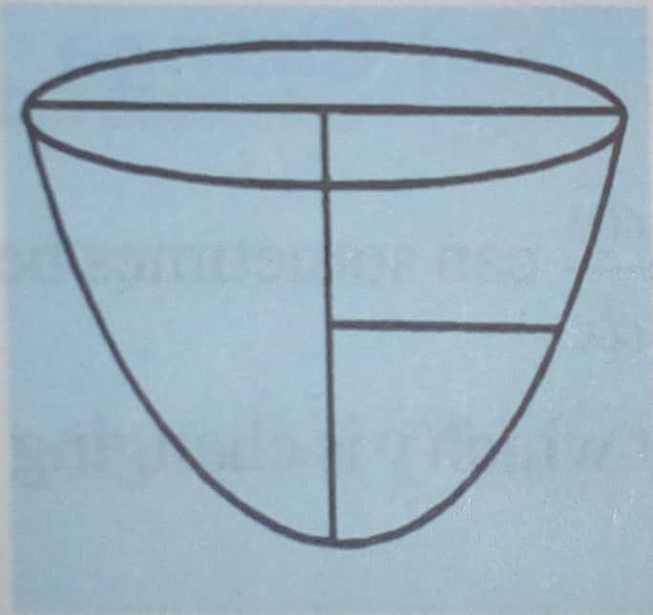

Let  be the surface area of the water in the hemispherical bowl of radius  then













Making  subject of the formula:





But 



Rectilinear Motion

This is the motion of a particle along a straight line. It is specified by the equation , where x is the distance of the particle from an initial point O, and t is the time.

The velocity of a particle is the time rate of change of displacement (distance in a specified direction). If V represents the velocity, then:

 where x is the displacement.

If the particle moves away from o, the initial point, .

If the particle moves towards O, then .

If the particle is momentarily at rest, .

The acceleration of a particle is the time rate of velocity. If  is the acceleration at time , then



If the velocity of the particle is increasing,  and the particle is said to be accelerating.

--------------------------------------------------------------------------------------------------------------------------------------------------------------------------------------------------------------------------------------

If the particle moves at a constant or uniform speed, then .

Example 5:

The motion of a particle along a straight line is specified by the equation , find the velocity and acceleration after 3 seconds.

Solution





When 









When 





Example 6:

The motion of a particle starting from O is described by the equation, . How far is the particle from O, when the particle is momentarily at rest?

Solution





When the particle is momentarily at rest, .







When 





When 





Class Work

Pg. 194, Ex. 10, nos. 14 and 19

Ticket Out:

Pg. 194, Ex. 10, no. 9.

Period 3

Maximum and Minimum Values

The points on a curve at which  = 0, are called **Stationary Points**.

Stationary points fall into three major categories:

1. Those in which  changes sign from positives through zero to negative. These are called **maximum points.**
2. Those in which changes sign from negative through zero to positive. These are called **minimum points.**
3. Those in which the sign of  is not changed in the immediate neighborhood of the stationary points. These are called **points of inflexion.**

The terms maximum and minimum points are used in the local sense and not in the absolute sense.

**Maximum Points**

**y=*f*(x)**

**y**

**X**

1. **x=a a+**

Fig.10. 11 shows part of the curve y = f (x). There is a maximum at the point where x = a

= *f*’(a) = 0

Let us denote a point at the immediate neighborhood of a to the left by a and a pint at the immediate neighborhood of a to the right by a+ then:

At x = a, > 0

*f’*(a-) > 0

At x = a+, < 0

*f*’ (a+) < 0

Hence for the existence of a minimum at x = a, three conditions must be satisfied:

1. *f*’(a) = 0 (ii) *f*’ (a) >0
2. *f*’ (a+)< 0

**Minimum Points**

**y=*f*(x)**

**y**

**X**

**b- x=b b+**

Fig. 10.12 shows a part of the curve y = *f* (x). There is a minimum at x = *b*

At x = b, f1 (b) =0

At x = b-, f1 (b-) <0

At x = b+, f1 (b+) <0

So a pint on a curve is a minimum at x = a.

If: (i) *f*’ (a) = 0 (ii) *f*’ (a-) <0

1. *f*’(a+)>0

**Points of Inflexion**

**y=*f*(x)**

**y**

**X**

**c-** c**c+**

**y=*f*(x)**

**y**

**X**

**d- dd+**

**(a)**

-

shows part of the curve y= f(x). We observe that

*f*’(c) = 0

*f*’(c-) < 0

*f*’(c+) < 0

The point *x = c* is a point of inflexion. Similarly, fig. 10.13(b) shows parts of the curve y = *f* (x)

We observe that

*f*’(d) = 0

*f*’(d-) >0

*f ’*(d+) >0

The point *x = d* is a point of inflexion.

A maximum point, a minimum point and a point of inflexion are all stationary points. Both maximum and minimum points are called turning points. A point of inflexion however, is not a turning point.

**Example**

Find the stationary points in each of the following curves whose equations are:

1. y = x3+ x2 -3x + 4

3

1. y = x4 +4 x3 – 2x2 – 16x + 1

4 3

**Solution**

1. y = x3 + x2-3x + 4

3

 = x2+ 2x – 3

= (x – 1) (x + 3)

At the stationary points,  = 0

 (x – 1) (x + 3) = 0

x =1 or x = -3

Hence there are stationary points at x = 1 and x = -3

y = x4+ 4 x3 -2x2 – 16x + 1

4 3

 = x3 + 4x2 – 4x – 16

= (x -2) (x + 2) (x + 4)

At the stationary points,  = 0.

(x – 2) (x + 2) (x + 4) = 0

x =2 or x= -2 or x = -4

Hence there are stationary points at x = 2, x = -2 and x = -4

**Example**

Find the turning points on the curve y = x4 +

2

5 x3 -2x2 - 3x + 1 and distinguish between them

3

**Solution**

y =x4+ 5 x3 – 2x2 – 3x + 1

2 3

 = 2x3 + 5x2 -4x – 3

 = (2x + 1) (x-1) (x+3)

At the stationary points,  =0

(2x + 1) (x – 1) (x + 3) = 0

*x* =, x = 1 and *x* = -3 are the x-

Coordinates of the stationary points.

Let *f*(x) = x4+ 5 x3 -2x2 – 3x + 1

2 3

*f‘(x)*= 2x3  + 5x2  - 4x – 3

= (2x + 1) (x – 1) (x + 3)

Let a =  = -0.5, a =-5, a+ = -0.4

Then *f*‘(a) = 0

*f’* (a) = (-1.2+1) (-0.6 – 1) (-0.6 + 3)

= (-0.2) (-1.6) (2.4)>0

= f1 (a) > 0

*f ’*(a+) = (-0.8 + 1) (-0.4 – 1) (-0.4 + 3)

= (0.2) (-1.4) (2.6) <0

*f* ’ (a+) < 0

**Table**

|  |  |  |  |
| --- | --- | --- | --- |
|  | f’(a-) | f’(a) | f’(a+) |
| Sign | **+**ve  / | 0  --- | **-**ve  \ |

Hence, there is a maximum point at x = 

At x = 1

Let a = 1, a- = 0.9, a+ = 1.1

f’(a-) = 0

*f*’ (a-) = (1.8 + 1) (0.9 -1) (0.9 + 3) < 0

*f’* (a+) = (2.2 + 1) (1.1 – 1) (1.1 + 4) > 0

**Table**

|  |  |  |  |
| --- | --- | --- | --- |
|  | f’ (a-) | f‘(a) | f ‘(a+) |
| Sign | **-ve**  **/** | **0**  **-** | **+ve**  **\** |

Hence, there is minimum point at x = 1.

At x = -3

Put a = -3, a- =-3.1; a+= -2.9

*f* ’ (a) = 0

*f*’ (a-) = (-6.2 + 1) (-3.1 – 1) (-3.1 + 3) < 0

*f* ’ (a+) = (-5.8 + 1) (-2.9 – 1) 9-2.9 + 3) > 0

**Table**

|  |  |  |  |
| --- | --- | --- | --- |
|  | f’ (a-) | f’(a) | f’(a+) |
| Sign | **-**ve  **/** | 0  **-** | **+**ve  **\** |

Hence, x = -3 is a minimum point

**Example**

Find the stationary points on the curve y = x3 – 6x2 + 12x – 8 and distinguish between them.

**Solution**

y = x3 – 6x2 + 12x – 8

 = 3x2 – 12x = 12

= 3(x2 – 4x + 4)

= 3(x – 2)2

At the stationary points,  = 0

Put a = 2, a- = 1.9, a+ = 2.1

and let *f*’(x) = x3 – 6x2 + 12x – 8

*f ’*(x) =3(x2 - 12x + 12)

= 3(x2 - 4x + 4)

= (3x -2)2

*f ’*(a) = 0

*f ’*(a-) = 3(1.9 – 2)2 > 0

*f ’* (a+) = 3(2.1 – 2)2 > 0

**Table**

|  |  |  |  |
| --- | --- | --- | --- |
|  | f’ (a-) | f’(a) | f’(a+) |
| Sign | **-**ve  **/** | 0  **-** | **+**ve  **\** |

Hence, there is a point of inflexion at x, =2

When x = 2

y = 8 – 24 + 24 – 8 = 0

=  The point (2, 0) is a point of inflexion on the curve y = x3 – 6x2  + 12 – 8

**The second derivative test for stationary points**

We recall that a necessary condition for the existence of stationary points for the curve.

y = f (x) is that  =. This condition is however not sufficient to determine the nature of the stationary points. We shall consider an alternative method which enables us to distinguish between the natures of stationary points.

***x***



**a-  a a+**

**y=*f(x)***

1. **aa+**

***x***

***y***

**EVALUATION**

**1)** Find the minimum and maximum points of the curve y= x3 –x-5x and sketch the curve

2) The area of a circle is increasing at the rate of 4cm2/s , find the rate of change of the circumference when the radius is 6cm

**GENERAL EVALUATION**

1) A curve is defined by f(x) = x3 -6x2-15-1 find (i) the derivative of f(x) (ii) the gradient of the curve at the point where x= 1 (iii) the minimum and maximum points

2) The distance of a particle from a starting point is S = t3 – 15t2 +63t – 40 where t = time taken in seconds, find the (i) distance of the particle from the starting point when the particle is at rest (ii) velocity when the acceleration is zero

Reading Assignment : New FURTHER MATHS PROJECT 2 page 149-167

**WEEKEND ASSIGNMENT**

1) Find the value of x at which the function y = x2 – 7x2 + 15x has the greatest value a) 5/3 b) 5/4 c) 5/2 d) 5/6

2) Find the values of x at the turning point of y = 2x3 – 3x2 -12x + 8 a) 1 or 2 b) -1 or -2 c) -1 or 2 d) 1 or -2

3) Find the maximum value of the function 3x2 –x3 a) 2 b) 4 c) 0 d) 6

4) Find the minimum value of the function f(x) = x3 + 3x2 – 9x + 1 a) -3 b) -5 c) -4 d) 0

5) At what rate is the area of a circle changing with respect to its radius when the radius is 5cm a) 25 b 15 c) 20 d) 10

**THEORY**

1) The displacement of a particle is given as S = 12t – 15t2 + 4t3 where t is the time taken . Find the velocity and acceleration of the particle after 3 seconds

2) Find the maximum and minimum points and values of the curve y = x3 – 6x2 + 9x -5.

Week: Three

Period: Three

Duration: 45 minutes per period

Subject: Further Mathematics

Class: SS2

Topic: Binomial Expansion

Subtopic: Pascal Triangle

**PASCAL’S TRIANGLE**

Consider the expressions of each of the following:

(x + y)0; (x + y )1; (x + y)2; (x + y)3; (x + y)4

(x + y)0 = 1

(x + y)1 = 1x + 1y

(x + y)2 = 1x2 + 2xy + 1y2

(x + y)3= 1x3 + 3x2y + 3xy2 + 1y3

(x + y)4 = 1x4 + 4x3y + 6x2y2 + 4xy3 + 1x4

The coefficient of x and y can be displayed in an array as:

1

1 1

1 2 1

1 3 3 1

1 4 6 4 1

The array of coefficients displayed above is called Pascal’s triangle, and it is used in determining the co-efficients of the terms of the powers of a binomial expression

Coefficient of (x + y)0 1

Coefficient of (x + y)1 1 1

Coefficients of (x + y)2 1 2 1

Coefficients of (x + y)3 1 3 3 1

Coefficients of (x + y)4 1 4 6 4 1

**Example 1**

Using Pascal’s riangle, expand and simplify completely: (2x + 3y)4

**Solution:**

(2x + 3y)4 = (2x)4 + 4(2x)3 (3y) + 6(2x)2(3y)2 + 4(2x)(3y)3 + (3y)4

= 16x4 + 96x3y + 216x2y2 + 216xy3 + 81y4

**Examples 2:**

Using pascal’s triangle, the coefficients of (x + y)5are: 1,5,10,10,5,1.

Therefore (x – 2y)5 = x5 + 5x4(-2y) + 10x3(-2y)2 + 10x2(-2y)3 + 5x(-2y)4 + (-2y)5

= x5 – 10x4y + 40x3y2 – 80x2y3 + 80xy4 – 32y5

**Example 3**

Using Pascal’s triangle, simplify, correct to 5 decimal places (1.01)4

**Solution**

We can write (1.01)4 = (1 + 0.01)4

(1 + 0.01)4 = 1 + 4(0.01) + 6(0.01)2 + 4(0.01)3+(0.01)4

= 1 + 0.04 + 0.0006 + 0.000004 + 0.00000001

= 1.04060401

= 1.04060 (5 d.p)

The Binomial Expansion Formula

Consider the expansion of (x + y)5 again

(x + y)5 = (x + y)(x + y)(x + y)(x + y)(x + y)

The first term is obtained by multiplying the xs in the five brackets. there is only one way to doing this

(x + y)n = xn + nxn – 1y +  xn – 2y2 +  xn-3y3 + …. 

xn-ryr + …. yn

------------------------------------------------------------------------------------------------------------------------------------------------------------------------------------------------------------------------------------------------------------------------------------

We shall however consider only the binomial expansion formula for a positive integral n

**Example 4:**

1. Write down the binomial expansion of 6 simplifying all the terms
2. Use the expansion in (a) to evaluate (1.0025)6 correct to five significant figures.

**Solution**

6 = 1 + 6C1 1 + 6C22

+ 6C3 3  + 6C4 

+ 6C5 5  + 6C6 6

6= 1 +  x + 3 +  x

4 + x 5  + 6

= 1 + x + x2+ x3 +x4 + x5 + x6

1. (1.0025)6 = (1 + 0.0025)6

=  )6

=  )6

Put x =

x =  x 4 = = 0.01

therefore (1.0025)6 = 1 +  (0.01) +  (0.01)2 + (0.01) +(0.01)4 + …

= 1 + 0.015 + 0.00009375 + 0.0000003125

= 1.0150940625

= 1.0151 (5 s.f.)

**EVALUATION**

Expand ( 2 + 4x )4 simplifying the terms

**Example 5**  
(a) Using the binomial theorem, obtain the expansion of (1 + 3x)6 + (1 – 3x)6 simplifying all the terms

(b)Use the above result to calculate the value of (1.03)6 + (0.97)6, correct to five decimal places

Solution:

(1 + 3x)6 = 1 + 6C1 (3x) + 6C2 (3x)2 + 6C3 (3x)3 _ 6C4 (3x)4 _ 6C5 (3x)5 + 6C6 (3x)6 ….. (1)

(1 - 3x)6 = 1 - 6C1 (3x) + 6C2 (3x)2 - 6C3 (3x)3 + 6C4 (3x)4 _ 6C5 (3x)5 + 6C6 (3x)6 ….. (2)

Adding (1) and (2)

(1 + 3x)6 +(1 - 3x)6 = 2 + 2 x 6C2 (3x)2 + 2 x 6C4 (3x)4 + 2 x 6C6 (3x)6

= 2 + 2 x  9x2 + 2 x  x 81x4 + 2 x 729x6

= 2 + 270x2 + 2430x4 + 1458x6

(1.03)6 = (1 + 0.03)6

(0.97)6 = (1 – 0.03)6

Put 1 + 0.03 = 1 + 3x

Therefore 3x = 0.03

Therefore x = 0.01

Hence

(1.03)6 + (0.97)6 = 2 + 270(0.01)2 + 2430(0.01)4 + 1458(0.01)

= 2 + 0.027 + 0.0000243 + 2.0270243

= 2.02702 (5 d.p)

**Example 6**

1. Using the binomial theorem, expamd (1 + 2x)5, simplifying all the terms
2. Use your expansion to calculate the value of 1.025, correct to six significant figures

If the first three terms of the expansion of (1 + px)n in ascending powers of x are 1 + 20x + 160x,

Find the values of n and p

Solution:

1. (1 + 2x)5 = 1 . 5C1(2x) + 5C2(2x)2 + 5C3(2x)2 + 5C4(2x)4 + 5C5(2x)5

= 1 + 5.(2x) +  . 4x2 +  . 8x3 + . 16x + 32x5

= 1 + 10x + 40x2 + 80x3 + 80x4 + 32x5

1. (1.02) = (1 + 0.02)

Put 1 + 0.02 = 1 + 2x

Therefore 2x = 0.02

x = 0.01

Hence:

(1.02)5 = 1 + 10(0.01) + 40(0.01)2 + 80(0.01)3 + 80(0.01)4 + 32(0.01)5

= 1 + 0.1 + 0.004 + 0.0008 + 0.00000008

= 1.10408 (6.s.f.)

6.3 The Binomial Theorem for any index

The Binomial expansion formula is also applicable to any index n, where n can be positive or negative integer or even a fraction

If /x/  1, then:

(1 + x)n = 1 + nx +  +  +  x4 + … where n may be a negative integer or a fraction.

**Example 7**

Use the Binomial expansion formula to obtain the first five terms of the expansion of (1 +  x)-2

**Solution:**

(1 +  x)-2 = 1 + (-2) ( x) + ( ( x)2 +  ( x)3 +  ( x)4 + ….

= 1 – x + 3. 2 - 4.3 + 5.4

1. (1 + px)n = 1 + 20x + 160x2 + …

(1 + px)n = 1 + nc1 (px) + nc1 (px)2 + …

= 1 + npx +  p2x2 …

= 1 + 20x + 160x2 + …

By equating coefficients

np = 20 … (1)

p2 = 160 … (2)

From (1) p =  … (3)

Therefore p2 =  … (4)

Substituting (4) into (2)

 x  = 160

x 200 = 160

There 200(n – 1) = 160n

200n – 200 = 160n

200n – 160n = 200

40n = 200

n = 5

From (3)p =  = 4

Hence, n = 5, p = 4

**Example 8**

Obtain the first four terms of the explanation of (2 +  x)8in ascending powers of x. hence, find the value of (2.005)8, correct to five significant figures.

Solution:

(2 +  x)8= 28(1+  x)8

= 28[1 +8C1(  x) + 8C2 (  )2 + 8C3 (  )3  + … ]

= 28[1 +8(  x) +  (  )2 +  (  )3  + …]

= 28[1 + 2X +  X2+ X3 + …]

Write 2.0.005

Put 2 +  x = 2 + 0.005

Therefore  x = 0.005

Therfore x = 0.005 x 2

= 0.01

Hence,

(2.005)8 = 28[1 +2(0.01) + (0.01)2+  (0.01)3 ]

(2.005)8 = 28 + 29(0.01) + 26.7(0.01)2 + 25 x 7(0.01)3 + …

= 256 + 5.12 + 0.0448 + 0.000224

= 261.165025

= 261.17 (5 s.f.)

**GENERAL EVALUATION**

1) Write down and simplify all the terms of the binomial expansion of ( 1 – x )6 . Use the expansion to evaluate 0.9976 correct to 4 dp

2) Write down the expansion of ( 1 + ¼ x ) 5 simplifying all its coefficients

3) Use the binomial theorem to expand ( 2 – ¼ x)5 and simplify all the terms

4) Deduce the expansion of ( 1 – x +x2 )6 in ascending powers of x

**Reading Assignment**

New Further Maths Project 2 page 73 – 78

**WEEKEND ASSIGNMENT**

If the first three terms of the expansion of ( 1 + px )n in ascending powers of x are 1 + 20v + 160x find the value of

1) n a) 2 b) 3 c) 4 d) 5

2) p a) 2 b) 3 c) 4 d) 5

3) In the expansion of ( 2x + 3y )4 what is the coefficient of y4 a) 16 b) 81 c) 216 d) 96

x 200 = 160

There 200(n – 1) = 160n

200n – 200 = 160n

200n – 160n = 200

40n = 200

n = 5

From (3)p =  = 4

Hence, n = 5, p = 4

**Example 8**

Obtain the first four terms of the explanation of (2 +  x)8in ascending powers of x. hence, find the value of (2.005)8, correct to five significant figures.

Solution:

(2 +  x)8= 28(1+  x)8

= 28[1 +8C1(  x) + 8C2 (  )2 + 8C3 (  )3  + … ]

= 28[1 +8(  x) +  (  )2 +  (  )3  + …]

= 28[1 + 2X +  X2+ X3 + …]

Write 2.0.005

Put 2 +  x = 2 + 0.005

Therefore  x = 0.005

Therfore x = 0.005 x 2

= 0.01

Hence,

(2.005)8 = 28[1 +2(0.01) + (0.01)2+  (0.01)3 ]

(2.005)8 = 28 + 29(0.01) + 26.7(0.01)2 + 25 x 7(0.01)3 + …

= 256 + 5.12 + 0.0448 + 0.000224

= 261.165025

= 261.17 (5 s.f.)

**GENERAL EVALUATION**

1) Write down and simplify all the terms of the binomial expansion of ( 1 – x )6 . Use the expansion to evaluate 0.9976 correct to 4 dp

2) Write down the expansion of ( 1 + ¼ x ) 5 simplifying all its coefficients

3) Use the binomial theorem to expand ( 2 – ¼ x)5 and simplify all the terms

4) Deduce the expansion of ( 1 – x +x2 )6 in ascending powers of x

**Reading Assignment**

New Further Maths Project 2 page 73 – 78

**WEEKEND ASSIGNMENT**

If the first three terms of the expansion of ( 1 + px )n in ascending powers of x are 1 + 20v + 160x find the value of

1) n a) 2 b) 3 c) 4 d) 5

2) p a) 2 b) 3 c) 4 d) 5

3) In the expansion of ( 2x + 3y )4 what is the coefficient of y4 a) 16 b) 81 c) 216 d) 96

4) How many terms are in the expansion of ( 1 – 4x ) 5 a) 3 b) 5 c) 6 d) 8

5) What is the third term in the expansion of ( 1 – 3x )6 in ascending powers of x a) 18 b) -540 c) 135 d) 729

**THEORY**

1) Using binomial theorem, write down and simplify the first seven terms of the expansion of ( 1 + 2x )10 in ascending powers of x

2) Expand ( 2 + x )5 ( 1 – 2x ) 6 as far as the term in x3 . Evaluate ( 1.999 )5 ( 1.002 )6

Week: Four - Five

Period: Three

Duration: 45 minutes per period

Subject: Further Mathematics

Class: SS2

Topic: Conic Sections

Subtopic: Equation of Circle

Definition:

---------------------------------------------------------------------------------------------------------------------------------------------------------------------------------------------------------------------------------------------------------

Equation of a circle with centre (a,b) and radius r.



PR = x – a, PQ=r

QR = y – b

Since PQR is the right angle triangle, we have:

PQ2 = PR2 + QR2

r2 = (x – a)2 + (y – b)2

hence, the equation of a circle with centre (a,b) and radius r is

r2 = (x – a)2 + (y – b)2

if the centre of the circle is the origin (0,0), the equation become x2  + y2 = r2

**GENERAL EQUATION OF A CIRCLE**

From (x – a)2 + (y – b)2 = r2

r2 – 2ax + a2 + y2 – 2by + b2 – r2 = 0

x2 + y2 – 2ax – 2by + a2 + b2 – r2 = 0

The above equation can be written as x2 + y2 + 2gx + 2fy + c = 0

Where a = - g, b = -f, c = - a2 + b2 – r2

Hence: x2 + y2 + 2gx + 2fy + c = 0 is called the general equation of a circle. observe the following about the general equation

1. It is a second degree equation in x and y

iiThe co-efficient of x2 and y2 are equal

iiiIt has no xy term

***Examples:***

1. Find the equation of a circle of centre (3, -2) radius 4 unit

***Solution:***

a = 3, b = -2 and r = 2

(x-a)2 + (y-b)2 = r2

(x-3)2 + (y+2)2 = 42

x2 – 6x + 9 + y2 + 4y + 4 = 16

x2 + y2 – 6x + 4y + 9 + 4 – 16 = 0

x2 + y2 – 6x + 4y – 3 = 0

Find the centre and radius of a circle whose equation is x2 + y2 – 6x + 4y – 3 = 0

***Solution:***

x2 + y2 – 6x + 4y – 3 = 0

x2 – 6x + y2 + 4y = + 3

Complete the square for x and y

x2 – 6x + 9 + y2 4y + 4 = 3 + 9 + 4

(x – 3)2 + (y + 2)2 = 16

Compare with (x – a)2 + (y – b) = r2

Equation of a circle passing through 3 points

Find the equation of the circumcircle of the triangle whose vertices are A (2,3) B (5,4) and C (3,7)

Solution:

The equation of the circle x2 + y2 + 2gx + 2fy + c = 0

22 + 32 + 4g + 6f + c = 0

52 + 42 + 10g + 8f + c = 0

32 + 72 + 6f + 14f + c = 0

Simplify the 3 equations

f = - 107 / 22

g = - 67 / 22

c = - 312 / 11

Hence, the equation of the circle is

x2 + y2 + 2  x + 2  y +  = 0

11x2 + 11y2 – 67x – 107y + 312 = 0

a = 3, b = -2, r2 = 16,

r =  = 4

hence the centre is (3, -2) and the radius is 4 unit

**Evaluation:**

1. Find the equation of the circle (-1 -1) and radius 3
2. Find the centre and radius of the circle x2 + y2 – 6x + 14y + 49 = 0
3. **EQUATION OF TANGENT TO A CIRCLE AT PONIT (x1, y1)**



At x1, y1

x12 + y12 + 2gx1 + 2fy1 + c = 0

C = - (x12 + y12 + 2gx1 + 2fy1) ……………… (i)

Differentiating the equation of circle above

2x + 2y dy / dx + 2g + 2f dy / dx = o

Divide through bu 2

x + y dy/dx + g + f dy/dx = 0

(y + f) dy/dx = - (x+g)  
 = 

The equation of the tangent at x1, y1

 = 

(y – y1) (y + f) = - (x – x1) (x + g)

yy1 + yf – y12 – y1f = - (xx1 + xg – x12 – x1g)

yy1 + yf – y12 – y1f = - (xx1 + xg + x12 + x1g)

yy1 + yf + xx1 + xg = x12 + x1g + y12 + y1f)

yy1 + + xx1 + yf + xg = x2 + y2 + x1g + y1f)

Adding gx1 + y1f to both sides

yy1 + xx1 + y1f + yf + xg + gx1 = x12 + y12 + x1g + x1g + y1f + y1f

yy1 + xx1 + ( y1 + y) f + (x + x1) g = x12 + y12 + 2x1g + 2y1f

but x12 + y12 + 2x1g + 2y1f = -C

yy1 + xx1 + ( y1 + y) f + (x + x1) g + C = 0

Hence the equation of the tangent to the circle x2 + y2 + 2gx + 2fy + C = 0 at (x1, y1) on the circle is xx1 + yy1 + (x + x1)g + (y + y1)f + c = 0

Examples:

Show that the point (2,3) lies on the circle x2 + y2 – 3x + 4y – 19 = 0. Hence or otherwise, determine the equation of the tangent to the circle at the point (2,3)

Solution:

x2 + y2 – 3x + 4y – 19 = 0

At (2,3)

22 + 32 – 3(2) + 4(3) – 19 = 0

4 + 9 – 6 + 12 _ 19 = 0

R.H.S = L.H.S, hence the point (2,3) lies on the circle

x2 + y2 – 3x + 4y – 19 = 0

Compare with:

x2 + y2 + 2gx + 2fy + c = 0

2g = -3, 2f = 4

g =  f =  = 2 c = -19

Equation of Tangent:

yy1 + xx1 + (x + x1) g + (y + y1) f + c = 0

3y + 2x + (x + 2) (  ) + (y + 3)2 – 19 = 0

3y + 2x - (  ) – 3 + 2y + 6 – 19 = 0

6y + 4x – 3x -6 + 4y + 12 – 38 = 0

10y + x – 32 = 0

Alternatively:

x2 + y2 – 3x + 4y – 19 = 0

2x + 2y dy/dx – 3 + dy/dx = 0

 (2y + 4) = 3 – 2x

 = 

At 2,3



y – y1 = m(x – x1)

y – 3 = -1/10 (x – 2)

10(y – 3) = -1 (x - 2)

10y – 30 = - (x + 2)

10y + x – 30 – 2 = 0

10y + x – 32 = 0

**Evaluation**

Find the equation of the tangent to the circle

1. x2 + y2 + 4x – 10y – 12 = 0 at (3,1)
2. x2 + y2 – 6x – 3y = 16 at (-2,0)

**GENERAL/REVISION EVALUATION**

1. Find the equation of the circle with center (1,3) and radius 
2. Find the equation of the circle that passed through the point (0,0), (2,0) and (3, -1)
3. Find the equation of the circumcircle of the triangle whose vertices are A( 2,3) B ( 5,4) and C(3,7)
4. Find the length of the tangent to the circle x2 + y2 -2x -4y -4 =0 from the point ( 8, 10)

**READING ASSIGNMENT**

Read equation of a circle, Further Mathematics Project II, page 205 – 210

**WEEKEND ASSIGNMENT**

1. What is the radius of the circle whose equation is x2 + y2 – 6x – 7=0 (a) 2 (b) 3 (c) 4 (d) 9
2. Which of the following is not an equation of a circle? (a) x2 + y2 =4 (b) x2 + y2 – 2x – 3=0 (c) x2 + y2 – 2xy + 4x – 6y + 1 = 0 (d) 2x2 + 2y2 – 6x + 4y + 3 = 0
3. The equation of a circle with centre (-2, 5) and radius 3 units is (a) x2 + y2 + 4x – 10y + 20 = 0 (b) x2 + y2 + 4x – 10y + 26 = 0 (c) x2 + y2 + 4x – 10y – 38 = 0 (d) x2 + y2 + 4x – 10y + 39 = 0
4. Find the coordinates of the centre of the circle 2x2 + 2y2 – 4x + 12y – 7 = 0 is (a) (-1, 3) (b) 1, 3) (c) (2, -6) (d) 41 (e) 10
5. The equation of a circle of radius 3 is x2 + y2 + 10x – 8y + k = 0. Find the value of the constant K (a) -50 (b) 18 (c) 32 (d) 41 (e) 10

**THEORY**

1. The equation of a circle is x2 + y2 – 10x + 8y = 0 find (i) its radius (ii) its area
2. A circle passes through the points (0,3) and (4,1), if the centre of the circle is on the x – axis, find the equation of the circle.

Week: Six

Period: Three

Duration: 45 minutes per period

Subject: Further Mathematics

Class: SS2

Topic: Permutation and Combination

Subtopic: Concept of Permutation.

Definition, Concept:

Definition: Permutation is defined as the number of arranged of objects. The different orders of arrangement are important. E.g. Find the number of ways of arranging the letters pqr.

Pqr, prq, qrp, qpr, rqp. The number of ways is 6 ways

Similarly, for 4 letters the number of arrangement is 24

In general, the number of different arrangement of n different objects is equal to n! (n factorial)

N! = n x (n-1) x (n-2) x … x 3x2 x 1x0! (But, 0! = 1)

1. Simplify the following: A. 5! B. 

**Solution**

1. 5! = 5x4x3x2x1 = 120
2.  = 7x6x5x4! = 7x5 = 35
3. Find the number of ways of arranging the letters of the word MACHINE

**Solution:**

There are seven different letters in the word MACHINE, therefore the number of permutation is 7! = 7x6x5x4x3x2x1 = 5040 ways

1. Simplify (n + 1)! = (n+1)n! = n+1

(n-1)! (n-1)n! n-1

ARRANGEMENT OF n-OBJECTS TAKING r-OBJECTS

If we are interested in the number of ways 2 letters of a 4 lettered word cnbe arranged, then the npr is the permutation of n objects taking at a time

npr = 

Example: Evaluate: (a) 8p3 (b) 11p9

Solution:

1. 8P3 =  =  =  = 8x7x6 = 336
2. 11P9= = 11x0x9x8x7x6x5x4x3x2! = 19958400
3. In how many ways can three people be seated on eight seats in a row?

Solution:

1st seat can be occupied by any of the 8 = 8 ways

2nd seat can be occupied in 6 ways

Hence, the number of ways = 8x7x6 = 336 ways

Alternatively, n = 8, r = 3

nPr = =  =  = 8x7x6 = 336 ways

**EVALUATION**

1. In how may ways can 8 students be seated in a row?
2. In how many ways can the 1st, 2nd 3rd prizes be won by 6 athletetes in a race?
3. In how many ways can the letters of the word HISTORY be arranged?

**CYCLIC PERMUTATION:** ----------------------------------------------------------------------------------------------------------------------------------------------------------------------------------------------------------------------------------------------------------------

If the circular object can be turned over e.g. circular ring e.t.c. the number of arrangement = 

Example: In how many ways can 6 members of a disciplinary committee be seated round a circular table?

**Solution:**

The number of ways = (n – 1)! X 1

N = 6,

Hence, (6 – 1)! X 1 = 5! X 1 = 120 ways

PERMUTATION OF IDENTICAL OBJECTS:

The number of ways of permuting n objects taking n at a time with n, objects alike, n2alke is,





1. Find the number of ways the word MATHEMATICS can be arranged.

Solution:

**MATHEMATICS**

There are: 2Ms, 2Asm 2Ts and 11 letters.

N=11, n1 = 2! N2 = 2! N3 = 2

 = 11x10x9x7x6x5x4x3x2x1 = 4989600

**CONDITIONAL PERMUTATION:**

Sometimes restrictions are placed on the order of arrangements of objects

**Examples:**

1. Find the number of ways the letters of the word COMMITTEE can be permuted, if the 2Ts must always be together.

**Solution:**

The 2Ts must be together, we can lump them as follows: COMMI (TT) EE = 8!

=   
= 10080 ways

1. Find the number of ways of arranging the letters of the word MOSHOESHOE if the letter M must always begin a word

**Solution:**

Since letter m must always begin, and then m can only occupy the first position

i.e M = 1 way

other letters, OSHOESHOE =  = 9x7x6x5x4 = 7560 ways

**COMBINATION: Selection, Conditional Selection And Its Application**

Combination can be defined as the number of ways r – objects can be selected from n – objects irrespective of the arrangement

Hence, the notation is thus, nCr or (nr)

, nCr= 

Relationship between permutation and combination is thus, nCr = 

**Example:**

1. Evaluate 10C4

**Solution:**

10C4 = = 10 x 3 x 7 = 210

1. In how many ways can three books be selected from 12 books?

**SOLUTION:**

N = 12, r = 3, 12C3 =  = 2x11x10 = 220 ways

1. A committee consisting of 3 men and 5 women is selected from 5 men and 10 women. Find how many ways this committee can be formed.

**Solution:**

**MEN WOMEN**

R = 3, n = 5 r = 5, n = 10

5C3 =  = 10 10C5 =  = 252

Therefore number of ways of selecting the committee = 10x252 = 2520 ways.

**GENERAL/ REVISION EVALUATION**

1. Find the number of ways the letters of the word FURTHER can be arranged
2. Find the number of ways of arranging 7 people in a straight line, if two particular people must always be separated
3. In how many ways can 6 pupils be lined up if 3 of them insist in the following one another
4. Verify that  = (n – 1) (n – 2) (n – 3)!

**READING ASSIGNMENT**

Read permutation and combination, further mathematics project 2 pages 47-54

**WEEKEND ASSIGNMENT**

1. Evaluate 6C2 + 6C3 + 6C4 + 6C5 (a) 6C6 (b) 6C5 (c) 8C5
2. How much ways can the letters of the word EVALUATE be arranged? (a) 10080 (b) 20160 (c) 40320
3. In how many ways can 2 boys and 3 girls be arranged to sit in a row, if the boys must sit together (a) 6 (b) 4 (c) 24
4. Find the number of ways 6 people can be seated in a round table, if two particular friends must sit next to each other (a) 48 9b) 24 (c) 120
5. In how many ways can 6 pupils be lined up if 3 of them insist on following one another? (a) 720 (b) 144 (c) 24

**THEORY**

1. Out of 7 lawyers, 5 judges, a committee consisting of 3 lawyers, 2 judges is to be formed, in how many ways can this be done, if
2. Any lawyer and any judge can be included
3. One particular judge can be included
4. Two particular lawyer cannot be in committee
5. If nP3 / nC2 = 6, find the value of n

Week: Seven

Period: Three

Duration: 45 minutes per period

Subject: Further Mathematics

Class: SS2

Topic: Dynamics

Subtopic: Newton’s Laws of Motion

**DYNAMICS :NEWTON’S LAWS OF MOTION, MOTION ALONG INCLINED PLANE AND MOTION OF CONNECTED PARTICLES**

**Sir Isaac Newton** put forward three important laws which relate to the motion of bodies under the action of given forces. These laws are central to the study of dynamics, since **dynamics** essentially involves the study of motion of bodies under given forces

**The Frist Law OF Motion**

-------------------------------------------------------------------------------------------------------------------------------------------------------- Once it is kicked, it will start moving and continue to move until something happens either to stop it or change its direction of motion. This basic idea is stated in Newton’s First Law which may be stated as: **Everybody continues in its state of rest, or of uniform motion in a straight line, unless it is compelled to change that state by external impressed forces.**

This law re-emphasizes the fact that a force can change the state of rest or uniform motion of a body. A stationary point will remain stationary unless it is pushed from its stationary position. By pushing, we are exerting a force on the object. A moving car will continue to move unless brakes are applied to bring it to a halt. The brakes applied have introduced a kind of force that makes the car to come to a stop.

The tendency of a body to remain in its state of rest or uniform motion in a straight line is called **inertia** and is a function of the mass of a body. The greater the mass of a body, the greater its inertia and hence the greater the force required to change the state of the body.

**The Second Law of Motion**

The law states that **the rate of change of momentum of a body is proportional to the applied force and is in the direction of the force.**

The second law of motion helps us to obtain an expression for 5the force acting on a body. We recall that momentum is defined as the product of mass and velocity.

By the second law of Newton

*F α*

Since the mass of a given body is a constant, we have

*F α m*

 *F = km*

Where *k* is a constant.

By a suitable choice of unit for *F,* we can make

*k =*1

Hence

*F=m**.* But  = a

***F = ma***

Where **a** is the acceleration of the body.

The law established an exact relationship between force *F,* the mass *m* of a body, as well as the acceleration **a** of the body.

If a force *F*acts on a body of mass m kg it produces an acceleration in the mass given by the relation

**F = ma**

Newton’s second law also enables us to deduce the unit of force. We recall that the unit of mass is kilogramme (kg). The unit of mass is meter per second (). Hence, the unit of force is kg .

A force acting on a body of mass 1 kg, producing an acceleration of 1  is called **1 Newton (1N).** So the unit of force is the Newton.

**Newton’s Third Law of Motion**

Newton’s third law of motion states:  **Action and reaction are equal and opposite.** When two bodies are in contact, the forces of action and reaction are equal in magnitude and opposite in direction.

Such forces are also collinear. Let us consider a heavy block placed on a table, the force due to gravity on the body (weight of the block) acts directly on the table downwards. The table will have to exert an equal but opposite force on the block. This force acts upwards and balances the weight of the block on the table. If the table cannot withstand the weight of the block, it collapses.

**Example 1**

A boy sits on a log. The mass of the log is 8 kg and the weight of the boy is 55N. What is the reaction of the ground on the log on which the boy is sitting? (Take g= 9.8)

**Solution**

Weight of the log = 8  9.8N

=78.4N  
 Weight of the boy and the log = (78.4 + 55) N

= 133.4N

By the third law of Newton, the ground will expert an equal but opposite force on the log on which the boy is sitting.

Hence if *R* is the force reaction of the

**MOTION ALONG AN INCLINED PLANE**

R

mgsinθ

mg

mgcosθ

θθ

F

Consider a body of mass m on a smooth plane inclined at angle θ to the horizontal.

The force on the body due to gravity (weight) acts vertically downward and is *mg.*The force which acts perpendicularly to the inclined plane in *mg* cosθ .

The reaction of the inclined surface on the body is *R* and is equal in magnitude to *mg.*  The force which tends to move the body down the plane is *mg*sinθ. The force which tends to move the body up the plane is *F* –mg sinθ. The equation of motion is:

*F* – mgsinθ = ma

Where a is the acceleration of the body. If however, F <mgsinθ then the body will move down the plane with a net force of *mg*sinθ – F = ma where a is the acceleration of the body down the plane.

**Example 5**

An object whose weight is 10kg is placed on a smooth plane inclined at 30 to the horizontal. Find:

1. the acceleration of the object as it moves down the plane;
2. the velocity attained after 3 seconds if:
3. it starts from rest;
4. it moves with an initial velocity of 5

[Take g = 10 

**Solution**

R

mgsinθ

mg

mgcosθ

30

F

The force acting on the body down the plane is *mg* sin 300

The force acting onm the body up the plane is Zero. The net force acting on the body down the plane is *mg* sin 300

From newton’s law

*Mg* sin 300 = ma

Where a is the acceleration of the body down the plane.

10  10  sin 300 = 10a

50 = 10a

a = 5 

(b) (i) if the body start from rest, u = 0.

from equations of motion

v = u + at

= 0 +5  3

= 15 

1. if the body moves with an intial velocity of 5 , then

v = u+at

=5+35  
 = (5 +15)

**Example 6**

A body of mass m is placed on the surface of a smooth plane which is inclined at an angle θ to the horizontal. A force f whose line of action is parallel to the surface of the inclined plane acts on the body to just prevent it from slipping down the plane. If R is the reaction between the surface of the inclined plane and the body, show that F = R tanθ

**Solution**

Since the body lies on the surface of the plane

*R –mgcosθ = 0 , R = mgcosθ*….(1)

The force which tends to move the body down the plane is mg sinθ

Since the force F just prevents the body from slipping down the plane

*F = mg sinθ*

Dividing (2) by (1)

 = 

= 

 = tanθ Hence, F = R tanθ

**MOTION OF CONNECTED PARTICLES**

In this unit, we shall examine the motion of two or more bodies connected by a light inextensible string, connected to a light smooth pulley. The basic assumption we make is that the tensile force in the string is always the same throughout every section of the string. We can easily write down the equation of motion of the connected particles, once they are set in motion.

**Example**

The particles whose masses are 15kg and 12 kg respectively are attached to the ends of a light inextensible string. The string passes over a light frictionless pulley and the masses hang freely. The system is released from rest when the 15kg mass is 32m above the floor. Find:

1. the tension in the string;
2. the time taken by the 15kg mass to reach the floor.

[t g = 10 ]



Let a be the acceleration , for the 15kg mass

The net force is 15g –T

15g –T =15a

For the 12kg mass

The net force is T-12kg

By Newton”s 2nd law T-12kg

3g = 27a a =g/9a = 10/9 , T – 12g = 12a

T = 12a + 12g =12x 10/9 +12 x10 =400/3

**EVALUATION**

A force P acts on a body of mass 5kg on a smooth horizontal floor if it produces an acceleration of 4.5 m/s , find the magnitude of P

**GENERAL EVALUATION**

1) A body of mass 15kg is placed on a smooth plane which is inclined at 60 to the horizontal, find the acceleration of the body as it moves down the plane

2) A body of mass 5kg is connected by a light inelastic string which is passed over a fixed frictionless pulley by a movable frictionless pulley of mass 1kg over which is wrapped another light inelastic string which connects masses 3kg and 2kg , find the acceleration of the masses and the tension in the strings

**Reading Assignment**

New Further Maths Project 2 page 237- 242

**WEEKEND ASSIGNMENT**

A body of mass of mass 100kg is placed in a lift , find the reaction between the floor of the lift and the body when the lift moves upward

1)at constant velocity a) 800N b) 900N c) 1000N d) 600N

2) with an acceleration of 3.5m/s a) 100N b) 1350N c) 1200N d) 1500N

3) A body of mass 20kg is placed in a lift , find the reaction between the floor of the lift and the body when the lift moves downward with a retardation of 2.5 m/s a) 250N b) 300N c) 350N d) 400N

4) Law of inertia is also known as Newton”s ----- Law of motion a) 2nd b) 1st c) 3rd d) 4th

5) The relationship between force and acceleration of a body in motion can be attributed to Newton”s -------- Law of motion a) 1st b) 2nd c) 3rd d) 4th

**THEORY**

1) A car of mass 0.9 tonnes is moved by a constant force F from a speed of 12m/s to 16m/s over a distance of 50m, find F

2) Two masses 10kg and 8kg are connected by a light inextensible string which is passed over a light frictionless pulley fin the tension in the string

**WORK, POWER AND ENERGY ;IMPULSE AND MOMENTUM**

**Work**

If the point of application of a force is displaced, the force is said to do work. For a constant force *F*, whose point of application is given a displacement *d*, work done is the product of */F*/ and *d*.

The **work** done by a constant force is defined as the product of the force and the distance moved by its point of application along the line of application of the force.

*W*= / *f*/*d*

Consider a force *F* displaced a distance d along is line of application *AB.*

B

A

*F*

If the magnitude of the displacement is d then

*W*= /*F*/  d

**Power**

Power is the rate at which work is being done. For example, if work of 90j is done in 15 seconds, the power is 6J/sec. The unit of power is the **Watt** (W)

Example 16

On the level, a car develops a power of 60KW. if the resistance to motion is 9ooN, what is the maximum speed of the car?

Working at the same power and with the same resistance operating, what would be the maximum speed possible up an inclined plane whose slope is sin-1, if the mass of the car is 800kg?

What is the acceleration at the time when the car is moving up the inclined plane at 40ms-1? (Take g= 10ms-2)

**Solution**

Let *P* be the power developed by the car.

Let *W* be the work done.

Let *F* be the tractive force of the car

P =  (w)

= (f)

**Energy**

**Kinetic Energy**

The work done in bringing a particle of mass m from rest to a velocity v is called the kinetic energy of the particle

If we donate Ek as the kinetic of particle of mass m reaching a velocity v from rest, then

Ek =*mv*2

If *W* is the work done in bringing the particle of mass *m* to a velocity v from an initial velocity *u*, and if *s* is the distance travelled in the process, then

*W= F*

*=m* where *a* is the acceleration

But

*s =*

*a=*

*:. W = m*

*= m*

=*mv*2 -*mu2*

If we denote the last expression b

Ek = mv2 -  mu2

Ekis the change in kinetic energy in bringing a particle of mass *m* from an initial velocity *u* to final velocity *v*

**Potential energy**

Potential energy of a particle of mass *m* is the energy of the particle, by virtue of its position relative to a reference level. It is the work done in bringing a particle from a reference level to a height *h*

If we donate the potential energy by Ek then

Ep = 

Since F = *mg*, and S = */*

Ep= mgh

**Law of Conversation of Energy**

This is a generalization if the experience from nature and it state that energy cannot be created nor destroyed. It can only be changed from one from to another

When a particle falls from a height, it loses potential energy. This loss in potential energy is compensated for, in the gain in kinetic energy

**Example**

A particle starting from rest falls freely from a height *H* above the ground. If *g* is the acceleration due to gravity, show from energy consideration that the velocity *v* with which the particle strikes the ground is given by the expression

*v* = 

**Solution**

Let the particle have mass *mkg.*

Loss of potential energy = *mgH*.

Gain in kinetic energy =  2

from the principle of conversation of energy:

Impulse and Momentum

We recall from Newton’s secondary law of motion that for a constant force *F*

*F = m*

*or F dt = m dv*

The expression on the L.H.S. of (1) gives the time- effect of force and is called Impuse. The expression on the R.H.S gives the velocity effect of mass and is called change in momentum. The expression (1) is a restatement of newton’s second law of motion ant it states that **the time- effect of force is equal to the change in momentum**.

From Newton’s second law of motion

*F = m* = *ma*

**GENERAL EVALUATION**

1) A body of mass 20kg moves a distance of 8m in the direction of line of action of force F =5N on a smooth table find the work done

2) A particle of mass 3kg is projected vertically upward with an initial velocity of 5 m/s from the ground, calculate the potential energy at the greatest height

3) A sphere of mass 12kg and another sphere of 8kg moves toward each other with velocities 5 m/s and 3 m/s respectively find the speed of the sphere after collision

4) Calculate the loss in kinetic energy caused by the collision of the two bodies above in (3)

**Reading Assignment**

New Further Maths Project 2 page 245 – 257

**WEEKEND ASSIGNMENT**

A body at rest and of mass 8kg is acted upon by a force of 30N for 0.4 seconds, calculate the

1) impulse on the body a) 120Ns b) 240Ns c) 3.2Ns d) 12Ns

2) final speed of the body a) 1.5m/s b) 2.5m/s c) 2.0m/s d) 3m/s

3) distance covered within the time interval a) 3m b) 30m c) 0.3m d) 0.354m

4) kinetic energy possessed by the body a) 6J b) 9J c) 12J d) 15J

5) power of the body a) 50W b) 22.5W c) 45W d) 12.5W

**THEORY**

1) A body of mass 6kg moves with speed 3m/s , if it is acted upon by a force of 18N for 4 seconds find the speed of the body.

2) The resistance to the motion of a cart being pushed by a man is 220N, if the man pushed the cart a distance of 10km for 45 mins calculate (i) the work done by the man (ii) power exerted by the man.

Week: Eight

Period: Three

Duration: 45 minutes per period

Subject: Further Mathematics

Class: SS2

Topic: Dynamics 2

Sub Topic: Projectile Motion

**Projectile Notes**

1. Definition of a Projectile: An object that is “projected” or thrown, which has no capacity for self-propulsion.

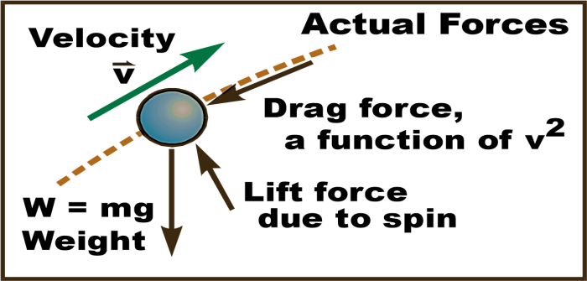

1. Actual forces on a Projectile: Drag, lift due to spin, weight, wind.
2. Are the forces on a projectile (other than weight) significant? In other words, does the ideal projectile model “fit” or not?

For low speed objects with reasonable mass, e.g. a shot put, or a baseball, tennis ball or golf ball tossed softly across a room, the ideal projectile model “fits” relatively well.

For high speed objects, e.g. a hit or thrown baseball, a well-hit golf ball or tennis ball, etc., drag and other forces are significant and our ideal model is not accurate.

For example, a well-hit home run, by ideal theory, will travel nearly 750 ft. In reality it only travels around 450 ft—a significant difference!

Light objects, e.g. a ping pong ball, feather, foam ball, etc., do not fit the ideal model very well. A relatively small drag or spin force markedly affects the ball because the ball has such low mass.

Interesting fact-------------------------------------------------------------------------------------------------------------------------------------------------------------------------------------“Ideal” Projectile: The only force is weight.(This is what we will cover in this class.)

1. Ideal Projectile: If the only force is weight, then the x velocity stays constant. The y velocity changes with time and position.

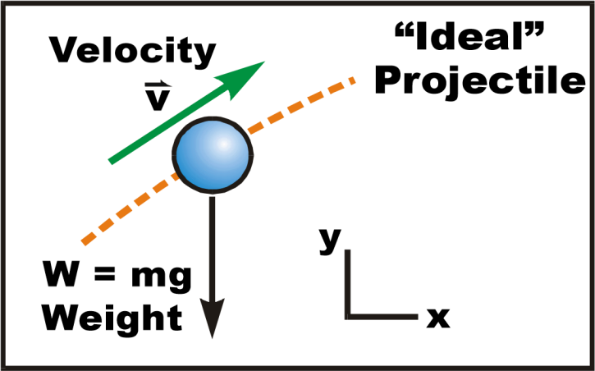

1. Ideal Projectile: If the only force is weight, then… The x velocity stays constant.

The y velocity changes with time and position.

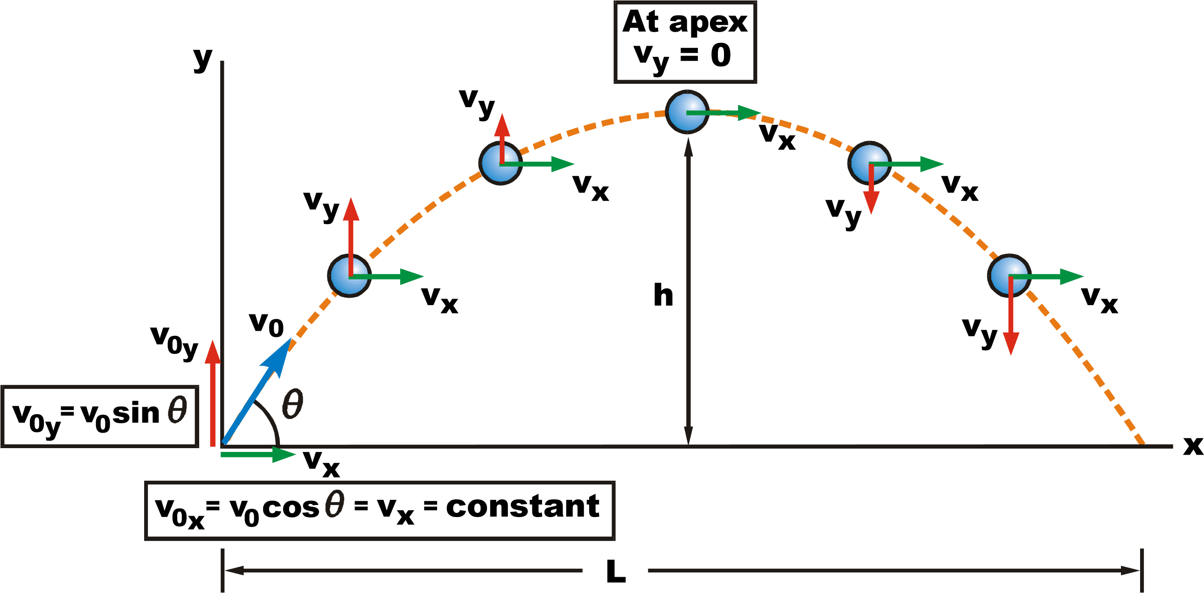

# TERMS ASSOCIATED WITH PROJECTILE

1. *Time of flight (T)* - The time of flight of a projectile is the time required for it to return to the same level from which it projected.

T= time to reach the greatest or maximum height

V = u + at (but, v = 0, a = -g)

0 = u sin – gt

t =  ------------------- 3

T = 2t =  ------------------- 4

2. *The maximum height (H)* - is defined as the highest vertical distance reached measured from the horizontal projection plane.

For maximum height H,

v2 = u2 sin2θ - 2g H

At maximum height H, v =0

0 = u2 sin2θ - 2g H

H = ------------------- 5

3. *The range (R)* - is the horizontal distance from the point of projection of a particle to the point where the particle hit the projection plane again.

Horizontally, considering the range covered

Using (where a=0 for the horizontal motion)

OR

s = R = u cosθ x T (distance = velocity x time; there time is the time of flight)

R = 

R = 

From Trigonometry function

2 sin θ cos θ = sin 2θ

R= 

For maximum range, θ = 450

Sin 2θ = sin (2 ×45) = sin 900 = 1

= 

## USE OF PROJECTILES

1.    To launch missiles in modern warfare

2.    To give athletes maximum takeoff speed at meets

In artillery warfare, in order to strike a specified target, the bomb must be released when the target appears at the angle of depression φ given by:

Tan φ =

EXAMPLES

1.    A bomber on a military mission is flying horizontally at a height of 300 m above the ground at 60kmmin-1. lt drops a bomb on a target on the ground. Determine the acute angle between the vertical and the line joining the bomber and the tangent at the instant. The bomb is released

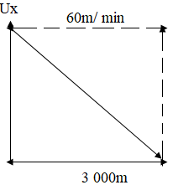

Horizontal velocity of bomber = 60kmmin-1= 103 ms-1

Bomb falls with a vertical acceleration of g = 10 ms-1

At the release of the bomb, it moves with a horizontal velocity equals that of the aircraft i.e. 1000 ms-1

Considering the vertical motion of the bomb we have

 (u=o)

 Where; t is the time the bomb takes to reach the ground:



300=1/2gt2

t2= 600

t=10√6 sec

Considering the horizontal motion we have that horizontal distance moved by the bomb in time t is given by

s =horizontal velocity x time

s = 1000 x10√6

s = 2.449x104 m

But tanθ = s = 2.449 x 104

3,000 3,000

  θ =83.02~~0~~

2. A stone is shot out from a catapult with an initial velocity of 30m at an elevation of 600. Find

a. the time of flight

b. the maximum height attained

c. the range

a. The time of flight

T = 2U sin θ

g

T= 2 x 30 sin 600

10

T= 5.2s

b. The maximum height,

H=U2 sin2 θ

2g

H = 302 sin2 (60)

20

H = 33.75 m

c. The range,

R = U2sin 2θ

g

R = 302 sin 2 (60)

10

R = 90 sin 120

R = 77.9 m

3. A body is projected horizontally with a velocity of 60 ms-1 from the top of a mast 120m above the grand, calculate

(i) Time of flight, and (ii) Range

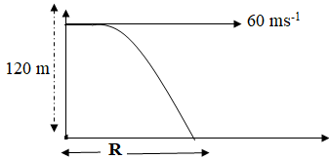

i. 







t2 = 24

t =  = 4.9s

ii. Range = uxt

R = 60 × 4.9

**R = 294 m**

4. A stone is projected horizontally with a speed of 10 ms-1 from the top of a tower 50m high and with what speed does the stone strike the ground?

**Solution**

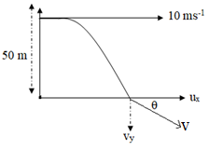

ux = 10 ms-1 [constant]

ux2= 100

vy2= 02 + 2gh

vy2= 0+ 2 × 10 × 50

vy2= 1000

vy2= 1000

vy=  ms-1

v == 

=33.17 ms-1

Magnitude of velocity =33.17 ms-1







4. A projectile is fired at an angle of 60 with the horizontal with an initial velocity of 80 ms-1. Calculate:

1. the time of flight
2. the maximum height attained and the time taken to reach the height
3. the velocity of projection 2 seconds after being fired (g = 10m/s)

θ =600; u =80 ms-1

1. 

 = 13 .86 s

1. A. 



H = 240 m

B. 

t = 6.93 s



R = = 554.3m

iii. 

vy = 80 sin 60 – 10 ×2

vy = 49.28 ms-1

ux = U cos θ

ux = 80 cos 60

ux = 40 ms-1

v == 

 = 63.41 ms-1







**CLASSWORK**

1. (a) Define the term projectile (b) mention two application of projectiles
2. A ball is projected horizontally from the top of a hill with a velocity of 30m/s. if it reaches the ground 5 seconds later, the height of the hill is
3. A stone propelled from a catapult with a speed of 50m/s attains a height of 100m. Calculate: a. the time of flight b. the angle of projection c. the range attained.

**ASSIGNMENT**

**SECTION A**

1. A stone is projected at an angle 60 and an initial velocity of 20m/s determine the time of flight (a) 34.6s (b) 3.46s (c) 1.73s (d) 17.3s (e) 6.92s
2. A stone is projected at an angle 60 and an initial velocity of 20m/s determine the time of flight (a) 34.6s (b) 3.46s (c) 1.73s (d) 17.3s (e) 6.92s
3. For a projectile the maximum range is obtained when the angle of projection is; (a) 600 (b) 300 (c) 450 (d) 900
4. The maximum height of a projectile projected with an angle of to the horizontal and an initial velocity of U is given by

(a) U sin2 θ (b) U2 sin2θ (c) U2sin θ (d) 2U2sin2θ

g 2g g g

Use this information to answer questions 5 and 6: An arrow is shot into space with a speed of 125m/s at an angle of 150 to the level ground. Calculate the:

1. Time of flight (a) 5seconds (b) 6.47seconds (c) 16.01seconds (d) 4.7seconds
2. Range of the arrow (a) 350m (b) 781.25m (c) 900m (d) 250.71

**SECTION B**

1. A gun fires a shell at an angle of elevation of 300 with a velocity of 2x10m. What are the horizontal and vertical components of the velocity? What is the range of the shell? How high will it rise?
2. (a) What is meant by the range of a projectile? (b) An object is projected into the air with a speed of 50m/s at an angle of 300 above the ground level. Calculate the maximum height attained by the object

Week: Nine and ten

Period: Six

Duration: 45 minutes per period

Subject: Further Mathematics

Class: SS 2

Topic: Operations Research II

Subtopic: Replacement Theory

Learning Objectives: At the end of the lesson, learners should be able to:

* explain the concept of inventory;
* define important terms in inventory;
* compute the optimal quantity in inventory model;
* explain the concept of replacement terms;
* identify the various types of replacement analysis;
* solve problems on replacement of sudden failure items;
* solve problems on items that wear off gradually.

Concept of Inventory

Inventory is the goods, materials, men, machines and money held available in stock by a business. It consists of usuable but idle resources. These resources include good, materials, men, machines and money.

Types of inventory

Inventory can be classified into:

(a) Raw materials

These include materials and componentsscheduled for use in making a product.

(b) Materials and components   
These are the goods in the process of being transformed to finished goods.

(c) Finished goods   
These are goods ready for sale to customers.

(d) Goods for resale

These are returned goods which are saleable.

Reasons for keeping stock

Stocks are kept for the following reasons:

Time

The time lag in the supply chain from the supplier to the end-user at every stage requires that certain amounts of inventory to be used be maintained in the lead time. A practical way of addressing lead time which is the time lag in the supply chain from the supplier to the end-user, can be addressed by ordering ahead of time.

Uncertainty

Inventories serve as buffers to meet uncertainties in demand, supply and movement of goods.

Economics of scale

Bulk purchasing , movement and storing ensures economies of scale.

The principle of "one unit at a time at a place", although an ideal condition tends to incur lots of costs in logical terms.

Inventory Control

It is the supervision of supply, storage and accessibility of items in order to ensure adequate supply without excessive over supply.

Benefits of inventory/stock control

(a) It ensures availability of the right amount of stock at the right at the right place.

(b) It ensures that the capital is not tied down unnecessarily.

(c) It protects production if problems arise in the supply chain.

Types of stocks

Stock is everything used in making products, providing services and running a business. Stocks include:

(a) raw materials and components which are ready for use in production;

(b) unfinished goods in production;

(c) finished goods ready for sale;

(d) consumables e.g. fuel and stationary.

Definitions of Terms in Inventory Model

Ordering quantity

Ordering quantity designated D is the amount or size of stock ordered at a specified time.

Average stock

The average stock is half of the ordering quantity i.e. D/2

Ordering frequency

It is the time rate at which stock is ordered.

Ordering cost

-------------------------------------------------------------------------------------------------------------------------------------------------------------------------------------------------------------------------------------

Stock holding cost

Also known as holding cost is the cost of keeping the average stock for a specified time, it is expressed as a percentage of the value of the stock.

Economic Ordering Quantity (EOQ)

The economic ordering quantity (EOQ) is the quantity that sets the holding cost and ordering cost at equilibrium.

It is the quantity of stock that must be ordered in order to minimize total variable cost.

The economic order quantity model is formulated as follows :

D = Annual demand quantity

Q* = Optimum order quantity

P = Purchase cost per unit

C = Fixed cost per order

H = Holding cost per unit ( carrying cost or storage cost)

V = Total Variable cost

Where

Q* = 

Ordering cost = 

Holding cost = 

Number of order = 

Variable Cost = Holding cost + Ordering cost

Total cost per annum = Purchasing cost + Variable cost

Example 1: A factory demands 10000 units of stock annually. The cost per unit order is N320 and the cost per unit of stock is N100. If the holding cost is 10% of the stock value, calculate the:

(a) economic order quantity

(b) amounts of orders per annum

(c) total variable cost per annum

(d) total cost per annum.

Solution

(a) Q* = 

= 

= 800 units

(b) Amount of orders = 

= 

= 

= 12.5

(c) Total Variable cost = Ordering cost + Holding cost

=  = 

= N8000

(d) Total cost per annum = Purchasing cost + Variable cost

= 100 x 10000 + 8000 = N1008000

Ticket Out

Page 320, Ex 17, nos. 1 and 2

Concept of replacement model

When machines or equipment is used for a long period of time, the item deteriorates as a result of wear and tear. There is a need to bring the item to its original state of production. This need necessitates the replacement of such item.

The problem of replacement is to find the right time when a remedial action should be taken which will minimize some measure of effectiveness. Also technical or economic obsolescence may make it imperative for us to make a replacement of the machine or equipmernt.

Types of replacement analysis

In our analysis of replacement model, we shall consider two major types namely:

(i) replacement of items with gradual deterioration:

(ü) replacement of items that fail completely and suddenly.

Replacement of items with gradual deterioration

Practical examples of items with gradual deterioration are vehicles and machinery. These items undergo wear and tear with the passage of time. The operation and maintenance costs tend to increase year by year. It gets to the stage where the maintenance cost becomes too large that it is better and economical to replace the machinery or equipment with a new one.

In assessing the opportuned time to replace the item, we take into consideration, the salvage value of the item which is the estimated value that the item will realize upon its sale at the end of its useful life.

If we assume zero interest rate for the money or capital, we can make a comparison on the basis of an average cost. The total cost of the capital in owning and operating the item is accumulated for n years and we divide this total by n.

If the costs for various vears are discrete, we can use the tabular method to do the analysis.

Example 3

The operational costs, the maintenance costs and the resale prices of a motorcycle for five consecutive years are shown in the table below.

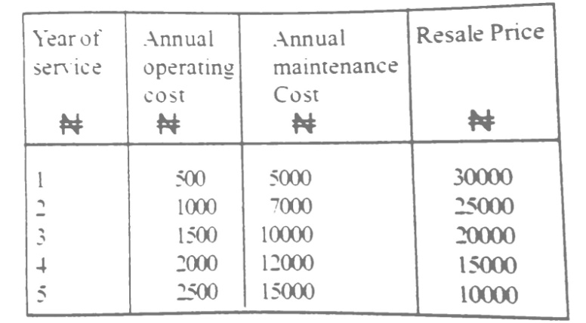

If the initial cost of the motorcycle is #80.000, determine the best time to purchase a new motorcycle.

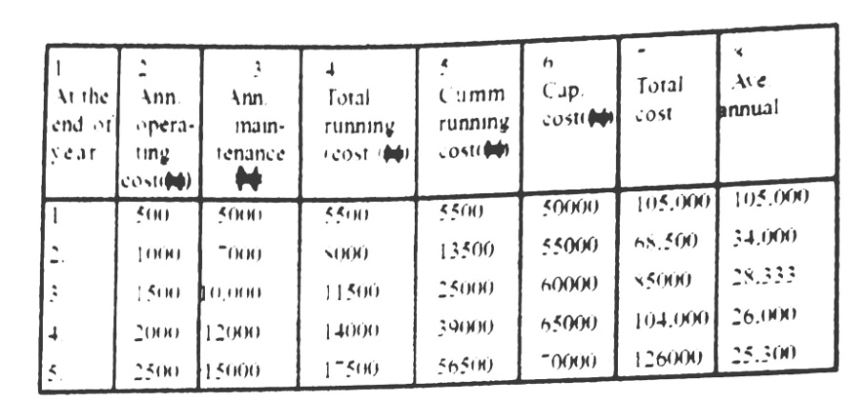

The table above gives the detailed analysis for finding the appropriate time to replace the motorcycle.

The cumulative running cost is shown in column 5 of the table.

The capital cost is equal to the initial value of the motorcycle resale price i.e. N80000

The average annual cost is calculated in column 8 of the table.

From the table, it is evident that the average annual cost ( N25,300) is least at the end of five years. Hence. this is the best time to replace the motorcycle.

Ticket Out

Page 320, Ex 17, nos. 7 and 8