

**LAGOOZ SCHOOLS**

**SECOND TERM**

**LEARNER’S E-NOTE**

**SUBJECT: PHYSICS**

**CLASS: SS1**

**SECOND TERM SCHEME OF WORK**

|  |  |
| --- | --- |
| **WEEK** | **TOPICS** |
| **1** | **Particulate nature of matter – evidence of the particulate nature of matter, structure of matter. State of matter.** |
| **2** | **Elastic properties - Hooke's law , Young's modulus, Work done** |
| **3** | **Fluid at rest and in motion - surface tension capillary, cohesion and adhesion, viscosity** |
| **4** | **Equilibrium of forces – Resultant and Equilibrant force, Moments of Forces, Centre of gravity and Stability** |
| **5** | **Equilibrium of bodies in liquids and gases – Archimedes and Principle of Floatation** |
| **6** | **Newton’s Laws of Motion, Linear momentum and Impulse** |
| **7** | **Mechanical Energy - Simple Machines** |
| **8** | **Projectiles Motion** |
| **9** | **Circular Motion** |
| **10** | **Simple Harmonic Motion** |
| **11** | **Revision** |
| **12** | **Examination** |

**WEEK 1**

**TOPIC: PARTICULATE NATURE OF MATTER**

**REFERENCE BOOK: NEW SCHOOL PHYSICS FOR SENIOR SECONDARY SCHOOL BY M.W. AYANKOHA**

**LEARNING OBJECTIVES: by the end of the lesson, learners should be able to**

* **Explain Brownian motion, diffusion and osmosis**
* **Explain the structure of matter**
* **Calculate the size of a molecule**
* **Explain the three states of matter**

Matter is anything that has mass and can occupy space. Ancient Greek philosophers and scientists postulated that all matter are composed of very minute (tiny) particles called atoms.

The kinetic theory of matter also known as the atomic theory of matter assumes that all matter consists of tiny particles called atoms which are always in motion. The fact that these particles are always in motion suggest that they have kinetic energy. The kind of motion exhibited by the particles depends on the temperature of the matter and some other factors.

The particulate nature of matter is based on the following evidence:

1. Brownian motion
2. Diffusion
3. Osmosis

**BROWNIAN MOTION**

In 1827, Robert Brown, a botanist used a microscope to observe pollen grains suspended in water. He observed that the pollen grains were constantly moving in an irregular manner in all directions even though the water appeared to be perfectly still. The haphazard motion of the pollen grains was as a result of collisions between the water molecules and the pollen grains. The water molecules themselves were in constant rapid motion although they were too small to be seen under the microscope. Brownian motion is defined as the rapid, constant and irregular motion of tiny particles. Brownian motion can be observed experimentally in the smoke cell experiment.

**DIFFUSION**

Diffusion is a process whereby molecules migrate and fill an empty space due to their continuous motion. If perfume is sprayed at one end of a room, someone at the other end perceives the smell almost immediately. The molecules of the perfume has diffused through the air to fill the surrounding space. Diffusion occurs in solids, liquids and gases. The rate of diffusion is higher in gases than in liquids because the molecules in gases move faster than those in liquids. Diffusion occurs at an extremely slow rate in solids.

Diffusion in liquids can be demonstrated by dropping some blue crystals of copper (ii) tetraoxosulphate (vi) at the bottom of a tall cylinder containing water. A dense blue solution forms at the bottom of the cylinder but the water above this solution still remains clear. If the cylinder is now put away where it will be undisturbed, after some days, it will be observed that the blue colour has spread randomly throughout the liquid through the process of diffusion. The factors affecting the rate of diffusion are mass, temperature, density and state of matter.

**OSMOSIS**

Osmosis is the process by which when two solutions of different concentrations are separated by a semi permeable membrane, the molecules of the solvent pass through the semi permeable membrane from the weaker solution to the stronger solution. A semi permeable membrane is a membrane that allows molecules of solvent e.g. water to pass through it but not molecules of the substance dissolved in the solvent (solute).

**ATOMIC STRUCTURE**

An atom is the smallest part of an element which can take part in a chemical reaction.

According to Lord Rutherford, an atom consists of a heavy centre called the nucleus with electrons orbiting the nucleus just as the planets move round the sun in orbits. The nucleus of an atom houses heavy particles called protons and neutrons. The particles that make up the atom are thus: protons, neutrons and electrons.

The proton is positively charged and has a relative mass of 1. Neutrons have a relative mass of 1 but they carry no electric charge i.e. they are electrically neutral. Electrons are very light, having a relative mass of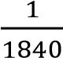. The electron is negatively charged. The protons and neutrons which are found in the nucleus of an atom are collectively known as nucleons.

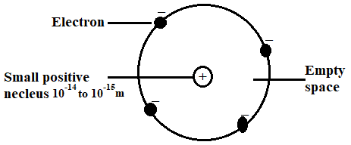

The atom is electrically neutral because the number of protons in an atom is equal to the number of electrons. If an atom loses or gains one or more electrons, it will carry a net charge. Such an atom is called an ion.

**MOLECULES**

A molecule is the smallest particle of a substance which can have a separate existence and still retain the properties of that substance. The molecule is too small that it cannot be seen with a microscope. Atoms are even smaller. Molecules are formed when atoms of the same or different elements combine in a simple or compound proportion.

**ESTIMATING THE SIZE OF A MOLECULE**

Fill a shallow tray to the brim with water and sprinkle lycopodium powder lightly on it. Use a dropper to form a drop of oil and carefully measure its diameter using a rule and a lens. Place the oil drop on the on the surface of the water, the oil spreads and pushes the lycopodium powder outwards to form a clear oil film on the water surface. This film is one molecule thick. Measure the diameter of the oil film. This represents the diameter of the oil molecule. Let the volume of the oil drop be V (cm3)

Area of oil film = 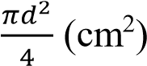

Thickness of oil film,

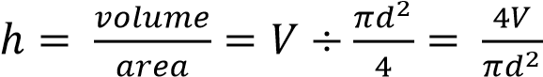

Accurate experiments lead to a value of about 2 × 10−7𝑐𝑚 as the thickness of the oil film.

The size of an oil molecule is hence estimated to be about 2 × 10−7𝑐𝑚.

**STATES OF MATTER**

Matter can exist in three states namely solid, liquid and gas.

Solids are rigid and have definite shapes. Liquids have no shape; they take the shape of their container. Gases have no shape and volume. They occupy the entire volume of their container. Gases can easily be compressed while solids and liquids are almost incompressible. When a solid is sufficiently heated, it melts and turns into a liquid and when a liquid is sufficiently heated, it changes to vapour.

The kinetic molecular theory explains the states of matter as follows:

**SOLID**

In solids, molecules are closely packed and held together by strong intermolecular forces. These forces restrict the movement of the molecules so that they are held in fixed positions and the molecules can only vibrate or oscillate about their mean position. Because of this, the solid is rigid and have a definite shape. The molecular structure of a solid can collapse when it is sufficiently heated. When this happens, the solid changes into liquid. The temperature at which this happens is known as the melting point of the solid.

**LIQUID**

In liquids, the molecules are not held in fixed positions and the molecules are free to move about because the attractive forces between them are weaker than those in solids. The molecules are still closely packed together and they also vibrate. They are also able to undergo translational motion. If the liquid is sufficiently heated, the molecules gain kinetic energy and escape into the atmosphere where they exist as gases.

**GAS**

In gases, the molecules are far apart and move randomly in all directions with high speeds. They quickly fill the vessel into which they are contained. Since the gas molecules are far apart, they can be readily compressed, unlike solids and liquids which are incompressible.

Gas molecules collide with one another and with the walls of the containing vessel. These collisions with the walls of the container constitute the pressure of the gas.

It should be noted that of the three states of matter, gases have the weakest intermolecular forces and hence their molecules have the highest kinetic energy.

**EVALUATION**

* **Explain Brownian motion, diffusion and osmosis**
* **Explain the structure of matter**
* **Calculate the size of a molecule**
* **Explain the three states of matter**

**ASSESSMENT**

Reference: New School Physics, page 93, Exercise 8

**TICKET OUT**

Reference: New School Physics, page 93, Exercise 8

**WEEK 2**

**TOPIC: ELASTIC PROPERTIES OF SOLIDS**

**REFERENCE BOOK: NEW SCHOOL PHYSICS FOR SENIOR SECONDARY SCHOOL BY M.W. AYANKOHA**

**LEARNING OBJECTIVES: by the end of the lesson, students should be able to:**

1. **state Hooke's law of elasticity**
2. **explain Young's modulus**
3. **solve simple problems on Hooke's law and Young Modulus of elasticity**
4. **explain potential energy**
5. **explain elastic potential energy**
6. **solve simple problems on elastic potential energy**

**REFERENCE BOOK: New School Physics for SSS by M.W. Anyakhoha. African First Publisher,**

**ELASTIC PROPERTIES OF MATERIALS**

When a material is stretched by a force, its size or shape may change. The larger the force applied, the greater the deformation. Some materials can regain their original shape or size when the straining force is removed. Such materials are called Elastic Material.

Elasticity is the ability of a material to return to its original shape and dimension upon removal of the applied force.

Elastic properties of materials are very useful in many applications. The application of this property of materials includes spring balance of a clock, spiral spring used in the shock absorber of cars, materials for bridges, etc are shooting of stones and in a catapult.

**ELASTICITY**

The ability of a material to return to its original shape and dimension upon removal of the applied force. This ability varies from one material to another.

**HOOKE'S LAW**

Hooke's law states the extension made by an elastic material is proportional to the applied force (load), provided the elastic limit is not exceeded.



Hooke's law can be written as

**F = k e**,

Where

**F** is **Force (in N)**,

**e** is **extension (in m)**; and

**k** is the **Stiffness Constant** or **Elastic Constant** or **Force Constant** of the material.

The stiffness constant describes the stiffness of a material, and is measured in **Nm-1 (or Kgs-1)**. Hooke's law can be demonstrated with the use of Force-Extension (**fig a**) or Extension-Force graphs (**fig b**)

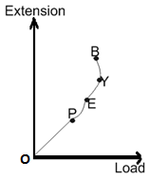 

Where,

**P = Proportionality Limit**

**E = Elastic Limit**

**Y = Yield Point**

**OE = Elastic Region**

**EB = Plastic Region**

**B = Breaking Point**

No solid follows Hooke's law indefinitely, there comes a point, called the **PROPORTIONALITY LIMIT**, where there is no longer a linear relationship between force and extension.

When more force is applied, the **ELASTIC LIMIT** will be reached. This means that the solid will no longer return to its original shape when the force ceases to be present.

Eventually, the force will become so greatthat the material snaps. This is called the **YIELD POINT.**

Before the **ELASTIC LIMIT** is reached, the solid is experiencing **Elastic Deformation**, where it will return to its original shape when the load (force) has been removed. However, once the material passes that point, it experiences **PLASTIC DEFORMATION,** where its shape is permanently changed.

**Stiffness or force constant**

The Stiffness or Force constant of an elastic material is the force required to give a unit extension.



The unit is **Nm-1**.

**HOOKE’S LAW EXAMPLE PROBLEM**

1. A force of 0.8 N stretches an elastic material by 2 cm. Find the elastic constant of the spring.

**SOLUTION**

From Hooke’s law, **F = k e**

**F = 0.8 N,**

**;**



1. **A** force of 2 N stretches an elastic material by 30 mm. what additional force will stretch it by 35 mm? Assume that the elastic limit is not exceeded

**SOLUTION**

**e1** 

**e2**  **,**

**F1 = 2 N**



**F2 = k x2 =** 

**Therefore, additional force = 2.33 - 2 = 0.33 N**

1. A spiral spring extends by 5 m under a load of 60 N. When the load is replaced by a steel block, the new extension is 7 m, the weight of the steel block is

**Solution**

**From Hooke's law**











**k= 12 Nm-1**

**Again,**

**F = ke**

**k = 12 Nm-1,**

**e =7**

**F = 12 x 7 = 84 N**

Therefore, Weight of the block = **84 N**

**YOUNG'S MODULUS**



Strain is defined as the ratio of force (F) to area (A)

**.** The SI unit of stress in Newton per square metre (Nm-2)

**. Strain has no unit.**

Therefore,  the SI unit of Young's modulus is **Nm-2.**

**Since the unit** **of stress** is **Nm⁻² and strain has no unit, then the unit of Young's modulus is Nm⁻².**

**Example**

Determine Young’s modulus, when 2N/m2 stress is applied to produce a strain of 0.5.

**Solution:**

Stress, = 2 **Nm-2**

Strain, = 0.5

**Nm-2**

**ENERGY STORED IN A STRETCHED MATERIAL**

Whenever an elastic material is stretched, work is done on the material. This work is stored in the material as potential energy. For instance, when you stretch a catapult it has potential energy, which can throw a stone.

The stored potential energy is thereby converted to the kinetic energy of the stone.

**WORK DONE BY ELASTIC MATERIALS**

The work done in stretching or compressing a spring or rubber from its original length **l0** by an extension **e** is given as:

Work done = average force × extension



**But from Hooke’s law,**

**F = k e**

**Therefore,**







**ELASTIC POTENTIAL ENERGY**

What is elastic potential energy? This is the energy that an object has in it due to being deformation of its shape. Any object which can be deformed and then return to its original shape, then it can have elastic potential energy. Examples of such objects are rubber bands, sponges, and bungee cords, and many others.

**ELASTIC POTENTIAL ENERGY**

The elastic potential energy or energy stored in an elastic bar or spring is equal to the work done in stretching the bar by an extension **e**.

**Elastic potential energy =** 

Therefore, when Hooke's law is obeyed, the work done is the area under the force vs extension plot.

**Worked examples**

1. A spring is stretched 40mm by a force of 15 N. What is the work done by the force?

**Solution**

**W = ½ Fe**

**e = 40 mm = 0.04 m [divide by 1000]**

**F= 15 N**

**W= ½ X 15 x 0.04**

**W = 0.3J**

1. If a force of 8 N extends a spring by 0.4 m. Calculate the force constant of the spring and the energy stored in the spring

**Solution**

**F = 8 N,**

**e = 0.4m**

**F = ke**





**k = 20 Nm-¹**

**Energy stored**

**= ½ ke²**

**= ½ ˣ 20 x 0.4²**

**= 1.6 J**

1. A rubber band of length 20 cm has a load of 10 N tied to one end while suspended freely at the other end. If the length of the band now increases to 25 cm, calculate the stiffness of the rubber band. What will be the new length when a load of 15 N is suspended from its end?

**Solution**

**Extension = new length - original length**

1. **e = l₁ - l₀**

**= 25 cm - 20 cm = 5 cm**

**Force = 10N**

**F = ke**

**10 = k x 5 cm**

**k = 2N cm-¹**

1. **e = l₂ - l₀**

**F = ke**

**15 = 2(l₂ - 20)**

**= l₂ - 20**

**7.5 = l₂ - 20**

**l₂ = 7.5 + 20 = 27.5 cm**

**The new length is 27.5cm**

1. A force of 2 N stretches an elastic material by 30 mm. What additional force will stretch the material to 35 mm? Assume that the elastic limit is not exceeded.

**Solution**

**From Hooke's law**

F = 2 N,

e = 30 mm = 0.03 m (divide by 1000)

F= ke

k  = = 66.67 Nm⁻¹

let the force stretching the material **35 mm** be:

**F = k e**

e = 0.035 m

F = 66.67 x 0.035

F= 2.33 N

Therefore additional force = 2.33 N - 2.00 N = 0.33 N

1. The force-extension graph of an elastic wire subjected to a certain force is as shown in Figure. From the graph calculate the work done in stretching the wire.

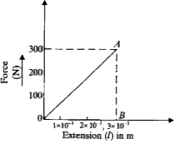

**Work done = area of ∆OAB**

**= ½ × AB × OB**

**= ½ × 300 × 3 x 10-3**

**= 0.45 J.**

**EVALUATION**

1. **state Hooke's law of elasticity**
2. **explain Young's modulus**
3. **solve simple problems on Hooke's law and Young Modulus of elasticity**
4. **explain potential energy**
5. **explain elastic potential energy**
6. **solve simple problems on elastic potential energy**

**ASSESSMENT**

Reference: New School Physics, page 100, Exercise 9

**TICKET OUT**

Reference: New School Physics, page 100, Exercise 9

**WEEK3**

**TOPIC: FLUID AT REST AND IN MOTION**

**REFERENCE BOOK: NEW SCHOOL PHYSICS FOR SENIOR SECONDARY SCHOOL BY M.W. AYANKOHA**

**LEARNING OBJECTIVES: by the end of the lesson, students should be able to:**

1. **explain surface tension and state some applications of surface tension**

* **explain capillarity and differentiate between cohesion and adhesion**
* **explain angle of contact and give examples of capillarity in nature.**
* **explain viscosity and terminal velocity**

**SURFACE TENSION**

**Surface tension** is the force acting along the surface of a liquid, making the liquid surface to act like a stretched elastic skin.

The cohesive forces between liquid molecules are responsible for the phenomenon known as surface tension. The molecules at the surface do not have other like molecules on all sides of them and consequently they cohere more strongly to those directly associated with them on the surface. This forms a surface "film" which makes it more difficult to move an object through the surface than to move it when it is completely submersed.

**APPLICATIONS OF SURFACE TENSION**

1. Small insects such as the water strider can walk on water because their weight is not enough to penetrate the surface.
2. A carefully placed small needle can be made to float on the surface of water even though it is several times as dense as water.
3. Common tent materials are somewhat rainproof in that the surface tension of water will bridge the pores in the finely woven material. But if you touch the tent material with your finger, you break the surface tension and the rain will drip through.
4. Soaps and detergents help the cleaning of clothes by lowering the surface tension of the water so that it more readily soaks into pores and soiled areas.
5. Washing with cold water: The major reason for using hot water for washing is that its surface tension is lower and it is a better wetting agent.
6. Why bubbles are round: The surface tension of water provides the necessary wall tension for the formation of bubbles with water. The tendency to minimize that wall tension pulls the bubbles into spherical shapes.
7. Surface tension and droplets: Surface tension is responsible for the shape of liquid droplets. Although easily deformed, droplets of water tend to be pulled into a spherical shape by the cohesive forces of the surface layer.

**REDUCTION OF SURFACE TENSION**

Surface tension can be reduced through one of the following ways:

1. By adding detergent / soap to the water

2. By adding camphor to the water

3. By adding oil to the water

4. By adding alcohol to the water

5. By boiling the water

6. By using kerosene

7. By using grease.

**HOW TO CALCULATE SURFACE TENSION**

Mathematically, surface tension can be expressed as T= F/L

F is the force per unit length

L is the length in which force act

T is the surface tension of the liquid

The SI unit of Surface Tension is Newton per Meter or Nm-1.

**EXAMPLE:**

1. Compute the surface tension of a given liquid whose dragging force is 7 N and length in which the force acts is 2 m?

**Solution**:

**Given,**

**F = 7N**

**L = 2m**

According to the formula,

**T = F**

**L**

**⇒ T = 7**

**2**

**⇒ T = 3.5 Nm-1**

1. Calculate the surface tension of a given liquid whose dragging force is 14 N and length in which the force acts is 5 m.
2. The surface tension of a given liquid is 2 Nm-1 and length in which the force acts is 5 cm. What is the drag force acting on it?
3. The surface tension of a given liquid 20 Nm-1 whose dragging force is 5 N. Find the length in which the drag force acts.

**CAPILLARITY**

Capillarity (or capillary action) is the tendency of a liquid to rise or fall in a narrow tube.

**Demonstration of Capillary Action**

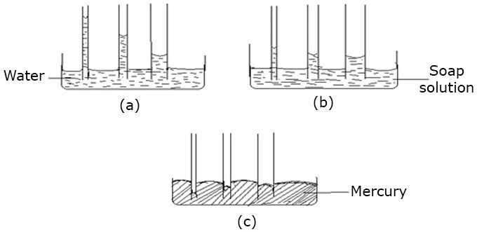

Dip three capillary tubes with fine bores but with different diameters into clean water as in the figure above. You will observe that the water rises in the tubes but the narrower the bore the greater the height to which the water rises.

Repeat the experiment with soap solution. You will observe a similar situation except that the heights of soap solution are lower than in the case of water.

Repeat the experiment again with mercury. You will observe that the level of mercury falls in the three tubes. The mercury level is depressed below the level of mercury outside the tubes (i.e. in the container). Again the narrower the tube the lower the level of mercury.

**EXPLANATION OF CAPILLARITY**

The meniscus of water or soap solution is curved upwards (concave) because the adhesion of water and soap solution to glass is greater than the cohesion of water or soap. Therefore water or soap solution wets the glass tube and so spreads a thin film of water/soap solution on the inner surface of the tube. The adhesive forces thus force the water (soap solution) to creep up the inside of the tube. The water/soap solution is held up as it creeps by surface tension forces acting around the circumference of the meniscus. The water/soap solution thus keeps rising in the tube until the weight of the column of water/soap solution balances the surface tension acting at the top of the column.

In the case of mercury the cohesion of mercury molecules which is greater than the adhesion of mercury to glass causes the mercury level to be depressed in the tube. The surface tension forces acting around the circumference of the tube holds down the mercury column as it is depressed by cohesive forces of the mercury molecules. The depression continues until the weight of the mercury column in the tube is equal to the surface tension.

**COHESIVE AND ADHESIVE FORCES**

**Force of cohesion** is the force of attraction existing among molecules of the same substance while **force of adhesion** is the force of attraction that exists between molecules of different substances. These forces can be used to explain why water wet glass and mercury does not.

The **force of adhesion** of water molecules to glass molecules is stronger than the **force of cohesion** of water molecules. This makes water to wet glass when it is spilled on it.

The **force of cohesion** of mercury molecules is greater than the **force of adhesion** between mercury and glass molecules. Hence, when mercury is spilled on glass, it does not wet the glass but forms spherical droplets. For the same reason, the water surface in a glass vessel is convex i.e curves downward while the mercury in a glass vessel is concave (it curves upward).

Cohesion and adhesion

**ANGLE OF CONTACT**

Angle of contact is the angle measured through the liquid between the wall of the container and the tangent to the meniscus, which could be concave or convex depending on the nature of the liquid. Angle of contact depends on the cleanliness and neatness of the glass wall of the capillary tube. The diagram below shows angle of contact for a capillary tube dipped vertically in water and mercury.

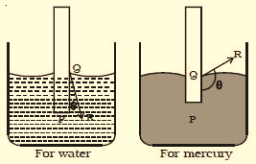

**EXAMPLES OF CAPILLARITY ACTION ARE;**

1. the action of blotting paper
2. the rising of oil in the wick of a lamp through the spaces between the common threads which make up the wick.
3. the absorption of water by a towel.
4. the rising of water in soil composed of fine particles.
5. the rising of liquid wax up the wick of a candle.
6. the rising of water up the stem of a plant.
7. the flow of blood through the fine capillary channels in the body.

**FACTORS THAT AFFECT CAPILLARITY ARE:**

1. intermolecular forces (Adhesion and cohesion)
2. temperature
3. density of liquid
4. size of the tube
5. pressure

**VISCOSITY**

Viscosity simply means friction in fluids.

It is observed that it is easier to pour water or kerosene from a container than to pour honey or engine oil. A little stone dropped into a cylinder of water gets to the bottom of the cylinder faster than when the same stone is dropped into a cylinder containing engine oil or glycerin, we can also draw inference from the time of movement of a teaspoonful of castor oil through your throat to that of a teaspoonful of water.

These differences are due to the property of viscosity in these liquids.

Viscosity is the internal friction between layers of a liquid or gas in motion. Liquids which pour slowly are said to be more viscous than those which pour faster. Hence very cold thick palm oil is more viscous than very cold water.

The movement of one layer of fluid over a neighboring layer is opposed by viscous forces.

Also when a stone or a ball bearing is thrown down a cylinder of a viscous fluid, the downward motion of the body is opposed by the viscosity of the liquid. The opposition to the movement of the stone is a function of the viscosity of the fluid and hence the slower its motion.

Viscosity is denoted by **η**, measured in **Nsm-2** (SI Unit) and it is a vector quantity.

**Thus,** 

**EFFECTS Of VISCOSITY**

1. It is responsible for the different rates of flow of fluids.
2. It affects motion of bodies in fluids.

**TERMINAL VELOCITY**

When a stone falls through a viscous fluid, it is subject to three forces: its weight (**W**) acting downwards, the upthrust (**U**) of the liquid on the stone acting upwards and the viscous force (**V**) opposing its motion. The viscous force acts opposite to the motion of the stone, i.e. upwards.

We can therefore write the equation of motion of the stone as

**W - V- U = ma**

Where **a** is the acceleration of the stone through the liquid, and **m** is the mass of the stone. The viscous force **V** increases with the speed of the stone. So as the stone falls faster and faster through the liquid, the viscous force increases until it reaches a maximum speed, the viscous drag, balances the downward force of the weight of stone.

At this point the stone moves with constant velocity because its acceleration, **a**, is now zero.

**Hence our equation becomes**

**W - V - U = 0**

**Or**

**V = W -U**

This **constant velocity** is termed the ***terminal velocity*.**

***Terminal velocity*** is the maximum velocity of an object when the viscous force acting on it is equal to the apparent weight of the object in the fluid.

It can also be defined as the maximum velocity of an object when there is no net force acting on the object. T

**EVALUATION**

**ASSESSMENT**

Reference: New School Physics, page 109, Exercise 11

**TICKET OUT**

Reference: New School Physics, page 109, Exercise 11

**WEEK4**

**TOPIC: EQUILIBRIUM OF FORCES**

**REFERENCE BOOK: NEW SCHOOL PHYSICS FOR SENIOR SECONDARY SCHOOL BY M.W. AYANKOHA**

**LEARNING OBJECTIVES:** by the end of the lesson, students should be able to:

1. Define equilibrium of forces and differentiate between resultant and equilibrant forces.
2. State the conditions for equilibrium of a body.
3. State the principle of moment
4. Explain centre of gravity and state tate the center of gravity for different types of objects.
5. Explain the three types of equilibrium and state tate the effects of CG on stability of objects.
6. Solve simple problems involving equilibrium.

**EQUILIBRIUM OF FORCES**

A body is said to be in equilibrium if the resultant (sum) of all forces acting on it is zero.

**Concurrent:** forces are forces that pass through the same point.

**Resultant:** A resultant force is that single force that act alone and has the same effect in magnitude and direction as two or more forces acting together.

**Equilibrant:** An equilibrant force is a single force which will balance all other forces taken together. It is equal in magnitudes but opposite directions to the resultant force.

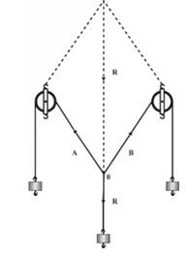

From the force board experiment, the resultant **R** of two forces A and B acting at point 0, is found using the parallelogram method. It is found to be equal in magnitude but opposite in direction to the third force. This third force which is equal in magnitude but opposite in direction to the resultant force is called equilibrant force. This means that when the sum of the 3 vectors is zero, the resultant of any two has a magnitude equal to the magnitude of the third one, and a direction opposite to direction of that third one.

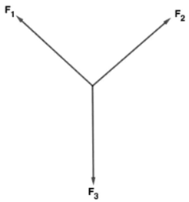

If **F1**, **F2** and **F3** are in equilibrium, **F1** is the equilibrant of **F2** and **F3, F2** is the equilibrant of **F1** an**d F3, F2** is the equilibrant of **F1** and **F3**.

**MOMENT OF A FORCE**

When taps are opened, a turning effect of force is experienced, likewise, when doors are opened, the applied force brings about a turning effect about a point or hinges attached to the wall of the door. The turning effect experienced in each case is called moment of a force.

Moment of a force about a point is the product of the force and the perpendicular distance from the line of action to the point or pivot.

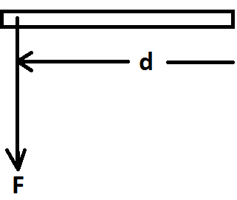

**Moment = Force x Perpendicular distance of pivot to the line of action of the force.**

***Its unit is Newton metre (Nm), hence, it is a vector quantity***

**COUPLE**

A **couple** is a pair of forces, equal in magnitude but opposite in direction, whose lines of motion do not coincide.

**Torque (Moment of a couple**) is the product of one of the forces and the perpendicular distance between their lines of action of the forces.

**Moment of couple = F × d**

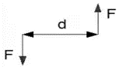

**PRINCIPLE OF MOMENTS**

The Principle of Moments states that when a body is in equilibrium, the total clockwise moment about a point equals the total anticlockwise moment about the same point.

Some of applications of torque or moment of couple include;

1. The easiness to turn a tap on or off
2. It is easier to turn a steering wheel of a vehicle by couple using the two hands
3. The wind vane
4. Spinning to

**EQUILIBRIUM OF PARALLEL FORCE SYSTEM**

**Conditions for Equilibrium of Parallel Coplanar Forces**

The sum of all the forces is zero.

**ΣF=0**

The sum of moment at any point O is zero.

**ΣMO=0**

**EQUILIBRIUM OF NON-PARALLEL COPLANAR FORCES**

There are three equilibrium conditions that can be used for non-concurrent, non-parallel force system.

The sum of all forces in the x-direction or horizontal is zero.

**ΣFx=0** **or ΣFh=0**

The sum of all forces in the y-direction or vertical is zero.

**ΣFy=0 or ΣFv=0**

The sum of moment at any point O is zero.

**ΣMO=0**

**CENTRE OF GRAVITY AND STABILITY OF OBJECTS**

**Centre of gravity of a body is the point at which the total weight of a body appears to act.**

**OR**

**Centre of gravity of a body is the point at which the total weight of a body appears to pass through.**

**Centre of mass of a body is the point at which the total mass of a body appears to pass through.**

**For a person standing upright, the centre of gravity is roughly in the middle of the body, behind the navel.**

**CENTRE OF GRAVITY FOR SOME REGULAR OBJECTS**

**For a uniform circular ring, it is at the centre**

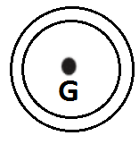

**For a circle it is at the center**



**For a rectangle it is at the point of intersection of its diagonals**

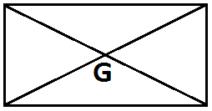

**For a uniform meter rule it is at the 50 cm mark**

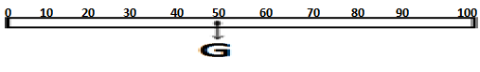

**FINDING THE CENTRE OF GRAVITY AN IRREGULAR OBJECT (LAMINA)**

1. Small holes are made round the edge of the irregularly shaped object.
2. A pin is put through one of the holes and held firmly in a clamp and stand so the object can swing freely.
3. A length of string is attached to the pin. The other end of the string has a heavy mass attached to it. This arrangement is called a plumb line.
4. The object will stop swinging when its centre of gravity is vertically below the point of suspension.
5. A line is drawn on the object along the vertical string of the plumb line.
6. The centre of gravity must lie on this line.
7. To find the position of the centre of gravity, the process is repeated with the object suspended from different holes.
8. The centre of gravity will be at the point of intersection of the lines drawn on the object.

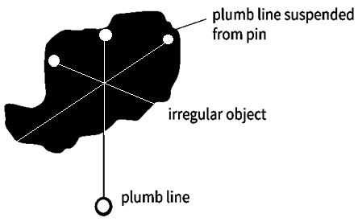

**STABILITY**

**There are three types of equilibrium, namely;**

**Stable Equilibrium**: A body is in stable equilibrium if it comes back to its normal position on slight displacement. A body in stable equilibrium

1. Has a low CG
2. A broad base.

**Examples**

1. A ball inside a bowl.
2. A book lying on a horizontal surface
3. A cone resting on it base.
4. A racing car.

**Unstable equilibrium: A** body is in unstable equilibrium if it does comes back to its normal position on slight displacement. A body in unstable equilibrium

1. Has a high CG
2. A narrow base.

**Example**

1. Pencil standing on its point or a stick in vertically standing position.
2. thin rod standing vertically
3. Vertically standing cylinder
4. A ball at the top of a round bowl
5. A cone resting on it apex

**Neutral equilibrium**: If a ball is pushed slightly to roll, it will neither come back to its original nor it will roll forward rather it will remain at rest.

**Examples**:

(1) A ball on a flat surface.

**EFFECTS OF CG ON STABILITY OF AN OBJECT.**

1. The position of the center of gravity of an object affects its stability. The lower the CG, the more stable the object. The higher it is the more likely the object is to topple over if it is pushed.
2. The body always try to go the lowest point for the center of gravity. So if the center of gravity is tilted above on displacement from equilibrium position, then the body will come back to lowest point. So equilibrium would be stable. If the center of gravity is tilted below on displacement from equilibrium position, then the body will not come back to normal position. So equilibrium would be unstable. This looks to be very clear from example ball in the bowl.

**WORKED EXAMPLES**

* A metal frame weighing 40N is hung on a nail using two ropes as shown. Find the tension in the rope.

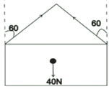

**Solution**

Solution Resolving in vertical direction, ∑Fy= 0

Tcos60° + Tcos60° - 40N = 0

2Tcos60° = 40N

Tcos60 = 20



* A 100 m uniform rod has a load of 40 N suspended at 20 cm from one end. If the fulcrum is at the centre of gravity. Calculate the force that must be applied at its other end to keep it in horizontal equilibrium.

**SOLUTION**

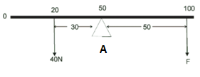

Taking moments about A,

Clockwise moments = Anticlockwise moment

F x 50 = 40 x 30



3. A light rod CD, sits on pivots A and B. A Ioad of 30 N hangs at 4 m from the pivot support at A. Find the value of the reaction forces at A and B as shown

**Solution**

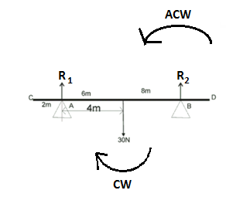

From conditions of equilibrium of parallel forces, total upward forces = total downward forces.

R1 + R2 = 30 N.

Taking moments about A,

The total clockwise moments = total anticlockwise moments

**30 x 4 = R x (8 + 4)**



**R1 = 30 – R2**

**R1 = 30 – 12 = 18 N**

**EVALUATION**

**ASSESSMENT**

Reference: New School Physics, page 163, Exercise 4

**TICKET OUT**

Reference: New School Physics, page 163, Exercise 4

**WEEK5**

**TOPIC: EQUILIBRIUM OF BODIES IN LIQUID**

**REFERENCE BOOK: New School Physics for SSS by M.W. Anyakhoha. African First Publisher.**

**LEARNING OBJECTIVES:** by the end of the lesson, students should be able to:

1. **State Archimedes principle.**
2. **State the principle of floatation.**

**EQUILIBRIUM OF BODIES IN LIQUID**

It is a common experience that when an object is immersed in water, it becomes lighter whether it is wholly or partially immersed.

There is some upward force exerted by the liquid on an object when it is immersed in a fluid or liquid. This upward force experienced is called upthrust.

If the true weight of the object in air is W1 and the apparent weight in liquid is W2, then,

**Upthrust, U = W1 - W2**

Upthrust depends on:

1. the volume of the object immersed
2. the density of the liquid in which the object is immersed.

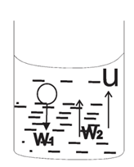

**ARCHIMEDES PRINCIPLE**

It states that when an object is wholly or partially immersed in a fluid, it experiences a loss in weight or an upthrust which is equal to the weight of the fluid displaced by the object.

FLOATATION

If a body is denser than the liquid, it will completely sink in it, but if the density of the body is less than that of the liquid, the body sinks until the weight of liquid displaced is just equal to the weight of the body. The body then floats and is said to be in equilibrium. This is the condition necessary for a body to float.

**PRINCIPLE OF FLOATING**

It states that a floating body displaces its own weight of the liquid in which it floats or a body floats when the upthrust exerted upon it by the fluid is equal to the weight of the body.

**IMPORTANCE OF FLOATING PRINCIPLE**

Ships float in water even though they are made of steel which is denser than water. This is because they are hollow objects containing large amounts of air and so able to displace a large amount of water, given an upthrust large enough to support the weight of the ship. Likewise, the weight of a balloon and its content is equal to the upthrust of air on the balloon.

**EXAMPLE**

An object weighs 0.08N in air and 0.01 N in a liquid of density 700 kgm-3. Calculate the upthrust of the liquid on the solid.

**SOLUTION**

**Since upthrust = loss in weight**

**Upthrust = weight in - weight in liquid**

**U = (0.08 – 0.01) N = 0.07N.**

**DENSITY AND UPTHRUST**

**The density of a substance is its mass per unit volume.**





**Where ρ (rho) is a Greek letter representing density and its SI unit is kgm-3.**

**EXAMPLE**

An object weighs 0.08 N in air and 0.01 N in a liquid of density 700 kgm-3. Calculate the volume of the solid.

**SOLUTION**

**Upthrust = loss in weight**

**U = 0.08 - 0.01 = 0.07 N**

**Also,**

**Upthrust = density of liquid × volume of solid × acceleration due to gravity**

**U = ρl × Vs × g**

**0.07 = 700 × Vs × 10**

**0.07 = 7000 Vs**



**Vs = 1 × 10-5 m³.**

**RELATIVE DENSITY (R.D)**

Since water is the most common substance and its density is 1000 kgm-3 or 1 gcm-3, it is convenient to use it as a standard for comparing the densities of other substances.

The relative density (R.D) of a substance is defined as follows:







From Archimedes principle,



For a liquid,



Relative Density has no unit.

**DETERMINATION OF R.D**

**(i) Regular body:** For a regular body, the volume can easily be found and the mass can be obtained by direct weighing. Hence density can be calculated.

**(ii) Irregular body:** The mass can be obtained by direct weighing. The volume is found by immersing the body in water provided it will not dissolve in water and it will sink. The volume of water displaced will equal the volume of the solid. Hence, the density can be calculated.

**RELATIVE DENSITY OF LIQUID BY DIRECT METHOD**

A relative bottle can be used to find the density of a liquid directly.

The relative bottle is weighed empty, and has a mass of **m**. It is then filled with liquid and weighed and has mass **m1**. Finally it is emptied, dried and refilled with water and weighed again, when it has mass **m2**.

Recall that

**R.D =** 



**INSTRUMENT USED FOR MEASURING DENSITY**

1. **A** hydrometer is an instrument for measuring the density of liquids. Its construction and operation are based on the fact that the depth to which a tube sinks depends on the density of the liquid in which it is floating.
2. A practical hydrometer is an instrument which gives a direct density reading of the liquid in which it floats. It works from the principle that less the density of the liquid, further the hydrometer sinks into it.

**This shows that**



**EVALUATION**

**ASSESSMENT**

Reference: New School Physics, page 163, Exercise 4

**TICKET OUT**

Reference: New School Physics, page 163, Exercise 4

**WEEK6:**

**TOPIC: NEWTON'S LAW OF MOTION AND MOMENTUM**

**REFERENCE BOOK: NEW SCHOOL PHYSICS FOR SENIOR SECONDARY SCHOOL BY M.W. AYANKOHA**

**Learning outcomes: by the end of the lesson, learners should be able to:**

1. **define linear momentum**
2. **state and apply the principle of conservation of momentum to collisions in one and two dimensions**
3. **relate force to the rate of change of momentum**
4. **discuss energy changes in perfectly elastic and inelastic collision**

**NEWTON’S LAWS OF MOTION**

***Newton’s first law of motion*** states that everybody continues in its state of rest or of uniform motion in straight line unless it is acted upon by a force. The tendency of a body to remain at rest or, if moving, to continue its motion in a straight line is called the *inertia*. That is why Newton’s first law is otherwise referred to as the law of inertia.

***Newton’s second law of motion*** states that the rate of change of momentum of a body is directly proportional to the applied force and takes place in the direction in of the force.



: ows that 







Where k =1



**MOMENTUM**

***Momentum*** of a body is the product of the mass and velocity of the body. The S.I. unit of momentum is kgms-1.

**IMPULSE**

***Impulse*** is the product of a force and time. It is also defined as the change in momentum. Thus both momentum and impulse have ‘Ns’ as unit



Ft = mv – mu (where ‘mv - mu’ is the change of momentum)

F x t = I (Ns)

***Newton’s third law of motion*** states that to every action, there is an equal but opposite reaction. A practical demonstration of this law can be observed when a bullet is fired from a gun, the person holding it experiences the backward recoil force of the gun (reaction) which is equal to the propulsive force (action) acting on the bullet.

According to Newton second law of motion, force is proportional to change in momentum.

Therefore the momentum of the bullet is equal and opposite to the momentum of the gun i.e.

Mass of bullet x muzzle velocity = mass of gun x recoil velocity

Hence, if:

m = mass of bullet,

v= velocity of bullet,

M = mass of gun,

V = velocity of the recoil of the gun.

Then, the velocity, V, of the recoil of the gun is given by:

MV = mv



**CONSERVATION OF LINEAR MOMENTUM**

The principle of conservation of linear momentum states that *when two or more bodies collide, their momentum remain constant provided there is no external force acting on the system*. This implies that in a closed or isolated system where there is no external force, the total momentum after collision remains constant. The principle is true for both elastic and inelastic collision.

**COLLISION**

There are two types of collision- elastic and inelastic.

*In elastic collision* the two bodies collide and then move with different velocities. Both *momentum and kinetic energy are conserved* e.g. collision between gaseous particles, a ball which rebounds to its original height etc.

If the two colliding bodies have masses m1and m2 initial velocities u1 and u2 and final velocities v1 and v2. The conservation principle can be mathematically expressed as:

**m1u1 + m2u2 = m1v1 + m2v2**

***In an inelastic collision***, the two bodies join together after the collision and with the same velocity. Here, *momentum is conserved but kinetic energy is not conserved* because part of it has been converted to heat or sound energy, leading to deformation.

Thus, the conversation principle can be re-written as:

**m1u1 + m2u2 = v (m1 +m2)**

Since momentum is a vector quantity, all the velocities must be measured in the same direction, assigning positive signs to the forward velocities and negative signs to the backward or opposite velocities

**TWO BODIES MOVING IN THE SAME DIRECTION BEFORE COLLISION**

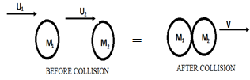

**M1U1 + M2U2 = V (M1 + M2)**

Where V = common velocity



**TWO BODIES TRAVELLING IN OPPOSITE DIRECTION**

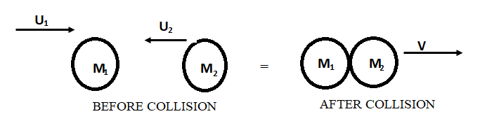

**M1U1 - M2U2 = V (M1 + M2)**



**COLLISION BETWEEN A STATIONARY AND MOVING BODY**

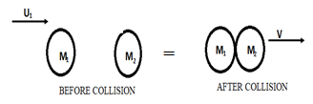

The momentum of a stationary body is zero because velocity is zero

**M1U1 + M2U2 = V (M1 + M2)**



**EXAMPLE**

1. Two moving toys of masses 50 kg and 30 kg are traveling on the same plane with speeds of 5 ms-1 and 3 ms-1 respectively in the same direction. If they collide and stick together, calculate their common velocity.

**M1U1 - M2U2 = V (M1 + M2)**









1. Two balls of masses 0.5 kg and 0.3kg move towards each other in the same line at speeds of 3 m/s and 4 m/s respectively. After the collision, the first ball has a speed of 1m/s in the opposite direction. What is the speed of the second ball after collision

**SOLUTION**

**3 x 0.5 + (0.3 x -4) = 0.5 (-1) + 0.3 v**

**1.5 - 1.2 = -0.5 + 0.3 v**

**0.3v = 2.0 - 1.2**



**V = 2.7 ms-1**

1. A gun of mass 100kg fires a bullet of mass 20g at a speed of 400m/s. What is the recoil velocity of the gun?

**Solution**

**Momentum gun = momentum of bullet**

MV = m v

10 × V = 0.002 × 400



V= 0.8 ms-1

**EVALUATION**

**ASSESSMENT**

Reference: New School Physics, page 189, Exercise 6

**TICKET OUT**

Reference: New School Physics, page 189, Exercise 6

**WEEK7:**

**Mechanical Energy**

1. **Machines**

**REFERENCE BOOK: NEW SCHOOL PHYSICS FOR SENIOR SECONDARY SCHOOL BY M.W. AYANKOHA**

**LEARNING OBJECTIVES:** by the end of the lesson, students should be able to:

1. Calculate the potential and mechanical energy of a body.
2. Define a machine and list the types of machines.
3. Define force ratio, velocity ratio and efficiency

**WORK**

Work is said to be done whenever a force moves through a distance in the direction of the force.



Work is scalar.

When the force and the motion are in the same direction, **θ** = 0, hence 

**MECHANICAL ENERGY**

We distinguish between two types of mechanical energy.

1. **Potential energy (PE)** is the energy possessed by a body by virtue of its position.

**Types of Potential energy (PE**

1. **Gravitational potential energy** is given as;

**Eg = mgh**

1. **Elastic potential energy** is given as;

**Ep = ½ Kx²**

1. **Kinetic energy (KE)** is energy possessed by a body by virtue of its motion. It is given as;

**KE = ½ mv²**

**CONSERVATION OF ENERGY**

The principle of conservation of mechanical energy states that in a closed or isolated system, the total mechanical energy is always conserved (constant) but it can be changed from one form to another.

**MACHINES**

A **machine** is a device or too which when a force (effort) is applied at one point is used to overcome a resisting force (load) at another point.

**MECHANICAL ADVANTAGE (M.A.) or FORCE RATIO**

It is the ratio of load to effort or the ratio of output force to input force.

 **OR** 

**VELOCITY RATIO (V.R.)**

VR is the ratio of distance moved by effort to distance moved by load.



**IDEAL OR PERFECT MACHINE**

**F**or an ideal machine, there is no friction.

Work done by load = work done by effort

Work output = work input.

Load × distance moved by load = Effort × distance moved by effort

 = 

Therefore, ***MA = VR***

**FACTORS THAT AFFECT V.R.**

* It depends on the geometry of the machine
* It is independent of friction.

**FACTORS THAT AFFECT M.A.**

1. It depends on friction

**EFFICIENCY OF A MACHINE**

The efficiency of a machine is defined as the ratio of the useful work done by the machine to the input work done,

**eff** 

***eff*** 



**× 100%**

**×**  **× 100%**

**Recall that VR =**  **and MA =** 

**Therefore,**

**Eff = MA ×**  **100%**

**Eff =** **× 100%**

**TYPES OF MACHINES**

**LEVER**

A lever consists of a stiff bar or rigid rod which is pivoted at the fulcrum and it is free to rotate.

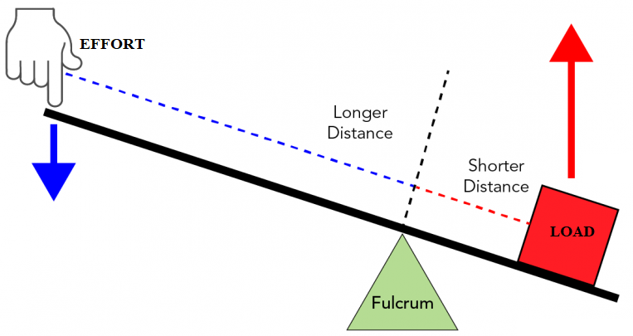

**TYPES OF LEVER**

1. **First class lever:** Fulcrum is between effort and load. E.g. scissors, secateurs, shears. The VR is usually greater than 1 but may be less than or equal to 1.

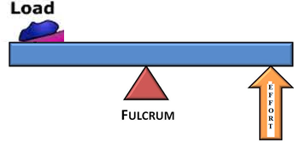

1. **Second class lever:** The load is between effort and fulcrum. Eg. But crackers and wheel barrow. Both VR and MA are greater than 1.

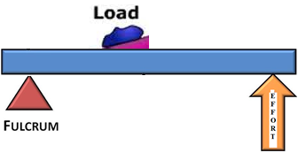

1. **Third class lever:** The effort is between load and fulcrum. Eg. Forearm, tongs. MA and VR are less than 1.

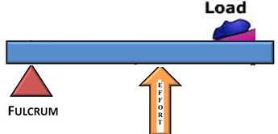

**PULLEYS**

A simple pulley is a fixed wheel hung on a suitable support with a rope passing through its grove.

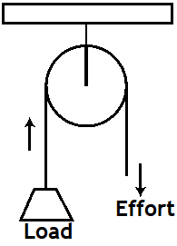

**Simple pulley**

If there is no friction,

**Effort = Load**

**MA = VR = 1**

**The MA increases as the number of pulleys increases.**

**The VR is equal to the number of pulleys or ropes connecting the pulleys.**

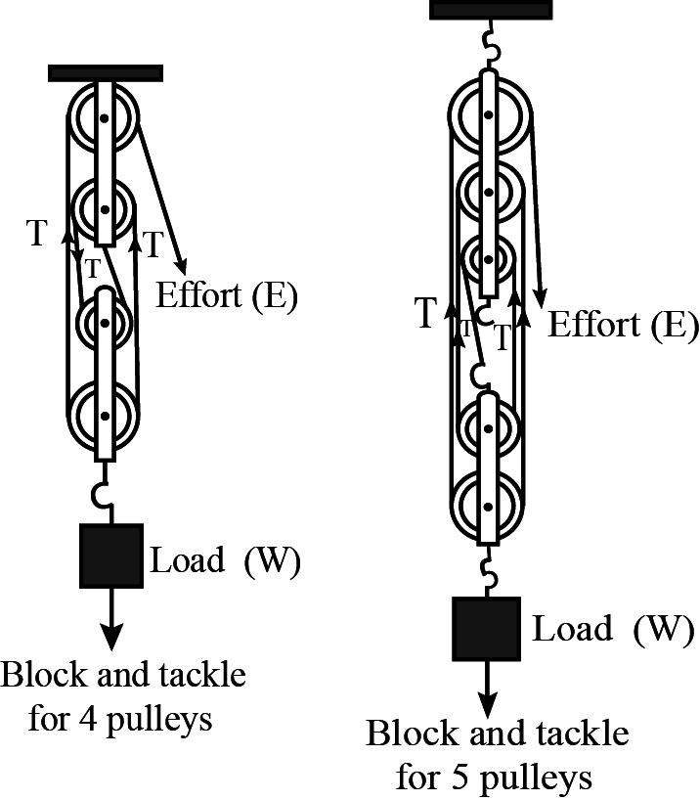

**VR = 4 VR = 5**

**THE INCLINED PLANE**

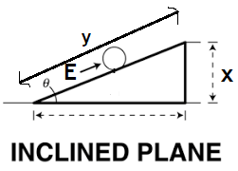

**VR = Distance moved by effort/distance moved by load**

**VR =** 

**VR =** 

**COEFFICIENT OF FRICTION FROM INCLINED PLANE**

**μ = =** **tan**

**WEDGE**

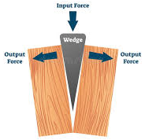

**It is a combination of two inclined planes and it is used to split or separate bodies held by large forces. Eg. Axe, chisel, knives, and any cutting tool.**

**MA =**  **=** 

**SCREW JACK**

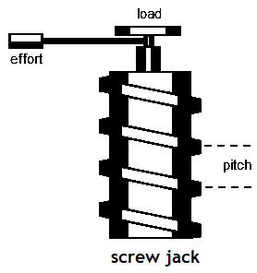

**The screw jack can be considered as an inclined plane wrapped around a cylinder.**

**VR =** 

**If there is no friction,**

**VR = MA =** 

**Where,**

**r = length of tommy bar**

**p = pitch of the screw jack.**

**WHEEL AND AXLE**

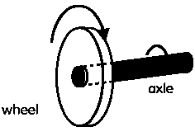

**VR = Circumference of wheel/circumference of axle.**

**VR *=*** 

**VR =** 

**VR =** 

**MA =** 

**GEAR WHEEL**

**VR =** 

**EVALUATION**

**ASSESSMENT**

Reference: New School Physics, page 204, Exercise 7

**TICKET OUT**

Reference: New School Physics, page 204, Exercise 7

WEEK 8

TOPIC: PROJECTILES AND ITS APPLICATION

**REFERENCE BOOK: NEW SCHOOL PHYSICS FOR SENIOR SECONDARY SCHOOL BY M.W. AYANKOHA**

**LEARNING OBJECTIVES: by the end of the lesson, learners should be able to:**

1. Explain the meaning of projectile
2. Explain terms associated with projectiles
3. State the uses of projectile
4. Solve simple problems on projectiles

**MEANING OF PROJECTILE**

A projectile motion is one that follows a curved or parabolic path .It is due to two independent motions at right angle to each other .These motions are

1. a horizontal constant velocity
2. a vertical free fall due to gravity

Examples of projectile motion are the motion of;

1. a thrown rubber ball re-bouncing from a wall
2. An athlete doing the high jump
3. A stone released from a catapult
4. A bullet fired from a gum
5. A cricket ball thrown against a vertical wall.

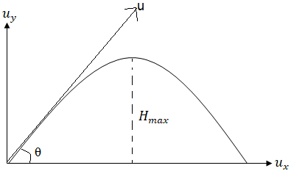

 = u sin θ (vertical component) ------------------- 1

 = u cos θ (horizontal component) ------------------- 2

# **TERMS ASSOCIATED WITH PROJECTILE**

1. *Time of flight (T)* - The time of flight of a projectile is the time required for it to return to the same level from which it projected.

T = time to reach the greatest or maximum height

V = u + at (but, v = 0, a = -g)

0 = u sin – gt

t =  ------------------- 3

T = 2t =  ------------------- 4

2. *The maximum height (H)* - is defined as the highest vertical distance reached measured from the horizontal projection plane.

For maximum height H,

v2 = u2 sin2θ - 2g H

At maximum height H, v =0

0 = u2 sin2θ - 2g H

H =  ------------------- 5

3. *The range (R)* - is the horizontal distance from the point of projection of a particle to the point where the particle hit the projection plane again.

Horizontally, considering the range covered

Using  (where a = 0 for the horizontal motion)

OR

s = R = u cos θ x T (distance = velocity x time; there time is the time of flight)

R = 

R = 

From Trigonometry function

2 sin θ cos θ = sin 2θ

R= 

For maximum range, θ = 450

Sin 2θ = sin (2 ×45) = sin 900 = 1

= 

**USE OF PROJECTILES**

1.    To launch missiles in modern warfare

2.    To give athletes maximum takeoff speed at meets

In artillery warfare, in order to strike a specified target, the bomb must be released when the target appears at the angle of depression φ given by:

Tan φ = 

**EXAMPLES**

1.    A bomber on a military mission is flying horizontally at a height of 300 m above the ground at 60 kmmin-1. lt drops a bomb on a target on the ground. Determine the acute angle between the vertical and the line joining the bomber and the tangent at the instant. The bomb is released

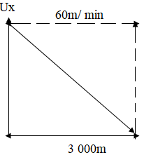

Horizontal velocity of bomber = 60 kmmin-1 = 103 ms-1

Bomb falls with a vertical acceleration of g = 10 ms-1

At the release of the bomb, it moves with a horizontal velocity equals that of the aircraft i.e. 1000 ms-1

Considering the vertical motion of the bomb we have

 (u = o)

 Where; t is the time the bomb takes to reach the ground:



300=1/2gt2

t2= 600

t=10√6 sec

Considering the horizontal motion we have that horizontal distance moved by the bomb in time t is given by

s =horizontal velocity x time

s = 1000 x10√6

s = 2.449x104 m

But tan θ = s = 2.449 x 104

3,000 3,000

  θ =83.02~~0~~

2. A stone is shot out from a catapult with an initial velocity of 30m at an elevation of 600. Find

a. the time of flight

b. the maximum height attained

c. the range

a. The time of flight





T= 5.2s

b. The maximum height,





H = 33.75 m

c. The range,





R = 90 sin 120

R = 77.9 m

3. A body is projected horizontally with a velocity of 60 ms-1 from the top of a mast 120 m above the grand, calculate

(i) Time of flight, and (ii) Range

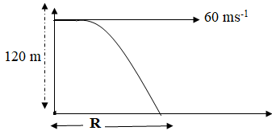

i. 







t2 = 24

t =  = 4.9 s

ii. Range = uxt

R = 60 × 4.9

**R = 294 m**

4. A stone is projected horizontally with a speed of 10 ms-1 from the top of a tower 50 m high and with what speed does the stone strike the ground?

**Solution**

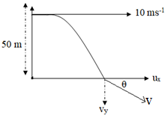

ux = 10 ms-1 [constant]

ux2= 100

vy2 = 02 + 2gh

vy2 = 0+ 2 × 10 × 50

vy2 = 1000

vy2 = 1000

vy=  ms-1

v = = 

  = 33.17 ms-1

Magnitude of velocity = 33.17 ms-1







4. A projectile is fired at an angle of 60 with the horizontal with an initial velocity of 80 ms-1. Calculate:

1. the time of flight
2. the maximum height attained and the time taken to reach the height
3. the velocity of projection 2 seconds after being fired (g = 10m/s)

θ = 600; u =80 ms-1

1. 

 = 13 .86 s

1. A. 



H = 240 m

B. 

t = 6.93 s



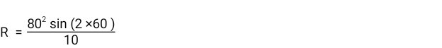 = 554.3m

iii. 

vy = 80 sin 60 – 10 ×2

vy = 49.28 ms-1

ux = U cos θ

ux = 80 cos 60

ux = 40 ms-1

v = = 

 = 63.41 ms-1

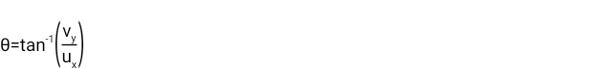





**EVALUATION**

1. Explain the meaning of projectile
2. Explain terms associated with projectiles
3. State the uses of projectile
4. Solve simple problems on projectiles

**ASSESSMENT**

Reference: New School Physics, page 139, Exercise 3

**TICKET OUT**

Reference: New School Physics, page 139, Exercise 3

# WEEK 9

**CIRCULAR MOTION**

**REFERENCE BOOK: NEW SCHOOL PHYSICS FOR SENIOR SECONDARY SCHOOL BY M.W. AYANKOHA**

**LEARNING OBJECTIVES: by the end of the lesson, learners should be able to:**

* Define uniform circular motion
* Relate angular speed with linear speed.
* Define centripetal acceleration and centripetal force.
* Solve simple problems on circular motion.

## MEANING OF CIRCULAR MOTION

Circular motion is the motion of a body around a circle. The simplest form of circular motion is the uniform circular motion, where the speed is constant but the direction is changing.

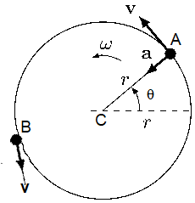

Consider a body moving in a circular path center C with a constant speed.

1. The direction at different points are not the same i.e. the direction at A is different from the direction at B. This leads to a change in velocity.
2. This difference in velocity produces an acceleration directed towards the center of the circle. This acceleration is called centripetal acceleration.
3. Since there is an acceleration, there is a force directed towards the center of the circle called centripetal force.
4. In addition to the centripetal force, there is an equal but opposite force which acts outwards from the center of the circle. This force is called the centrifugal force. The centripetal and the centrifugal forces enable the object to move in the orbit.

## **Definition of Terms Used in Circular Motion**

### *Angular velocity (ω):* The ratio of the angle turned through to the elapsed time.

### ω = Angular velocity

### 



### *The S.l unit is radians per second (rads-1)*

### *Tangential velocity (v):* This is the linear velocity whose direction is along the tangent to the circumference of the circle.

### v = linear displacement × time

### 

### 

### But

### Then



### *The unit is ms-1*

### *Centripetal acceleration (a):* This can be defined as the acceleration of a body in uniform circular motion whose direction is towards the centre of the circle. It is given as:



### The unit is ms-2

### But v = rω



### Centripetal force (F): It is defined as that inward force that is always directed towards the centre of the circle required to keep an object moving with a constant speed in a circular path.

Centripetal force = mass × centripetal acceleration



OR



*The unit is Newton*

### *Centrifugal force:* This force is equal in magnitude to the centripetal force but opposite in direction. (it is always directed away from the centre of the circle)



OR



### *Period (T):* This is the time taken for a body to complete one revolution round the circle.

### 

*The SI unit is second.*

### *Frequency (f)*: It is the number of revolutions in one second.





*The unit is Hertz or per seconds. (Hz or s-1)*

## CALCULATIONS ON CIRCULAR MOTION

**Question**

A stone of mass 2 kg is attached to the end of an inelastic string and whirled round two times in a horizontal circular path of radius 3 m in 3 sec, find:

1. Angular velocity
2. Linear velocity
3. Centripetal acceleration
4. Centripetal force
5. Centrifugal force

**Solution**

1. 

θ = 2 × 3600 =7200 or θ = 2 × 2π rad (2π rad = 3600)

θ = 4π rad.

 =1.33πrads-1

1. =3×1.33π = 3.99π ms-1
2. 

= 5.31π2 ms-2

1. F = ma =2×5.31π2 =10.62π2 N

(v) F = − mv2r = −10.62π2 N

**EVALUATION**

* Define uniform circular motion
* Relate angular speed with linear speed.
* Define centripetal acceleration and centripetal force.
* Solve simple problems on circular motion.

**ASSESSMENT**

Reference: New School Physics, page 28, Exercise 2

**TICKET OUT**

Reference: New School Physics, page 28, Exercise 2

**WEEKS 10**

# SIMPLE HARMONIC MOTION

**REFERENCE BOOK: NEW SCHOOL PHYSICS FOR SENIOR SECONDARY SCHOOL BY M.W. AYANKOHA**

**LEARNING OBJECTIVES: by the end of the lesson, learners should be able to:**

1. Define simple harmonic motion
2. Calculate the energy of simple harmonic motion.
3. Explain forced vibration and resonance
4. Calculate the period of simple harmonic motion

## DEFINITION

This is the periodic motion of a body or particle along a straight line such that the acceleration of the body is directed towards a fixed point or centre or equilibrium position, and it is proportional to the displacement from that point.

A particle undergoing simple harmonic motion will move to and fro in a straight line under the influence of a force. This influential force is called a restoring force as it always directs the particle back to its equilibrium position.

Examples of simple harmonic motions are

1. loaded test tube in a liquid
2. Mass on a string
3. The simple pendulum

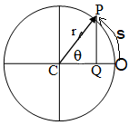

As the particle P moves round the circle once, it sweeps through an angle θ = 360 (or 2π radians) in the time T, the period of motion. The rate of change of the angle θ with time (t) is known as the angular velocity, ω

Angular velocity (ω) is defined by

ω = 

ω =  (rads-1)

θ = ωt

This is similar to the relation distance = uniform velocity × time (s = vt) for motion in a straight line

As the angle is changing with time so is the arc length = s

Changing with time. By definition θ in radians = , and hence

s = rθ

v =r ω

The linear velocity, v at any point, Q, whose distance from C the central point is  is given by

V = ω 

A = r = radius or amplitude of oscillation.

The minimum velocity, Vm corresponds to the point at  = 0 that is the velocity at the central point or centre of motion .

Hence, V**m** =ω A

Thus the maximum velocity of the SHM occurs at the centre of the motion ( = 0), while the minimum velocity occurs at the extreme position of motion ( = A).

# **RELATIONSHIP BETWEEN LINEAR ACCELERATION AND ANGULAR VELOCITY**

 = A Cos θ

But

θ = ωt

 = A Cos ω t

Differentiating with respect to t,

 = -ω A sin ω t

On differentiating with respect to t again,

= -ω2 A cos ω t

 = -ω2

The negative sign indicates that the acceleration is always directed towards the centre, C while the displacement is measured outwards from C.

**ENERGY OF SIMPLE HARMONIC MOTION**

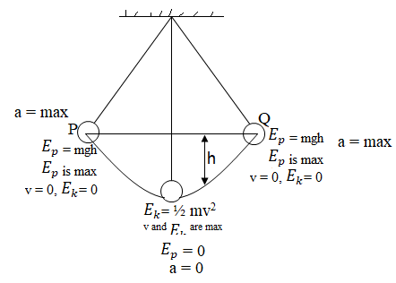

Since force and displacement are involved, it follows that work and energy are involved in simple harmonic motion.

At any instant of the motion , the system may contain some energy as kinetic energy () or potential energy().The total energy ( + ) for a body performing SHM is always conserved although it may change form between  and .

When a mass is suspended from the end of a spring stretched vertically downwards and released, it oscillates in a simple harmonic motion. During this motion, the force tending to restore the spring to its elastic restoring force is simply the elastic restoring force which is given by

F = - ky

k is the force constant of the spring.

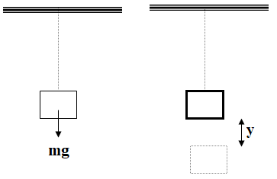

 The total work done in stretching the spring at distance y is given by

W = average force x displacement

W =  = 

Thus the maximum energy total energy stored in the spring is given by

W = 

A = amplitude (maximum displacement from equilibrium position).

This maximum energy is conserved throughout the motion of the system.

At any stage of the oscillation, the total energy is

W = 

W= + 

 =  – 

 =  – 



The constant k, is obtained from Hooke’s law in which

F= mg = k**e**

Where **e** is the extension produced in the spring by a mass **m**

But 

Therefore ω =



Hence the period, T = 

**EXAMPLE**

A body of mass 20 g is suspended from the end of a spiral spring whose force constant is 0.4 Nm-1. The body is set into a simple harmonic motion with amplitude 0.2 m. Calculate:

1. The period of the motion
2. The frequency of the motion
3. The angular speed
4. The total energy
5. The maximum velocity of the motion
6. The maximum acceleration

SOLUTION

1. T =  = T =  = 0.447π sec = *1.41 sec*
2.  =  = *0.71 Hz*
3. *ω = 2πf = 2π × 0.71= 4.46 rads-1*
4. Total energy = = =  *= 0.008 J*
5.  =  =

vm2 = 

vm =  = 0.89 ms-1

f. = ω2A

= 4.462 x 0.2

= 3.98 ms-2

**FORCED VIBRATION AND RESONANCE**

Vibrations resulting from the action of an external periodic force on an oscillating body are called forced vibrations. Every vibrating object possesses a natural frequency (fo) of vibration. This is the frequency with which the object will oscillate when it is left undisturbed after being set into vibration. The principle of the sounding board of a piano or the diaphragm of a loudspeaker is based on the phenomenon of forced vibrations.

Whenever the frequency of vibrating body acting on a system coincides with the natural frequency of the system, then the system is set into vibration with relatively large amplitude. This phenomenon is called resonance.

**EVALUATION**

1. Define simple harmonic motion
2. Calculate the energy of simple harmonic motion.
3. Explain forced vibration and resonance
4. Calculate the period of simple harmonic motion

**ASSESSMENT**

Reference: New School Physics, page 178, Exercise 5

**TICKET OUT**

Reference: New School Physics, page 178, Exercise 5