**Robotics I – Project 1 Fall 2018**

**Jumping Right In – Competition: Navigating a point robot on an unknown map**

[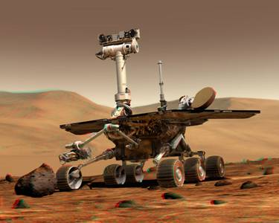](https://www.google.com/url?sa=i&rct=j&q=&esrc=s&source=images&cd=&cad=rja&uact=8&ved=2ahUKEwjUkKrqsYHdAhVRRqwKHd30BqkQjRx6BAgBEAU&url=http://www.cs.cmu.edu/~reliability/&psig=AOvVaw2hamXlLTl8lC22tDj-rsT9&ust=1535052362299319)

**Project Assignment: Given a previously unknown 100 x 100 meter map containing 4 walls and several obstacles, devise a method to navigate a point robot to a pre-defined goal location given a pre-defined starting location.**

**Rules and Notes:**

1. **Matlab code containing functions to plot the map and move and plot the location of the point robot is provided.**
2. **The robot can only be moved with the provided moveRobot() Matlab function and this function cannot be altered.**
3. **The pathLength variable can only be set as an output to the moveRobot() function as provided in the example.**
4. **An Occupancy Map will be provided at the time of the competition. This map can be queried by the program but cannot be altered by the program.**
5. **All moveRobot() calls must be done in the provided while loop. However, other code may be inserted anywhere in the provided script as long as it doesn’t affect the competition result.**
6. **The robot can only be moved one discrete cell at a time in any of the cardinal or diagonal directions.**
7. **The robot cannot move through the walls or any obstacles.**
8. **The student who can navigate to the goal location with the smallest path length (or movements) will win the competition and receive bonus points. If there is a tie between winners, the extra points will be evenly distributed between winners.**
9. **A createMaps.m script is provided that can be used to create new maps given you figure out how to change the code and save and load the maps.**
10. **The professor reserves the right to disqualify any unethical hack of the code which gives an unfair advantage. However, this right will be used only under limited circumstances.**

**Example Map:**

