1. Rolling Element Bearing Data

Rotating Machines are very common in various industrial applications, but also in many other areas such as Aerospace or Power Generation. In Manufacturing, most machine failures are linked to Bearing Faults in rotating machines (Lou, Loparo, Discenzo, Yoo, & Twarowski, 2004). Consequently, much research has been done to develop techniques for the classification and prediction of Bearing Faults (Marwala, 2012), (Nelvamondo, Marwala, & Mahola, 2006), (Li, Chow, Tipsuwan, & Hung, 2000).

A popular Rolling Bearing Benchmark Dataset mentioned in several research papers can be found at (Case Western University). The dataset contains data obtained from a Rolling Element Bearing running under normal and under various faulty conditions.

Rolling Bearings consist of two concentric rings, the Inner and Outer Raceway with a set of rolling elements running between their tracks, as illustrated in Figure 2

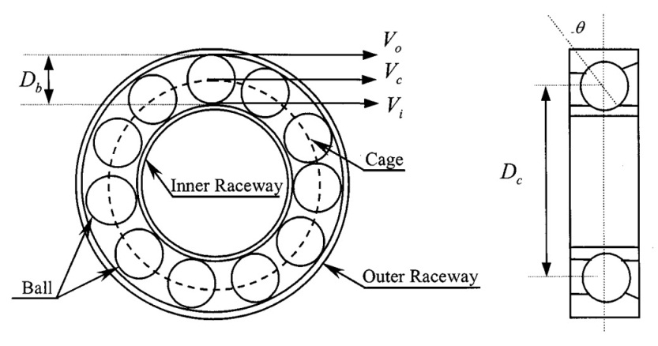

Fig. 1 Rolling Element Bearing

The Rolling Elements are usually contained in a cage to prevent contact between elements.

Rolling Bearings generate vibration signals with characteristic signatures for different states of the raceways and the rolling elements (Li, Chow, Tipsuwan, & Hung, 2000). Figure 3 shows sample data from the Case Western Rolling Bearing dataset for five revolutions of the Rolling Bearing.

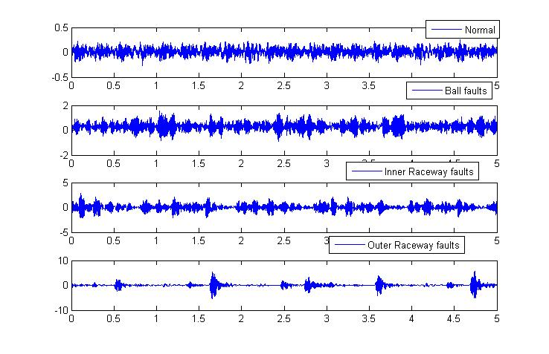

Fig. 2 Rolling Bearing Data of 5 revolutions

1. Feature Extraction

Datasets occurring in the Condition Monitoring domain are usually large time-series datasets which are expensive to process directly. Besides, significant data aspects linked to normal or faulty system states are usually hidden in the time series data and cannot be detected directly. Condition Monitoring Frameworks therefore usually combine some kind of preprocessing and Feature Extraction techniques with suitable decision algorithms.

Several techniques have been applied to extract useful features from the Rolling Bearing dataset (Marwala, 2012). Some successful approaches combined Mel Frequency Cepstral Coefficients (MFCC), Multi Fractal Dimensions (MFD) and Kurtosis measure as feature extraction techniques with machine learning algorithms such as Neural Networks, Hidden Markov Models and Support Vector Machines to classify faults (Marwala, 2012), (Nelvamondo, Marwala, & Mahola, 2006).

* 1. Mel Frequency Cepstral Coefficients

Mel Frequency Cepstral Analysis is a technique commonly used in Speech Recognition, which can capture the dynamic characteristics of a signal by extracting both linear- and non-linear features (Marwala, 2012) .

The Cepstrum $C(τ)$ is defined as the inverse Fourier Transform of a logarithmic Frequency Spectrum

$$C\left(τ\right)=F^{-1}\left(log⁡(F\left(f\right)\right)$$

(4.1.1)

Where $F^{-1}$ is the inverse Fourier Transform and $F\left(f\right)$ is the frequency spectrum of a signal.

Some insight into important properties of a Cepstrum can be gained by regarding a time signal $y(t)$ as the output of a *Linear Time Invariant (LTI)* system which is characterized by its impulse response $h(t)$. The output $y(t)$ of an *LTI* is given by the convolution of an input signal $x\left(t\right)$ and the impulse response

$$y\left(t\right)=x\left(t\right)*h\left(t\right).$$

(4.1.2)

In the Frequency domain, the convolution in (4.1.2) transforms into the multiplication

$$Y\left(f\right)=X\left(f\right)H\left(f\right).$$

(4.1.3)

With (4.1.1) and (4.1.3) the cepstrum of a linear system is

$$C\left(τ\right)=F^{-1}\left(log⁡(X\left(f\right)H\left(f\right)\right)$$

$$C\left(τ\right)=F^{-1}\left(log⁡(X\left(f\right)+log⁡(H\left(f\right)\right)$$

$$C\left(τ\right)=F^{-1}\left(log⁡(X\left(f\right)\right)+F^{-1}\left(log⁡(H\left(f\right)\right)$$

$$C_{y}\left(τ\right)=C_{x}\left(τ\right)+C_{H}\left(τ\right)$$

(4.1.4)

From (4.1.1) and (4.1.4) it can be seen, that a Cepstrum separates the input signal and the impulse response in the time domain, which can be very useful when time signals $y\left(t\right)$ are compared which are generated by different input signals $x\left(t\right)$ in combination with the same system, characterized by $h\left(t\right)$.

Applied to the Condition Monitoring of machines, $y\left(t\right)$ in (4.1.2) represents the signal measured by accelerometers at a certain point outside the machine. The actual information about the machine condition is contained in the signal $x\left(t\right)$, which is generated somewhere at an inaccessible point inside the machine and filtered by the transmission path. The Cepstrum separates the signal containing the state information from the characteristics of the transmission path (Kolerus & Wassermann, Zustandsüberwachung von Maschinen , 2008).

The Mel Frequency Coefficients used as Features in various Condition Monitoring applications (Nelvamondo, Marwala, & Mahola, 2006), (Marwala, 2012) are based on a Mel-transformation of the Frequency Spectrum and can be calculated by

1. Transforming the input signal $x\left(t\right)$ from the time domain into the frequency domain by applying the Fast Fourier Transform:

$$y\left(m\right)=\frac{1}{F}\sum_{n=0}^{F-1}{x(n){w(n)e}^{-j\frac{2π}{F}nm}}$$

Where $F$ is a number of signal frames of equal length, $x(n)$ are the signal samples and $w(n)$ is the Hamming Window given by

$$w\left(n\right)=β(0.5-0.5cos\frac{2πn}{F-1})$$

with $0≤n≤F-1$ and the normalization factor $β$.

1. Changing the frequency spectrum to the Mel scale with the equation
$$mel=2595×\log_{10}\left(1+\frac{f_{Hz}}{700}\right)$$

2. Converting the logarithmic Mel Spectrum back to the time domain with the Discrete Cosine Transform

* 1. Multi Fractal Dimensions

Fractals are patterns which can recursively be divided into sub-patterns, where the sub-patterns of one recursion level are equal or similar in shape to the sub-patterns of other recursion levels. A fractal shape is characterized by a Fractal Dimension, which exceeds the topological dimension of the shape and may fall between two integer numbers (Mandelbrot, 2004).

Applied to the analysis of time series, Fractal Dimension can be seen as a measurement for the irregularity of a curve (Polychronaki, et al., 2010), which has a topological dimension of one and a Fractal Dimension between one and two. Various algorithms exist for the calculation of the fractal dimension of time series, often based on some kind of length or distance measurements between the discrete points of a curve over several scales. Popular algorithms involve the Box-counting Method, Katz’s Method and Higuchi’s Method (Raghavendra & Dutt, 2010).

Fractal Dimension Measurement has been successfully used in Condition Monitoring for the extraction of features from machine-vibration data (Nelvamondo, Marwala, & Mahola, 2006), (Marwala, 2012). In this thesis, Higuchi’s method is used for its efficiency and its proven reliability in various applications.

Given a sampled discrete time series consisting of $N$ samples $\left(1\right),y\left(2\right),…,y(N)$, the Higuchi Fractal Dimension (HFD) is calculated by (Esteller, Vachtsevanos, Echauz, & Litt, 2001)

1. Constructing k new time series as

$$x_{m}^{k}=\left\{x\left(m\right),x\left(m+k\right),x\left(m+2k\right),…,x\left(m+\left\lfloor \frac{N-m}{k}\right\rfloor k\right)\right\},$$

for $m=1,2…,k$

where $m$ indicates the initial time value, k indicates the discrete time interval between points and $\left\lfloor a\right\rfloor$ represents the floor function which returns the next lowest integer value to a.

1. Computing the average length for each of the new time series $x_{m}^{k}$ as

$$L_{m}\left(k\right)=\sum_{i}^{\left\lfloor \frac{N-m}{k}\right\rfloor }{\left|x\left(m+ik\right)-x\left(m+\left(i-1\right)k\right)\right|}\frac{(N-1)}{\left\lfloor \frac{N-m}{k}\right\rfloor k}$$

for several scaling factors ranging from 1 to a freely chosen $k_{max}$, with $m=1,2…,k$ and the normalization factor

$$\frac{(N-1)}{\left\lfloor \frac{N-m}{k}\right\rfloor k}.$$

1. Calculating the complete length for each scale k as sum of the average lengths $L_{m}\left(k\right)$:
$$L\left(k\right)=\sum_{m=1}^{k}{L_{m}\left(k\right)}$$

2. Estimating the Fractal Dimension *HFD* as the slope of the least squares linear best fit line of the curve $ln\left(L(k)\right)$ versus $ln\left(\frac{1}{k}\right)$, since $L\left(k\right)\sim k^{-HFD}.$
   1. Kurtosis

Generally, Kurtosis is any measure for the “Peakedness” of a curve. A statistical Kurtosis measure is defined as the normalized fourth-order moment, which can be calculated by

$$K=\frac{1}{N}\sum_{i=1}^{N}{\frac{{\left(x_{i}-μ\right)}^{4}}{σ^{4}}}$$

Where N is the number of samples and the normalization factor is the squared second order moment, $σ^{4}$.

Kurtosis as quantification of peak sharpness can be useful in Condition monitoring of machines, where faults often manifest themselves in significant changes in the sharpness or spiking of the vibration signal (Nelvamondo, Marwala, & Mahola, 2006).

* 1. Features

In a preprocessing step, the large datasets representing the normal and the different fault states were subdivided into segments of equal length, with data from five revolutions of the Rolling Bearing per segment. The Kurtosis was calculated directly from each segment. For the extraction of MFD and MFCC, each segment was further divided into 14 frames of equal length. Figure 3 shows the MFD features of 14 sequences:

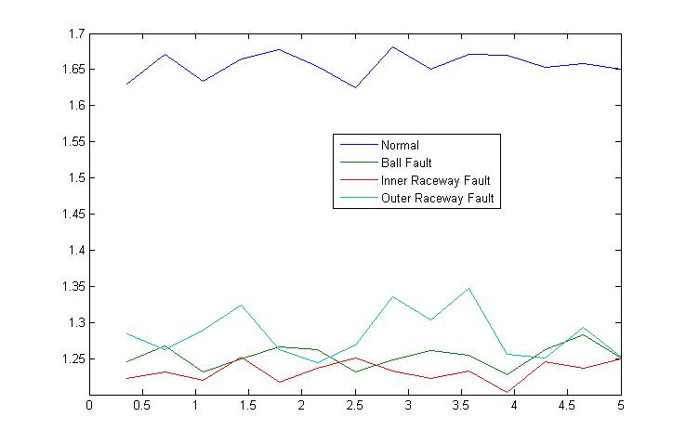

Fig. 3 MFD features of one data segment

Figure 4 illustrates the MFCC features of one sequence:

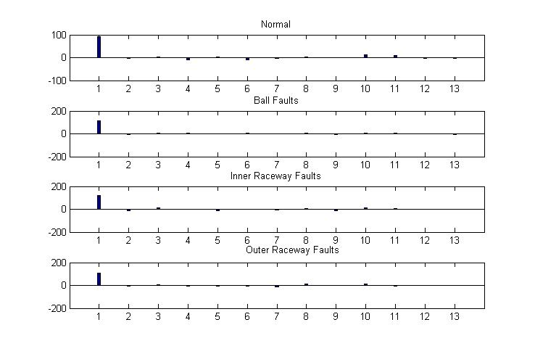

Fig. 4 MFCC features of one sequence

# References

Case Western University. (kein Datum). *Case Western University Bearing Data Center*. Von http://csegroups.case.edu/bearingdatacenter/pages/welcome-case-western-reserve-university-bearing-data-center-website abgerufen

Esteller, R., Vachtsevanos, G., Echauz, J., & Litt, B. (February 2001). A Comparison of Waveform Fractal Dimension Algorithms. *IEEE Transactions On Circuits And Systems-I: Fundamental Theory and Applications, Vol. 48, No.2,*.

Kolerus, J., & Wassermann, J. (2008). *Zustandsüberwachung von Maschinen .* Wien: Expert Verlag.

Li, B., Chow, M. Y., Tipsuwan, Y., & Hung, J. C. (October 2000). Neural-Network-Based Motor Rolling Bearing Fault Diagnosis. *IEEE Transactions on Industrial Electronics*.

Lou, X., Loparo, K. A., Discenzo, F. M., Yoo, J., & Twarowski, A. (2004). A model-based technique for rolling element bearing fault detection. *Mechanical Systems and Signal Processing*, S. pp.1077-1095.

Lunga, D., & Marwala, T. (2006). Time series analysis using Fractal theory and Online Ensemble Classifiers. *Lectures notes in Artificial Intelligence, Springer*, S. pp.312-321.

Mandelbrot, B. B. (2004). *Fractals And Chaos.* Berlin: Springer.

Marwala, T. (2012). *Condition Monitoring Using Computational Intelligence Methods.* Springer.

Nelvamondo, F. V., Marwala, T., & Mahola, U. (December 2006). Early Classification of Bearing Faults using Hidden Markov Models, Gaussian Mixture Models, Mel Frequency Cepstral Coefficients and Fractals. *International Journal of Innovative Computing, Information and Control*.

Polychronaki, G. E., Ktonas, P. Y., Gatzonis, S., Siatouni, A., Asvestas, P. A., Tsekou, H., et al. (23. June 2010). Comparison of fractal dimension estimation algorithms for epileptic seizure onset detection. *Journal Of Neural Engineering 7*, S. 18pp.

Raghavendra, B. S., & Dutt, D. N. (2010). Computing Fractal Dimension of Signals using Multiresolution Box-counting Method. *International Journal of Information and Mathematical Sciences 6:1*.