Es wurden keine Einträge für das Inhaltsverzeichnis gefunden.

Semi-Supervised Methods in Condition Monitoring

1. Condition Monitoring

Condition Monitoring refers to the systematic surveillance of industrial machinery or structures with the aim to detect faults and damages in an early stadium. In manufacturing, the monitoring and classification of machine states can help to prevent expensive production losses due to unforeseen downtimes of machines and reduces maintenance costs by supporting a more systematical approach to fault classification and lifetime prediction. In other areas such as aerospace or construction, Condition Monitoring methods are used to prevent or predict faults in structures which can result in severe accidents.

In the past, Condition Monitoring in manufacturing environments was usually conducted by experts with years of experience. This approach implied the personalization of essential knowledge, combined with the relatively high costs for experts and was generally a bad use of resources. With the spread of computational methods in manufacturing, more and more steps in Condition Monitoring processes where conducted by computers, but still experts where needed to analyze and draw conclusions from data collected by computers. Within the past 20 years, sophisticated methods from the areas of statistical computing, machine learning and pattern recognition where developed to support or replace human experts in Condition Monitoring (“Expert Systems”?)

Figure 1 illustrates a generalized theory of Condition Monitoring, described in (Marwala, 2012).

The data acquisition device comprises devices and infrastructure used to obtain useful data from processes or systems. This is usually done by sensors such as accelerometers, which are connected to computers.

The Data Analysis Device involves techniques concerning the representation of data. Raw data collected by sensors is represented in the time domain with discrete sensor values at certain points in time. Depending on the domain and the methods used in the following step, time domain data is not meaningful enough or completely useless. In such cases, techniques can be used to transform time domain data into the Frequency Domain (Fourier Analysis), the Time-Frequency Domain (Short Time Fourier Transform, Wavelet Transform) or other domains.

Feature Selection as a third step is used to identify and select aspects of the collected data that are best suited to classify and predict fault states. Feature Selection techniques used in Condition Monitoring involve general methods such as Principal Component Analysis but also more specialized techniques such as Mel Frequency Cepstral Coefficients or Fractal Analysis.

The Decision Making Device can be any – combination of - Statistical, Machine Learning, or Pattern Recognition algorithms which takes condition monitoring data as an input and produce state classifications as output. Popular techniques used in Condition Monitoring are Parametric and Non-parametric statistical Models, Artificial Neural Networks, Support Vector Machines and Hidden Markov Models.

The final step in a generalized Condition Monitoring scenario is the diagnosis and prediction of system states, based on the results of the decision step.

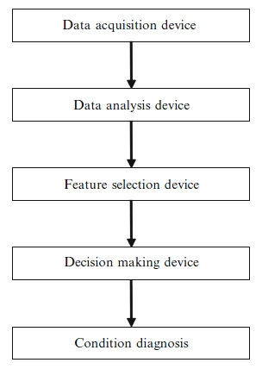

Fig. Condition Monitoring Framework

1. Condition Monitoring Data

Condition Monitoring techniques usually process time series data, with datasets representing some kind of sensor values at a certain point in time. In structural analysis problems, data can be obtained by exiting the structure and measuring the response. In the Condition Monitoring of Machines, vibrational data generated during running time of machines is used to

Another categorization of Data in a general theory of Computational Intelligence Methods is based on the availability of classified training data, which determines the choice of decision algorithms in phase 4. In a *supervised* setting, training data with samples for all classes to be predicted can be used to train a classifier. If the training data contains only samples of one class, *semi-supervised* decision techniques can be trained to detect all instances of the known class and reject anything else as outlier data. If no training data is available, *unsupervised* techniques have to be used which typically include a combination of various statistical measures.

The *semi-supervised* scenario is very common in Condition Monitoring, since it is often much easier and cheaper to obtain data from a system under normal condition than from a faulty system. In some domains, such as aerospace, it is not even possible to obtain a representative amount of fault data which could only be generated by accidents or catastrophes.

In a *semi-supervised* Condition Monitoring Setting, usually data representing the normal state of a system is available as training data. This data can be used to train classifiers that accept instances pertaining to the normal class and reject any other data instances as outliers.

In this thesis, *semi-supervised* techniques used for predictive maintenance are discussed and a *semi-supervised* variation of Support Vector Machines is implemented and tested. The data used to train and test the algorithm is described in the next section.

1. Rolling Element Bearing Data

Rotating Machines are very common in various industrial applications, but also in many other areas such as Aerospace or Power Generation. In Manufacturing, most machine failures are linked to bearing faults (Lou, Loparo, Discenzo, Yoo, & Twarowski, 2004). Consequently, much research has been done to develop techniques for the classification and prediction of Bearing Faults (Marwala, 2012), (Nelvamondo, Marwala, & Mahola, 2006), (Li, Chow, Tipsuwan, & Hung, 2000).

A popular Rolling Bearing Benchmark Dataset mentioned in many research papers can be found at (Case Western University). The data was obtained through accelerometers attached to a rotating machine with a central Rolling Bearing Element. Rolling bearing consist of two concentric rings, the Inner and Outer Raceway with a set of rolling elements running between their tracks as illustrated in Figure 2

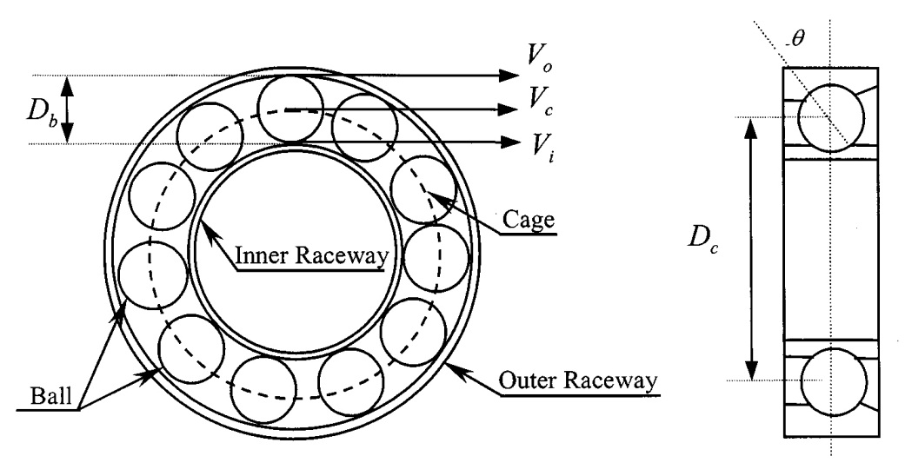

Fig. Rolling Element Bearing

The Rolling Elements are usually contained in a cage to prevent contact between elements.

Rolling Bearings generate vibration signals with characteristic signatures, according to the states of the raceways and the rolling elements. The Rolling Bearing Dataset from the Case Western University contains time-series accelerometer data obtained from different positions of the machine under normal condition and under several fault conditions. Figure 3 shows sample data of the Rolling Bearing under normal condtition, with Ball Faults and faults of the Inner and Outer Raceway.

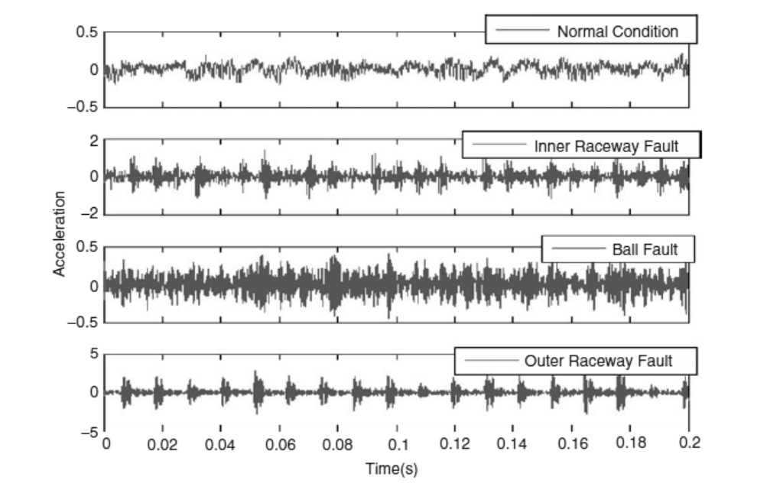

Fig. RollingBearing Sample Data

In this thesis, an artificial semi-supervised scenario is created by using only the normal data to train a classifier which accepts normal data and rejects any other data as outliers. The available fault-state data of the Rolling Bearing Elements is then used to test and evaluate the model.

1. Feature Extraction

Datasets occurring in the Condition Monitoring domain are often rather large time-series datasets which are expensive to process directly. Besides, data aspects linked to normal or faulty system states are in many cases hidden in the time series data and cannot be detected directly. Successful Condition Monitoring Frameworks therefore usually combine some kind of preprocessing and Feature Extraction techniques with a suitable decision algorithm.

“The robustness of a classification system depends on the usefulness of the extracted features and the reliability and effectiveness of a condition monitoring classification system”.

Several techniques have been applied to extract useful features from the Rolling Bearing dataset (Marwala, 2012). Some successful approaches combined Mel Frequency Cepstral Coefficients (MFCC), Multi Fractal Dimensions (MFD) and Kurtosis measure as feature extraction techniques with machine learning algorithms such as Neural Networks, Hidden Markov Models and Support Vector Machines to classify faults (Marwala, 2012), (Nelvamondo, Marwala, & Mahola, 2006). MFD, MFCC and Kurtosis are applied in this thesis for their proven ability to extract meaningful features from the Rolling Element Dataset time series. The techniques are introduced in the following section.

* 1. Mel Frequency Cepstral Coefficients
  2. Multi Fractal Dimensions

Fractals are patterns consisting of sub-patterns which are equal or similar to the complete pattern. A more precise definition introduces Fractals as “a mathematical set that has fractal dimension that usually exceeds its topological dimension and may fall between the integers” (Wikipedia).

Fractal Analysis has been successfully applied to the analysis of time series data (Lunga & Marwala, 2006). In accordance with the definition of Fractals given above, a time series signal has a topological dimension of 1, whereas the fractal dimension of the same signal may lie between 1 and 2. Several methods exist to determine the fractal dimension of a shape. A commonly used measure for fractal dimension is the box-counting dimension, also known as Minkowski-Bouligand dimension. It is based on the notion of a grid covering the shape of an object, as illustrated in Figure 4.

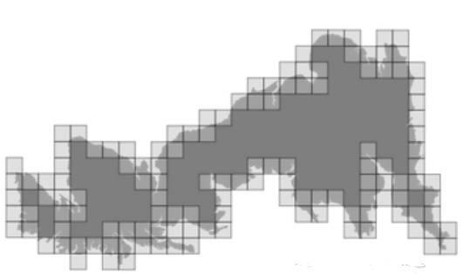

Fig. Box-Counting Dimension grid

The Box counting dimension of a fractal S is given by

$$D_{box}\left(S\right)=\lim_{ε→∞}{\frac{log⁡\left(N\left(ε\right)\right)}{log\left(\frac{1}{ε}\right)}}$$

Where $ε$ is the length of a quadratic box and $N\left(ε\right)$ is the number of boxes of size $ε$ needed to cover the shape completely.

Assuming a continuous time-series signal

$$s(t)(0≤t≤T)$$

Is sampled, with $S_{1},S_{2},…S_{T}$ representing the sampled values at time t, the box-counting dimension can be calculated by

$$D_{box}\left(S\right)=\frac{J\left(\sum_{j=1}^{J}{\ln\left(\frac{1}{ε_{j}}\right)ln\left(N\left(ε_{j}\right)\right)}\right)-\left(\sum_{j=1}^{J}{ln\left(\frac{1}{ε_{j}}\right)}\right)\left(\sum_{1}^{J}{ln\left(N\left(ε_{j}\right)\right)}\right)}{J\sum_{j=1}^{J}{{\left(\ln\left(\frac{1}{ε_{j}}\right)\right)}^{2}}-{\left(\ln\left(\frac{1}{ε_{j}}\right)\right)}^{2}}$$

Where $J$ is the computional

* 1. Kurtosis

Fig. 1 Condition Monitoring Framework 2