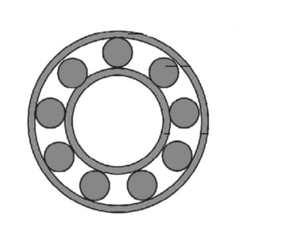

**Data acquisition**

Roller Bearing

Accelerometer

**Time signals**

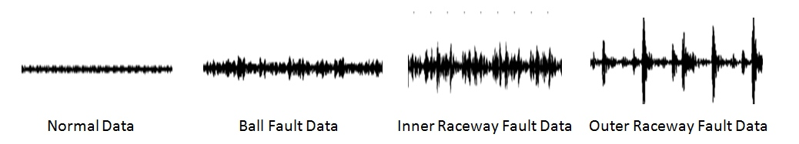

Normal time signal Ball fault signal Inner raceway fault signal Outer raceway fault signal

**Preprocessing: Partition time signals into segments of equal length**





**Feature Extraction**

Extract 13 Cepstral Coefficients per segement

Extract 13 Fractal Dimensions per segment

Calculate Kurtosis of segment

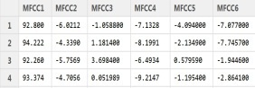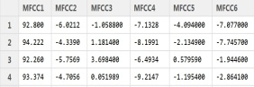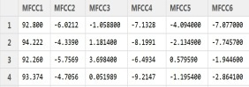

Normal Features Ball Fault Features Inner Raceway Fault Features Outer Raceway Fault Features

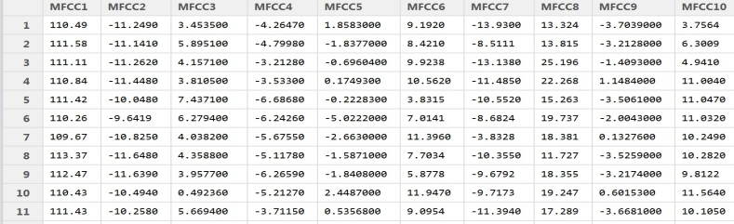

Testset (randomly drawn)

**Training**

Random Forest Data Description

K-Nearest-Neighbor Data Descriptiontion

Support Vector Data Description

Self-Organizing-Maps Data Description

Parzen Window Data Description

K-Means Data Description

K-Centers Data Description

Models Testset

ROC

Confusion Matrix

Type 2 Error (fraction of accepted outliers)

Type 1 Error (Fraction of rejected normal)

**Test**