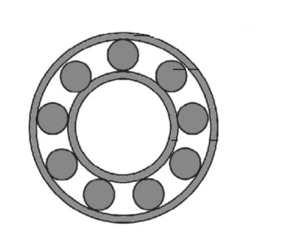

**Data acquisition**

Roller Bearing

Accelerometer

**Time signals**

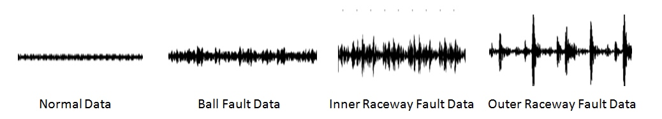

Normal time signal Ball fault signal IR- fault signal OR-ault signal

**Preprocessing: Time signal splitting**





**Feature Extraction**

Curtosis

Cepstral Coefficients

Fractal Dimensions

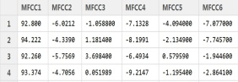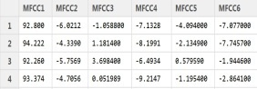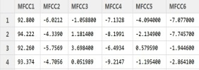

Normal Features Ball Fault Features IR-fault features OR-fault features

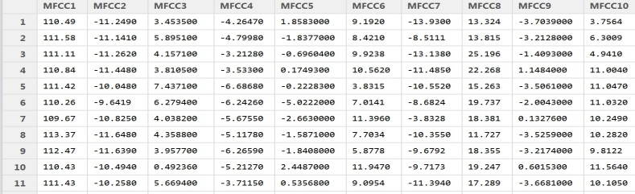

Testset

**Training**

RF-DD

KNN-DD

SV-DD

SOM-DD

Parzen-DD

K-MEANS-DD

K-Centers-DD

Models

Type 2 Error

Runtime

Accuracy

Type 1 Error

**Evaluation**